*Objectives:*

* *Select elements with $()*
* *Use .css() to style elements*

The first thing that we will learn to do is Selecting Elements. Just like with regular DOM manipulation or Vanilla JS, we need to Select things and then Manipulate them.

This lesson will mainly focus on Selecting Elements with jQuery.



In jQuery we can Select everything that we want using just one function, the *Dollar sign ($).* Unlike, Vanilla JS where we have *document.getElementById(), document.querySelector(), document.querySelectorAll(), document.getElementsByClassName()* and *getElementsByTagName(),* the $ in jQuery replaces all of them.

It basically works like *document.querySelectorAll(),* in that we give it a CSS style selector and then jQuery returns all the matching elements that match the selector that we give it.



We have an example here, if we wanted to select all the *“img”* tags on a page then it looks like this,

*$(“img”)*

If we want to select all the elements with a class called *“sale”* then we use it as below,

*$(“.sale”)*

Remember, these are CSS style selectors, that is why to select elements with an ID we need to use the #,

*$(“#bonus”)*

We can also perform some advance selecting this like selecting all the anchor tags those come inside a list element,

*$(“li a”).*

We will do a quick demo of how all these works. We will use the HTML page as below,

*<!DOCTYPE html>*

*<html>*

*<head>*

*<title>jQuery Demo</title>*

*<script type= “text/javascript” src= “https://code.jquery.com/jquery-2.1.4.js”></script>*

*</head>*

*<body>*

*<h1>jQuery Demo!</h1>*

*<ul>*

*<li>Newt</li>*

*<li>Howler Monkey</li>*

*<li>Pine Marten</li>*

*</ul>*

*</body>*

*</html>*



*Console coding:*

*$(“h1”)*

* *[ <h1>jQuery Demo!</h1> ]*

*$(“li”)*

* *[ <li>Newt</li>, <li>Howler Monkey</li>, <li>Pine Marten</li> ]*

*$(“body”)*

* *[<body>…</body>]*

*<!DOCTYPE html>*

*<html>*

*<head>*

*<title>jQuery Demo</title>*

*<script type= “text/javascript” src= “https://code.jquery.com/jquery-2.1.4.js”></script>*

*</head>*

*<body>*

*<h1>jQuery Demo!</h1>*

*<ul>*

*<li>Newt</li>*

*<li>Howler Monkey <a href= “monkey.com”> Monkey.com</a></li>*

*<li id= “adorable”>Pine Marten</li>*

*</ul>*

*</body>*

*</html>*



*Console coding:*

*$(“a”)*

* *[* *<a href= “monkey.com”>Monkey.com</a> ]*

*$(“li a”)*

* *[ <a href= “monkey.com”>Monkey.com</a> ]*

*$(“ul li a”)*

* *[ <a href= “monkey.com”>Monkey.com</a> ]*

*<!DOCTYPE html>*

*<html>*

*<head>*

*<title>jQuery Demo</title>*

*<script type= “text/javascript” src= “https://code.jquery.com/jquery-2.1.4.js”></script>*

*</head>*

*<body>*

*<h1>jQuery Demo!</h1>*

*<ul>*

*<li>Newt</li>*

*<li>Howler Monkey <a href= “monkey.com”> Monkey.com</a></li>*

*<li id= “adorable”>Pine Marten</li>*

*</ul>*

*<a href= “google.com”>Google</a>*

*</body>*

*</html>*

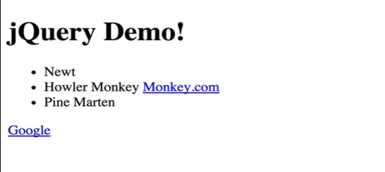

*Console coding:*

*$(“a)*

* *[<a href= “monkey.com”>Monkey.com</a>, <a href= “google.com”>Google</a>]*

*$(“ul li a”)*

* *[ <a href= “monkey.com”>Monkey.com</a> ]*

*$(“li a”)*

* *[ <a href= “monkey.com”>Monkey.com</a> ]*

*$(“#adorable”)*

* *[ <li id= “adorable”>Pine Marten</li> ]*

So, we have seen here how we can select our HTML tag elements, and it is not that exciting just print things on console or just to see them return here, we should introduce one method that will help us make things visual and help us alter the style.



That method is called *.css()* method. The way that it works is that we type,

*$(selector)*

And then we can add,

*.css(property, value)*

To change, thus we write the syntax as following,

*$(selector).css(property, value)*

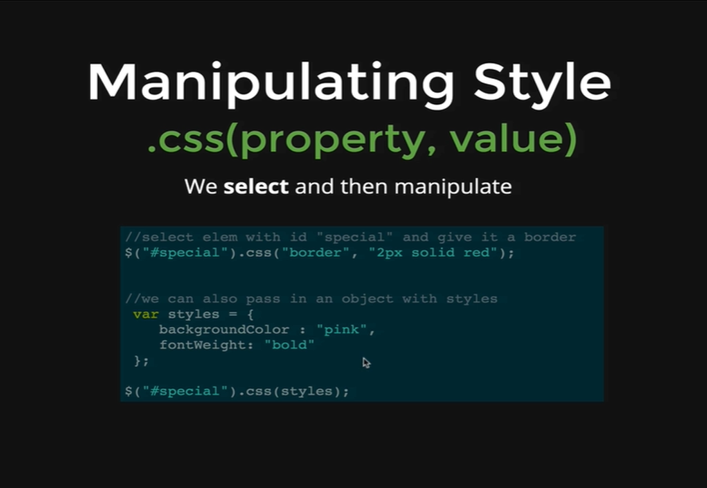

Here is an example, we are selecting something with an id called *“special”* and then we are running *.css* on it and changing the border to be *“2px solid red”.*

Let’s demonstrate that in the console.

*Console coding:*

*$(“h1”).css(“color”, “yellow”)*

* *[ <h1>jQuery Demo!</h1> ]*



We can see the *h1* content changed to yellow.

It is always good to keep in mind how we would do it without jQuery.

*Console coding:*

*document.querySelector(“h1”).style.color = “orange”;*

* *“orange”*



We can also use the object to change multiple properties of the content in our tag elements. In that case, we can use an object with new properties defined in the object, passing that object in jQuery’s *.css* method will implement the new properties on the content. We do not just have to pass one new property to change each single property of an object, we can define an object with multiple properties, multiple key-value pairs and pass that in and they will all be applied.

Let’s do that now,

*var styles = {*

*color: “red”,*

*background: “pink”,*

*border: “2px solid purple”*

*}*

*styles*

* *Object {color: “red”, background: “pink”, border: “2px solid purple”}*

*$(“h1”).css(styles)*

* *[ <h1 style= “color: orange;”>jQuery Demo!</h1>]*

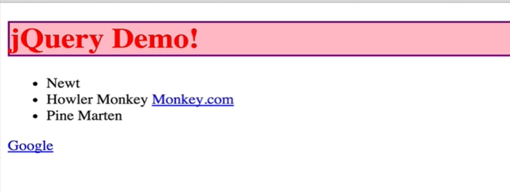

All those styles are applied.

To do this without jQuery will require us to do three separate lines. We need to do,

*document.querySelector(“h1”).style.color = “red”;*

*document.querySelector(“h1”).style.background = “pink”;*

*document.querySelector(“h1”).style.border = “2px solid purple”;*

As we can see with just few lines jQuery has proven to be powerful. And while we can do everything without it, it is saving us sometime and making our code a lot cleaner.

There is another feature of the *.css* method that makes it even more useful that we will see now.

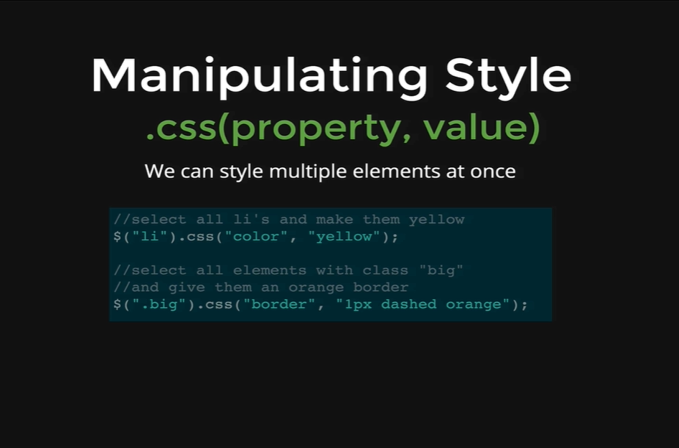

We can style multiple elements at once, rather than just selecting the first *h1* and making it yellow, we can select all *h1s* or all *lis* and we just need one line to do that.

Let’s make all the *lis* blue.

*Console coding:*

*$(“li”)*

* *[ <li>Newt</li>, <li>…</li>, <li id= “adorable”>Pine Marten</li> ]*

*$(“li”).css(“color”, “blue”);*

* *[ <li>Newt</li>, <li>…</li>, <li id= “adorable”>Pine Marten</li> ]*

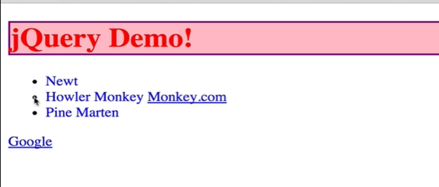

As we can see the one line changes all three *lis.* All we do is select with our selector *$(“li”)* and that gives us 3 *lis,* and by doing *.css* on the array of *lis,* it will make all the *lis* blue and we do not need to manually loop through as we would do without jQuery.

Just to remind ourselves if we want to make all the *lis* green, we need to select all the *lis* first,

*Console coding:*

*var lis = document.querySelectorAll(“li”);*

*for (var i = 0; i < lis.length; i++) {*

*lis[i].style.color = “green”;*

*}*

* *“green”*

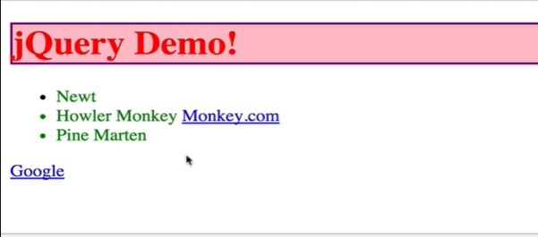

And we can see all the *lis* changed to green. So, it is doable without jQuery, but it is significantly more code. We need to select them all first and then we need to loop through manually with a *for loop* or *while loop* and then change each *lis* individually and then we are done.

With jQuery all we need is to get the *lis* back to blue that is why we select all *lis,* then connect the *.css* method and pass in the property which is *blue.*

*Console coding:*

*$(“li”).css(“color”, “blue”);*

*[ <li style= “color: green;”>Newt</li>, <li style= “color: green;”>…</li>, <li id= “adorable” style= “color: green;”>Pine Marten</li> ]*

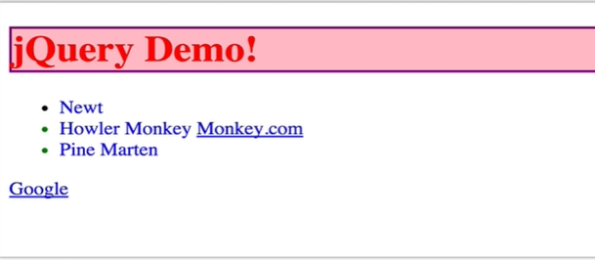

We will demonstrate few more examples here,

*Console coding:*

*$(“a”).css(“font-size”, “40px”)*

* *[ <a href= “monkey.com”>Monkey.com</a>, <a href= “google.com”>Google</a> ]*

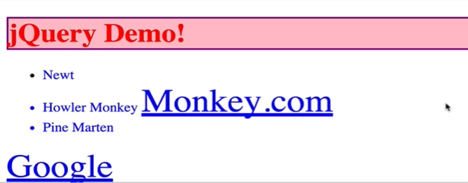

*Console coding:*

*$(“li”).css({*

*fontSize: “10px”,*

*border: “3px dashed purple”*

*background: “rgba(89, 45, 20, 0.5)”*

*});*

