Timittra Islam Hridi,15-01-04-056,timittra.cse.aust@gmail.com

Ishrat Mahjabin Nishat,15-01-04-064,imnnishat@gmail.com

Ahsanullah University of Science and Technology

Abstract: Analysing human creativity has always been a difficult undertaking. The reason for this is the vagueness of the term creativity itself. It is a location base application where there was already a dataset.It includes features like name,home location,prefer place etc.So in this project there are two features with two prediction questions. Firstly,finding preferable transport system while travelling to university. And second one is which vehicle they prefer mostly to travel versity.Here Logistic Regression is used asLogistic regression is the appropriate regression analysis to conduct when the dependent variable is dichotomous (binary).Logistic regression is used to describe data and to explain the relationship between one dependent binary variable and one or more nominal, ordinal, interval or ratio-level independent variables.Then KNN classifier as KNN is a non-parametric, lazy learning algorithm. Its purpose is to use a database in which the data points are separated into several classes to predict the classification of a new sample point.In other words, the model structure is determined from the data.

Introduction: **What is problem? Make sure the problem is very clear.**

Taking current place, latitude, longitude as input for calculating the preferable transport system while travelling to university. If a person is happy or not based on his or her family life lead, monthly income and university travel cost.

**Why is it important to solve this problem?**

We will make a ride sharing app. For this reason depending on from where a student comes from, monthly affordable money, how much he or she use for university travelling, we will give a ride suggestion. Depending on one person’s life lead type, monthly income we will predict if he or she is happy or not at his or her current situation.

In the next section we will discus about the solution of these problems.

Background: **What you did?**

First of all we had used Logistic regression train test for the following two problems. Then we had used KNN classification.

**Why you did it and what is the significance?**

We had used Logistic regression for these two problems as the used dataset was not infinite, that was fixed. And we had used KNN to see the accuracy of the solution.

The next section will show the flow chart and steps of the solution.

Methods: **How will you solve these problem?**

|  |
| --- |
| Start |

|  |
| --- |
| Dataset Collection |

|  |
| --- |
| Selection of features |

|  |
| --- |
| Logistic regression |

|  |
| --- |
| KNN |

**Step to solution:**

* Creating data frame with necessary features.
* Fixing dependent and independent variables.
* Taking the dependent variables as the output.
* Appling Logistic Regration.
* Calculating accuracy.
* Applying KNN classifier to calculate solution’s accuracy.

The next session will show the results of these problem

Results:

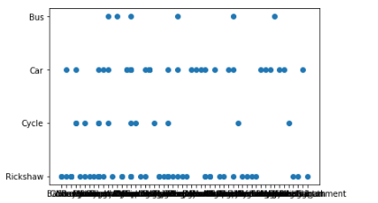

Fig.1

Figure 1 describe the problem no 1. This is scatter plot. This is indecating area wise preferable transportation mode by student.

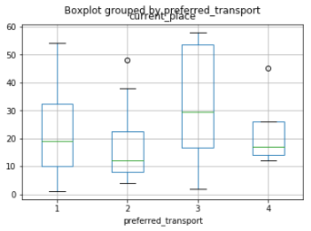

Fig.2

This is the figure of problem 1 box plot.Here the current place and prefered transport are shown as integer value. 1.rickshaw, 2. Bicycle, 3. Car and 4. Bus.Show the persentage of using vehicles based on the current living place of the students.

Problem 1 Logistic regression result 63.15% KNN using 3 neighbour the accuracy test result 42.1%.

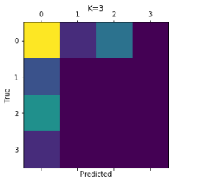

Fig.3 Problem 1 KNN.

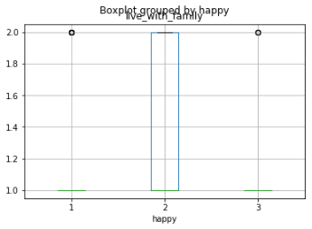

Fig.4

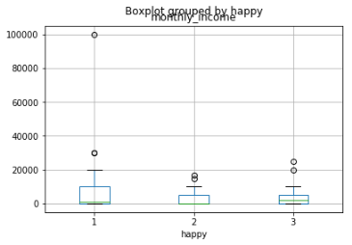

Fig.5

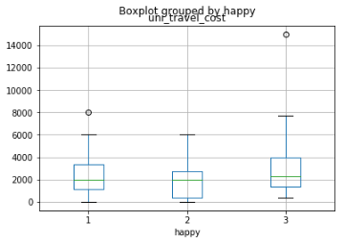

Fig.6

Figure 4, 5, 6 shows the boxplot indicating three different things. 4th one indicates that if he lives with the family or how much he is happy. 5th one indicates if he is happy or not based on his monthly income.And 6th one indicates if he is happy or not based on his monthly cost of university travel.

For problem 2 Logistic regression result is 57.57% and KNN using 3 neighbour the result of accuracy test is 68.4%.



Fig.7 KNN for problem 2.

Disccusion: In this project we have worked for location. We have collected different people’s location, latitude, longitude and different features.Using the collected dataset we have predicted that a person is happy or not based on their location wise transport system and current living state.

We do not get satisfied result as we thought. Our work do not out properly.

In future we will add more features to get our satisfied result.