

Department of Electrical and Computer Engineering

EE8104-Adaptive Signal Processing

Nasim Shams

25/03/2008

In this report, Least Mean Square (LMS) and Recursive Least Square (RLS), two of the important algorithms in adaptive filtering have been implemented and compared. Also effect of different factors such as delay, learning rate (mu), noise and channel parameter on the performance of the algorithms was investigated.
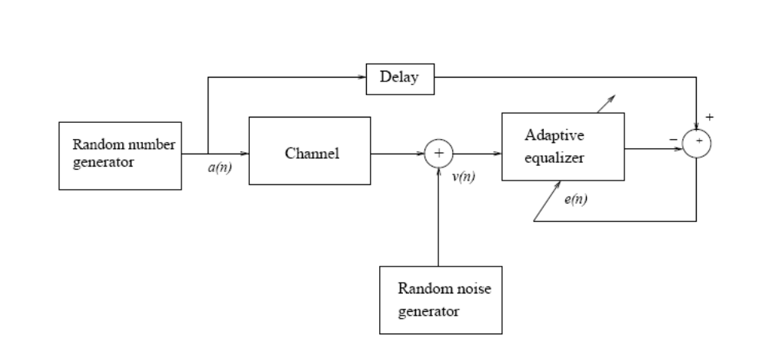
Figure 1: System Block Diagram

The above figure, shows the block diagram of the system. Where the input sequence is corrupted by the channel and additive Gaussian noise. The goal is to find the filter coefficients for the equalizer using LMS and RLS. This goal is achieved by the program. Then some of the system parameters have been modified for further investigation.

Finding the optimal delay:

To find the optimum value for delay, learning curve has been plotted for different values, as we can see in the graph choosing a delay of 4 results in the minimum error in steady state, so we take d = 4 as the optimum delay.
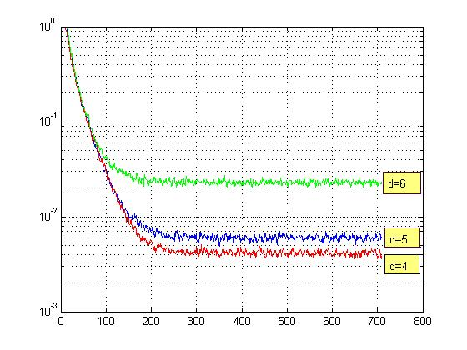
Figure 2: Leaning curve for delays of 4, 5 and 6

The following graphs show the effect of delay on the equalizer coefficients and overall response of the system (convolution of the channel and equalizer) for d = 4 and d = 6.

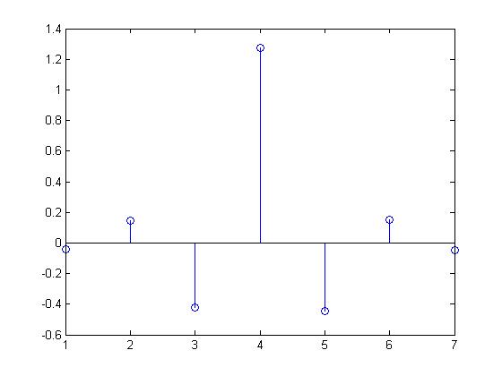
Figure 3: Equalizer Coefficients for d = 4

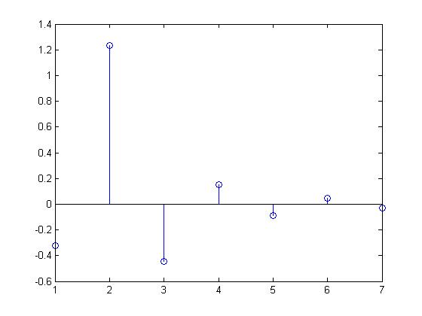
Figure 4: Equalizer coefficients for d = 6

Effect of noise on the performance:

Effect of noise on the results can be seen in the following graphs. As we can see when the variance of the noise is increased from 0.001 to 0.06 we have greater error after convergence.

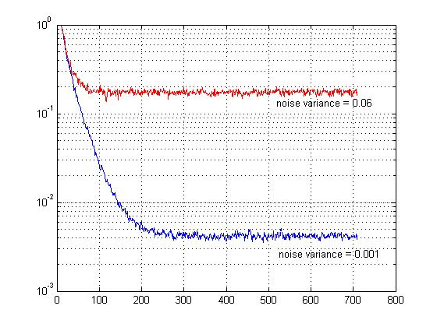
Figure 5: Learning curve for different noise powers

Also we can see the effect of higher power of noise on the achieved filter coefficients and overall system response. In this case, the result moves away from ideal response. We have more ISI after equalization.

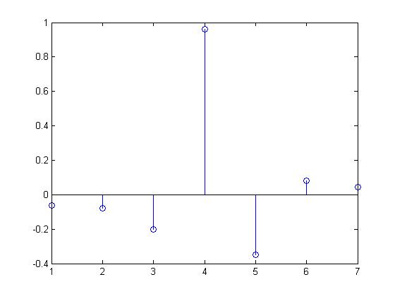
Figure 6: Equalizer response for increased noise

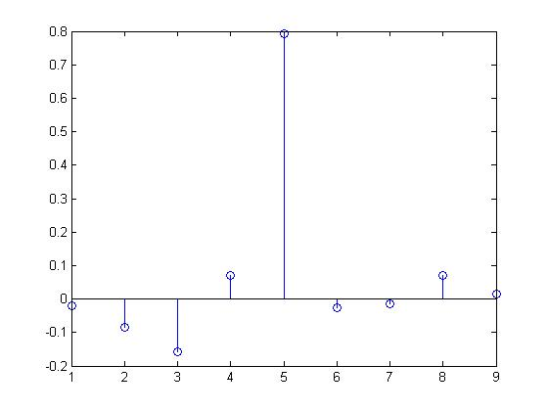
Figure 7: combined (equalizer and channel) response for increased noise

Effect of learning rate (mu):

Another important factor that influences the convergence of the algorithm and its speed is mu. We know that there is an upper band for mu, which for values greater than that the system dose not converge. This value is theoretically 1/λmax. To find the critical value for mu, the program was run for different values. The following figure shows the learning curve for values that seemed to be close to the critical mu.

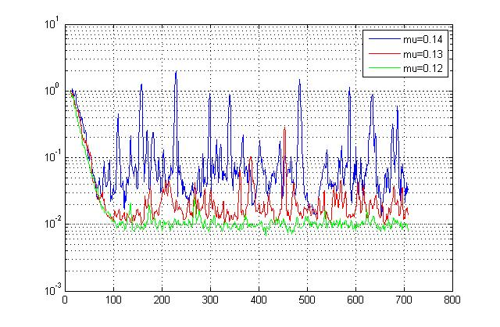
Figure 8: Finding critical mu

It can be observed from the graph that for mu=0.12 the algorithm is converging. For mu=0.13 , the variation in the learning curve is radically increasing. However it is somewhat showing some converging behavior. The peaks seem to be decreasing over the time. For mu=0.14 the algorithm is obviously diverging.
Other values for mu also have been tested. The graph below shows the leaning curve for mu=0.14 (for which the algorithm is not converging) , mu=0.07 (as a suitable value) and mu=0.03 (in this case we also have convergence, however it takes much longer due to small value of mu).

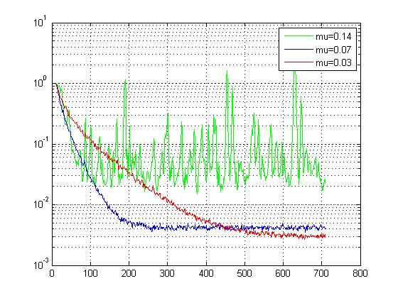
Figure 9: Learning curves for three mu values

Effect of channel capacity (W):

When the W has a higher value it means the channel is more complex and finding an equalizer takes more time or it is more difficult to reach a certain error after equalization. Because higher W introduces more ISI.The following figures show channel response for different channel capacities and the learning curve, equalizer response and combined response for W = 2.8, 3.2 and 3.6.

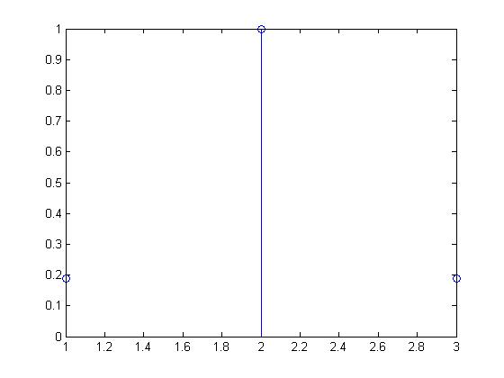
Figure 10: channel response for W = 2.8

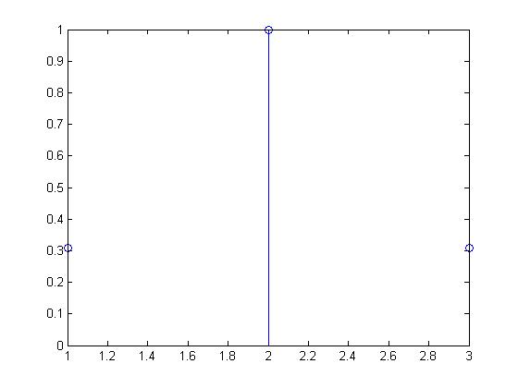
Figure 11: Channel response for W = 3.2
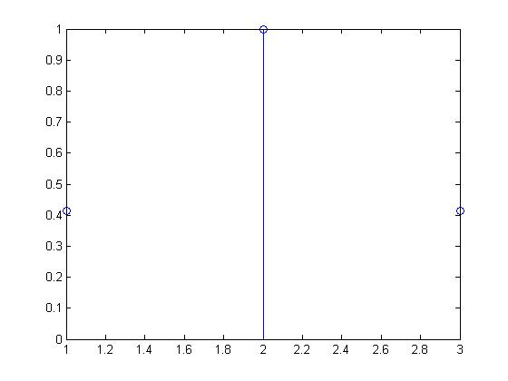
Figure 12: Channel response for W = 3.6

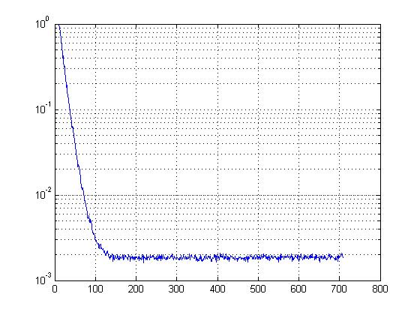
Figure 13: Learning curve for W = 2.8
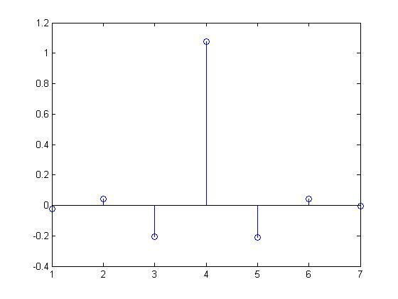
Figure 14: Equalizer response for W = 2.8

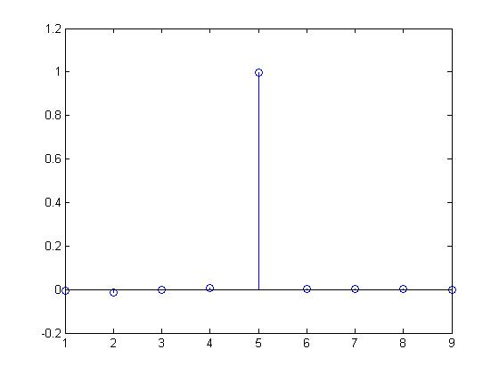
Figure 15: Combined response for W = 2.8

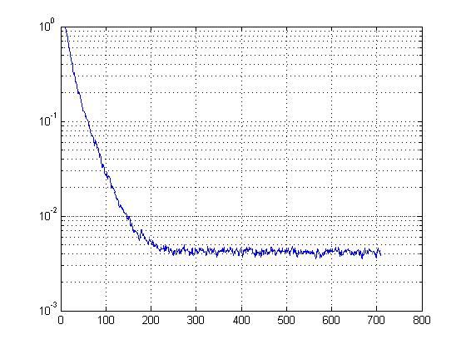
Figure 16: Learning curve for W = 3.2
Figure 17: Equalizer response for W = 3.2

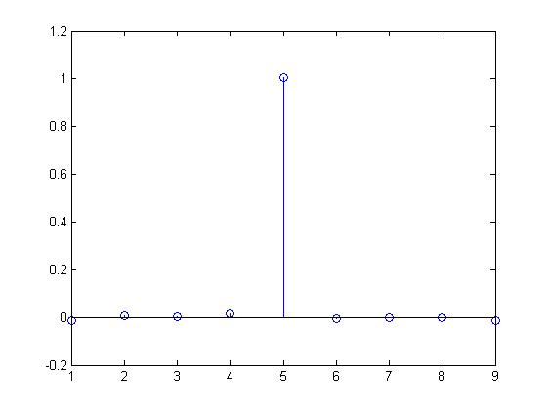
Figure 18: Combined response for W = 3.2

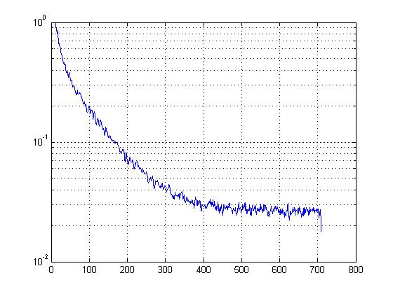
Figure 19: Learning curve for W = 3.6

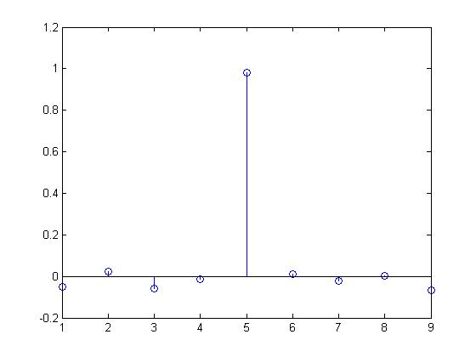
Figure 20: Combined response for W = 3.6

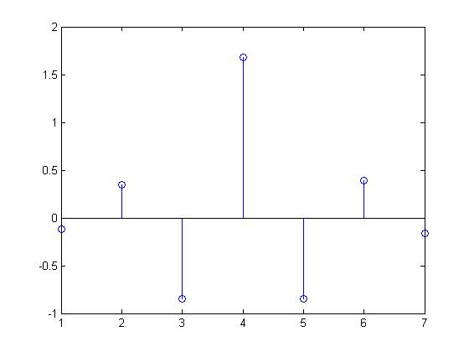
Figure 21: Equalizer response for W=3.6

Recursive Least Square (RLS):

RLS is another algorithm that we are considering here. The most important advantage of RLS over LMS is that it converges faster because it exploits the correlation in the input data. The effect of the mentioned parameters was also examined for RLS. Here are the results:

Effect of the noise:

This graph shows the learning curve for two values for noise variance.

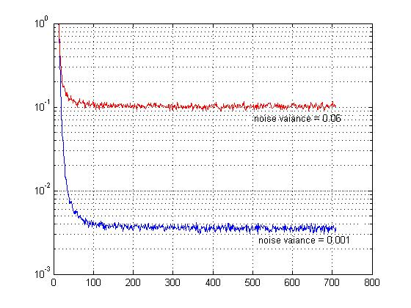
Figure 22: Learning curve for different noise values

Effect of delay:
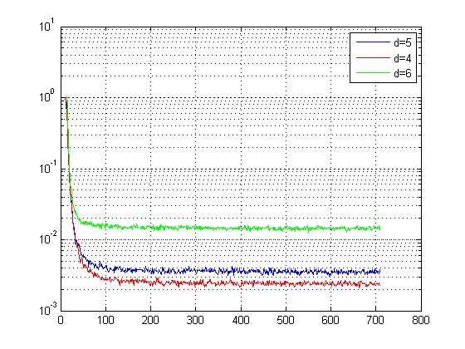
Figure 23: RLS learning curve for three delays

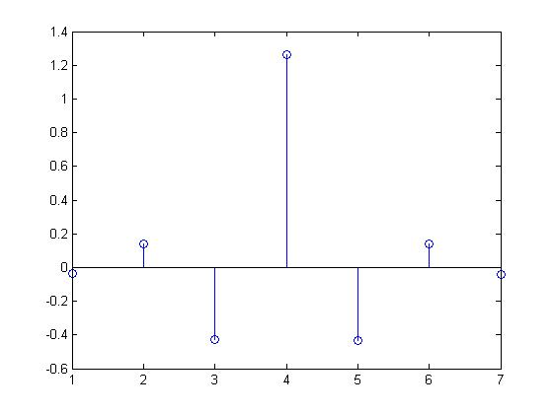
Figure 24: RLS equalizer response for d = 4

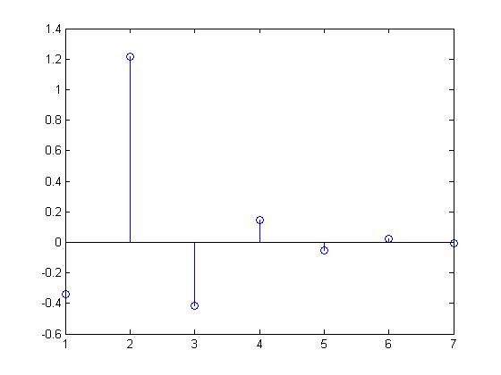
Figure 25: RLS equalizer response for d = 6

The results are the same as LMS, d = 4 seems to have the lowest error.

Effect of W :

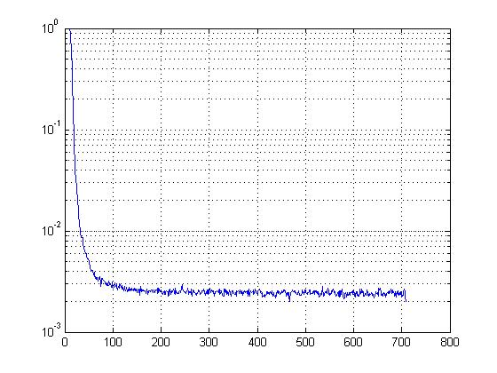
Figure 26: learning curve for W = 3.2

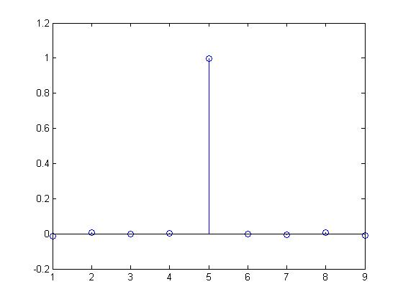
Figure 27: combined response for W = 3.2

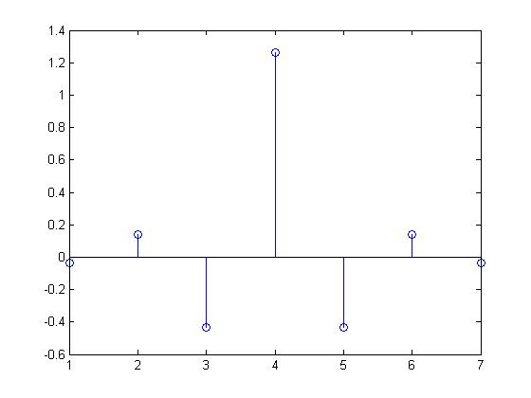
Figure 28: Equalizer response for W = 3.2
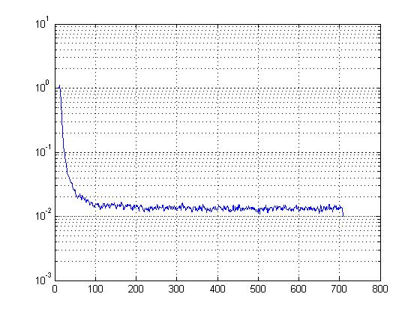
Figure 29: Learning curve for W = 3.6
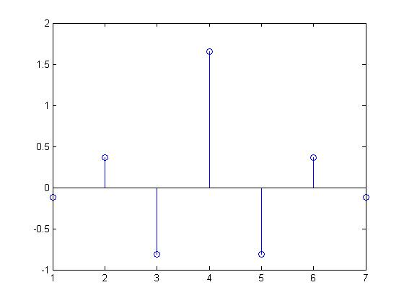
Figure 30: Equalizer response for W = 3.6

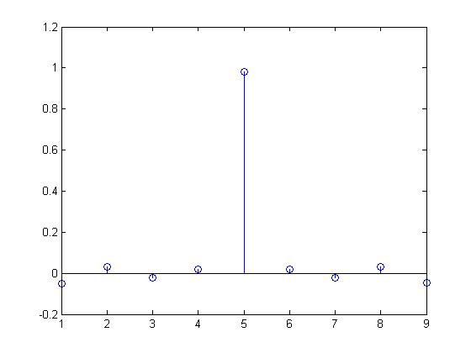
Figure 31: Combined response for W = 3.6

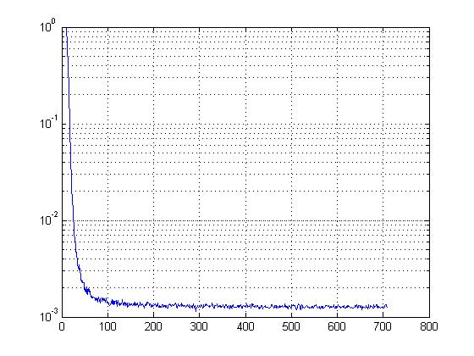
Figure 32: Learning curve for W = 2.8
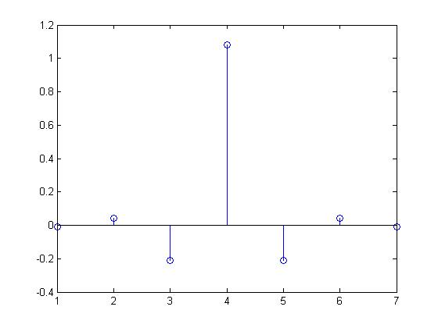
Figure 33: Equalizer response for W = 2.8
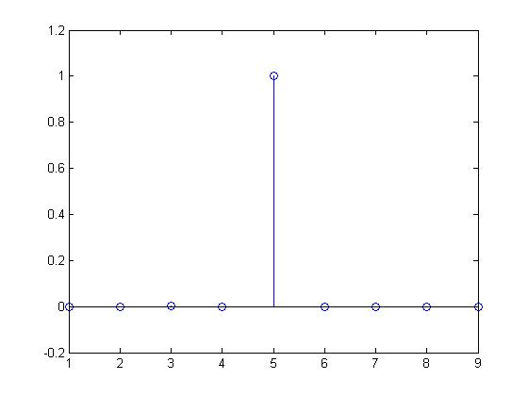
Figure 34: Combined response for W = 2.8
Spectrum of the combined response:
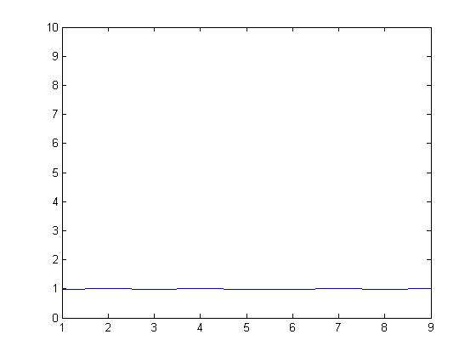
Figure 35: FFT of the combined response

As we can see in Fig35, the spectrum of the combined system response is flat. Which means the equalizer is working properly.

Comparison of LMS and RLS:

According to the observations we can enumerate differences between LMS and RLS

- As the most important advantage of RLS over LMS, one can consider faster convergence time of RLS. The following graphs clearly show that RLS algorithm, in this case, converges almost two times faster than LMS and hence can track high frequency changes in input better.

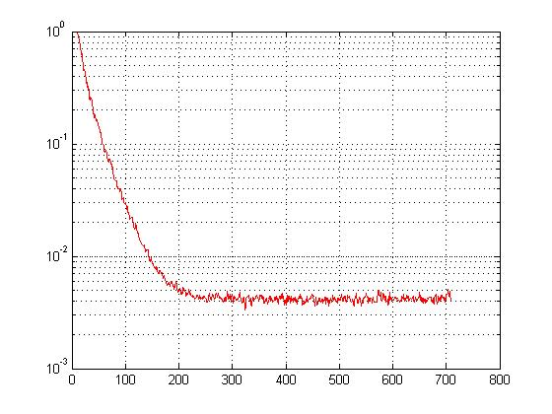
Figure 36: Learning curve for LMS

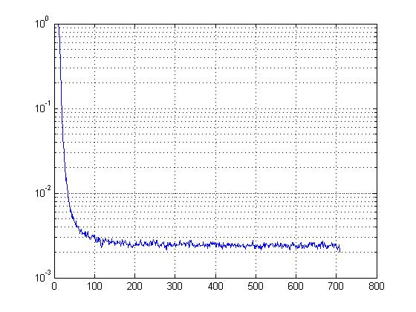
Figure 37: Learning curve for RLS

- By increasing the noise variance we can see that RLS is less sensitive to noise

Figure 38: LMS results

Figure 39: RLS result

- Also to test robustness of the algorithms against the noise, performance of the algorithms were tested while increasing variance of the noise. At the variance of 0.5 LMS algorithm stopped converging.

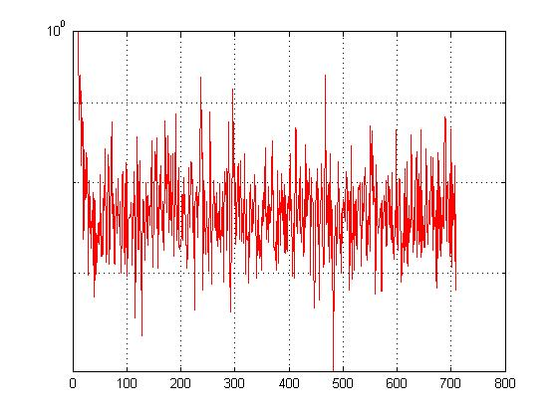
Figure 40: Learning curve for LMS for noise power = 0.5

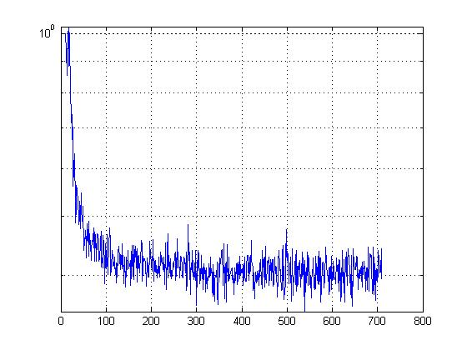
Figure 41: Learning curve for RLS for noise power = 0.5

However, these outcomes might be a result of not choosing the optimum value for mu for LMS. Hence we can conclude that in this case RLS is outperforming LMS with a mu of 0.07.
Generally RLS algorithm gives good results, but in some there are cases that RLS algorithm does not converge while LMS does.

- Theoretically, RLS has more computational complexity than LMS. For instance, setting N as the number of data taps or length of the data sequence to sound the echo channel, the RLS algorithm requires N² computational steps, whereas the LMS method only requires N computations.

Appendix1 (LMS):

%%%%%%%%%%%%%%%%%%%%%%%%%%%%%%%%%%%%%%%%%%%%%%%%%%%%%%%%%%%%
% %
% LEAST MEAN SQUARES (LMS) ALGORITHM & EQUALIZATION %
% ~~~~~~~~~~~~~~~~~~~~~~~~~~~~~~~~~~~~~~~~~~~~~~~~~~ %
% %
% AUTHOR : NASIM SHAMS %
% STUDENT ID # : 500217820 %
% File : equ1.m %
%%%%%%%%%%%%%%%%%%%%%%%%%%%%%%%%%%%%%%%%%%%%%%%%%%%%%%%%%%%%
clear;
%% Assumptions for Channel Capacity W, No. of Samples, No. of trials %%
eSquare = zeros (1,709);
mu = 0.07;
W = 3.2; % Channel Capacity
alp = 2; % alpha
forder = 7; % filter order
tsamples = 700; % total # of samples
delay = 4; % delay for desired response
trials = 500; % No. of independent trials
de = zeros(1,tsamples); % Intializing the squared error
nvari = 0.5; % Noise variance
dvari = 1; % Input data variance
taps = zeros(1,forder); % Initializing the tap weight counter
for trys = 1:trials % Loop for No. of trials
u = zeros(1,forder); % intialization of tap I/p for time < 1
a = zeros(1,forder-1); % intialization of data i/p for time < 1
% for j = 1:forder
% w(forder,j) = 0; % intializing tapweight vector w(0) = 0
% end
w = zeros(1,forder);
%%%%%%%%%% MODULE 1 %%%%%%%%%%%%%%%%
for sampgen = forder : tsamples+forder %% Generates Random data & desired resp
a(sampgen) = fix(rand+0.5)*2-1;
end
d = [zeros(1,delay) a];
for sampgen = forder : tsamples+forder %% Generates Random noise
v(sampgen) = fix(rand+0.5)*2*sqrt(nvari)-sqrt(nvari);
end

%% Impulse Response of the Channel for given W %%
for k = 1:3
h(k) = 1/2*(1+cos(2*pi/W*(k-2)));
end;
%% Mu
%muu = ; %%% Fill the appropriate mu
%%%%%%% MODULE 2 : UPDATING THE WEIGHTS & PLOTTING THE LEARNING CURVE %%%%%%%
%% Output from Channel
cop = conv(h,a);

%% Input to the equalizer (Channel o/p + Random Noise)
copn = cop + [v 0 0];
copn_size = size(copn);
%% Finding the Estimate
%% Calculating the Error (desired resp - estimate)
%% Updating the tap weights
for n = forder : copn_size(2)
u = copn(n-forder+1:n);
y(n) = w*u';
e(n) = d(n) - y(n);
w = w + mu*e(n)*u;
end
%% Calculating the error square for each trial & adding it up
eSquare = eSquare + e.^2;

end %%% Loop for number of trials (try variable)
%% Calculating the Mean square error (ie total err at instant i / # of trials)
error = eSquare./trials;
%% Plotting the Learning Curve
figure(1);
%hold on
semilogy(error,'red');
grid on
figure(2);
stem(w);
figure(3);
combine= conv(h,w);
stem(combine);

%%%%% Plotting the channel responses %%%%
%%%%% Plotting the equalizer responses %%%%
%%%%% Plotting the combined responses %%%%%

Appendix2(RLS):

%%%%%%%%%%%%%%%%%%%%%%%%%%%%%%%%%%%%%%%%%%%%%%%%%%%%%%%%%%%%
% %
% RLS ALGORITHM & EQUALIZATION %
% ~~~~~~~~~~~~~~~~~~~~~~~~~~~~~~~~~~~~~~~~~~~~~~~~~~ %
% %
% AUTHOR : NASIM SHAMS %
% STUDENT ID # : 500217820 %
% File : equ1.m %
%%%%%%%%%%%%%%%%%%%%%%%%%%%%%%%%%%%%%%%%%%%%%%%%%%%%%%%%%%%%
clear;
%% Assumptions for Channel Capacity W, No. of Samples, No. of trials %%
eSquare = zeros (1,709);
mu = 0.07;
W = 3.2; % Channel Capacity
alp = 2; % alpha
forder = 7; % filter order
tsamples = 700; % total # of samples
delay = 4; % delay for desired response
trials = 500; % No. of independent trials
de = zeros(1,tsamples); % Intializing the squared error
nvari = 0.001; % Noise variance
dvari = 1; % Input data variance
taps = zeros(1,forder); % Initializing the tap weight counter
for trys = 1:trials % Loop for No. of trials
u = zeros(1,forder); % intialization of tap I/p for time < 1
a = zeros(1,forder-1); % intialization of data i/p for time < 1
% for j = 1:forder
% w(forder,j) = 0; % intializing tapweight vector w(0) = 0
% end
w = zeros(1,forder);
p = eye(forder).*2;

%%%%%%%%%% MODULE 1 %%%%%%%%%%%%%%%%
for sampgen = forder : tsamples+forder %% Generates Random data & desired resp
a(sampgen) = fix(rand+0.5)*2-1;
end
d = [zeros(1,delay) a];
for sampgen = forder : tsamples+forder %% Generates Random noise
v(sampgen) = fix(rand+0.5)*2*sqrt(nvari)-sqrt(nvari);
end

%% Impulse Response of the Channel for given W %%
for k = 1:3
h(k) = 1/2*(1+cos(2*pi/W*(k-2)));
end;
%% Mu
%muu = ; %%% Fill the appropriate mu
%%%%%%% MODULE 2 : UPDATING THE WEIGHTS & PLOTTING THE LEARNING CURVE %%%%%%%
%% Output from Channel
cop = conv(h,a);

%% Input to the equalizer (Channel o/p + Random Noise)
copn = cop + [v 0 0];
copn_size = size(copn);
%% Finding the Estimate
%% Calculating the Error (desired resp - estimate)
%% Updating the tap weights
for n = forder : copn_size(2)
u = copn(n-forder+1:n);
y(n) = w*u';
e(n) = d(n) - y(n);
alpha(n) = d(n)-w*u';
k = (p*u')./(1+u*p*u');
p = p-k*u*p;
w = w+(k*alpha(n))';
end
%% Calculating the error square for each trial & adding it up
eSquare = eSquare + e.^2;

end %%% Loop for number of trials (try variable)
%% Calculating the Mean square error (ie total err at instant i / # of trials)
error = eSquare./trials;
%% Plotting the Learning Curve
figure(1);
%hold on
semilogy(error,'b');
grid on
figure(2);
stem(w);
figure(3);
combine= conv(h,w);
stem(combine);
figure;
plot(abs(fft(combine)));
ylim ([0 10]);
%%%%% Plotting the channel responses %%%%
%%%%% Plotting the equalizer responses %%%%
%%%%% Plotting the combined responses %%%%%

