

Department of Electrical and Computer Engineering

ELE8212 Digital Image Processing

Nasim Shams

15/02/2008

Convolution mask is a matrix, usually with odd number of rows and columns. As this matrix is shifted over the image, from left to right and from top to bottom, it calculates a weighted summation for all of the pixels. For each pixel in the image, it multiplies value of that pixel (as the central pixel) and all 8 (or 24) surrounding pixels by the corresponding values in the convolution matrix. Then it adds the results, and the value of the central pixel is set to this final value. The effect of the mask on the image depends on the size of the mask and its values. For example a matrix with the following values
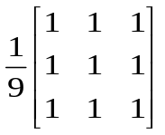
acts like a low pass filter while this one
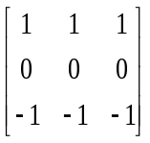
can be considered a high pass filter or an edge detector.
Also in the program we can provide two additional parameters: divisor and offset.
The result of the former calculations will be divided to divisor. We can use this value to maintain the energy of the image. For example we can use 9 for a 3*3 mask or 25 for a 5*5 mask. In the code when no value is entered for this parameter, it is set to 1.
The offset value is added to the division result. This value can be useful when we get negative results or we can use a negative value when we want to reduce the energy of the image or when saturation occurs.
When the code is run, user is provided with a 5 by 5 table to enter the values for the convolution mask and two boxes for entering the divisor and offset values. In order to apply a 3*3 convolution mask, one can simply leave the outer boxes empty so a value of zero will be returned as default. Once the OK button is hit, these values are stored to be applied to the image.
An issue that arises in the convolution process is the fact that when we want to apply the convolution mask on the boundary pixels, the convolution mask extends beyond the borders of the image. To overcome this problem I create a padded image, which is four pixels larger than the original image in width and height.
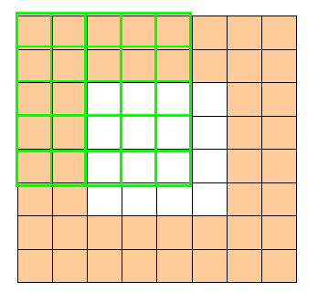
Original Image
Padded Image

In order for the values of the added rows and columns to be close and relevant to the real values at the borders of the image, the boundary rows and columns are repeated at each side of the image in padding. This padding is performed for each of the R, G and B planes separately and then the convolution mask is applied to these padded matrices. The added rows and columns will be removed before reconstructing the image.
After all the multiplications, summations and divisions, we may end up with values that are not in the valid range for display. Some of the values can be more than 255 or can be negative. Therefore, before displaying the result, some preprocessing is needed. In the program the result of the convolving are mapped between 0 and 255. Using the following equation:
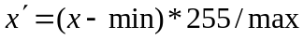

Where 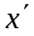is the new value, is the previous value, min is the minimum value in the result matrix and max is the maximum value after subtracting the minimum.

Results for different filters:

- The first filter is a sharpening filter. It magnifies the value in the center and gives a negative weight to the values around it, so it works like a high pass filter.
Below is result of this filter:

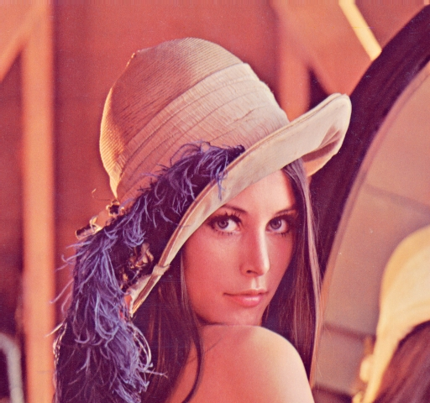
Figure 1: Original Image

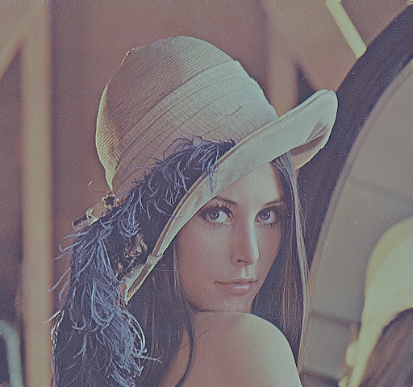
Figure 2: After filtering

b & d) These two mask perform an averaging on the image, they make the image smoother and have a blurring effect on the image

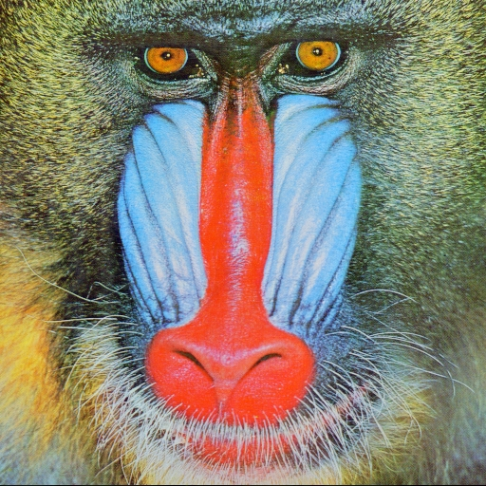
Figure 3 Original image

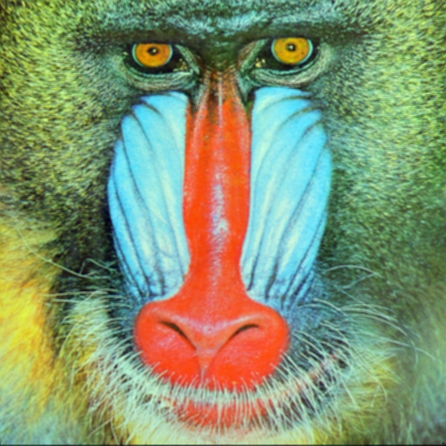
Figure 4: after filtering

c) This filter emphasizes variation in vertical direction, hence it detects horizontal edges.

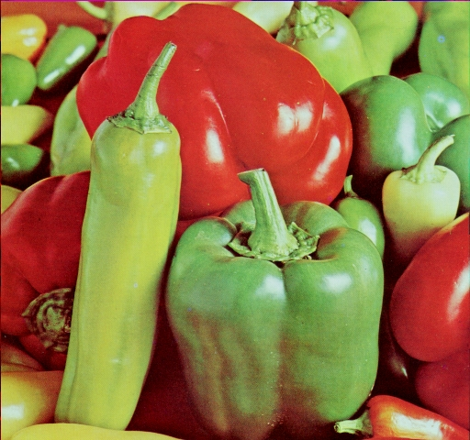
Figure 5: Before filtering

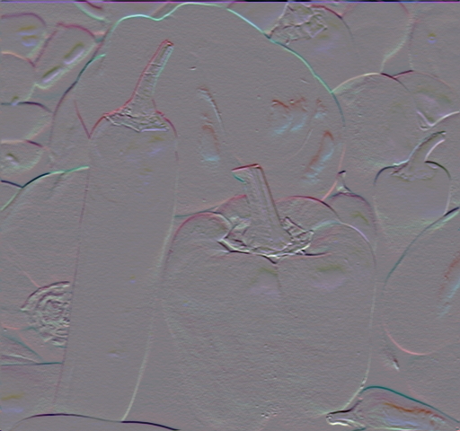
Figure 6: after filtering

Appendix

using System;
using System.Collections.Generic;
using System.ComponentModel;
using System.Data;
using System.Drawing;
using System.Text;
using System.Windows.Forms;

namespace DIP
{
public partial class Form1 : Form
{
public Form1()
{
InitializeComponent();
}
//my vaiables
public string fileName = null;
public Bitmap myBitmap, resultBitmap;
public int W, H;
public float[,] convMask = new float[5, 5];
public float scale, offset;
public float t1;
public int t2;

float[,] redArray, greenArray, blueArray;

float[,] paddedRed, paddedGreen, paddedBlue, redResult, greenResult, blueResult;

private void load_Click(object sender, EventArgs e)
{
try
{

/// this part opens an open file dialog, reads the input file and creats an object in from the bitmap
/// class then reads all the values of the image, stores them in redArray, greenArray and blueArray
/// and performs the padding for each plane
///
openFileDialog1.InitialDirectory = "c:\\My Documents";
openFileDialog1.Filter = "All files (*.*)|*.*";
openFileDialog1.RestoreDirectory = true;
if (openFileDialog1.ShowDialog() == DialogResult.OK)
{
if ((openFileDialog1.OpenFile()) != null)
{
openFileDialog1.OpenFile();
fileName = openFileDialog1.FileName;
}
else
{

}
}
label1.Text = fileName;
myBitmap = new Bitmap(fileName);
resultBitmap = new Bitmap(fileName);
pictureBox1.BackgroundImage = myBitmap;

H = myBitmap.Height;
W = myBitmap.Width;

redArray = new float[H, W];
greenArray = new float[H, W];
blueArray = new float[H, W];

paddedRed = new float[H + 4, W + 4];
paddedGreen = new float[H + 4, W + 4];
paddedBlue = new float[H + 4, W + 4];

redResult = new float[H, W];
greenResult = new float[H, W];
blueResult = new float[H, W];

Color tmpColor;
int i, j;

for (i = 0; i < H; i++)
{
for (j = 0; j < W; j++)
{
tmpColor = myBitmap.GetPixel(j, i); // changed from (j,i)
redArray[i, j] = tmpColor.R;
paddedRed[i + 2, j + 2] = tmpColor.R;
greenArray[i, j] = tmpColor.G;
paddedGreen[i + 2, j + 2] = tmpColor.G;
blueArray[i, j] = tmpColor.B;
paddedBlue[i + 2, j + 2] = tmpColor.B;
}
}

for (i = 0; i < H; i++)
{
paddedRed[i, 0] = paddedRed[i, 1] = redArray[i, 0];
paddedRed[i, W + 2] = paddedRed[i, W + 3] = redArray[i, W - 1];

paddedBlue[i, 0] = paddedBlue[i, 1] = blueArray[i, 0];
paddedBlue[i, W + 2] = paddedBlue[i, W + 3] = blueArray[i, W - 1];

paddedGreen[i, 1] = paddedGreen[i, 0] = greenArray[i, 0];
paddedGreen[i, W + 2] = paddedGreen[i, W + 3] = greenArray[i, W - 1];
}

for (j = 0; j < W; j++)
{
paddedRed[0, j] = paddedRed[1, j] = redArray[0, j];
paddedRed[H + 2, j] = paddedRed[H + 3, j] = redArray[H - 1, j]; // changed from W+2/W+3 to H+2/H+3

paddedBlue[0, j] = paddedBlue[1, j] = blueArray[0, j];
paddedBlue[H + 2, j] = paddedBlue[H + 3, j] = blueArray[H - 1, j];

paddedGreen[0, j] = paddedGreen[1, j] = greenArray[0, j];
paddedGreen[H + 2, j] = paddedGreen[H + 3, j] = greenArray[H - 1, j];

}

paddedRed[0, 0] = paddedRed[0, 1] = paddedRed[1, 0] = paddedRed[1, 1] = redArray[0, 0];
paddedRed[0, W - 1] = paddedRed[0, W - 2] = paddedRed[1, W - 1] = paddedRed[1, W - 2] = redArray[0, W - 1];
paddedRed[H - 2, W - 2] = paddedRed[H - 2, W - 1] = paddedRed[H - 1, W - 2] = paddedRed[H - 1, W - 1] = redArray[H - 1, W - 1];
paddedRed[H - 1, 0] = paddedRed[H - 1, 1] = paddedRed[H - 2, 1] = paddedRed[H - 2, 0] = redArray[H - 1, 0];

paddedGreen[0, 0] = paddedGreen[0, 1] = paddedGreen[1, 0] = paddedGreen[1, 1] = greenArray[0, 0];
paddedGreen[0, W - 1] = paddedGreen[0, W - 2] = paddedGreen[1, W - 1] = paddedGreen[1, W - 2] = greenArray[0, W - 1];
paddedGreen[H - 2, W - 2] = paddedGreen[H - 2, W - 1] = paddedGreen[H - 1, W - 2] = paddedGreen[H - 1, W - 1] = greenArray[H - 1, W - 1];
paddedGreen[H - 1, 0] = paddedGreen[H - 1, 1] = paddedGreen[H - 2, 1] = paddedGreen[H - 2, 0] = greenArray[H - 1, 0];

paddedBlue[0, 0] = paddedBlue[0, 1] = paddedBlue[1, 0] = paddedBlue[1, 1] = blueArray[0, 0];
paddedBlue[0, W - 1] = paddedBlue[0, W - 2] = paddedBlue[1, W - 1] = paddedBlue[1, W - 2] = blueArray[0, W - 1];
paddedBlue[H - 2, W - 2] = paddedBlue[H - 2, W - 1] = paddedBlue[H - 1, W - 2] = paddedBlue[H - 1, W - 1] = blueArray[H - 1, W - 1];
paddedBlue[H - 1, 0] = paddedBlue[H - 1, 1] = paddedBlue[H - 2, 1] = paddedBlue[H - 2, 0] = blueArray[H - 1, 0];
}
catch (Exception expec)
{
MessageBox.Show("Image incompatible", "Check Please");
}
}

///
/// in this part, values of the convolution mask are obtained , and convolution is performed.
private void preview_Click(object sender, EventArgs e)
{
try
{

resultBitmap = new Bitmap(W, H);
float redMin = 10000;
float greenMin = 10000;
float blueMin = 10000;
float redMax = -10000;
float greenMax = -10000;
float blueMax = -10000;

int i, j, t, k;
float redSum = 0;
float greenSum = 0;
float blueSum = 0;

///
///
/// reading the values of the convoution mask

convMask[0, 0] = (float)(textBox1.Text.Trim() == "" ? 0 : Convert.ToDouble(textBox1.Text));
convMask[0, 1] = (float)(textBox2.Text.Trim() == "" ? 0 : Convert.ToDouble(textBox2.Text));
convMask[0, 2] = (float)(textBox3.Text.Trim() == "" ? 0 : Convert.ToDouble(textBox3.Text));
convMask[0, 3] = (float)(textBox4.Text.Trim() == "" ? 0 : Convert.ToDouble(textBox4.Text));
convMask[0, 4] = (float)(textBox5.Text.Trim() == "" ? 0 : Convert.ToDouble(textBox5.Text));

convMask[1, 0] = (float)(textBox6.Text.Trim() == "" ? 0 : Convert.ToDouble(textBox6.Text));
convMask[1, 1] = (float)(textBox7.Text.Trim() == "" ? 0 : Convert.ToDouble(textBox7.Text));
convMask[1, 2] = (float)(textBox8.Text.Trim() == "" ? 0 : Convert.ToDouble(textBox8.Text));
convMask[1, 3] = (float)(textBox9.Text.Trim() == "" ? 0 : Convert.ToDouble(textBox9.Text));
convMask[1, 4] = (float)(textBox10.Text.Trim() == "" ? 0 : Convert.ToDouble(textBox10.Text));

convMask[2, 0] = (float)(textBox11.Text.Trim() == "" ? 0 : Convert.ToDouble(textBox11.Text));
convMask[2, 1] = (float)(textBox12.Text.Trim() == "" ? 0 : Convert.ToDouble(textBox12.Text));
convMask[2, 2] = (float)(textBox13.Text.Trim() == "" ? 0 : Convert.ToDouble(textBox13.Text));
convMask[2, 3] = (float)(textBox14.Text.Trim() == "" ? 0 : Convert.ToDouble(textBox14.Text));
convMask[2, 4] = (float)(textBox15.Text.Trim() == "" ? 0 : Convert.ToDouble(textBox15.Text));

convMask[3, 0] = (float)(textBox16.Text.Trim() == "" ? 0 : Convert.ToDouble(textBox16.Text));
convMask[3, 1] = (float)(textBox17.Text.Trim() == "" ? 0 : Convert.ToDouble(textBox17.Text));
convMask[3, 2] = (float)(textBox18.Text.Trim() == "" ? 0 : Convert.ToDouble(textBox18.Text));
convMask[3, 3] = (float)(textBox19.Text.Trim() == "" ? 0 : Convert.ToDouble(textBox19.Text));
convMask[3, 4] = (float)(textBox20.Text.Trim() == "" ? 0 : Convert.ToDouble(textBox20.Text));

convMask[4, 0] = (float)(textBox21.Text.Trim() == "" ? 0 : Convert.ToDouble(textBox21.Text));
convMask[4, 1] = (float)(textBox22.Text.Trim() == "" ? 0 : Convert.ToDouble(textBox22.Text));
convMask[4, 2] = (float)(textBox23.Text.Trim() == "" ? 0 : Convert.ToDouble(textBox23.Text));
convMask[4, 3] = (float)(textBox24.Text.Trim() == "" ? 0 : Convert.ToDouble(textBox24.Text));
convMask[4, 4] = (float)(textBox25.Text.Trim() == "" ? 0 : Convert.ToDouble(textBox25.Text));

scale = (float)(textBox26.Text.Trim() == "" ? 1 : Convert.ToDouble(textBox26.Text));
offset = (float)(textBox27.Text.Trim() == "" ? 0 : Convert.ToDouble(textBox27.Text));

//
///
///
////

//multiplying convoloution mask

//**********************************************************************************************//

if (checkBoxRed.Checked == true)
{
for (i = 0; i < H; i++)
{
for (j = 0; j < W; j++)
{
for (t = 0; t < 5; t++)
{
for (k = 0; k < 5; k++)
{

redSum = redSum + convMask[t, k] * paddedRed[i + t, j + k];

}
}

redResult[i, j] = (int)((float)redSum / (float)scale) + offset;

redSum = 0;

if (redResult[i, j] > redMax)
{
redMax = redResult[i, j];
}
if (redResult[i, j] < redMin)
{
redMin = redResult[i, j];
}

}
}
}
else
{
for (i = 0; i < H; i++)
{
for (j = 0; j < W; j++)
{
redResult[i, j] = redArray[i, j];
}
}
}

if (checkBoxGreen.Checked == true)
{
for (i = 0; i < H; i++)
{
for (j = 0; j < W; j++)
{
for (t = 0; t < 5; t++)
{
for (k = 0; k < 5; k++)
{

greenSum = greenSum + convMask[t, k] * paddedGreen[i + t, j + k];

}
}

greenResult[i, j] = (int)((float)greenSum / (float)scale) + offset;

greenSum = 0;
if (greenResult[i, j] > greenMax)
{
greenMax = greenResult[i, j];
}
if (greenResult[i, j] < greenMin)
{
greenMin = greenResult[i, j];
}

}
}
}
else
{
for (i = 0; i < H; i++)
{
for (j = 0; j < W; j++)
{
greenResult[i, j] = greenArray[i, j];
}
}
}

if (checkBoxBlue.Checked == true)
{
for (i = 0; i < H; i++)
{
for (j = 0; j < W; j++)
{
for (t = 0; t < 5; t++)
{
for (k = 0; k < 5; k++)
{

blueSum = blueSum + convMask[t, k] * paddedBlue[i + t, j + k];

}
}

blueResult[i, j] = (int)((float)blueSum / (float)scale) + offset;

blueSum = 0;
if (blueResult[i, j] > blueMax)
{
blueMax = blueResult[i, j];
}
if (blueResult[i, j] < blueMin)
{
blueMin = blueResult[i, j];
}

}
}
}
else
{

for (i = 0; i < H; i++)
{
for (j = 0; j < W; j++)
{
blueResult[i, j] = blueArray[i, j];
}
}
}

//******************************************************************************************//

/// preparing the data for display (mapping)

for (i = 0; i < H; i++)
{
for (j = 0; j < W; j++)
{

if (checkBoxRed.Checked == true)
{
if (redMax != redMin)
redResult[i, j] = ((int)((float)(redResult[i, j] - redMin) * 255 / (float)(redMax - redMin)));
else
redResult[i, j] = 0;
}
if (checkBoxGreen.Checked == true)
{
if (greenMax != greenMin)
greenResult[i, j] = ((int)((float)(greenResult[i, j] - greenMin) * 255 / (float)(greenMax - greenMin)));
else
greenResult[i, j] = 0;
}
if (checkBoxBlue.Checked == true)
{
if (blueMax != blueMin)
blueResult[i, j] = ((int)((float)(blueResult[i, j] - blueMin) * 255 / (float)(blueMax - blueMin)));
else
blueResult[i, j] = 0;
}
}
}

for (i = 0; i < H; i++)
{
for (j = 0; j < W; j++)
{
resultBitmap.SetPixel(j, i, Color.FromArgb((int)redResult[i, j], (int)greenResult[i, j], (int)blueResult[i, j]));
}
}

pictureBox1.BackgroundImage = resultBitmap;

}
catch (Exception exep)
{
System.Windows.Forms.MessageBox.Show(exep.ToString(), "Next time");
}

}// end of preview

private void save_Click(object sender, EventArgs e)
{
string saveLocation = "";

saveFileDialog1.InitialDirectory = "c:\\My Documents";
saveFileDialog1.Filter = " Bitmap File (*.bmp)|*.bmp";
saveFileDialog1.RestoreDirectory = true;
saveFileDialog1.ShowDialog();
saveLocation = saveFileDialog1.FileName;
resultBitmap.Save(saveLocation);

}

}
}

