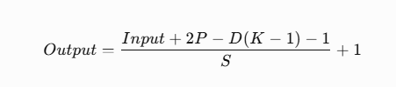
Input= size of input
P=padding
D=dilation
K=kernel size
S=stride
Answer Q1: (32+2(0)-1(3-1)-1/1)+1=30
Answer Q2: (128+2(0)-1(7-1)-1/3)+1=41
Answer Q3: (100+2(1)-2(3-1)-1/1)+1=98
Answer Q4:
Since the input dimensions and stride are specified for both directions, we calculate the height and width separately.
Hout=(200+2(0)-1(5-1)-1/2)+1=98
Wout=150+2(0)- )-1(5-1)-1/2)+1=73
Output=98*73
Answer Q5: Hout=(80+2(2)-2(3-1)1/1)+1=80
Wout=(120+2(2)-2(7-1)-1/3)+1=38
Output=80*38

Answer Q6:
First layer:
(96+2(3)-1(7-1)-1/2)+1=48
Second layer:
(48+2(0)-1(3-1)1/2)+1=23
Third layer:
(23+2(1)-1(3-1)-1/1)+1=23
Final out put:
23*23

Practice 2
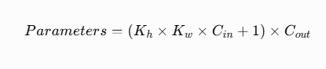
Kh= height of kernel
Kw= width of kernel
Cin= number of input channels
Cout=number of filters
1= bias
Answer Q1: (3*3*3+1)*8=224

Answer Q2: (5*5*1+1)*11=286

