## Objective

To design **Use Case Diagrams** for the **BidyaSetu** system that visually represent the interactions between **users (actors)** and **system functionalities (use cases)**.

## Actors & Key Use Cases

### Parent

* Sign in / Log out
* View child’s attendance
* View exam schedules & results
* Receive notifications (SMS/App)
* Download study materials
* Access e-library (books, videos)
* Communicate with teachers
* Submit feedback

### Teacher

* Sign in / Log out
* Mark attendance
* Upload assignments & study resources
* Manage classwork & grading
* Post notices (class/school level)
* Communicate with parents
* Generate student reports
* Access e-library

### Admin

* Sign in / Log out
* Manage users (Parents, Teachers, Students)
* Manage notices & announcements
* Oversee e-library & downloads
* Configure SMS & notifications
* Generate analytical reports
* Manage system settings
* Handle backups & data security

## Use Case Diagrams

### Parent Use Case Diagram

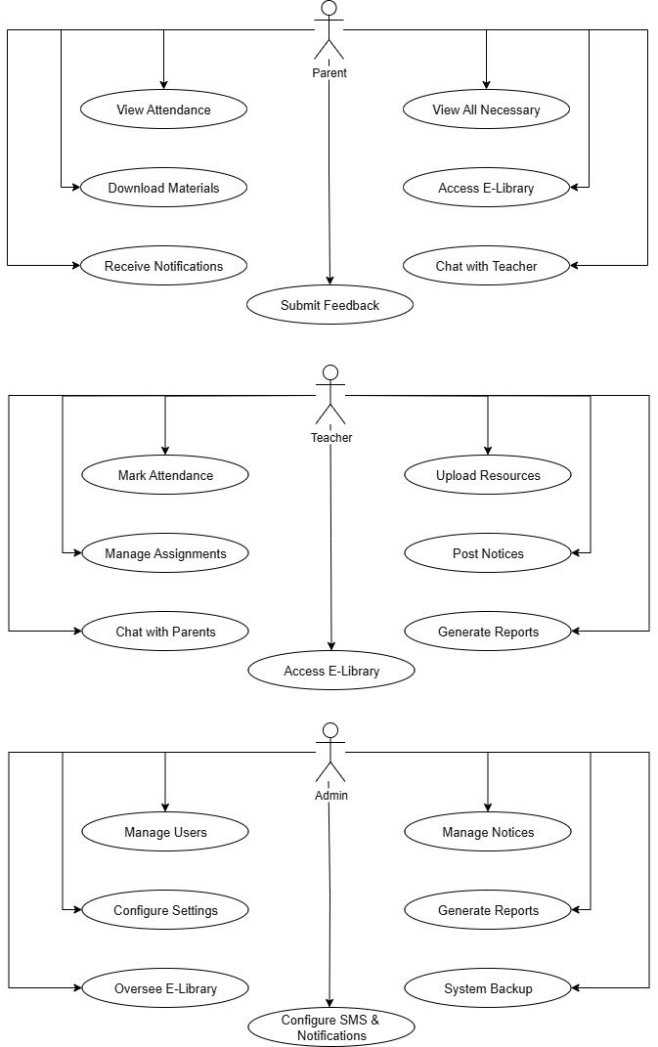

### Teacher Use Case Diagram



### Admin Use Case Diagram



### Conclusion

In this lab, we designed **use case diagrams** for the **BidyaSetu** system. The diagrams clearly show how **Parents, Teachers, and Admins** interact with system features. This step ensures clarity in system requirements and guides the next stages of system design.