### ****Objective****

To model the dynamic behavior of the Bidya Setu system by designing activity diagrams (UML) and flowcharts for key processes, such as **Student Attendance**, **Parent Viewing Progress**, and **Admin Monitoring**.

1. **Activity Diagram**:  
   UML activity diagrams represent workflows of stepwise activities and actions, supporting choices, iteration, and concurrency.
2. **Flowchart**:  
   A graphical representation of an algorithm or process, using standard symbols (start/end, process, decision, data, etc.).

### ****Features to Model****

* Student Attendance Process (Teacher taking attendance).
* Parent Viewing Child Progress.
* Admin Monitoring & Managing Data.

### ****Diagrams****

#### ****Activity Diagram of Parent Progress****

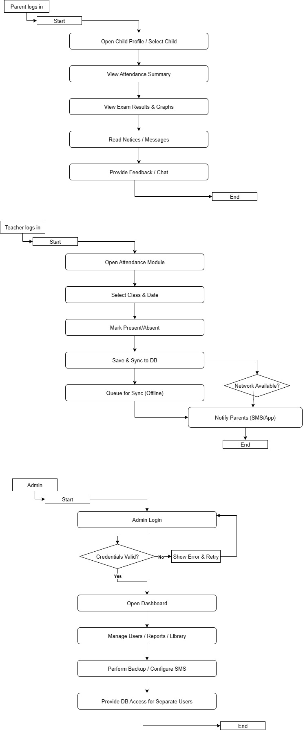

#### ****Activity Diagram of Teacher Progress****



#### ****Flowchart of Admin Monitoring****



### ****Conclusion****

Activity diagrams and flowcharts help visualize the **workflow** of the system, ensuring all roles (Teacher, Parent, Admin) and their processes are clearly defined. These diagrams serve as a bridge between **requirement analysis** and **system design**, reducing ambiguity.