**A Project Proposal – Summer 2025**

**Project Title: IoT-Based Home Automation System And Auto Water Pump Control Using ESP-32 NodeMCU**

This proposal is submitted to fulfilment of the requirements for the course CSE 0613-3299 (Project Development).



**Submitted To:**

Md. Hasibur Rahman

Lecturer, Dept. of CSE

[hasibur.cse@kyau.edu.bd](mailto:hasibur.cse@kyau.edu.bd)

Khwaja Yunus Ali University

**Submitted by:**

|  |
| --- |
| **Name: Md. Nasir Uddin** ID: 0622310105101001 Dept. of CSE (15th Batch) Mail: sknasirbd420@gmail.com |
|  |
| **Name: Mst. Sharmin khatun Sultana** ID: 0622310205101002 Dept. of CSE (15th Batch) Mail: sharminsultanaap12@gmail.com |
|  |
| **Name: Md. Zannat Ul Islam Eon** ID: 0622310105101016 Dept. of CSE (15th Batch) Mail: smeon1655@gmail.com |

Department of Computer Science and Engineering (CSE)

School of Science and Engineering

Khwaja Yunus Ali University, Enayetpur, Sirajganj-6751

Date of Submission: 30 July, 2025

**Title: IoT-Based Home Automation System and Auto Water Pump Control Using ESP-32 NodeMCU**

**1. Objectives:**

The objectives of this project are to:

To design and implement a low-cost IoT-based home automation system using ESP-32 NodeMCU that can remotely control home appliances, including a water pump, through a smartphone or web interface, enhancing convenience, safety, and water usage efficiency.

**2. Proposed Work/ Project Architecture:**

#### **System Overview:**

This project aims to automate and remotely control basic household appliances like lights, fans, and especially a **water pump**, using Wi-Fi-based communication via the **ESP-32 microcontroller**.

#### **Components:**

* **ESP-32 Development Board** – main controller with Wi-Fi & Bluetooth.
* **Relay Module (4-Channel)** – to switch appliances and water pump.
* **Water Level Sensor** – to prevent dry run of water pump.
* **Smartphone App or Web Dashboard** – to control devices.
* **Power Supply** (5V/12V with regulator).
* **Jumper wires, Breadboard.**
* **Manual Override Switches** (for fail-safe local control).
* **Water level sensor.**
* **Casing/Box (optional)**

**Total Estimated Cost:** BDT 2,350 - BDT 2,700.

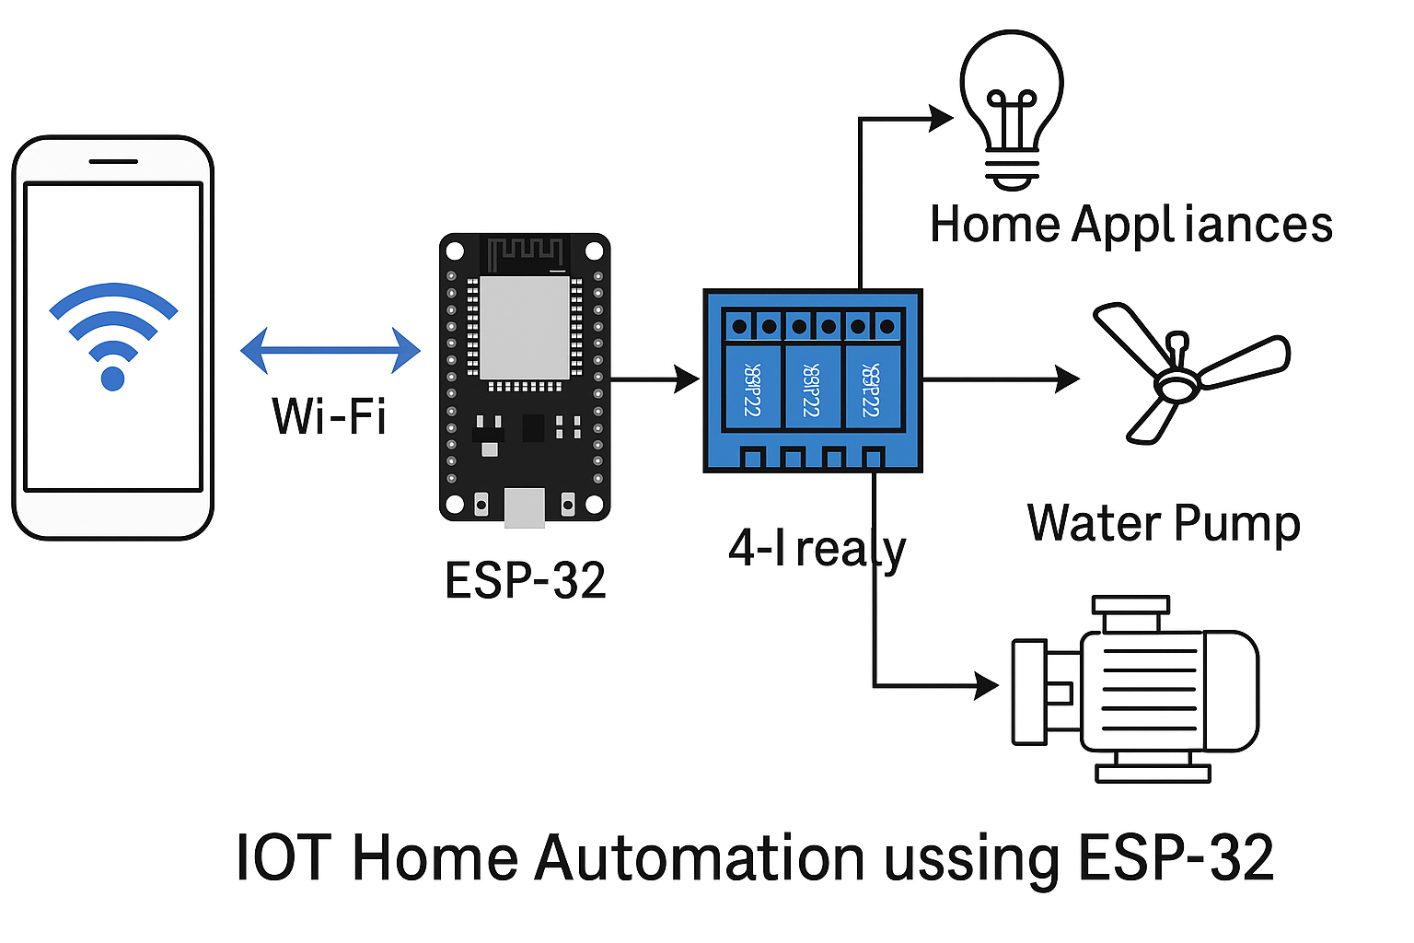

**Fig 1.0:** System Architecture of the proposed system.

**3. Applications/Social Impact:**

**Smart Home Appliance Control:** Control light, fan, and water pump from a smartphone or web interface. And enable scheduled or real-time control of appliances.

**Water Pump Automation:** Automatically turns on the pump when water level is low and turns it off when the tank is full.

**Elderly and Physically Challenged Support:** Makes it easier for people with limited mobility to control appliances. Adds convenience and safety.

**Water and Energy Conservation:** Prevents water overflow and unnecessary power usage by turning devices off automatically.

**Affordable Smart Solutions:** Low-cost alternative to expensive foreign smart home systems. Suitable for low-income and rural households.

**Empowering Elderly and Disabled:** Allows independent living by enabling remote control of home appliances.

**Opportunities for Innovation and Employment:** Promotes learning in IoT, electronics, and embedded systems. Can lead to local manufacturing, startups, and job creation.

**Approval/Supervisor's Feedback:**

This project proposal is approved for development, subject to periodic review and guidance by the supervisor during implementation.