**Assignment 02**

**Name: Nasir Hussain**

**Roll #:779**

**Department: Software Engineering**

**Semester :4th**

**Course : Web Designing**

**Course instructor: Engr Jehangir Muhammad Khan**

**HTML CODE FOR INDEX PAGE**

<html lang="en">

<head>

  <meta charset="UTF-8">

  <meta http-equiv="X-UA-Compatible" content="IE=edge">

  <meta name="viewport" content="width=device-width, initial-scale=1.0">

  <link rel="stylesheet" href="css/index.css">

  <link rel="stylesheet" href="css/header.css">

  <title>IEEE</title>

</head>

<body>

  <header>

    <div class="ieee"><img src="images/ieee.jpg" alt=""></div>

    IEEE ANNUAL MEETUP

    <br>

    in collabration with University Of Malakand

    <br>

    Student Societies

  </header>

  <nav>

    <li>

      <button><a href="index.html">HOME</a></button>

      <!-- <button><a href="#">ORGANIZERS</a></button> -->

      <button><a href="#invite">INVITATION</a></button>

      <button><a href="#">VENUE</a></button>

      <button><a href="#footer">CONTACT</a></button>

      <button><a href="registrationform.html">REGISTER</a></button>

    </li>

  </nav>

  <div class="purpose">

    <h2>PURPOSE</h2>

    <p>The purpose of our annual student community meetup is to bring together like-minded individuals who are

      passionate about learning and personal growth. This event serves as a platform for attendees to share their

      experiences, exchange ideas, and collaborate on projects. It is also an opportunity for attendees to network with

      each other and make new connections. Additionally, the meetup aims to provide a safe and inclusive space for

      attendees to have meaningful discussions and engage in activities that foster personal and professional

      development. We hope that this meetup will not only be a learning experience, but also a fun and enjoyable one for

      all attendees.</p>

  </div>

  <marquee height='20%' width='100%' behavior="scroll" direction="left" scrollamount=8>

    <div class="speakersinfo">

      <div class="speaker1 eng">

        <h3>SPEAKER</h3>

        <h3>Engr.Khalil Ullah (BSc,Msc,Phd)</h3>

        <h3>Assistant proffesor and Chairman department

          of Software Engineering University of Malakand

        </h3>

      </div>

      <div class="speaker2 eng">

        <h3>SPEAKER</h3>

        <h3>Engr.Jehangir Muhammad Khan (BSc,Msc)</h3>

        <h3>Lecturer department

          of Software Engineering University of Malakand

        </h3>

      </div>

      <div class="speaker3 eng">

        <h3>SPEAKER(Organizer)</h3>

        <h3>Sana Ullah (BS,Mphil)</h3>

        <h3>Lecturer department

          of Software Engineering University of Malakand

        </h3>

      </div>

    </div>

  </marquee>

  <div class="speakers">

    <div class="speaker"><img src="images/khalil.JPG" alt="">

      <h3><a href="#">Engr.Khalil Ullah</a></h3>

    </div>

    <div class="speaker">

      <img src="images/jehangir.JPG" alt="">

      <h3><a href="#">Engr.Jehangir Muhammad Khan</a></h3>

    </div>

    <div class="speaker">

      <img src="images/sana.jpg" alt="">

      <h3><a href="#">Engr.Sana Ullah</a></h3>

    </div>

  </div>

  <div id="invite" class="invitation">

    <h3 class="in">INVITATION</h3>

    <p><br><b>Dear Students and Faculty</b><br>

      We are excited to announce the annual meetup of our student community!

      This year's event will be held on [date] at [location], and

      we are thrilled to invite all students to attend.

      Our annual meetup is a chance for students to come together, network, and learn from each other.

      We have a great lineup of speakers and activities planned, including presentations, workshops, and social events.

      Whether you are a current student, recent graduate, or just interested in learning more about our community, we

      welcome you to join us.

      To RSVP for the event, <br>

      please visit event registration page. <br>We hope to see you there!

      <br>

      Sincerely,

      <br>

      [Student Community Organizers]

    </p>

  </div>

  <!-- footer._________________________________________________________________________________ -->

  <footer id="footer">

    <div class="content">

      <div class="left box">

        <div class="upper">

          <<div class="topic">About us

        </div>

        <p>Welcome to Swat Software Company! We are a team of skilled software developers, designers, and project

          managers who are dedicated to creating high-quality software solutions for businesses and organizations. With

          a focus on innovation and user experience, we strive to deliver software products that exceed our clients'

          expectations and help them achieve their goals.

          Thank you for considering Swat Software Company for your software needs. We look forward to working with

          you!<br>BEST REGARDS <br>Nasir Hussain</p>

      </div>

      <div class="lower">

        <div class="topic">Contact us</div>

        <div class="phone">

          <a href="#"><i class="fas fa-phone-volume"></i>+007 9089 6767</a>

        </div>

        <div class="email">

          <a href="#"><i class="fas fa-envelope"></i>abc@gmail.com</a>

        </div>

      </div>

    </div>

    <div class="middle box">

      <div class="topic">Our Services</div>

      <div><a href="#">Web Design, Development</a></div>

      <div><a href="#">Web UX Design, Reasearch</a></div>

      <div><a href="#">Web User Interface Design</a></div>

      <div><a href="#">Theme Development, Design</a></div>

      <div><a href="#">Mobile Application Design</a></div>

      <div><a href="#">Wire raming & Prototyping</a></div>

    </div>

    <div class="right box">

      <div class="topic">Subscribe us</div>

      <form action="#">

        <input type="text" placeholder="Enter email address">

        <input type="submit" name="" value="Send">

        <div class="media-icons">

          <a href="#"><i class="fab fa-facebook-f"><img src="images/facebook.svg" alt=""></i></a>

          <a href="#"><i class="fab fa-instagram"><img src="images/instagram.svg" alt=""></i></a>

          <a href="#"><i class="fab fa-twitter"><img src="images/twitter.svg" alt=""></i></a>

          <a href="#"><i class="fab fa-youtube"><img src="images/youtube.svg" alt=""></i></a>

          <a href="#"><i class="fab fa-linkedin-in"><img src="images/linkedin.svg" alt=""></i></a>

        </div>

      </form>

    </div>

    </div>

    <div class="bottom">

      <p>Copyright © <a href="#">Nasir Hussain</a> All rights reserved</p>

    </div>

  </footer>

</body>

</html>

</body>

</html>

**HTML CODE FOR REGISTRATION PAGE**

<html lang="en">

<head>

    <meta charset="UTF-8">

    <meta http-equiv="X-UA-Compatible" content="IE=edge">

    <meta name="viewport" content="width=device-width, initial-scale=1.0">

    <title>Document</title>

    <link rel="stylesheet" href="css/header.css">

    <link rel="stylesheet" href="css/register.css">

</head>

<body>

    <header>

        <div class="ieee"><img src="images/ieee.jpg" alt=""></div>

        IEEE ANNUAL MEETUP

        <br>

        in collabration with University Of Malakand

        <br>

        Student Societies

      </header>

      <nav>

        <li>

          <button><a href="index.html">HOME</a></button>

          <!-- <button><a href="#">ORGANIZERS</a></button> -->

          <button><a href="index.html#invite">INVITATION</a></button>

          <button><a href="#">VENUE</a></button>

          <button><a href="#footer">CONTACT</a></button>

          <button><a href="registrationform.html">REGISTER</a></button>

        </li>

      </nav>

      <div class="purpose">

        <h2>PURPOSE</h2>

        <p>The purpose of our annual student community meetup is to bring together like-minded individuals who are passionate about learning and personal growth. This event serves as a platform for attendees to share their experiences, exchange ideas, and collaborate on projects. It is also an opportunity for attendees to network with each other and make new connections. Additionally, the meetup aims to provide a safe and inclusive space for attendees to have meaningful discussions and engage in activities that foster personal and professional development. We hope that this meetup will not only be a learning experience, but also a fun and enjoyable one for all attendees.</p>

      </div>

<!-- above every page     -->

<div class="register">

  <div class="main">

    <input type="checkbox" id="chk" aria-hidden="true">

      <div class="signup">

        <form>

          <label for="chk" aria-hidden="true">Sign up</label>

          <input type="text" name="txt" placeholder="User name" required="">

          <input type="email" name="email" placeholder="Email" required="">

          <input type="password" name="pswd" placeholder="Password" required="">

          <button>Sign up</button>

        </form>

      </div>

      <div class="login">

        <form>

          <label for="chk" aria-hidden="true">Login</label>

          <input type="email" name="email" placeholder="Email" required="">

          <input type="password" name="pswd" placeholder="Password" required="">

          <button>Login</button>

        </form>

      </div>

  </div>

</div>

<footer id="footer">

  <div class="content">

    <div class="left box">

      <div class="upper">

        <div class="topic">About us</div>

        <p>Welcome to Swat Software Company! We are a team of skilled software developers, designers, and project managers who are dedicated to creating high-quality software solutions for businesses and organizations. With a focus on innovation and user experience, we strive to deliver software products that exceed our clients' expectations and help them achieve their goals.

          Thank you for considering Swat Software Company for your software needs. We look forward to working with you!<br>BEST REGARDS <br>Nasir Hussain</p>

      </div>

      <div class="lower">

        <div class="topic">Contact us</div>

        <div class="phone">

          <a href="#"><i class="fas fa-phone-volume"></i>+007 9089 6767</a>

        </div>

        <div class="email">

          <a href="#"><i class="fas fa-envelope"></i>abc@gmail.com</a>

        </div>

      </div>

    </div>

    <div class="middle box">

      <div class="topic">Our Services</div>

      <div><a href="#">Web Design, Development</a></div>

      <div><a href="#">Web UX Design, Reasearch</a></div>

      <div><a href="#">Web User Interface Design</a></div>

      <div><a href="#">Theme Development, Design</a></div>

      <div><a href="#">Mobile Application Design</a></div>

      <div><a href="#">Wire raming & Prototyping</a></div>

    </div>

    <div class="right box">

      <div class="topic">Subscribe us</div>

      <form action="#">

        <input type="text" placeholder="Enter email address">

        <input type="submit" name="" value="Send">

        <div class="media-icons" >

          <a href="#"><i class="fab fa-facebook-f"><img src="images/facebook.svg" alt=""></i></a>

          <a href="#"><i class="fab fa-instagram"><img src="images/instagram.svg" alt=""></i></a>

          <a href="#"><i class="fab fa-twitter"><img src="images/twitter.svg" alt=""></i></a>

          <a href="#"><i class="fab fa-youtube"><img src="images/youtube.svg" alt=""></i></a>

          <a href="#"><i class="fab fa-linkedin-in"><img src="images/linkedin.svg" alt=""></i></a>

        </div>

      </form>

    </div>

  </div>

  <div class="bottom">

    <p>Copyright ©  <a href="#">Nasir Hussain</a> All rights reserved</p>

  </div>

</footer>

  </body>

</html>

**CSS CODE FOR HEADER AND FOOTER**

*{

    padding: 0;

    margin: 0;

}

:root{

    --deeper:#0A2647;

    --deep:#144272;

    --sky:#205295;

    --skyer:#2C74B3;

    --base:#2C74B3;

}

body{

    background-image:linear-gradient(to right, var(--base) , var(--deep),var(--base));;

}

header{

    border-bottom: solid 2px black;

    text-align: center;

    /* background: var(--base); */

    overflow: hidden;

    background-image: linear-gradient(to right, var(--base) , var(--deep),var(--base));

    height: 16vh;

    width: 100%;

    margin-top: 0px;

    color: white;

    font-size: 30px;

}

header .ieee{

    float:right ;

}

.ieee img{

    height: 15vh;

}

nav button{

    background: rgb(0, 0, 0);

    border: none;

    padding: 20px;

}

nav{

    background: rgb(0, 0, 0);

    display: flex;

    justify-content:center;

}

li{

    list-style: none;

}

nav button a{

    color:rgb(51, 159, 222);

    font-size: 20px;

    text-decoration: none;

    font-weight: bold;

}

nav button a:hover{

    font-weight: bolder;

    color:rgb(255, 255, 255);

}

.purpose {

    text-align: center;

    background-image: linear-gradient(to right, var(--base) , var(--deep),var(--base));

   color: white;

   font-family: Arial, Helvetica, sans-serif;

   font-size: larger;

}

 .purpose h2{

    background-color: var(--deeper);

    margin-top: 0;

 }

 @import url('https://fonts.googleapis.com/css2?family=Poppins:wght@200;300;400;500;600;700&display=swap');

*{

  margin: 0;

  padding: 0;

  box-sizing: border-box;

  font-family: 'Poppins',sans-serif;

  text-decoration: none;

}

footer{

  width: 100%;

  /* position: fixed; */

  bottom: 0;

  left: 0;

  background: var(--deeper);

}

footer .content{

  max-width: 1350px;

  margin: auto;

  padding: 20px;

  display: flex;

  flex-wrap: wrap;

  justify-content: space-between;

}

footer .content p,a{

  color: #fff;

}

footer .content .box{

  width: 33%;

  transition: all 0.4s ease;

}

footer .content .topic{

  font-size: 22px;

  font-weight: 600;

  color: #fff;

  margin-bottom: 16px;

}

footer .content p{

  text-align: justify;

}

footer .content .lower .topic{

  margin: 24px 0 5px 0;

}

footer .content .lower i{

  padding-right: 16px;

}

footer .content .middle{

  padding-left: 80px;

}

footer .content .middle a{

  line-height: 32px;

}

footer .content .right input[type="text"]{

  height: 45px;

  width: 100%;

  outline: none;

  color: #d9d9d9;

  background: #000;

  border-radius: 5px;

  padding-left: 10px;

  font-size: 17px;

  border: 2px solid #222222;

}

footer .content .right input[type="submit"]{

  height: 42px;

  width: 100%;

  font-size: 18px;

  color: #d9d9d9;

  background: var(--deep);

  outline: none;

  border-radius: 5px;

  letter-spacing: 1px;

  cursor: pointer;

  margin-top: 12px;

  border: 2px solid var(--deep);

  transition: all 0.3s ease-in-out;

}

.content .right input[type="submit"]:hover{

  background: none;

  color:  var(--deep);

}

footer .content .media-icons a{

  font-size: 16px;

  height: 45px;

  width: 45px;

  display: inline-block;

  text-align: center;

  line-height: 43px;

  border-radius: 5px;

  border: 2px solid #222222;

  margin: 30px 5px 0 0;

  transition: all 0.3s ease;

}

.content .media-icons a:hover{

  border-color: var(--deep);

}

footer .bottom{

  width: 100%;

  text-align: right;

  color: #d9d9d9;

  padding: 0 40px 5px 0;

}

footer .bottom a{

  color: var(--deep);

}

footer a{

  transition: all 0.3s ease;

}

footer a:hover{

  color: var(--deep);

}

@media (max-width:1100px) {

  footer .content .middle{

    padding-left: 50px;

  }

}

@media (max-width:950px){

  footer .content .box{

    width: 50%;

  }

  .content .right{

    margin-top: 40px;

  }

}

@media (max-width:560px){

  footer{

    position: relative;

  }

  footer .content .box{

    width: 100%;

    margin-top: 30px;

  }

  footer .content .middle{

    padding-left: 0;

  }

}

.media-icons img{

    background: var(--deep);

}

**CSS CODE FOR INDEX PAGE**

:root{

    --deeper:#0A2647;

    --deep:#144272;

    --sky:#205295;

    --skyer:#2C74B3;

    --base:#2C74B3;

}

.speakers{

    border: 4px solid var(--skyer);

    display: flex;

    justify-content: space-around;

    background-image: linear-gradient(to right, var(--base) , var(--deep),var(--base));

}

.speaker{

    border: 2px solid var(--sky);

    text-align: center;

    background-color: var(--deeper);

}

marquee{

    display: flex;

    background-color:var(--deeper);

    justify-content: space-around;

}

.eng{

    text-align: center;

    font-family: Arial, Helvetica, sans-serif;

    color: rgb(255, 255, 255);

    padding: 5px;

    border-right:#205295 solid 1px;

}

.speakersinfo{

    padding: 20px;

    /* border: 4px solid var(--skyer); */

    display: flex;

    justify-content: space-around;

}

.speaker h3 a{

    color:var(--base);

    text-decoration: none;

}

.speaker h3 a:hover{

    color: white;

}

.invitation{

    margin-top: 12vh;

    margin-bottom: 12vh;

    background-image: linear-gradient(to right, var(--deep) , var(--deeper),var(--deep));

    overflow: hidden;

        border-radius: 10px;

    box-shadow: 5px 20px 50px #000;

    margin-left: 25%;

    margin-right: 25%;

    border: 3px solid var(--sky);

    color: rgb(255, 255, 255);

    font-size: larger;

    font-family: Arial, Helvetica, sans-serif;

    animation-name: invitation;

    animation-duration: 1s;

    animation-delay: -1;

    animation-iteration-count: infinite;

}

@keyframes invitation {

    0%   {    background-image: linear-gradient(to bottom right, var(--deeper),var(--deep) ,var(--sky), var(--skyer));

    }

  25%  {    background-image: linear-gradient(to bottom right, var(--skyer),var(--deeper) ,var(--deep), var(--sky));

  }

  50%  {    background-image: linear-gradient(to bottom right, var(--sky),var(--skyer) ,var(--deeper), var(--deep));

  }

  100% {    background-image: linear-gradient(to bottom right, var(--deep),var(--sky) ,var(--skyer), var(--deeper));

  }

}

.invitation h3{

    text-align: center;

    font-size: 60px;

    font-family: Arial, Helvetica, sans-serif;

}

@media (max-width:950px){

    .speakers{

        display: block;

    }

    .invitation{

        margin-left: 0;

        margin-right: 0;

    }

}

**CSS CODE FOR REGISTRATION PAGE**

    :root{

        --deeper:#0A2647;

        --deep:#144272;

        --sky:#205295;

        --skyer:#2C74B3;

        --base:#2C74B3;

    }

.register{

    height: 100%;

    width: 100%;

    margin: 0;

    padding: 0;

    display: flex;

    justify-content: center;

    align-items: center;

    min-height: 100vh;

    font-family: 'Jost', sans-serif;

    background: linear-gradient(to bottom,var(--deeper), var(--deep),var(--sky));

}

.main{

    width: 350px;

    height: 500px;

    background:var(--deep);

    overflow: hidden;

        border-radius: 10px;

    box-shadow: 5px 20px 50px #000;

}

#chk{

    display: none;

}

.signup{

    position: relative;

    width:100%;

    height: 100%;

}

label{

    color: #fff;

    font-size: 2.3em;

    justify-content: center;

    display: flex;

    margin: 60px;

    font-weight: bold;

    cursor: pointer;

    transition: .5s ease-in-out;

}

input{

    width: 60%;

    height: 20px;

    background: #e0dede;

    justify-content: center;

    display: flex;

    margin: 20px auto;

    padding: 10px;

    border: none;

    outline: none;

    border-radius: 5px;

}

form button{

    width: 60%;

    height: 40px;

    margin: 10px auto;

    justify-content: center;

    display: block;

    color: #fff;

    background: var(--sky);

    font-size: 1em;

    font-weight: bold;

    margin-top: 20px;

    outline: none;

    border: none;

    border-radius: 5px;

    transition: .2s ease-in;

    cursor: pointer;

}

form button:hover{

    background: var(--deeper);

}

.login{

    height: 460px;

    background: #eee;

    border-radius: 60% / 10%;

    transform: translateY(-180px);

    transition: .8s ease-in-out;

}

.login label{

    color: var(--deeper);

    transform: scale(.6);

}

#chk:checked ~ .login{

    transform: translateY(-500px);

}

#chk:checked ~ .login label{

    transform: scale(1);

}

#chk:checked ~ .signup label{

    transform: scale(.6);

}

**IMAGES USED**

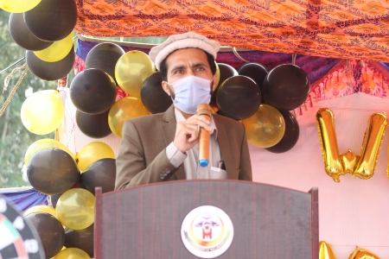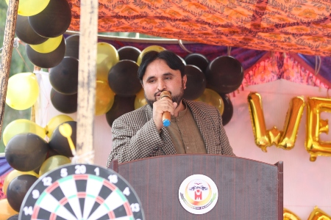

**ICONS USED**

*Faceboook*



**RESULTS**

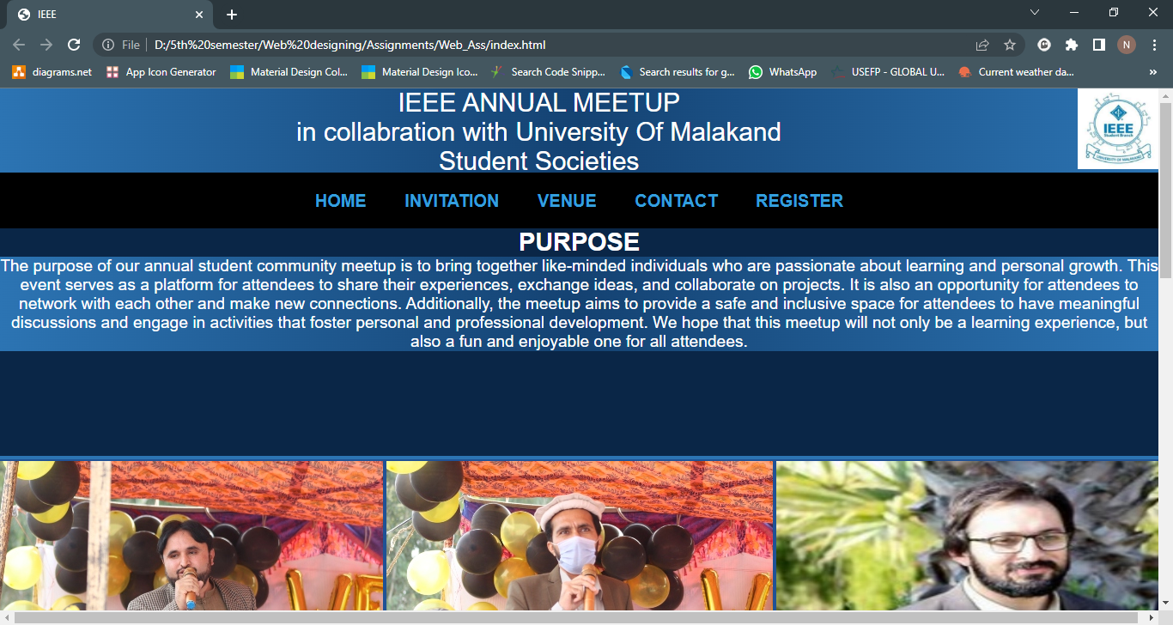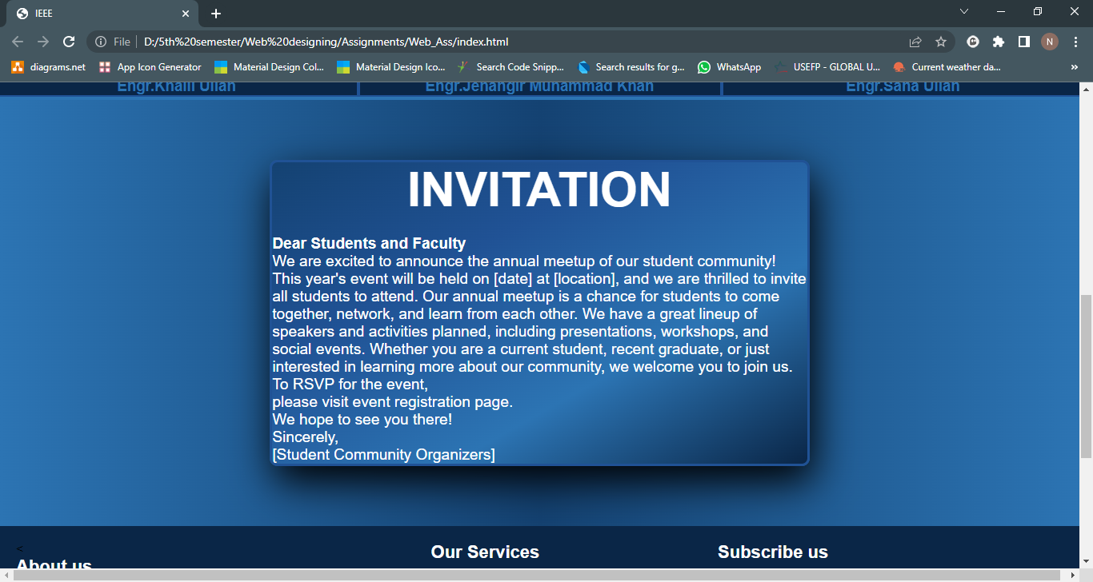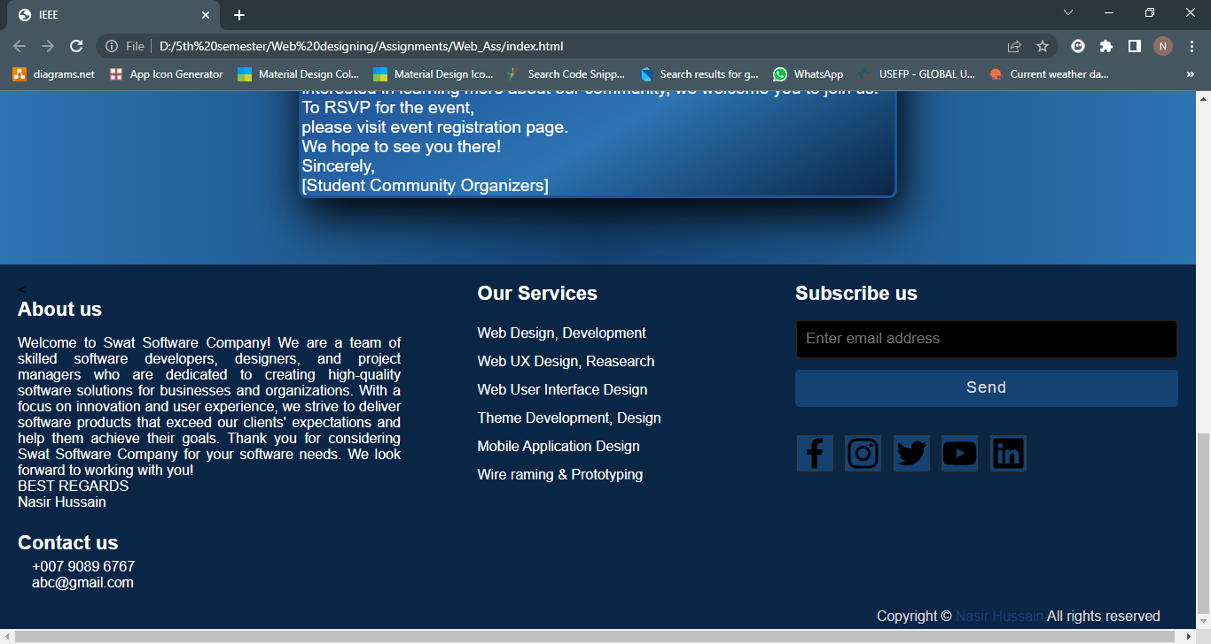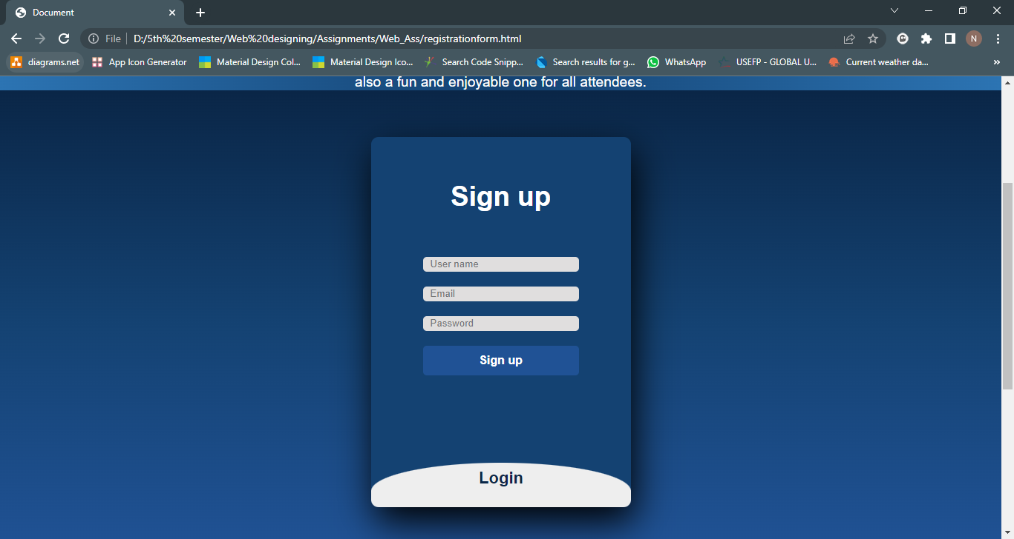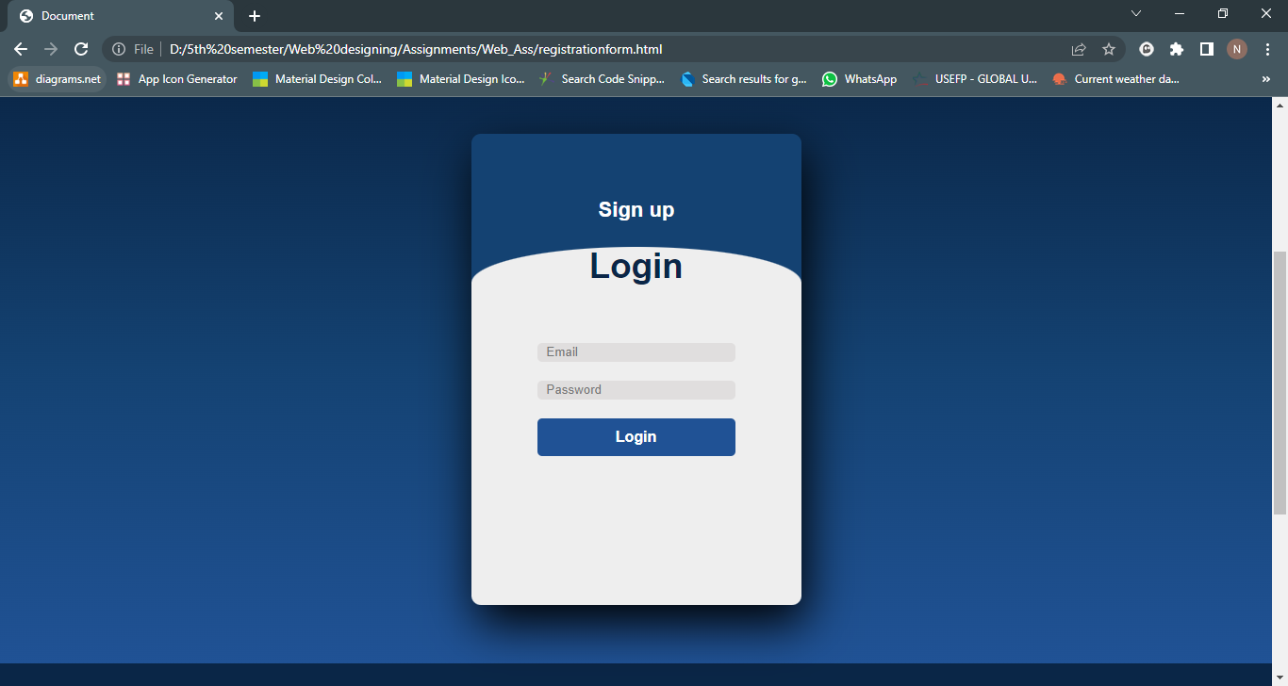

THE END_