**Assignment 1**

Name : Nasir Hussain

Department : Software Engineering

Semester : 6th

Reg ID; 779

Course : Web Engineering

Instructor : Engr.Jehangir Muhammad Khan

Task : Create HTML form And Validate it with the help of JavaScript:

Html code( form.html)

<html lang="en">

<head>

    <meta charset="UTF-8">

    <meta http-equiv="X-UA-Compatible" content="IE=edge">

    <meta name="viewport" content="width=device-width, initial-scale=1.0">

    <title>Form Validation</title>

    <link rel="preconnect" href="https://fonts.googleapis.com">

    <link rel="preconnect" href="https://fonts.gstatic.com" crossorigin>

    <link href="https://fonts.googleapis.com/css2?family=Poppins:wght@400;700&display=swap" rel="stylesheet">

    <link rel="stylesheet" href="https://fonts.googleapis.com/css?family=Secular One">

    <link rel="stylesheet" href="style.css">

    <script defer src="script.js"></script>

</head>

<body>

    <div class="container">

        <form id="form" action="">

            <h1>Admission</h1>

            <div class="input-control">

                <label for="Name">Name</label>

                <input id="Name" name="Name" type="text">

                <div class="error"></div>

            </div>

            <div class="input-control">

                <label for="father_name">Father Name</label>

                <input id="father_name" name="father_name" type="text">

                <div class="error"></div>

            </div>

            <div class="input-control">

                <label for="department">Department</label>

                <input type="text" name="department" id="department" >

                <div class="error"></div>

            </div>

            <div class="input-control">

                <label for="email">Email</label>

                <input id="email" name="email" type="text">

                <div class="error"></div>

            </div>

            <div class="input-control">

                <label for="semester">Semester</label>

                <input id="semester"name="semester" type="text">

                <div class="error"></div>

            </div>

            <div class="input-control">

                <label for="address">Address</label>

                <input id="address"name="address" type="text">

                <div class="error"></div>

            </div>

            <button type="submit">Sign Up</button>

        </form>

    </div>

</body>

</html>

CSS code (style.css)

body {

  background: linear-gradient(to right, #d7dba0, #10c8ce, #32b7f0);

  font-family: 'Poppins', sans-serif;

}

#form {

  box-shadow: 2px 2px 4px 2px rgba(0, 0, 0,0.5);

  width: 300px;

  margin: 20vh auto 0 auto;

  padding: 20px;

  background-color: whitesmoke;

  border-radius: 4px;

  font-size: 12px;

}

#form h1 {

  font-family: 'Secular One';

  color: #0f2027;

  text-align: center;

  width: 100%;

}

#form button {

  padding: 10px;

  margin-top: 10px;

  width: 100%;

  color: white;

  background-color: rgb(41, 57, 194);

  border: none;

  border-radius: 4px;

}

.input-control {

  display: flex;

  flex-direction: column;

}

.input-control input {

  box-shadow: 2px 2px 4px 2px rgba(0, 0, 0,0.1);

border: 2px solid #f0f0f0;

border-radius: 4px;

display: block;

font-size: 12px;

padding: 10px;

width: 100%;

}

.input-control input:focus {

  outline: 0;

}

.input-control.success input {

  border-color: #09c372;

}

.input-control.error input {

  border-color: #ff3860;

}

.input-control .error {

  color: #ff3860;

  font-size: 9px;

  height: 13px;

}

JavaScript code(script.js)

const form = document.getElementById('form');

const Name = document.getElementById('Name');

const father_name=document.getElementById('father_name');

const department=document.getElementById('department');

const email = document.getElementById('email');

const semester = document.getElementById('semester');

const address = document.getElementById('address');

form.addEventListener('submit', e => {

    e.preventDefault();

    validateInputs();

});

const setError = (element, message) => {

    const inputControl = element.parentElement;

    const errorDisplay = inputControl.querySelector('.error');

    errorDisplay.innerText = message;

    inputControl.classList.add('error');

    inputControl.classList.remove('success')

}

const setSuccess = element => {

    const inputControl = element.parentElement;

    const errorDisplay = inputControl.querySelector('.error');

    errorDisplay.innerText = '';

    inputControl.classList.add('success');

    inputControl.classList.remove('error');

};

const isValidEmail = email => {

    const re = /^(([^<>()[\]\\.,;:\s@"]+(\.[^<>()[\]\\.,;:\s@"]+)*)|(".+"))@((\[[0-9]{1,3}\.[0-9]{1,3}\.[0-9]{1,3}\.[0-9]{1,3}\])|(([a-zA-Z\-0-9]+\.)+[a-zA-Z]{2,}))$/;

    return re.test(String(email).toLowerCase());

}

const validateInputs = () => {

    const NameValue = Name.value.trim();

    const father_nameValue=father_name.value.trim();

    const departmentValue=department.value.trim();

    const emailValue = email.value.trim();

    const semesterValue = semester.value.trim();

    const addressValue = address.value.trim();

    if(NameValue === '') {

        setError(Name, 'Name is required');

    } else {

        setSuccess(Name);

    }

    if(father_nameValue === ''){

        setError(father_name,'Father Name is required');

    }else{

        setSuccess(father_name);

    }

    if(departmentValue === ''){

        setError(department,'Department Name is required');

    }else{

        setSuccess(department)

    }

    if(emailValue === '') {

        setError(email, 'Email is required');

    } else if (!isValidEmail(emailValue)) {

        setError(email, 'Provide a valid email address');

    } else {

        setSuccess(email);

    }

    if(semesterValue === '') {

        setError(semester, 'Semester is required');

    }  else {

        setSuccess(semester);

    }

    if(addressValue === '') {

        setError(address, 'Address is required');

    }  else {

        setSuccess(address);

    }

};

OUTPUT

(form)

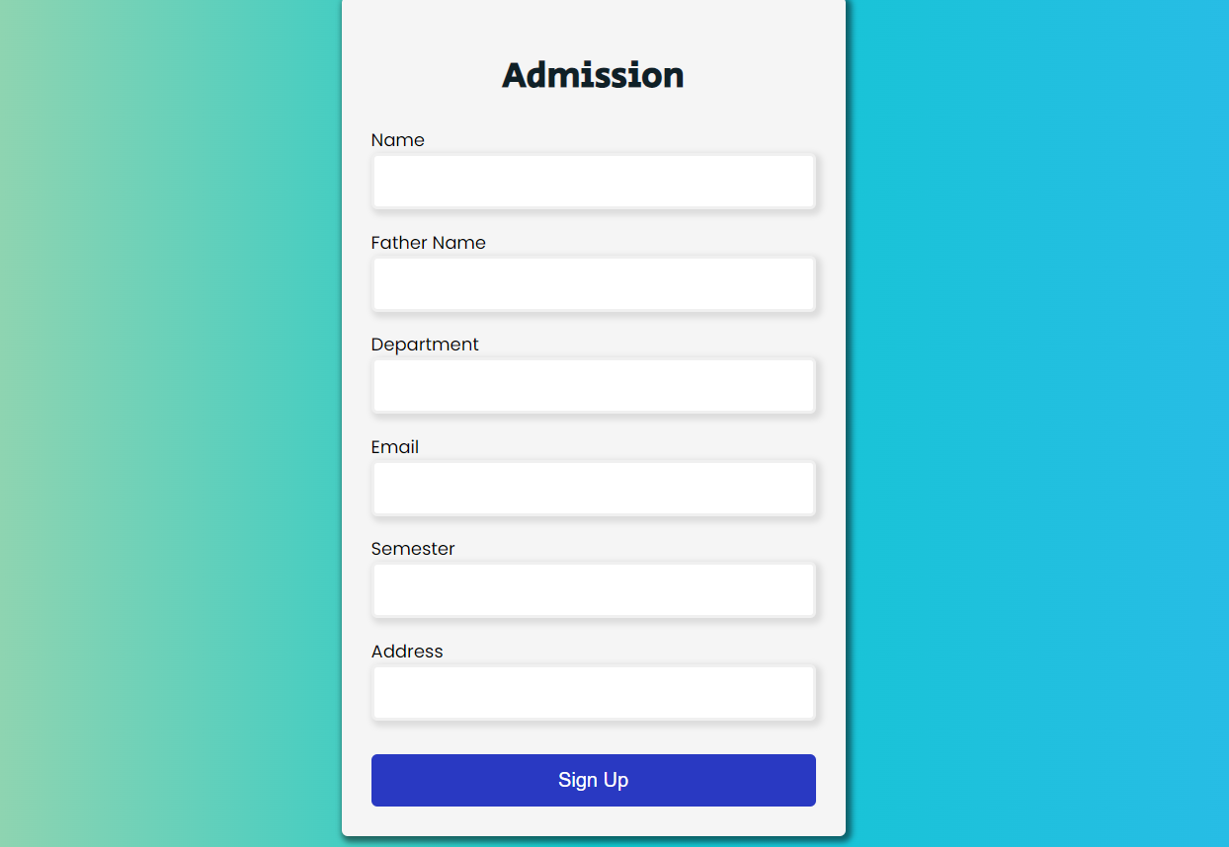

(Form validation)

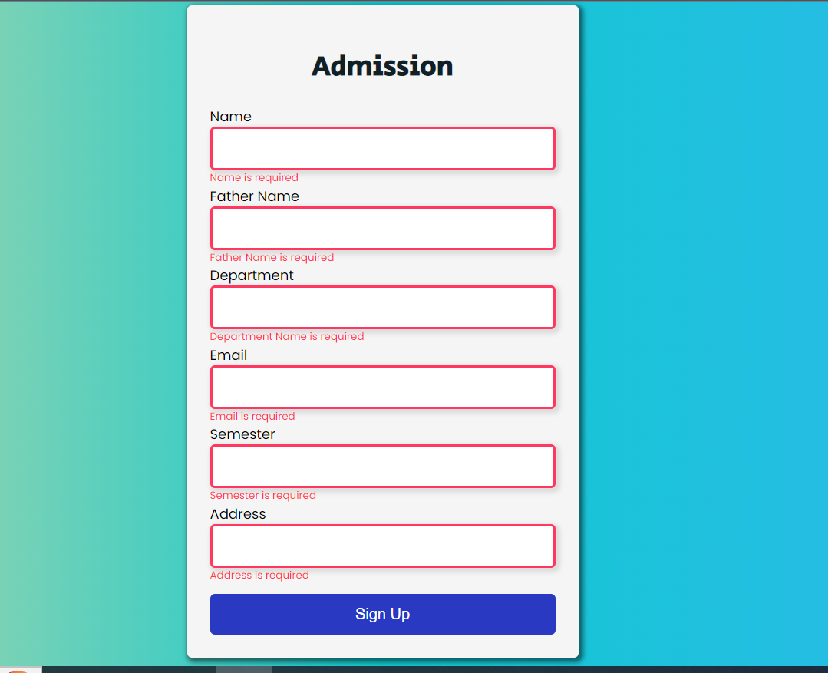

(form with proper entries)



The -End