 | American International University- Bangladesh (AIUB)  Faculty of Science and Technology (FST)  Project Report (Individual)
Course Name: |  | Computer Graphics |  |  | Course Code: | CSC4118
Semester: |  | Spring 2024-2025 |  |  | Section: | L
Faculty Name: |  | Aneem Al Hasan Rupai
Scene Title: |  | Middle Age Scene
From Group: |  | 07
 |  | SUBMITTED BY
Student ID |  |  | Student Name | Serial | Department
22-48370-3 |  |  | Nasir Sarkar | 11 | CSE

Date: 30th June, 2025
Table of Contents
#SL | Topic
1 | Introduction
2 | Project Graph
3 | List of objects assigning an object ID
4 | List of Functions to Represent Objects
5 | List of Animation Functions with ID
6 | Contribution
7 | Conclusion

Introduction
The Middle Age Scene in our project illustrates a key transitional period in the evolution of human civilization. This era is historically characterized by the rise of kingdoms, the expansion of agriculture, the construction of castles and stone houses, and the emergence of social hierarchies. Our 2D animated representation brings these elements to life using OpenGL with C++ in Code::Blocks, blending visual storytelling with interactive programming.
In this scene, the environment has been carefully crafted to reflect medieval aesthetics and societal progress. A majestic palace, surrounded by trees, rivers, hills, and residential houses, symbolizes the rise of governance and community. Natural components like rain, flowing rivers, and waterfalls show the environmental richness of the time, while man-made elements such as bridges, roads, boats, and lamp posts depict the early steps toward infrastructure and technological development.
Each object and animation function—ranging from moving clouds and swaying trees to floating boats and illuminating torches—has been designed to represent the lifestyle, challenges, and achievements of the Middle Ages. Users can interact with the scene through keyboard and mouse inputs to trigger weather effects, lighting, and movement, enhancing the immersive experience. This scene acts as a bridge between the primitive old age and the modern era, showcasing the journey of growth, adaptation, and innovation.

Project Graph
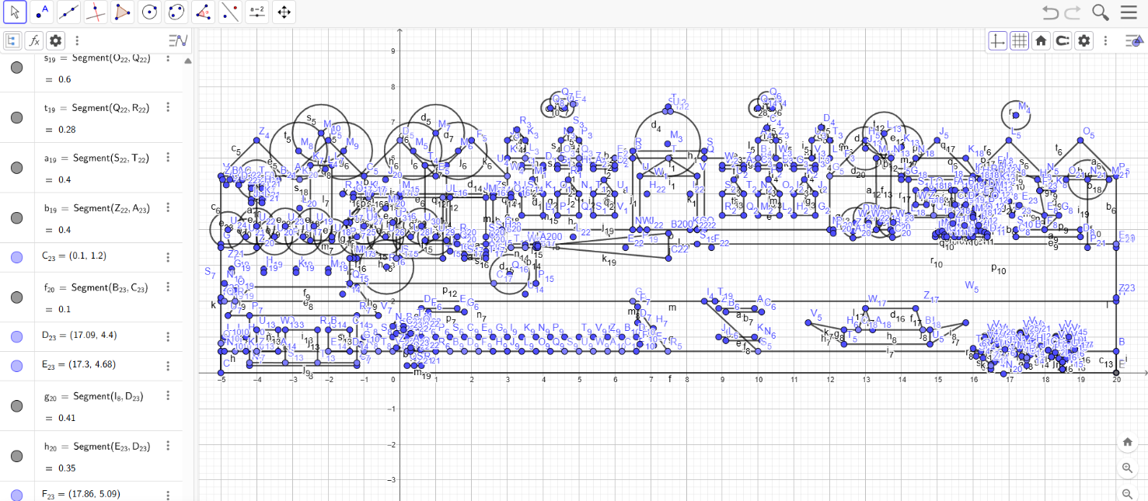
Fig: Graph of Middle-Age scene

List of objects assigning an object ID
SL# | Object ID | Object Name
01 | 9001 | Rain
02 | 9002 | Sky
03 | 9003 | Clouds
04 | 9004 | Sun
05 | 9005 | Hills
06 | 9006 | Ground
07 | 9007 | Tree-1
08 | 9008 | Tree-2
09 | 9009 | Tree-3
10 | 9010 | Road
11 | 9011 | Palace
12 | 9012 | Windows of Palace
13 | 9013 | Flower-1
14 | 9014 | Flower-2
15 | 9015 | Flower-3
16 | 9016 | Flower-4
17 | 9017 | Flower-5
18 | 9018 | Flower-6
19 | 9019 | Fish
20 | 9020 | Waterfall
21 | 9021 | Stone
22 | 9022 | River Flow Lines
23 | 9023 | River
24 | 9024 | Bridge
25 | 9025 | Boat
26 | 9026 | House-1
27 | 9027 | Windows OF House-1
28 | 9028 | House-2
29 | 9029 | Windows of House-2
30 | 9030 | Blockage-1
31 | 9031 | Blockage-2
32 | 9032 | Blockage-3
33 | 9033 | Wheels
34 | 9034 | Car
35 | 9035 | Headlight
36 | 9036 | Bush-1
37 | 9037 | Bush-2
38 | 9038 | Bush-3
39 | 9039 | Bush-4
40 | 9040 | Bush-5
41 | 9041 | Post-1
42 | 9042 | Light OF Post-1
43 | 9043 | Post-2
44 | 9044 | Light OF Post-2
45 | 9045 | LmpPost-1
46 | 9046 | Lamppost-1 Light
47 | 9047 | LampPost-2
48 | 9048 | LampPost-2 Light
49 | 9049 | Stand
50 | 9050 | Plant

List of Functions To Represent Objects
SL# | Object Name | Function Name
01 | Rain | drawRain()
02 | Sky | sky()
03 | Clouds | clouds()
04 | Sun | sun()
05 | Hills | hills()
06 | Ground | ground()
07 | Tree-1 | tree1()
08 | Tree-2 | tree2()
09 | Tree-3 | tree3()
10 | Road | road()
11 | Palace | palace()
12 | Windows of Palace | windowPalace()
13 | Flower-1 | flower1()
14 | Flower-2 | flower2()
15 | Flower-3 | flower3()
16 | Flower-4 | flower4()
17 | Flower-5 | flower5()
18 | Flower-6 | flower6()
19 | Fish | fish()
20 | Waterfall | waterfall()
21 | Stone | stone()
22 | River Flow Lines | riverFlowLines()
23 | River | river()
24 | Bridge | bridge()
25 | Boat | boat()
26 | House-1 | house1()
27 | Windows OF House-1 | windowHouse1()
28 | House-2 | house2()
29 | Windows of House-2 | windowHouse2()
30 | Blockage-1 | blockage1()
31 | Blockage-2 | blockage2()
32 | Blockage-3 | blockage3()
33 | Wheels | wheels()
34 | Car | car()
35 | Headlight | headlight()
36 | Bush-1 | bush1()
37 | Bush-2 | bush2()
38 | Bush-3 | bush3()
39 | Bush-4 | bush4()
40 | Bush-5 | bush5()
41 | Post-1 | post1()
42 | Light OF Post-1 | post1Light()
43 | Post-2 | post2()
44 | Light OF Post-2 | post2Light()
45 | LmpPost-1 | lampPost1()
46 | Lamppost-1 Light | lampPost1Light()
47 | LampPost-2 | lampPost2()
48 | LampPost-2 Light | lampPost2Light()
49 | Stand | stand()
50 | Plant | plant()

List of Animation Functions with ID
SL# | Animation Function ID | Animation Function | Object/Scene
01 | 8001 | updateScene(int value) | Rain animation
02 | 8002 | updateClouds(int value) | Cloud movement
03 | 8003 | updateFlowers(int value) | Flower swaying motion
04 | 8004 | updateWaterfall(int value) | Waterfall animation
05 | 8005 | updateRiverFlow(int value) | River flow animation
06 | 8006 | updateBoat(int value) | Boat floating
07 | 8007 | updateCar(int value) | Car movement
08 | 8010 | void updateTree(int value) | Tree movement
09 | 8008 | keyboard(unsigned char key, int x, int y) | Controls Day/Night scene, Rain, Clouds, Waterfall, River flow, Boat floating, and Lighting effect animations.
10 | 8009 | mouse(int button, int state, int x, int y) | Controls Flower swaying, Tree Movement, Clouds speed, Car’s headlight, and Screen size animations.
Contribution
Member Name | Implemented Functions | Implemented Animation Functions | Percentage of Contribution
Nasir Sarkar  ID: 22-48370-3 | drawRain(), sky(), clouds(), sun(), hills(), ground(), tree1(), tree2(), tree3(), road(), palace(), windowPalace(), flower1(), flower2(), flower3(), flower4(), flower5(), flower6(), fish(), waterfall(), stone(), riverFlowLines(), river(), bridge(), boat(), house1(), windowHouse1(), house2(), windowHouse2(), blockage1(), blockage2(), blockage3(), wheels(), car(), headlight(), bush1(), bush2(), bush3(), bush4(), bush5(), post1(), post1Light(), post2(), post2Light(), lampPost1(), lampPost1Light(), lampPost2(), lampPost2Light(), stand(), plant() | updateScene(int value),updateClouds(int value),updateFlowers(int value),updateWaterfall(int value),updateRiverFlow(int value),updateBoat(int value),updateCar(int value), void updateTree(int value),keyboard(unsigned char key,int x,int y),mouse(int button,int state,int x,int y) | 25%

Conclusion
The Middle Age Scene stands as a central part of our project’s narrative, effectively capturing the spirit of a historically rich and transformative time period. By combining static 2D drawings with dynamic animations and interactive control, the scene goes beyond visual representation to convey the story of societal evolution. The structured buildings, flowing water, cultivated land, and animated transport illustrate how human civilization began organizing its resources and environment to improve life and stability.
The technical implementation highlights the potential of computer graphics in storytelling, where every animation—from river flow to flower movement—adds depth and realism to the scene. Moreover, the ability to toggle day and night, rain effects, and other environmental features allows users to engage with the simulation in meaningful ways. Through this scene, we reflect the rise of social systems, architectural advancement, and early technology—laying the foundation for the present and future ages depicted in the project.
In essence, the Middle Age Scene not only enriches the historical timeline within our animation but also demonstrates the effective use of graphics programming to represent complex eras in a creative and educational format.

**THE END**

