INTERNATIONAL BILATERAL GRANT PROPOSAL
Quantum-Accelerated Simulation of Strongly Correlated Materials for Critical Minerals
A Co-Designed Classical-to-Fault-Tolerant-QPU Simulation Pipeline for Critical-Minerals Materials Strategy
Indian Partner: C-DAC
U.S. Partner: L7TR LLC, Amherst, New Hampshire)
Project Duration: 24 Months (2 Years) — Four 6-Month Milestones

III. Executive Summary

- What is the proposed specific deliverable(s) in terms of product and/or service? (50 words)

Proposed Specific Deliverable(s)
- The project will deliver a validated, end-to-end classical-to-quantum simulation pipeline that converts periodic DFT integrals for strongly correlated critical-minerals compounds into fault-tolerant-oriented Quantum Phase Estimation (QPE) circuits executed on C-DAC's indigenous FPGA-based simulator, producing chemically accurate materials properties for battery, magnet, and superconductor screening.

- Describe the Unique Selling Proposition (USP) of the proposed product/service. (50 words)

Unique Selling Proposition (USP)
- Unlike DFT-based screening used industry-wide, this pipeline resolves strong electron correlation with asymptotically exact accuracy via Quantum Phase Estimation, validated end-to-end on an indigenous FPGA-based quantum simulator. It is the only India-anchored, integral-to-property pipeline purpose-built for critical-minerals compound classes, reducing dependence on foreign computational benchmarking tools.

- Please provide a high-level pitch describing the project objectives. (200 words)

High-Level Pitch: Project Objectives
- India's clean-energy transition depends on critical minerals such as lithium, cobalt, nickel, manganese, and rare-earth elements, and on the ability to accurately model the strongly correlated materials cathodes, catalyst surfaces, and superconducting junctions that these minerals enable. Classical density functional theory systematically fails for these compound classes because it cannot resolve many-body electronic entanglement, leaving India dependent on empirical trial-and-error and foreign benchmarking tools for materials selection.
- This project, co-designed between C-DAC (India) and L7TR LLC (United States), builds the first validated, end-to-end classical-to-fault-tolerant-QPU simulation pipeline for these material families. C-DAC contributes its high-performance computing infrastructure, indigenous FPGA-based quantum simulator, and materials targeting expertise for lithium-cobalt oxide, nickel-manganese oxide, and rare-earth boride systems. The U.S. partner contributes software-architecture and systems-integration expertise developed over two decades of real-time communications, cyber-physical systems, and protocol-engineering R&D, applied here to bridge C-DAC's HPC and FPGA-simulation frameworks with the compilation and orchestration layers needed for fault-tolerant-oriented quantum workflows.
- Over a two-year, four-milestone programme, the partnership will generate converged orbital integrals, build Hamiltonian factorisation and serialisation toolchains, execute QPE-style circuits on the FPGA simulator, and validate at least one experimentally verifiable materials property benchmark, positioning India among the first nations with a domestically anchored, quantum-accelerated materials-discovery capability for its critical-minerals strategy.

Executive Summary
  - What is the specific problem you are trying to address?
Problem: India's clean-energy transition solid-state batteries, heterogeneous catalysts, superconducting electronics, and photovoltaics depends on a secure and well-characterised supply of critical minerals: lithium, cobalt, nickel, manganese, and rare-earth elements. Exploiting these minerals at full performance potential requires accurately predicting, from first principles, the ground-state electronic structure of the strongly correlated materials cathodes, catalyst surfaces, and superconducting junctions that they enable. Classical density functional theory (DFT), the workhorse of computational materials science, systematically fails for precisely these compound classes: transition-metal oxides, rare-earth intermetallics, and cuprate superconductors, because it cannot resolve the many-body entanglement governing their properties. For a system with N electrons in M orbitals, the exact wavefunction dimension scales combinatorially, exceeding 10^12 determinants for even modest active spaces of 20-24 electrons in 20-24 orbitals a scaling wall no classical post-Hartree-Fock method escapes for multi-reference systems with Kondo screening, orbital near-degeneracies, or magnetic frustration. The result is that India cannot yet computationally screen its own critical-minerals chemistries with chemical accuracy, and remains dependent on foreign benchmarking pipelines and slow, costly experimental trial-and-error.

  - What is your proposed solution and the underlying S&T novelty/technological innovation driving the solution?
Proposed solution and novelty: This project builds the first end-to-end classical-to-fault-tolerant-QPU-oriented simulation pipeline tailored to India's critical-minerals materials. Quantum Phase Estimation (QPE) on fault-tolerant logical qubits offers a principled, asymptotically exact route to ground-state energies without a parametrised variational ansatz and is immune to barren-plateau failures. The S&T novelty is not the QPE algorithm alone but the fully coupled pipeline around it: periodic DFT and quantum-embedding integral generation, active-space selection, Hamiltonian factorisation (double factorisation and tensor hypercontraction), circuit-ready serialisation for an indigenous FPGA-based simulator, and property post-processing that converts phase estimates into intercalation voltages, formation energies, and magnetic phase boundaries. This pipeline is co-designed by C-DAC, contributing HPC infrastructure and its indigenous FPGA-based quantum simulator, and the U.S. partner, contributing software-architecture and systems-integration expertise to bridge these HPC and simulation frameworks with fault-tolerant-oriented compilation workflows.
  - At what stage is your technology? Do you have a workable prototype?
Technology stage: C-DAC has already built and deployed a working prototype: an indigenous FPGA-based 30-qubit statevector simulator, running on C-DAC's HPC infrastructure and serving India's Qniverse research community, together with real-time decoder implementations for quantum error correction. This simulator will serve as the deterministic, inspectable fault-tolerant-QPU surrogate on which Hamiltonian-loading and QPE circuit workflows are compiled, debugged, and benchmarked before any real QPU submission.

  - How is your solution better/different from the existing solutions in terms of features and/or affordability?
Differentiation: Classical DFT-level screening is already used by battery and catalyst companies worldwide, but it is unreliable by 0.3-0.5 V for the very redox chemistries such as Ni-rich layered oxides that India needs to evaluate, an error comparable to the advantage of one cathode chemistry over another. A quantum-accurate pipeline removes this uncertainty at a cost profile accessible to a public research institution, rather than requiring proprietary foreign quantum-cloud access.

  - What is your business plan and commercialization strategy?
Business plan and commercialisation: The core software toolchain (integral generation adapters, factorisation and serialisation libraries) will be released to the Indian quantum research community, while validated screening workflows will be offered to domestic battery, catalyst, and magnet manufacturers as a pre-screening service, reducing their experimental candidate space before synthesis.

  - Does your product/service have a significant societal impact?
Societal impact: Accurate simulation of critical-minerals compounds directly supports supply-chain resilience: reducing costly experimental trial-and-error in cathode chemistry selection, guiding rare-earth separation process design, and enabling quantitative battery-recycling strategy all central to India's clean-energy transition and reduced import dependence on strategic minerals and their processing technology.

IV. Detailed Proposal and Business Plan

Technical Details
  - Describe the problem and existing alternate solutions (in terms of features and/or affordability). (250 words)

Problem and Existing Alternate Solutions
- The dominant computational-materials-science limitation today is the exponential scaling of the many-body Hilbert space with system size: the exact wavefunction dimension for a modest 20-24 electron, 20-24 orbital active space exceeds 10^12 determinants. Classical DFT reduces this to a tractable effective one-particle problem but relies on exchange-correlation approximations that break down for transition-metal oxides (LiCoO2, LiNiO2 cathode families), rare-earth tetraborides, and cuprate superconductors precisely the compound classes underpinning India's battery, magnet, and superconductor supply chains predicting incorrect spin ordering, band gaps, and reaction energies.
- Post-Hartree-Fock methods such as CCSD(T) recover most correlation energy for weakly correlated systems and are the current gold standard, but scale as O(N^7) and fail to converge for multi-reference systems with Kondo screening or strong magnetic frustration; for large periodic solids or nanostructured cathode interfaces, the problem is intractable by any classical method available today. Existing industrial screening pipelines are therefore built entirely on DFT, and inherit these systematic, structural errors rather than merely needing better tuning.
- No classical alternative removes this bottleneck, even quantum Monte Carlo and DMRG, used here only as validation benchmarks, do not scale to the periodic, multi-reference systems of ultimate interest. The absence of an accurate, affordable computational screening tool for these material classes leaves India dependent on slow, expensive experimental trial-and-error and on foreign-developed computational benchmarking pipelines for critical-minerals materials decisions.

  - Describe the product/service solution proposed with special focus on the S&T novelty/technological innovation in your product/service. (250 words)

Proposed Solution: S&T Novelty / Technological Innovation
The proposed solution is a co-designed, end-to-end pipeline spanning four coupled stages that are today each an open research problem for these material classes:
- Periodic DFT and quantum-embedding integral generation on C-DAC's HPC infrastructure for target chemistries including lithium-cobalt oxide and rare-earth boride families.
- Automated active-space selection and Hamiltonian factorisation using double factorisation and tensor hypercontraction (THC), adapted for periodic, delocalised-correlation systems.
- Circuit-ready serialisation and compilation onto C-DAC's indigenous FPGA-based quantum simulator, which functions as a deterministic, inspectable fault-tolerant-QPU surrogate for debugging Hamiltonian loading, QPE ancilla registers, and T-gate decompositions before costly QPU submission.
- The property post-processing that converts QPE phase estimates into intercalation voltages, oxygen-vacancy formation energies, and magnetic phase boundaries.
The S&T novelty is that these stages have never been integrated end-to-end and validated for India's specific critical-minerals compound classes: the quantum subroutine shapes what factorisation and integral accuracy the classical stage must deliver, and the classical post-processing shapes what property predictions the quantum result must support, so the pipeline must be designed iteratively rather than as separable modules. The U.S. partner's software-architecture and systems-integration expertise, developed through two decades of real-time communications and cyber-physical-systems R&D and protocol standardisation, is applied to the compilation and orchestration layer connecting C-DAC's HPC and FPGA-simulator frameworks, ensuring the classical-to-quantum interface is robust, inspectable, and reproducible across the four milestones.

  - What is the proprietary nature of the technology/service? (200 Words)

Proprietary Nature of the Technology/Service
The project's proprietary and protectable assets are concentrated in three areas. First, C-DAC's indigenous FPGA-based quantum simulator architecture and its associated HBM2 interleaving design remain C-DAC's proprietary hardware and firmware IP. Second, the Hamiltonian serialisation and circuit-loading toolchain developed under this project connecting factorised Hamiltonians to the FPGA simulator's instruction format will be released as an open-source software library to maximise community benefit and adoption, while implementation know-how and benchmarking datasets generated for specific critical-minerals target systems will be retained and disclosed under partner agreement. Third, the compilation and orchestration software architecture contributed by the U.S. partner, bridging HPC and simulator frameworks, constitutes partner-owned software IP subject to the collaboration agreement. No proprietary claim is made over the underlying published QPE, double-factorisation, or THC algorithms themselves, which are prior art; novelty and protectable value lie in the specific, validated, integrated pipeline and its performance on India's target material systems.

  - Describe the current stage of development of the product/service solution proposed and its validation, including the status of intellectual property involved. (200 words)

Current Stage of Development, Validation, and IP Status
C-DAC has an operational, validated prototype: an indigenous FPGA-based 30-qubit statevector simulator and a 12-qubit density-matrix simulator, both deployed-on C-DAC's HPC infrastructure and in production use by India's Qniverse research community, together with real-time MWPM and Union-Find quantum-error-correction decoders targeting sub-microsecond latency. This establishes the hardware/simulation substrate at Technology Readiness Level 4-5. The classical Hamiltonian-preparation and factorisation toolchain, and the compilation bridge to fault-tolerant-oriented QPE circuits, are not yet built for the critical-minerals target chemistries this is the specific gap this project closes. IP status: one patent has been filed by C-DAC covering the HBM2 interleaving architecture underlying the FPGA simulator; the Hamiltonian serialisation library to be developed under this project is intended for open-source release, while any partner-specific compilation software will be governed by the bilateral IP-sharing agreement executed at project start.

Collaboration
  - Describe the U.S. Partner’s role and specific contribution to the partnership. (150 Words)

U.S. Partner's Role and Contribution
The U.S. partner with a team driven by Rolando Herrero, PhD, Founder and CTO at L7TR LLC, contributes software-architecture and systems-integration expertise built over more than two decades of R&D in real-time communications, protocol standardisation, and cyber-physical and IoT systems, including over 30 U.S. patents and authorship of "Fundamentals of IoT Communication Technologies" (Springer Nature, 2021). Within this partnership, the U.S. partner's specific role is to design and validate the software-architecture layer that bridges C-DAC's HPC and FPGA-simulator frameworks with the compilation, orchestration, and data-interchange requirements of fault-tolerant-oriented quantum simulation workflows applying systems-engineering discipline for protocol design, interface robustness, and real-time execution to the classical-to-quantum handoff. This includes co-developing the serialisation interface specification, reviewing circuit-compilation workflow reliability, and advising on scalable, standards-aligned software-engineering practice for the open-source toolchain deliverable.

  - Describe the Indian Partner’s role and specific contribution to the partnership. (150 Words)

Indian Partner's Role and Contribution
C-DAC is the Indian partner and technical anchor of the collaboration, contributing its high-performance computing infrastructure and its indigenous FPGA-based quantum simulation ecosystem. Specific contributions include: generating converged periodic-DFT and quantum-embedding orbital integrals for target critical-minerals chemistries (lithium-cobalt oxide, nickel-manganese oxide, rare-earth boride families); developing and benchmarking active-space selection and Hamiltonian-factorisation (double factorisation, THC) codes on its HPC infrastructure; building and maintaining the Hamiltonian serialisation and circuit-loading toolchain for its indigenous FPGA-based 30-qubit statevector simulator, which functions as the primary fault-tolerant-QPU surrogate and integration testbed; leading QPE algorithm design, resource estimation, and fault-tolerant compilation strategy; and generating classical validation benchmarks (CCSD(T), DMRG, quantum Monte Carlo) against which every pipeline stage is checked before QPU-oriented execution. C-DAC further provides the materials-science domain targeting connecting simulation outputs to India's critical-minerals strategy.

  - Describe the role and value addition by other partners (If any) (150 Words)

Role and Value Addition by Other Partners
No additional formal partners are currently engaged in this bilateral collaboration. The project is structured as a two-party partnership between C-DAC (India) and a team managed and driven by Rolando Herrero at L7TR (United States). Should complementary expertise be required for example, additional experimental validation of predicted materials properties, or independent benchmarking of classical reference energies the partners will identify and onboard appropriately qualified academic or national-laboratory collaborators through an amendment to the governing collaboration agreement, subject to mutual consent of both existing partners and consistent with the IP-sharing framework established at project outset.

  - Describe the agreement (including IP sharing, during development and post-commercialization)/ MoU between the partners (If any). (150 Words)

Agreement / MoU Between Partners (Including IP Sharing)
A bilateral collaboration agreement will be executed between C-DAC and L7TR prior to project commencement, governing scope of work, milestone deliverables, and IP treatment. The agreement will provide that background IP each partner brings including C-DAC's FPGA-simulator architecture and filed patent, and the U.S. partner's software-architecture methods remains the property of the contributing partner. Foreground IP jointly developed during the project, principally the Hamiltonian serialisation toolchain and the compilation/orchestration interface, will be jointly owned, with the software toolchain released open-source under a permissive licence to maximise community benefit, while any patentable inventions arising from the FPGA-simulator integration will follow a joint-filing procedure with cost- and revenue-sharing terms to be defined in the MoU. Publication rights will be shared, subject to standard pre-publication review by both institutions.

  - How well do the partners know each other and since how long? (150 Words)

How Well Do the Partners Know Each Other?
This collaboration is being formally established for the purposes of this proposal, initiated on the basis of complementary technical fit between C-DAC's indigenous FPGA-based quantum simulation infrastructure and the U.S. partner's software-architecture and systems-integration expertise in real-time, standards-based communication and control systems. Formal engagement has begun through preliminary technical scoping discussions; the two-year, milestone-structured project design reflects an agreed division of labour intended to build sustained working familiarity from Milestone I onward, with joint technical review calls scheduled at the close of each six-month milestone to deepen collaborative alignment over the life of the project.

Business Plan
- Describe your overall commercialization strategy including specific channel(s) to be used for sales/marketing. (250 Words)

Commercialisation Strategy and Channels
The commercialisation strategy has two complementary tracks. First, the core Hamiltonian-preparation and serialisation software library will be released open-source, distributed through C-DAC's existing Qniverse platform and India's quantum-research community channels, to maximise adoption, external validation, and downstream contribution consistent with C-DAC's mandate as a national HPC and quantum-infrastructure body. Second, validated screening workflows applied to specific critical-minerals chemistries will be offered as a fee-for-service computational pre-screening capability to domestic battery, catalyst, and magnet manufacturers and to public-sector research laboratories, reducing their experimental candidate space before physical synthesis. Marketing and outreach channels include joint publication in high-impact venues (targeted at Nature Computational Science, PRX Quantum, or Nature Materials), presentation at national quantum-technology and materials-science conferences, and direct engagement with India's Ministry of Mines-aligned critical-minerals research programmes and battery-manufacturing consortia. Over the medium term, C-DAC will integrate the toolchain into its Qniverse platform for public research users, while L7TR LLC will lead commercial integration and enterprise cloud deployment for private industry clients.

- What are the risks associated with the development/marketing of this product or technology? How quickly does the overall technology landscape in this area change and how would that affect the prospects of the proposed business? How easily could others copy it? (150 Words)

Risks: Development/Marketing, Technology-Landscape Change, Replicability
The principal risk is timeline risk: fault-tolerant QPU hardware with sufficient logical-qubit counts is not yet available, so this project's demonstrator remains simulator-validated rather than QPU-executed within the two-year window, a risk mitigated by treating the FPGA simulator as the primary near-term deliverable target. Technical risk arises from the difficulty of periodic, relativistic Hamiltonian factorisation at scale; this is mitigated by starting with well-characterised surrogate systems before scaling to full target chemistries. The technology landscape changes rapidly algorithmic improvements in qubitization and factorisation have reduced resource estimates by orders of magnitude in recent years, so pipeline design deliberately favours modular, swappable components. Because the core methods (QPE, THC, double factorisation) are published and non-proprietary, replication by other groups is possible; the partnership's durable advantage lies in its validated integration with C-DAC's specific indigenous hardware and India-specific target chemistries, which is comparatively difficult to replicate quickly.

- What are the key challenges for bringing the product to the market? (100 Words)

Key Challenges for Bringing the Product to Market
Key challenges include securing timely access to sufficient classical HPC and FPGA-simulator compute capacity across both milestones; recruiting or retaining specialised personnel proficient in both quantum algorithms and periodic electronic-structure methods; and managing the dependency of Year 2 deliverables on the algorithmic and infrastructure progress made in Year 1. Coordinating asynchronous, cross-time-zone technical collaboration between C-DAC and the U.S. partner also requires disciplined milestone-review cadence to avoid integration drift between the classical and software-architecture workstreams.

- Describe your target customer. (100 Words)

Target Customer
Primary target customers are domestic public-sector and industrial materials-science users: C-DAC's own Qniverse research community, India's battery- and catalyst-manufacturing sector evaluating cathode and catalyst chemistries, rare-earth processing and separation researchers, and academic groups in strongly correlated electronic-structure theory. Secondary users include national mineral-strategy and clean-energy policy bodies seeking quantitative screening evidence for domestic materials substitution decisions.

- Describe market size. (100 Words)

Market Size
India's Ministry of Mines has identified 30 critical minerals essential to clean-energy and defence applications, spanning a battery-materials and rare-earth-magnet manufacturing base that is a national strategic priority under India's clean-energy transition. While no independent market-sizing study has been conducted for this specific computational-screening niche, the addressable base includes India's growing battery-cell and cathode-material manufacturing programmes, catalyst producers, and the public quantum- and materials-research ecosystem served by C-DAC's HPC and Qniverse infrastructure.

- Describe competition and respective market shares. (100 Words)

Competition and Market Shares
Classical DFT-based screening tools are already used by leading global battery and catalyst companies and are well established; no directly competing quantum-accelerated, India-anchored pipeline for critical-minerals compound screening is known to exist. International fault-tolerant quantum-chemistry efforts (from major cloud quantum-computing providers and national laboratories abroad) are addressing related problems, but not with India-specific target chemistries or infrastructure, and typically without public open-source release. Respective market shares are not quantifiable at this pre-commercial, research-validation stage.

- Describe competitive advantages. (100 Words)

Competitive Advantages
Competitive advantages include: an already-operational indigenous FPGA-based quantum simulator (rather than a from-scratch build), direct alignment with India's specific critical-minerals target chemistries, an open-source distribution model that lowers adoption barriers for domestic users, and a bilateral software-architecture partnership that strengthens pipeline reliability and standards alignment beyond what either partner could deliver independently.

- Describe the overall plan for scaling-up, including mobilization of additional funding/resources. (200 Words)

Scale-Up Plan and Mobilisation of Additional Funding/Resources
Scaling beyond this two-year validation project will proceed in stages. Within C-DAC, successful demonstrator results will support a proposal to scale the FPGA-simulator infrastructure and extend the toolchain to additional critical-minerals compound families beyond the initial lithium-cobalt oxide and rare-earth boride targets. Additional funding will be pursued through India's national quantum-technology mission-aligned programmes, MeitY digital-infrastructure grants, and bilateral or multilateral quantum-computing research partnerships building on the joint publication record established in Year 2. On the U.S. side, L7TR will drive commercialization and industrial scaling. L7TR LLC will integrate the validated orchestration toolchain into its enterprise software portfolio, enabling commercial materials-screening services for energy and materials enterprises. Long-term scale-up envisions integrating the validated toolchain into C-DAC's Qniverse platform as a standing computational-screening service for India's battery, catalyst, and magnet-manufacturing sectors, with QPU-execution access pursued as fault-tolerant hardware becomes available through domestic or partner programmes.

- Are any of the partners a commercial entity? If yes, please indicate the location and date of incorporation.

Commercial Entity Status
Yes. L7TR LLC is an active commercial entity:
- Legal Business Name: L7TR LLC.
- L7TR LLC Website: https://www.l7tr.com
- Business Type: Domestic Profit Corporation
- Jurisdiction / Location: Massachusetts, USA
- Date of Incorporation / Formation: February 25th, 2021
- Principal Office Address: 40 Horace Greeley Rd, Amherst, NH 03031

The U.S. partner (L7TR LLC) fulfills the USISTEF commercial entity eligibility requirement, serving as the enterprise integration and commercialization vehicle for the bilateral collaboration. The Indian partner, C-DAC, is a scientific society under India's Ministry of Electronics and Information Technology (MeitY).

Risks & Challenges for Scaling Up
  - Describe the risks and challenges (manufacturing, customer, service, HR etc.) for scaling up. (200 Words)

Risks and Challenges (Manufacturing, Customer, Service, HR, etc.)
Scaling risks include: sustained access to HPC and FPGA-simulator compute capacity as target-system complexity grows; the specialised-personnel bottleneck common to combined quantum-algorithms/electronic-structure teams, requiring deliberate training pipeline investment; dependency on continued fault-tolerant algorithmic progress (factorisation and compilation efficiency) to keep resource estimates tractable; and service-delivery risk in transitioning from a research toolchain to a dependable pre-screening service for external manufacturing customers, which will require additional software-hardening and support-infrastructure investment beyond the current project scope.

  - Specify regulatory compliances / environmental clearances / any other Government approvals required prior to commercialization of the product / process, present status and expected time required for such approvals. (200 Words)

Regulatory Compliances / Environmental / Government Approvals
As a collaboration between a Government of India scientific society (C-DAC, under MeitY) and a U.S. commercial entity (L7TR LLC), the project will require standard bilateral research-collaboration clearances, including institutional approval for cross-border data and software exchange, adherence to any applicable export-control review for dual-use computational methods, and standard institutional review for the collaboration agreement and IP terms. No product-specific regulatory or environmental clearance is anticipated at this research-validation stage, since no physical product or process is being commercialised; any future transition to a fee-for-service or licensed commercial offering would be reviewed for applicable IT/data-handling and government-technology-transfer compliance at that time. Current status: institutional approvals to be initiated concurrently with project sanction; expected clearance timeline of approximately two to three months ahead of Milestone I commencement.

V. Project Duration & Milestones

A. Project Duration
24 Months (2 Years)

B. Milestones of the Project
Year | Milestone | Duration | Role of Indian Partner (C-DAC) | Role of U.S. Partner (L7TR LLC)
Year 1 | Milestone I | 6 Months | - Select and characterise 2-3 target critical-minerals systems (LiCoO2 cathode family, rare-earth boride, cuprate/nickelate representative)  - Generate converged periodic-DFT / embedding orbital integrals on C-DAC's HPC infrastructure, including relativistic corrections  - Stand up classical validation benchmark suite (CCSD(T), DMRG, QMC) for target systems | - Define software-architecture specification for the classical-to-quantum data interchange and serialisation interface  - Review C-DAC's HPC/FPGA-simulator integration architecture for interface robustness and standards alignment  - Establish joint technical review cadence and documentation framework
Year 1 | Milestone II | 6 Months | - Implement and benchmark double-factorisation and THC Hamiltonian factorisation codes on C-DAC's HPC infrastructure  - Develop Hamiltonian serialisation and circuit-loading toolchain for the indigenous FPGA-based quantum simulator  - Run initial end-to-end pipeline tests on small surrogate systems (4-10 active electrons) | - Co-develop and validate the serialisation interface specification against C-DAC's toolchain implementation  - Conduct systems-integration review of surrogate-system pipeline test results; recommend interface hardening  - Deliver Year 1 joint technical progress documentation
Year 2 | Milestone III | 6 Months | - Run complete QPE-style pipeline on the FPGA-based simulator for at least two target systems (12-20 active electrons)  - Compare ground-state energies against CCSD(T)/DMRG classical references  - Generate updated resource estimates (logical qubit count, T-gate depth, physical qubit overhead) | - Provide software-architecture support for scaling the compilation/orchestration layer to larger active spaces  - Co-author joint technical paper on classical pipeline validation and simulator-based co-simulation demonstrator  - Advise on reliability and reproducibility practice for resource-estimation workflows
Year 2 | Milestone IV | 6 Months | - Validate property-prediction post-processing (e.g., Li intercalation voltage in a LiCoO2 analogue) against experimental data  - Finalise and publicly release the open-source Hamiltonian preparation software library  - Prepare final project report and roadmap toward fault-tolerant QPU execution | - Finalise and document the compilation/orchestration interface for public release alongside the open-source library  - Co-review final property-validation results and joint publication submission  - Contribute to project closeout report and future-collaboration roadmap

Annex A: Pipeline Architecture Flow Diagrams
The original technical architecture and flow diagrams are retained unchanged; textual references to "C-DAC Noida" have been updated to "C-DAC" for consistency with the partnership naming used throughout this proposal.

Diagram 1: End-to-End Co-Simulation St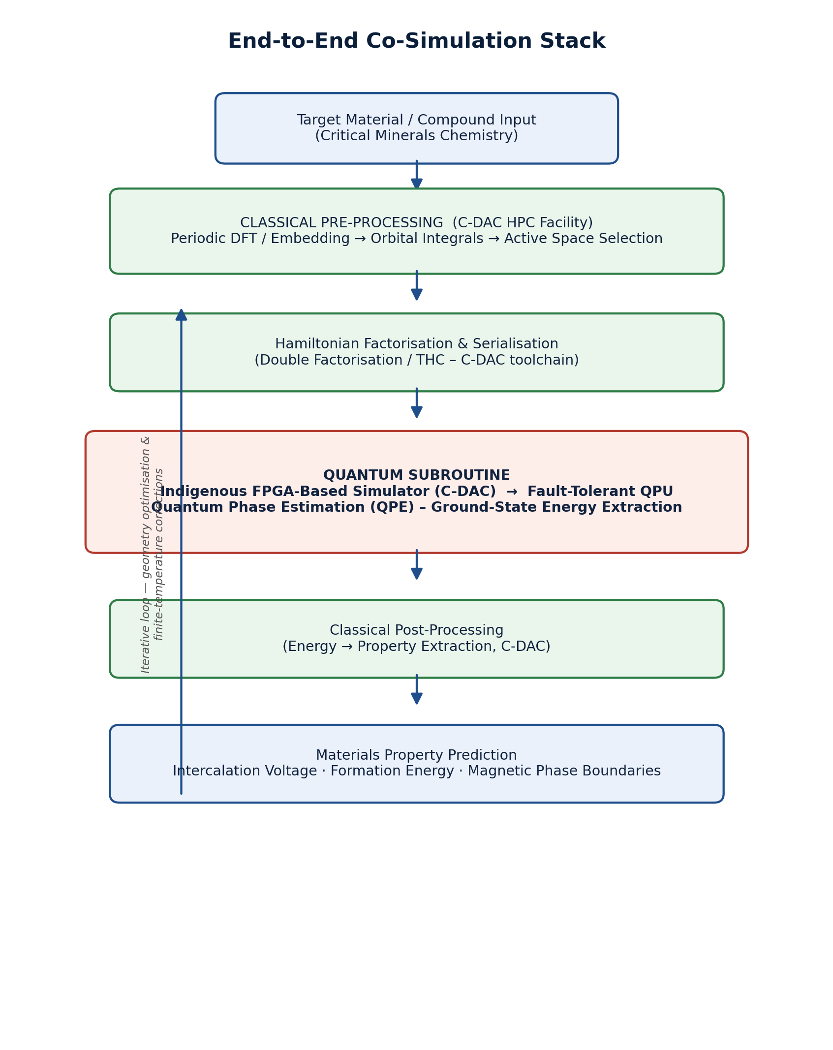
Diagram 1. Classical pre-processing (C-DAC's HPC facility) prepares the factorised Hamiltonian and active space; the quantum subroutine (indigenous FPGA-based simulator → fault-tolerant QPU) extracts the ground-state energy via QPE; classical post-processing converts this energy into property predictions for materials screening. The stack is iterative multiple QPE calls are required for geometry optimisation and finite-temperature corrections.

Diagram 2: Validation Pathway
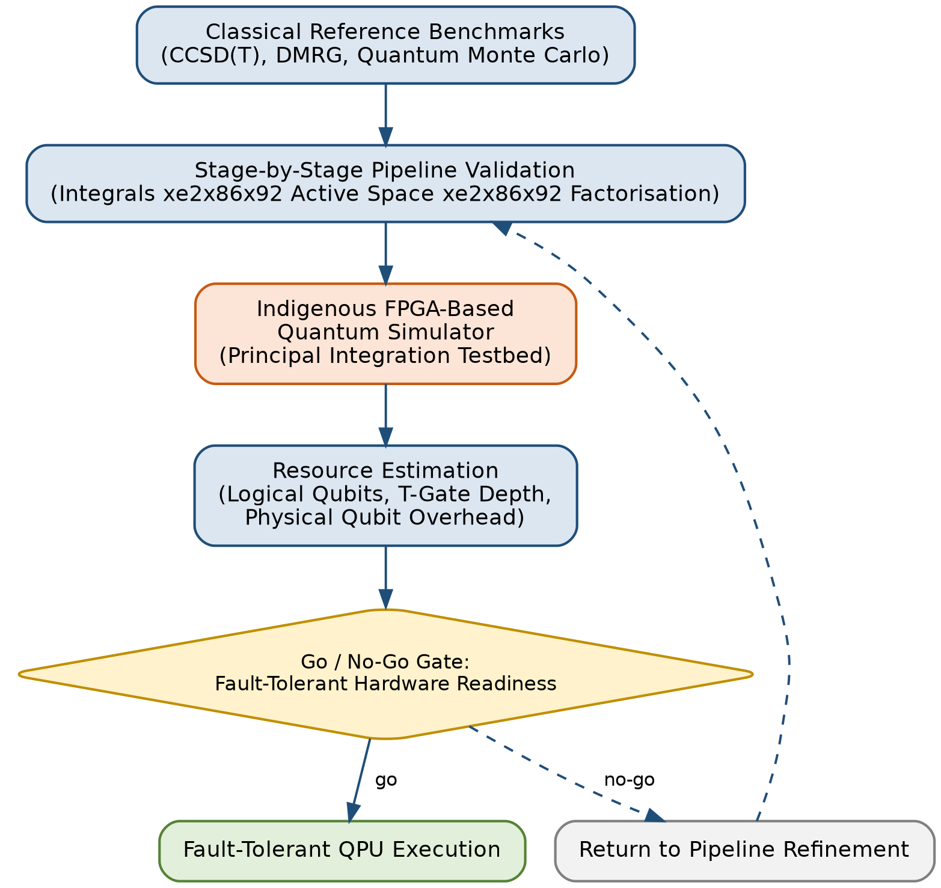
Diagram 2. Every stage of the pipeline is validated against classical benchmark energies before committing to QPU execution. The indigenous FPGA-based quantum simulator (C-DAC) functions as the principal integration testbed. Resource estimation gates the transition to fault-tolerant hardware.

