**DESIGN AND DEVELOPMENT OF ONLINE ATTENDANCE**

**SYSTEM**

**BY**

**PRIYANKA SHARMA**

**ID: 151 15-371**

**MD. ABDUN NASIR**

**ID: 151-15-366**

**AND**

**MD. SHEHABUR RAHMAN KHAN**

**ID: 151-15-367**

This Project is presented in Partial Fulfillment of the Requirements for the Degree of Bachelor of Science in Computer Science and Engineering

Supervised By

**TUMPA RANI SHAHA**

Lecturer

Department of Computer Science and Engineering

Daffodil International University



**DAFFODIL INTERNATIONAL UNIVERSITY**

**DHAKA, BANGLADESH**

**DECEMBER 2018**

**APPROVAL**

This project titled **“Design and development of online attendance system”** by Priyanka Sharma, Md. Abdun Nasir and Md. Shehabur Rahman Khan obtaining id respectively 151-15-371, 151-15-366 and 151-15-367 to the Department of Computer Science and Engineering, Daffodil International University, has been accepted as satisfactory for the partial fulfillment of the requirements for the degree of B.Sc. in Computer Science and Engineering (CSE) and approved as to its style and contents. The presentation has been held on 06-11-2018.

**Board of Examiners**

____________________   
 **Dr. Syed Akhter Hossain Chairman**  
 **Professor and Head**

Department of Computer Science and Engineering

Faculty of Science & Information Technology

Daffodil International University

____________________

|  |  |  |  |  |  |
| --- | --- | --- | --- | --- | --- |
|  | **Dr. Sheak Rashed Haider Noori** | | | **Internal Examiner** | |
|  | **Associate Professor & Associate Head** | | |  | |
|  | Department of Computer Science and Engineering | | |  | |
|  | Faculty of Science & Information Technology | | |  | |
|  | Daffodil International University | | |  | |
|  |  |  |  | |  | |
|  | **Md. Zahid Hasan** | **Internal Examiner** | | | |
|  | **Assistant Professor** |  | | | |
|  | Department of Computer Science and Engineering |  | | | |
|  | Faculty of Science & Information Technology |  | | | |
|  | Daffodil International University |  | | | |
|  |  |  | | | |
|  | **Dr. Mohammad Shorif Uddin** | **External Examiner** | | | |
|  | **Professor** |  | | | |
|  | Department of Computer Science and Engineering |  | | | |

Jahangirnagar University

**DECLARATION**

We hereby declare that, this project has been done by us under the supervision of **Tumpa Rani Shaha, Lecturer, Department of Computer Science and Engineering, Daffodil International University.** We also declare that neither this project nor any part of this project has been submitted elsewhere for award of any degree or diploma.

**Supervised by:**

**______________________________**

**Tumpa Rani Shaha**

Lecturer

Department of Computer Science and Engineering

Daffodil International University

**Submitted by:**

**_____________________________**

**(Priyanka Sharma)**

ID: 151-15-371

Department of Computer Science and Engineering

Daffodil International University

**_____________________________**

**(Md. Abdun Nasir)**

ID: 151-15-366

Department of Computer Science and Engineering

Daffodil International University

**______________________________**

**(Md. Shehabur Rahman Khan)**

ID: 151-15-367

Department of Computer Science and Engineering

Daffodil International University

**ACKNOWLEDGEMENT**

First we express our heartiest thanks and gratefulness to almighty God for His divine blessing makes us possible to complete the final year project/internship successfully.

We really grateful and wish our profound our indebtedness to **Tumpa Rani Shaha**, **Lecturer**, Department of CSE, Daffodil International University, Dhaka. Deep Knowledge & keen interest of our supervisor in the field of developing this web application. Her endless patience, scholarly guidance, continual encouragement, constant and energetic supervision, constructive criticism, valuable advice, reading many inferior draft and correcting them at all stage have made it possible to complete this project.

We would like to express our heartiest gratitude to **Dr. Syed Akhter Hossain, Professor and Head,** Department of CSE, for his kind help to finish our project and also to other faculty member and the staff of CSE department of Daffodil International University.

We would like to thank our entire course mate in Daffodil International University, who took part in this discuss while completing the course work.

Finally, we must acknowledge with due respect the constant support and patients of our parents.

**AbstracT**

In this era of fast technology and a world of self-dependency, online attendance system will be very helpful to make attendance system smarter to save time. Now-a-days educational institutions are concerned about regularity of student attendance. In present-day all work is done on paper. The whole attendance is stowed in register and at the end of the period the report is generated by calculating average of attendance which takes more time. Soundtrack and perceiving of class attendance is an area of administration that can require essential amounts of time and exertion in a school/university environment, largely due to the amount of time required in lectures to get the necessary information .In order to reduce time and human effort instead of manual attendance system we can use online attendance system. Hence, we design software for online attendance system. In this software guardian has log in account and has right to view attendance and student also can see their attendance. As guardian can see their children attendance, whether their children attend the class or not, for that student could not scoff at. In this project, at the end of session the students who did not do regular classes, then teacher send information to guardian. Here guardian also can communicate with teacher and when teacher send information to guardian then guardian can reply. In this system automatically generate the percentage of student attendance and mark based on of every student attendance.

In the overview, this project aspect at the present system of student attendance system and effort to covert the process from manual to a computerized one in order to reduce the time consumed on manual operations to eliminate mistakes and time consumptions. In this application, MySQL and PHP are used as back-end design and HTML, CSS and JavaScript are used as front-end tools.

**TABLE OF CONTENTS**

|  |  |
| --- | --- |
| **CONTENTS** | **PAGE** |
| Approval | i |
| Declaration | ii |
| Acknowledgements | iii |
| Abstract | iv |

|  |  |
| --- | --- |
| **CHAPTER** |  |
| **CHAPTER 1: INTRODUCTION** | **1-2** |
| 1.1 Introduction | 1 |
| 1.2 Welfares of the Project | 1 |
| 1.3 Motivation | 1 |
| 1.4 Goals of the project | 2 |
| 1.5 Summary | 2 |

|  |  |
| --- | --- |
| **CHAPTER 2: LITERATURE REVIEW** | **4-8** |
| 2.1 Introduction | 4 |
| 2.2 Related Works | 4 |
| 2.2.1 RFID Based Attendance System | 4 |
| 2.2.1.1 Strengths | 5 |
| 2.2.1.2 Weaknesses/Limitations | 5 |
| 2.2.2 Bar Code Scanner Based Student Attendance System (SAS) | 6 |
| 2.2.2.1 Strengths | 6 |
| 2.2.2.2 Weaknesses/Limitations | 7 |
| 2.3 Project scope | 7 |
| 2.4 Summary | 8 |

|  |  |
| --- | --- |
| **CHAPTER 3: SYSTEM ANALYSIS AND FEASIBILITY STUDY** | **9-13** |
| 3.1 Introduction | 9 |
| 3.2 Agile Model | 10 |
| 3.3 Feasibility Study | 12 |
| 3.3.1 Technical feasibility | 12 |
| 3.3.2 Economic feasibility | 13 |
| 3.3.3 Legal feasibility | 13 |
| 3.3.4 Operational feasibility | 13 |
| 3.3.5 Schedule feasibility | 13 |
| 3.4 Summary | 13 |

|  |  |
| --- | --- |
| **CHAPTER 4: SYSTEM DESIGN** | **14-22** |
| 4.1 Introduction | 14 |
| 4.2 Uses-Case Diagram | 14 |
| 4.2.1 Use Case Diagram of Admin | 15 |
| 4.2.2 Use Case Diagram of Teacher | 16 |
| 4.2.3 Use Case Diagram of Guardian | 17 |
| 4.2.4 Use Case Diagram of Student | 18 |
| 4.3 Data flow diagram(DFD) | 19 |
| 4.4 ER diagram | 20 |
| 4.5 The overall system of this project | 21 |
| 4.6 Methodology | 22 |
| 4.6.1 Admin specification | 22 |
| 4.6.2 Teacher specification | 22 |
| 4.6.3 Student specification | 22 |
| 4.6.4 Guardian specification | 22 |
| **CHAPTER 5**: **IMPLEMENTATION AND TESTING** | **23-37** |
| 5.1 Development Language & Database | 23 |
| 5.1.1 Sublime text 3 | 23 |
| 5.1.2 Feature of Sublime text 3 | 24 |
| 5.1.3 Advantage of sublime text 3 | 24 |
| 5.2 Login Form | 25 |
| 5.2.1 Admin Dashboard | 26 |
| 5.2.1.1Student Information Form | 27 |
| 5.2.1.2 Teacher Information Form | 28 |
| 5.2.2 Teacher Dashboard | 29 |
| 5.2.2.1 Contact Form | 30 |
| 5.2.2.2 Semester Form | 31 |
| 5.2.2.3 Attendance Form | 32 |
| 5.2.2.4 Attendance status form | 33 |
| 5.2.3 Student Dashboard | 34 |
| 5.2.3.1 Student Attendance information | 35 |
| 5.2.4 Guardian Dashboard | 36 |
| 5.2.4.1 Contact form  5.2.5 Database Design | 37  38 |
| **CHAPTER 6: CONCLUSION AND FUTURE SCOPE** | **39** |
| 6.1 Conclusion | 39 |
| 6.2 Future Scope | 39 |

**LIST OF FIGURES**

|  |  |
| --- | --- |
| **FIGURES** | **PAGE** |
| Figure 3.2 : Agile Model | 11 |
| Figure 4.1: Use Case Diagram of Admin | 15 |
| Figure 4.2: Use Case Diagram of Teacher | 16 |
| Figure 4.3 Use Case Diagram of Guardian | 17 |
| Figure 4.4: Use Case Diagram of Student | 18 |
| Figure 4.5: Data flow diagram | 19 |
| Figure 4.6: ER diagram | 20 |
| Figure 4.7: The overall system of this project | 21 |
| Figure 5.1 Login Form | 25 |
| Figure 5.2 Admin Dashboard | 26 |
| Figure 5.3 Student Information Form | 27 |
| Figure 5.4 Teacher Information Form | 28 |
| Figure 5.5 Teacher Dashboard | 29 |
| Figure 5.6 Contact Form | 30 |
| Figure 5.7 Semester Form | 31 |
| Figure 5.8 Attendance Form | 32 |
| Figure 5.9 Attendance percentages Form | 33 |
| Figure 5.10 Student Dashboard | 34 |
| Figure 5.11 Student Attendance information | 36 |
| Figure 5.12 Guardian Dashboard | 36 |
| Figure 5.13 Contact Form | 37 |

Figure 5.14 Database Design38

**CHATER 1**

**INTRODUCTION**

* 1. **Introduction**

Attendance System is an inventive way to maintain and accomplish the attendance of students. This system observing attendance details. Preceding a word “online” to this way makes this system very resourceful technique. This is because now this system can be retrieved from anywhere around the world. So an online attendance system is an inventive way to observer and track the attendance of students.

This proposed system is a web application named “Design and development of online attendance system” which is very helpful for user to take attendance, calculating the student attendance. This system will also help in evaluating attendance mark of every student. This system is developed for maintaining the attendance of the student on the daily basis in the university. Here the faculty members, who are conducting the subjects, will be responsible to mark the attendance of the students. Each faculty member will be given with a separate username and password based. In this project students can be login to see their attendance and guardian can be login to see their children attendance. As guardian can see their children attendance, whether their children attend the class or not, for that student could not scoff at. Here, teacher can inform to guardian about their children condition and guardian also can reply and send information to teacher. In this system automatically generate the percentage of each student attendance and automatically generate the mark based on the student attendance.

* 1. **Welfares of the Project**
* This project saves time.
* Parents can be login to this system and can view their children attendance. As guardian can see their children attendance, whether their children attend the class or not.
* Students also can be login to see their attendance in which classes they are attend or which classes they are not attend.
* Students can learn many things for getting enough time.
* Automatically generate the percentage of student attendance and generate the every student attendance mark.
  1. **Motivation**

The total concept of that task began through a little illustration that was pooled with us within one period of class, why not a mission to represent course making easier. Proper attendance system is very important for the success of any academic institution and  
it is also necessary to keep an eye on time. Manual attendance system is very time consuming and time is very valuable for all. For this reason we thought that, we will make online attendance system which is save time and for everyone it would be a handy tool. Then we developed a web application named “online attendance system” so that anyone could have used it easily and which is helps user to take attendance, calculating the student attendance and mark based on the student attendance easily. In this project students can be view their attendance and guardian can be view their children attendance. As guardian can see their children attendance, whether their children attend the class or not, for that student could not do remissness.

**1.4 Goals of the Project**

The aim of this project is to design and construct an application that is Online Attendance System -

* To computerize the manual system.
* To save time using online system instead of manual system.
* To reduce the attendance proxy.
* To make the system stable, understandable and cost effective.
* To generate the percentage of student attendance and attendance mark automatically.

**1.5 Summary**

In this chapter we have described about the welfare and goals of our project. Using this system, teachers will able to take attendance, calculating student attendance easily and short time and also can teaches more things to the students which is very helpful for the students.

**CHAPTER 2**

**LITERATURE REVIEW**

**2.1 Introduction**

A literature review can be denotes to as a review of present system that the investigator had done formerly and the review of the system that will be developed. Literature review also emphases on the knowledge and ideas recognized on a topic as well as their strengths and weaknesses. Nowadays, technology is accomplishment better and better to swapping the traditional system to speed up the process by introducing the computerized system. There are few types of attendance system that had been presented nowadays in school, college, and university. This proposed system will be very helpful for user to take attendance, calculating the student attendance and obtain mark. Maintenance and observing of attendance records plays a vital role in the analysis of performance of any association. The proposed system will manage the process of attendance that will be saving in a specific database. It also saves time and eliminates the paperwork. Here, teacher can inform to guardian about their children condition and guardian also can reply and send information to teacher. In this system automatically generate the percentage of student attendance and attendance mark of every student.

**2.2 Related Works**

Our proposed system is “online attendance system” which is reducing time consumption, for that it is very user friendly. We computerized the manual system which is very helpful for user to take attendance. There are some related works are given below-

**2.2.1 RFID Based Attendance System**

RFID based attendance system identified that the attendance is required to be taken in various places like school, college, university. Main objectives had anxious about to replace the old outmoded presence system technology with Radio Frequency Identification (RFID) technology. It is carry out to overcome some existing problems occur in the outmoded attendance system. It also stated that the RFID system is industrialized and is appropriate to take the attendance of the students as well as personnel. There are two modules presented in the article which contains reader module and RFID module. In details, each student must have a valid RFID card of RFID identifiers with them in order to interconnect with the RFID student placed on their school. The RFID student will mechanically detect the student attendance and greatest it while the RFID card gets closer to the RFID student which means it is using the non-contact type of student and passive types of card. We can get to know that the presence system using RFID technology is much better than the outmoded presence system in school as almost whole the system is done in mechanization and with high photograph process.

**2.2.1.1 Strengths**

There is some asset that can be found in the presence system that using RFID technology. First of all, the system can be known as a fully-automated system which requires less humanoid interaction in the presence record process. It is because the student will just need to bring their RFID card every time they attend classes. Compare to the existing presence system, it do not requires the student to pass the presence around the whole class which cause time overwhelming as well as do not needs worker to write down their check-in and check-out time as well. In calculation, the user will be able to view the attendance lists on the spot through the computer boundary or view distantly through another computer. It is because the database will be mechanically updating the attendance status once the reader read the card. Besides that, in using the RFID technology, the information providing by the system will be more accurate than manually record as it is logged by the computer to the system. At the same time, it will be able to evade the student from signing for their buddy who did not join the class as every student will have their own exclusive RFID card.

**2.2.1.2 Weaknesses/Limitations**

However, there is some disadvantage that can originate from the solution in using RFID technology in the presence system. First of all, the system will require the student to carry the RFID cards always with them while they are in class or workplace in order to check-in or check-out for the attendance. If the student misplaced their card, they may essential to go to the office to make a new card which will cause them to pay for the lost as well as to come for the new card to be produced and pass to them.

As we know, student will usually attend a few different classes per day which mean they will need to tell the orator if their card had been lost and will involve them to report to the faculty by themselves with lecturer endorsement as evidence in order to gain back their presence as the system do not provide a physical key in function for the lecturer which may lead to multifaceted process. However, although the system can help avoid the student from making fake attendance but nobody can assurance that the student will not take their friend’s RFID cards along with them to the classes which mean it is motionless get the same result which skimming the cards on behalf of their buddies.

**2.2.2 Bar Code Scanner Based Student Attendance System (SAS)**

“Bar Code Scanner Based Student Attendance System (SAS)” it had known that student attendance and contribution among a class is very significant in order to attain good academic outcome of a student and school. Here main objectives had worried about to replace the non-automated presence record system with the barcode scanner technology in order to record and manage the student presence records more competently and successfully. RFID-based technology and biometric-based technology is former too expensive to gadget into a school since it requires purchasing of certain hardware in order to get the system work. Compare to both RFID-based technology and biometric-based technology, barcode technology clearly shown that it is inexpensive than both the technology. Barcode scanner presence system had been presented to recover the admin staff handling process such as process daily, weekly and yearly student presence report.

In the barcode scanner technology, student will be delivered a student card for each of them with the barcode displayed on the card for a skimming purpose every time they join the classes. Student presence status will be automatically patterned and record into the system once lecturer scan their student card with barcode scanner. We can get to know that the presence system using barcode scanner technology is much better than the outmoded attendance system in school as the lecturer just necessitates to scan the barcode of the student cards as verify that the student attend the class.

**2.2.2.1 Strengths**

There is some forte that can be found in the attendance system that using barcode scanner technology. First of all, the system provide a report units which allow the lecturer to generate daily, weekly and monthly report that do not necessitates them to physically compute the fraction of presence of each specific student. This is certainly will speed up the dispensation speed of report cohort as likened to the current existing system as well as assist the lecturer/admin staff in obtain more precise and effectual student presence information.

In addition, as mentioned, the barcode scanner system also deliver a functionality which is if the student does not meet the presence supplies, the system will mechanically make cautionary letter to the student to be transport to their parent. Besides that, barcode scanner requires less cost growth associate to the RFID technology and biometrics technology as the hardware apparatus cost of the barcode scanner system is somewhat cheaper than both the hardware apparatus cost of RFID technology and biometrics technology. Other than that, it can minimize the error that may occur by human errors since it is almost a fully-automated system which just extremely be contingent on the barcode scanner.

**2.2.2.2 Weaknesses/Limitations**

However, there is some disadvantage that can found from the solution in using barcode scanner technology in the presence system. First of all, the system will necessitate the student to have their student card with the exclusive barcode displayed on their student card every time they attend a class. So sometime if the student overlooked to bring their student card lengthways with them while go to the class which may reason the lecturer will need to go to the office to ask the admin staff to alteration their student presence status. It is because lecturer is not official to physically key-in the student attendance as the system will mechanically inform the student presence status into database after image the student card.

In addition, although the system permit the admin staff to produce warning letter if the student does not meet the presence supplies, however, the produced warning letter will be given to the student and then pass it to their parent through the student themselves without charitable an immediate message or email to their parent. So, student may end up with just throw away the letter and fantasizing that they previously surrender the warning letter to their parents.

**2.3 Project scope**

The proposed system will achieve the process of attendance that will be saving in an exact database. It also saves time. For degenerative less time teachers will be able to teach more in the class and disregard paperwork. Guardian can be login to this system. For that guardian can see their children are coming in class or not. Then if guardian wants to take any action against their children, then they can. Students also can be login to see their presence in which classes they are attend or which classes they are not attend. Students can absorb many things for receiving sufficient time. In this proposed system, teacher can notify to custodian about their children condition and guardian also can reply and send information to teacher. In this system mechanically generate the percentage of student presence and mechanically generate the obtain mark of every student.

**2.4 Summary**

In this chapter we have described about the proposed system and the related works or related software with its strengths, weaknesses and limitations. And also describe the project scope.

**CHAPTER 3**

**SYSTEM ANALYSIS AND FEASIBILITY STUDY**

**3.1 Introduction**

The system analysis is a study of the numerous methods done by the remaining structure and their affairs within and outward of the system. One side of study is defining the limitations of the system and defining whether a candidate system should thoughtful other connected systems. During analysis records are combined on an accessible file, choice point and trades handled by the current system. It is the process of influencing what needs to be ended before how it would be finished. To complete this, the designer mentions the current systems and brochures. So, simply it is a skill of finding. Here, we completed system analysis by reaction analysis, output analysis and data analysis of remaining system. At the primary stage of the analysis, we had followed the following agile development methodology. The various tasks in the system analysis include the following-

* Web application types.
* Planning web design.
* Scheduling.
* Developing solution.
* Performing student attendance.

This system achieves to the analysis of the report creation and develops entry of the student attendance. First design the student entry form, the teacher entry form, the course entry form and add student to the course. This project will help the attendance system for sending student attendance to their parent. The application attendance entry system will afford flexible report for all students.

This web application follow agile model. As the **agile model** illustrates the software development process in a linear sequential flow; hence it is also referred to as a **Linear-Sequential Life Cycle Model.**

**3.2 Agile Model:**

Agile model is model where every project needs to be handled differently. The existing methods need to be tailored for the best suit project requirements. In Agile, time boxes divide the task to time boxes (small time frames) to deliver specific features for a release. Iterative access is taken and worked software build is delivered after each iteration. Each build is incremental in terms of features. All the features are hold by the final build and required by the user.

Agile SDLC model is a sequence of iterative and incremental process models. Agile SDLC model is with focus on process adaptability and user achievement by rapid delivery of working software product. The product is broken by Agile Methods into small additional builds. Iterations provide in these build. Each iteration commonly lasts from about one to three weeks. Cross functional teams are involved by every iteration cross functional teams working together on various areas like-

* Planning
* Requirements Analysis
* Design
* Coding
* Unit Testing
* Acceptance Testing.

In the agile methodology after every evolution iteration, the user is able to see the result. User understand if it satisfies him or he is not. It is one of the advantages of the agile software development life cycle model. One of its disadvantages is that with the absence of defined conditions it is difficult to estimate the assets and evolution cost. The practical use of the agile model is extreme programming. The basis of such model consists of short weekly meetings – Sprints which are the part of the Scrum access.

Here is a graphical illustration of the Agile Model:

**Figure 3.1: Agile Model**

**3.3 Feasibility Study**

A feasibility study aims to accurately and properly uncover the strengths and weaknesses of a existing business or proposed scheme, facilities and threats present in the environment, the properties essential to carry through, and finally the projections for success. In its easiest terms, the two principles to judge probability are cost significant and value to be attained. A well-designed probability study should afford a historical background of the business or project, a depiction of the product or service, accounting depiction, details of the operations and management, marketing research and policies, financial data, legal 13 requirements and proceeds obligations. Generally, probability studies precede the procedural improvement and the project implementation. A probability study evaluates the project's probable for success; therefore, seeming neutrality is a significant factor in the consistency of the study for potential investors and giving organization. An objective must therefore directs with it, neutral refuge to provide knowledge upon which decisions can be based. There are numerous factors in probability. Some Common are follows:

* Technical feasibility
* Economic feasibility
* Legal feasibility
* Operational feasibility
* Schedule feasibility

**3.3.1 Technical feasibility**

The assessment is based on a configuration design of system requirements in terms of Input, Processes, Output, Fields, Programs, and Procedures. This can be measured in terms of capacities of data, trends, frequency of updating, etc. in order to calculation whether the new system will perform adequately or not. Technological probability is carried out to ordain whether the company has the ability, in terms of software, hardware, personnel and expertise, to handle the fulfillment of the project.

**3.3.2 Economic feasibility**

Economic analysis is the most constantly used method for evaluating the efficiency of a new system. More generally known as cost/benefit analysis, the procedure is to proclaim the suitability and savings that are expected from an applicant system and relate them with costs. If welfares outweigh costs, then the declaration is made to design and implement the system. A businessperson must exactly weigh the cost versus suitability before taking an action.

**3.3.3 Legal feasibility**

Determinate whether the raised system conflicts with legal requirements, a data processing system must comply with the local Data Protection Acts. Since all the software we are using is free, so we are not violating any anti-piracy law.

**3.3.4 Operational feasibility**

Operational feasibility is a quantity of how well a projected system explains the problems, and takes benefit of the probabilities identified during opportunity explanation and how it satisfies the desires documented in the necessities analysis stage of system development.

**3.3.5 Schedule feasibility**

A project will fail if it proceeds too long to be accomplished before it is useful. Normally this means resembling how long the system will take to change, and if it can be finished in a given time period using some methods like return period. Schedule feasibility is a serving of how normal the project timetable. Some projects are instigated with exact goals.

**3.4 Summary**

In this chap we have described about our system, agile model and feasibility Study. The trend and feasibility study suggest the need of a new information system to keep pace with the modern world. A system is never quite infeasible. It is often more or less feasible from different perceptions and perspectives. The earlier sections discussed all the feasibility checkpoints and respective problems and conditions. The project is extremely strong technically, financially and legally.

**CHAPTER 4**

**SYSTEM DESIGN**

System Design is the process of defining architecture, modules, interfaces and data for a system to identify the requirements of proposed system. The design of a system is essentially a plan for a result for the system. It specifies what components are needed for the system, their behavior and how they should be interconnected. The goal is to transform the requirements identified in the document into a structure that is suitable for implementation in programming language. Design focuses on the use case diagram and ER diagram. These systems can be considered a system, with its own modules. A system as set of modules with defined behavior interacts with each other in a defined manner may produce some behavior or services for its environment.

**4.1 Uses-Case Diagram**

A use case diagram is a graphical depiction of the connections among the elements of a system. A use case is a methodology used in system analysis to classify, simplify, and organize system requirements. Its purpose is to present a graphical summary of the functionality provided by a system in terms of actors, their goals (represented as use cases), and any dependencies between those use cases. The main objective of a use case diagram is to show what system functions are accomplished for which actor. A use case is a single unit of significant work to recognize, refine and organize system requirements. The most significant elements are: use cases, association, actors and the relationship between them. The actor can be an external system or a human. Use case diagrams are the blueprints for a system. A standard notation for modeling for real time objects and systems is known as UML (Unified Modeling Language) in which use case deployed.

**4.1.1 Use Case Diagram of Admin**

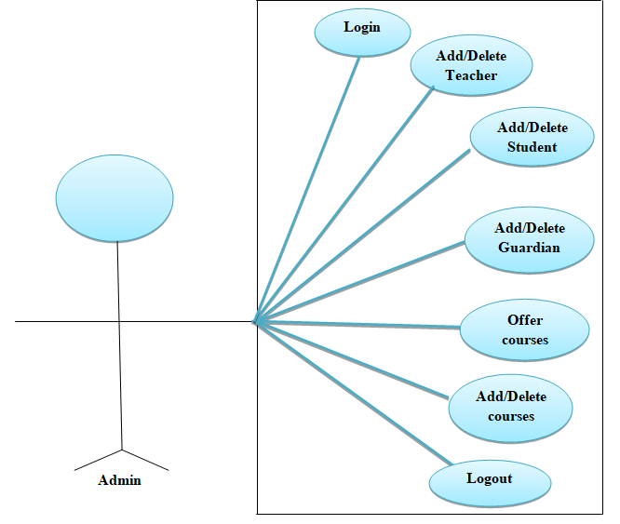

**Figure 4.1: Use Case Diagram of Admin**

**4.1.2 Use Case Diagram of Teacher**

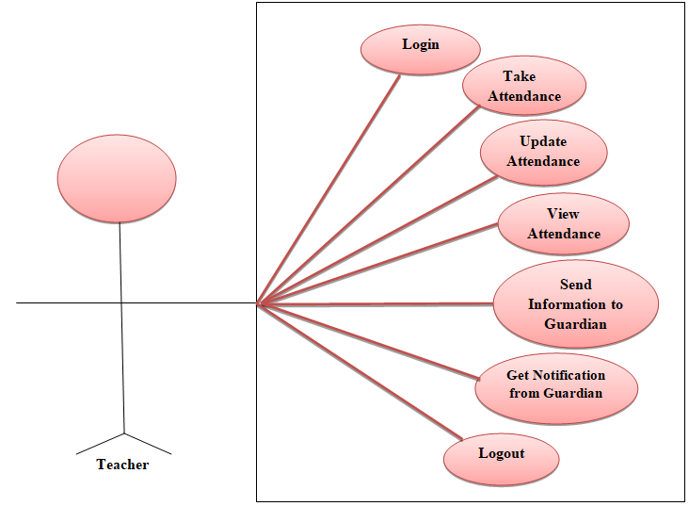

**Figure 4.2: Use Case Diagram of Teacher**

**4.1.3 Use Case Diagram of Guardian**

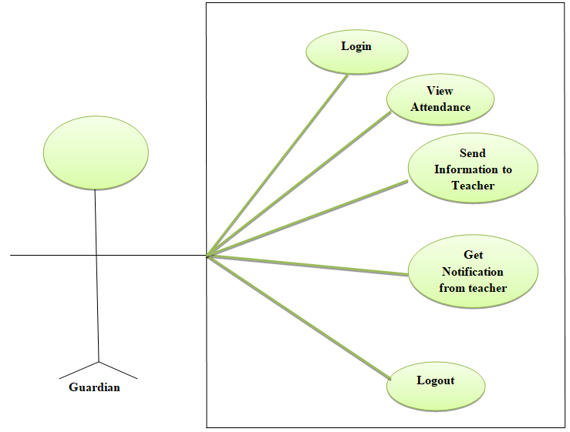

**Figure4.3 Use Case Diagram of Guardian**

**4.1.4 Use Case Diagram of Student**

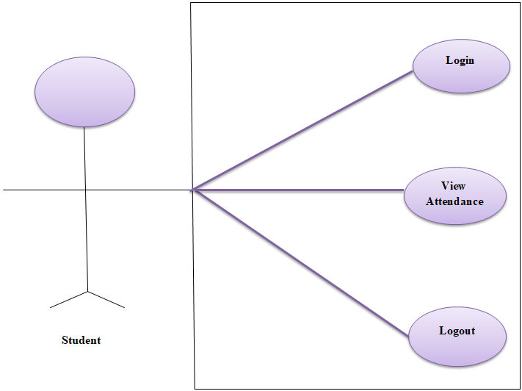

**Figure 4.4: Use Case Diagram of Student**

**4.2 Data flow diagram (DFD)**

A data flow diagram (DFD) is a graphical illustration of the "flow" of data through an information system, modeling its process features. A DFD is often used as an initial step to create an overview of the system without going into great part, which can later be expounded. A DFD shows what kind of information will be input to and output from the system, how the data will development through the system, and where the data will be stowed. It does not show information about process judgment or whether processes will work in sequence or in parallel, unlike an outmoded structured [flowchart](https://en.wikipedia.org/wiki/Flowchart) which efforts on control flow, or a UML activity diagram, which dowries both control and data, flows as an integrated model.

**4.2.1 Data flow diagram (DFD)**

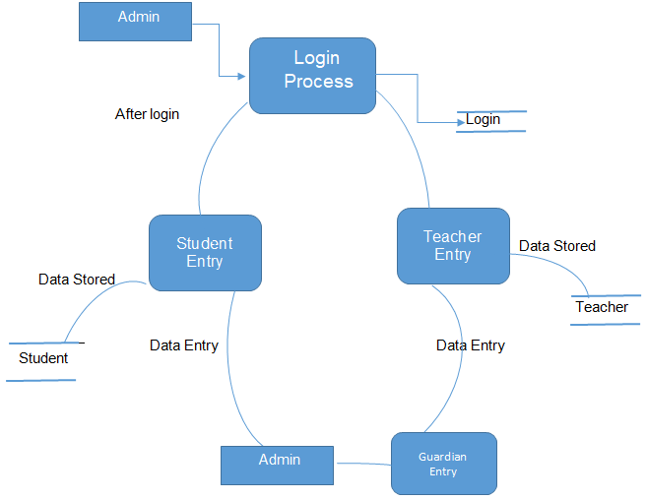

**Figure 4.5: Data flow diagram**

**4.3 ER diagram**

Entity Relationship (ER) Diagram is a type of flowchart that set forth how “entities” such as community, objects or concepts relate to each other within a system.

Admin

Student

Teacher

Manage

Guardian

Contact

teaches

Belongs

Attendance

Studied

Subject

**Figure 4.6: ER diagram**

ER Diagrams are most often used to design or debug relational databases in the fields of software engineering, business intelligence systems, education and research. Also known as ERDs or ER Models, they use a defined set of emblem such as rectangles, diamonds, ovals and connecting lines to depict the inter-connectedness of entities, relationships and their attributes. They reflect grammatical structure, with entities as nouns and relationships as verbs. Here is the complete diagram of this system-

**4.4 The overall system of this project**

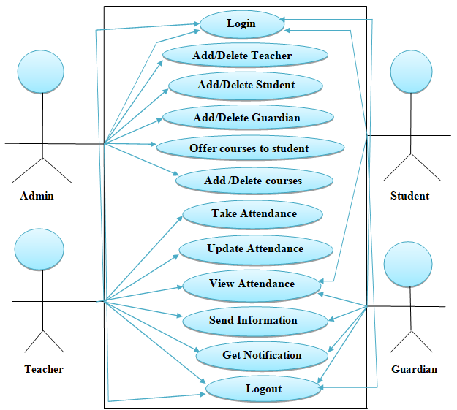

**Figure 4.7: The overall system of this project**

**4.5 Methodology**

Methodology is the terms of project that describes the working procedures. In this term the procedure of online attendance system is written. The methodology for “Online Attendance System” was founded on the strategies given below.

**4.5.1 Admin specification**

The administration will set up an admin for monitoring the system. Admin is a super user who enjoys all the rights. Admin will get username and password. Then admin have to login the system. In the system, admin will add teacher. Then admin will give course to the teacher. Now admin will have to add student with their proper information and insert them to a course with the respective teacher. Admin will able to add and delete the course, teacher and student.

**4.5.2 Teacher specification**

Teacher is a user who is created by admin. Teacher will get username and password from admin. Teacher can see the course and semester. The main term will be done by teacher. Teacher can only take the attendance and update. Teacher also can see the student attendance mark. Teacher can send notification to student’s parent and also can reply.

**4.5.3 Student specification**

Student is also a user who is created by admin. Student will get username and password from admin. Students can only see their attendance. Students also able to their attendance percentage.

**4.5.4 Guardian specification**

Parents can login with student id. Parent can also able to see the attendance and percentages. Parents get notification from teacher and also can reply

**CHAPTER 5**

**IMPLEMENTATION AND TESTING**

Attendance Management System is a software developed for daily student attendance in schools, colleges and institutes**.** If facilitates to access the attendance information of a particular student in a particular class. The information is sorted by the operators, which will be provided by the teacher for a particular class. This system will also help in evaluating attendance eligibility criteria of a student.

Before making a program or software most important things to about a platform that can make easy to do specific work properly. That’s why we have chosen sublime text 3. Sublime text 3 is most reliable platform for any kind of application. In this chapter we will discuss about sublime text 3 and its advantage, its development and its evaluation and discuss will other tools which we used in our project and also techniques.

**5.1 Development Language & Database**

Our System using the following Language and Database:

* **Language:** PHP (back-end)
* **For Design**: HTML, CSS, Jquery, Java Script(front-end)
* **Database:** XAMPP SQL Server
* **Platform** : SUBLIME TEXT 3

**5.1.1 Sublime text 3**

Sublime Text is a [source code editor](https://en.wikipedia.org/wiki/Source_code_editor) with an [application programming interface](https://en.wikipedia.org/wiki/Application_programming_interface) (API). It natively backings many [programming languages](https://en.wikipedia.org/wiki/Programming_languages) and [markup languages](https://en.wikipedia.org/wiki/Markup_languages), and functions can be added by users with [plugins](https://en.wikipedia.org/wiki/Plugins), typically community-built and conserved under [free-software licenses](https://en.wikipedia.org/wiki/Free_software_licenses). Version 3 entered beta on 29 January 2013. At first obtainable only for registered users who had procured Sublime Text 2, on 28 June 2013 it became obtainable to the general public. Though, the very latest development builds immobile mandatory a registration code. Sublime Text 3 was formally released on 13 September 2017.

Two of the key features that Sublime Text 3 adds contain symbol indexing and pane management. Symbol indexing allows sublime text to test files and build an index to simplify the features go to definition and go to symbol in project. Pane Management consents users to move between panes via hotkeys.

**5.1.2 Feature of Sublime text 3**

Now we will go discuss about the features -

* Uses go to anything to open files with only a few keystrokes, and instantly jump to symbols, lines or words.
* Go to classification.
* Multiple selections.
* Command Palette.
* Powerful API and Package Ecosystem.
* Customize Anything.
* Split Editing.
* Instant Project Switch.

**5.1.3 Advantage of sublime text 3**

* Faster startup. Like way, way faster.
* Support for high DPI screens.
* PHP formatting improvement.
* Atomic save setting that compliments file agreements on OS X and Linux.
* Improvements to the side bar right-click menu.
* New Jump Forward and Jump Backward commands.
* Better HTML support, including attribute completion, auto pockmark, and automatic tag finishing.
* New Invert Selection command.
* Fields in find and exchange panels auto resize for multi-line strings.
* Auto updating for Windows, OS X.
* More OS-native look for dialogs.

**5.2 Login Form:**

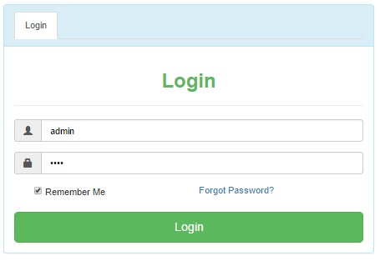

**Figure 5.1: Login Form**

This login form is made for security purpose. So only authenticated user only access in to the project. There are four type of persons can enter in the project

* Admin
* Teacher
* Guardian
* Student

**5.2.1 Admin Dashboard:**

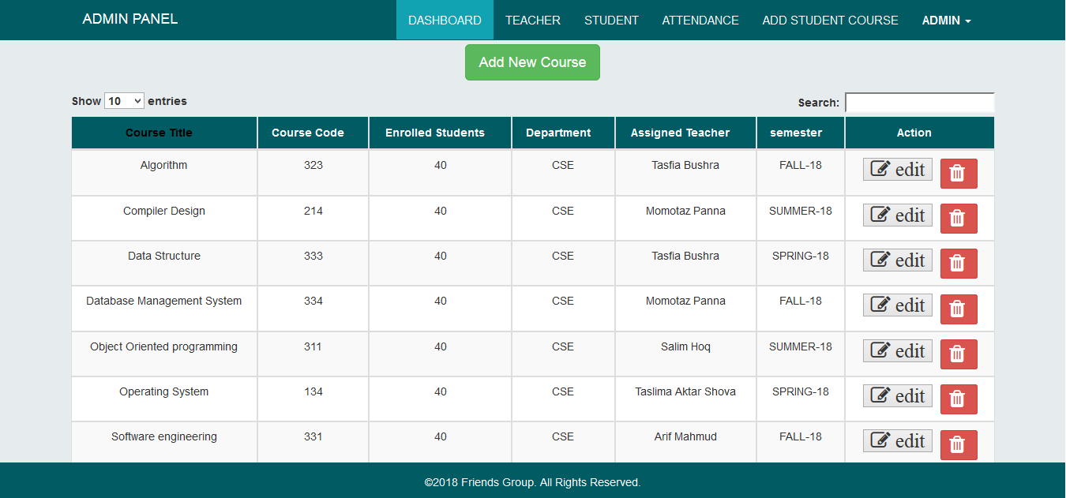

**Figure 5.2: Admin Dashboard**

This Dashboard is showed when authorized administrator enters his correct user name and password. This dashboard gives the option to fill the name of Students and the name of Teacher and also add new course.

**5.2.1.1Student Information Form:**

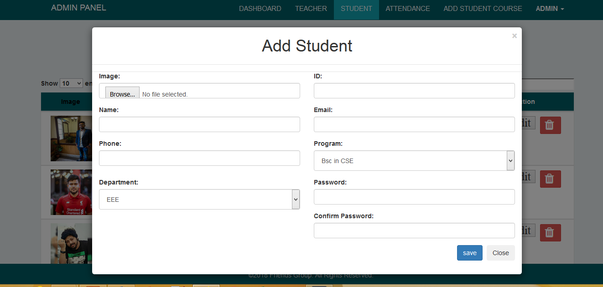

**Figure 5.3: Student Information Form**

This form enables the administrator to fill the information of students and their department and also set there login username and password.

**5.2.1.2Teacher Information Form:**

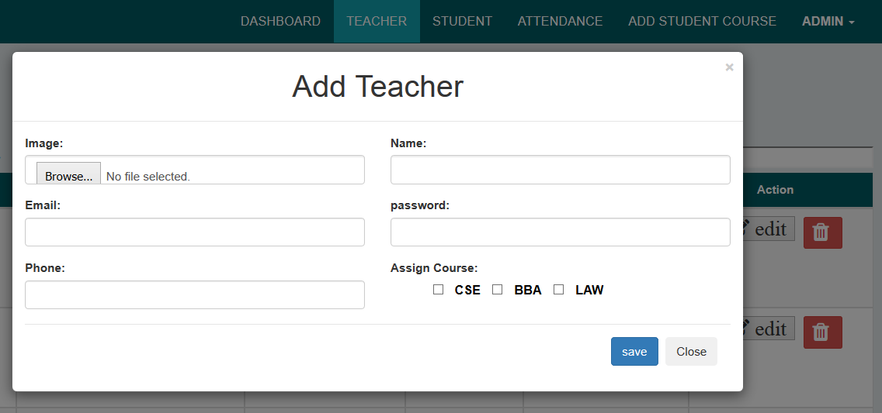

**Figure 5.4: Teacher Information Form**

This Form is made for administrator to fill up the information of teachers and there Department and also set there login user name and password.

**5.2.2 Teacher Dashboard:**

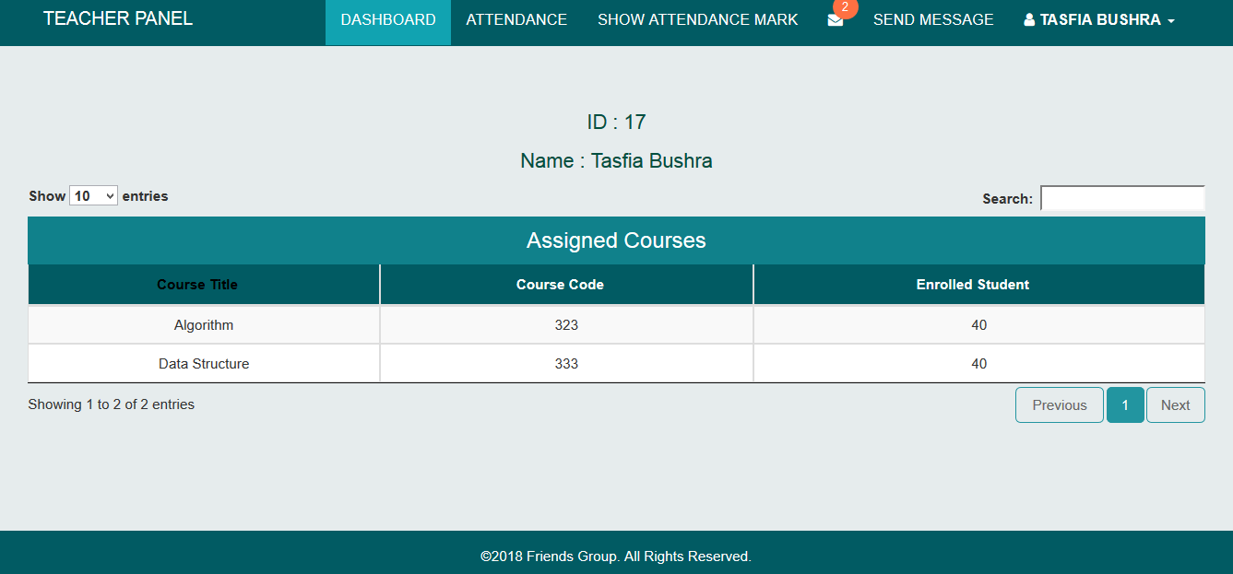

**Figure 5.5: Teacher Dashboard**

This form is opened when user fill up his correct User Name and Password and User Type Is user. This form enables the user to fill up attendance of every student and see whish student is short listed and what is the total attendance of each individual attendance in a particular Subject and in a particular month.

**5.2.2.1 Contact Form:**

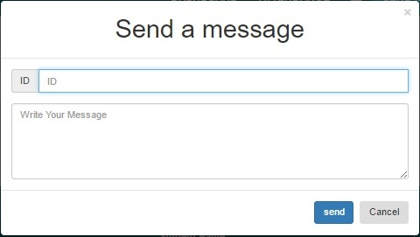

**Figure 5.6: Contact Form**

This form is opened when user click the message button .Teacher can direct contact to the guardian thought this messenger

**5.2.2.2 Taken Attendance Form:**

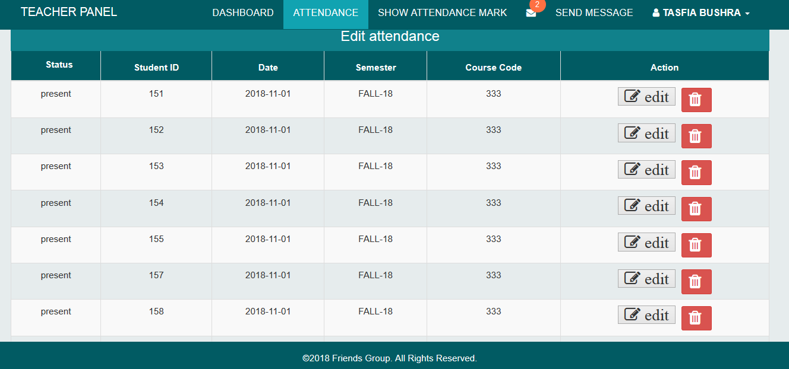

**Figure 5.7: Taken Attendance Form.**

This form facilitates the teacher to choose a semester in which attendance is to be filled. In this system we are using the Fall-18 Semester so when the user clicks on Fall-18 the list of Fall-18 students will come.

**5.2.2.3 Attendance Form:**

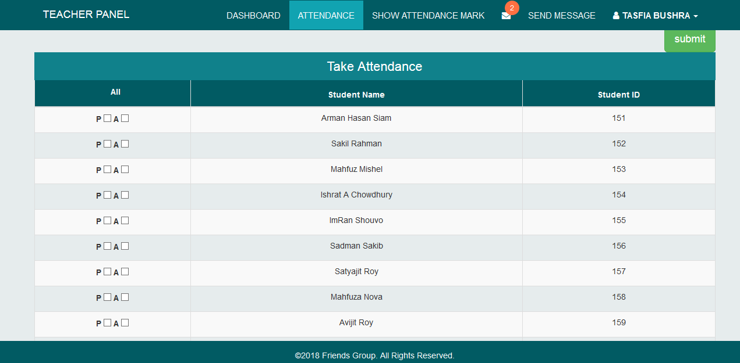

**Figure 5.8 Attendance Form**

This Form is used to choose subjects and the month for which attendance is to be filled up and show a list of students. When a User click to corresponding Check box and click on save the students will be stated present and their attendance is added.

**5.2.2.4 Attendance status form:**

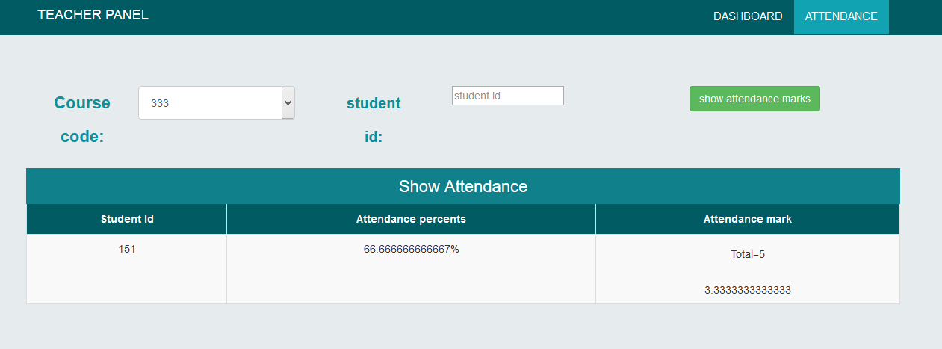

**Fig 5.9 Attendance percentage Form**

This form shows the status of the students or we can say number of classes attended in a particular subject in a particular month. When user click on the ‘View Status’ button of short list form then this form will appear with the status.

**5.2.3 Student Dashboard:**

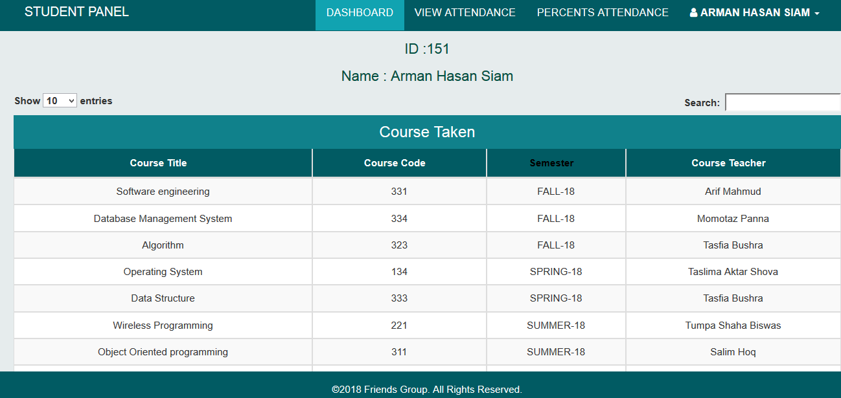

**Fig 5.10 Student Dashboard**

This form is opened when Student fill up his correct User Name and Password.

**5.2.3.1 Student Attendance Information:**

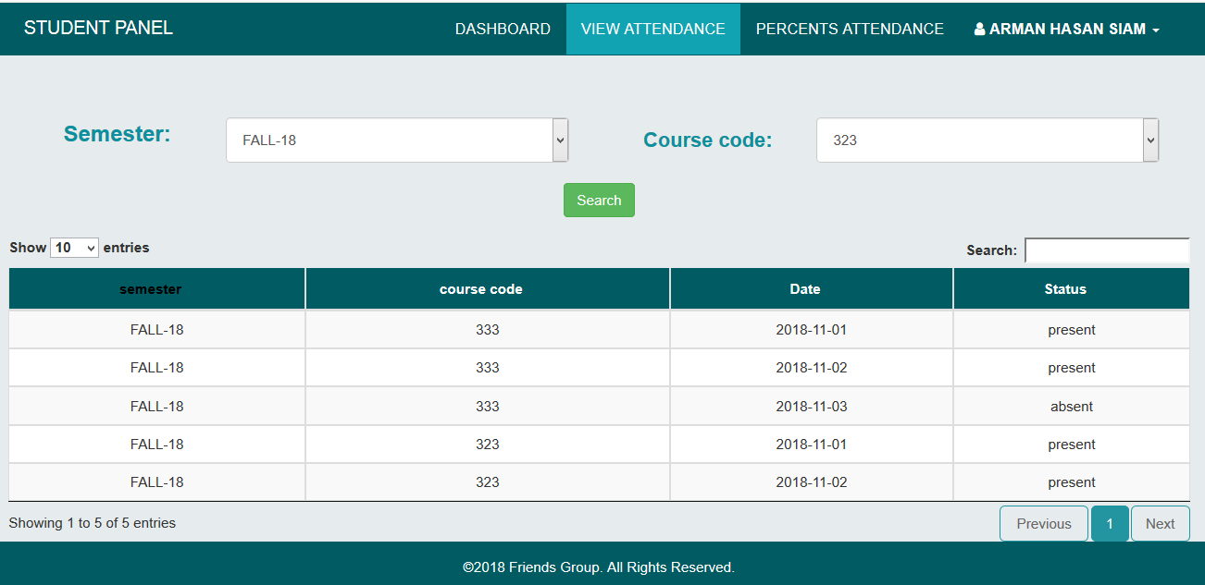

**Figure 5.11: Student Attendance information**

This form enables the student to view taken course and attendance and also what is the total attendance of each individual attendance in a particular Subject and in a particular month.

**5.2.4 Guardian Dashboard:**

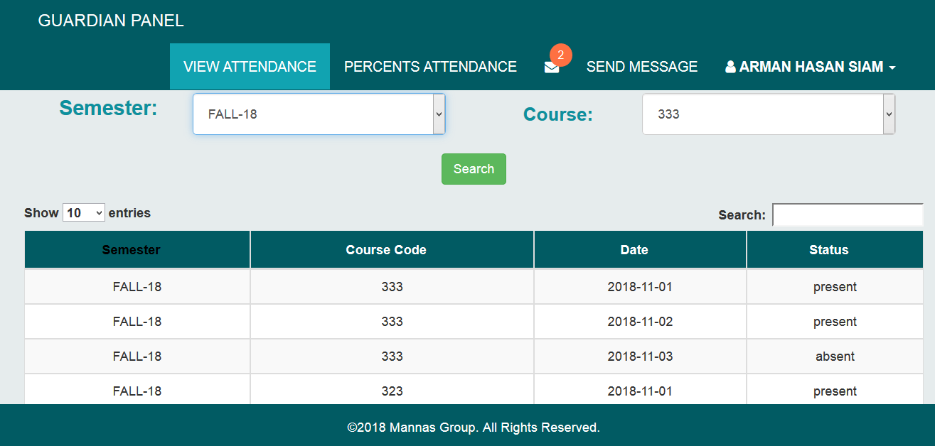

**Figure 5.12 Guardian Dashboard**

This form is opened when Guardian fill up his correct User Name and Password. This form facilitates the Guardian to choose a semester in which attendance is to be view. But Guardian can only view his/her student attendance only. In this system we are using the Fall-18 Semester. When the user clicks on Fall-18 the list of Fall-18 students will come.

**5.2.4.1 Contact form:**



**Figure 5.13 Contact Form**

This form is opened when guardian click on the message button. Guardian can direct contact to the teacher thought this messenger.

**5.2.5 Database Design**

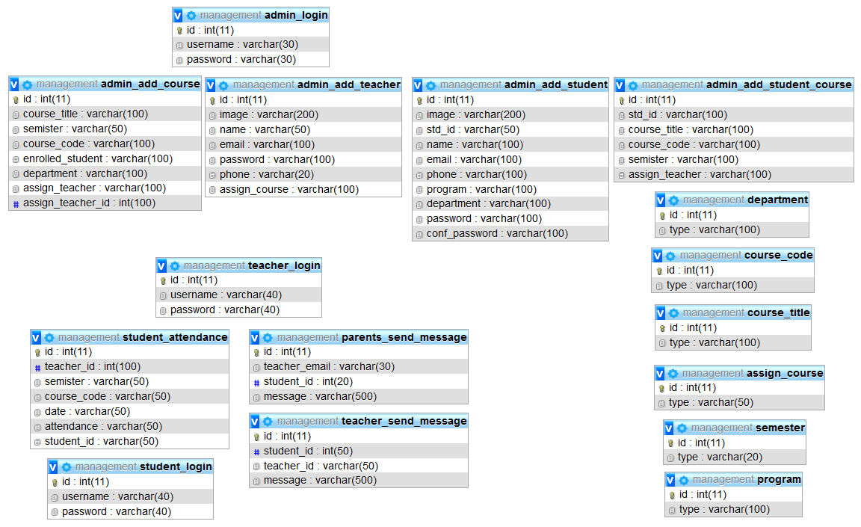

**Figure 5.14: Database Design**

This is the design of the database.

**CHAPTER 6**

**CONCLUSION AND FUTURE SCOPE**

**6.1 Conclusion**

This project will be very helpful for user to take attendance, calculating the student attendance and attendance mark. Maintenance and observing of attendance records plays a vital role in the analysis of performance of any organization. The proposed system will manage the process of attendance that will be saving in a specific database. It also saves time and removes the paperwork. For wasting less time teachers will be able to teach more in the class. In this project students can be login to view their attendance and guardian can be login to see their children attendance. Whereas guardian can see their children attendance, for this reason there is 0 percent chance for student to play false. In this proposed system there is a good and important feature is teacher-guardian communication which is very good and blessing for the students. There is another feature in this system is generate the percentage of student attendance automatically and generate the mark based on the student attendance which is very helpful for teacher and student. Because students can see their attendance percentage and the teacher's time is less than waste for calculating the attendance mark. In this web application user can see the daily weather.

**6.2 Future Scope**

The system has been developed with future development possibilities in consideration. We wish we could improve the system and reduce the limitation of the system in a short time. The developers of the system wish to continue their involvement contribution to this system for further development operation. This project can be become a face detection based attendance system using face detection process. This project also can become an individual student’s absence and attendance system. Course routines can be added to this system and then students can find out their routine easily.

**APPENDIX**

**Some important Code**

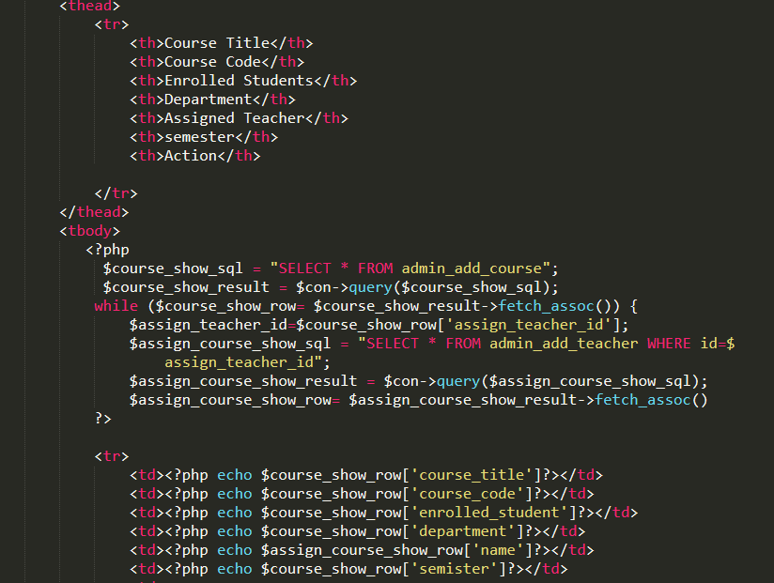

FIG A.1: Admin add course.

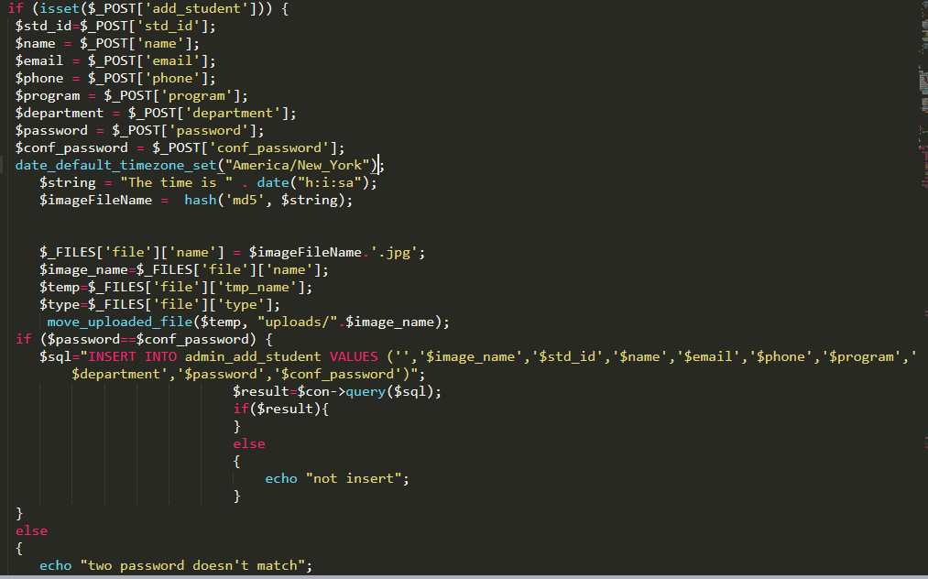

FIG A.2: Admin add student.

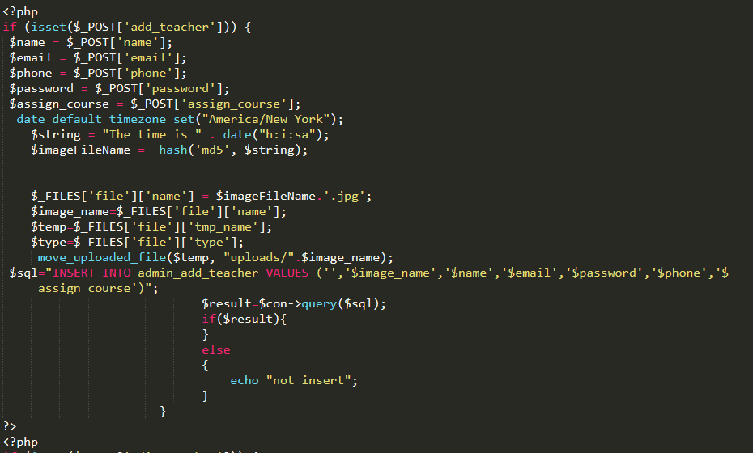

FIG A.3: Admin add teacher.

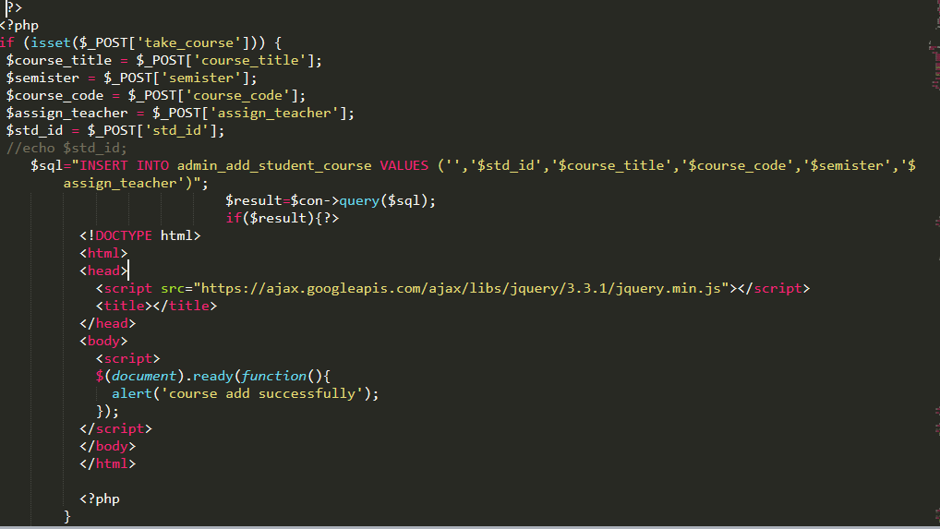

FIG A.4: Admin take course to student.

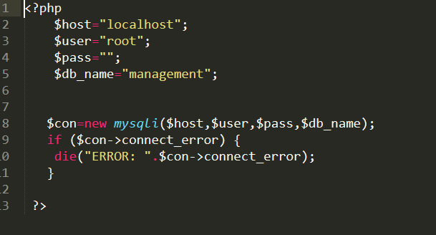

FIG A.5: Database connection.

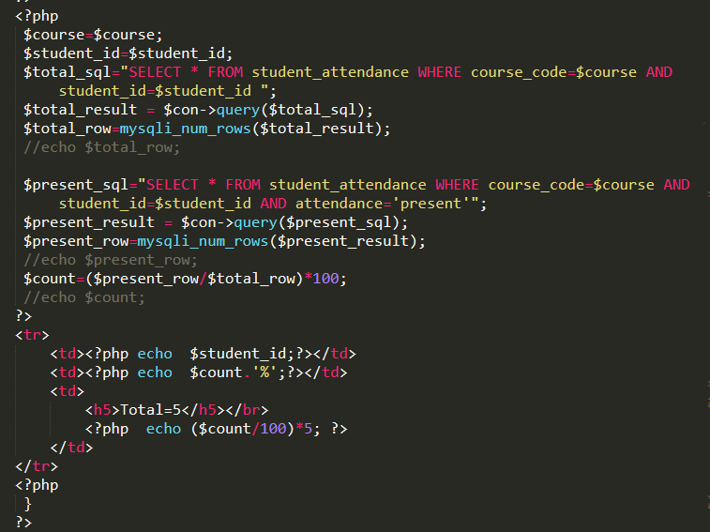

FIG A.6: Attendance mark.

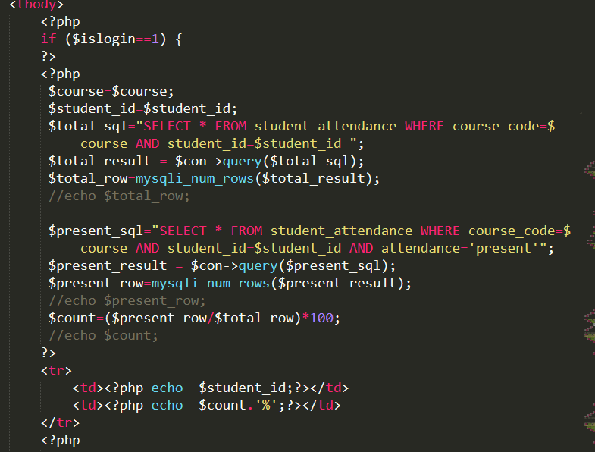

FIG A.7: Attendance percentage.

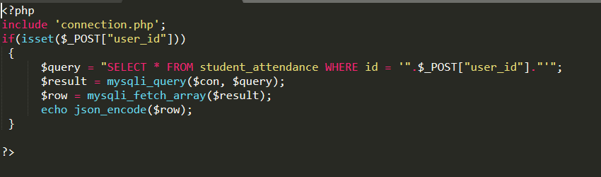

FIG A.8: Edit attendance.

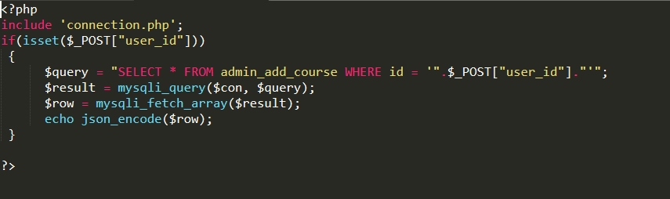

FIG A.9: Edit course.

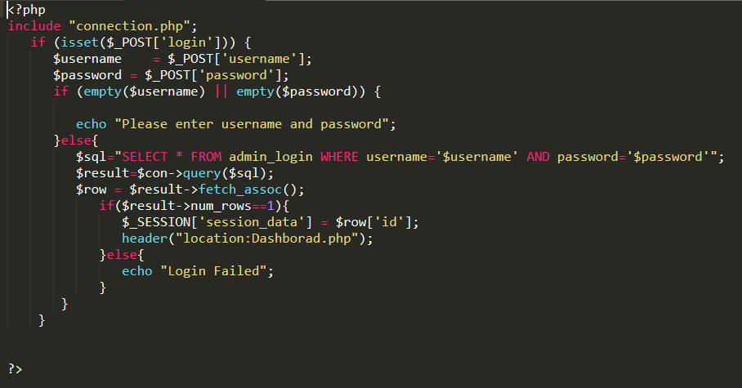

FIG A.10: Login part.

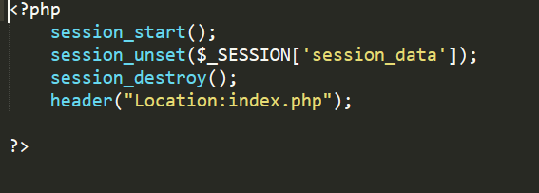

FIG A.11: Logout part.

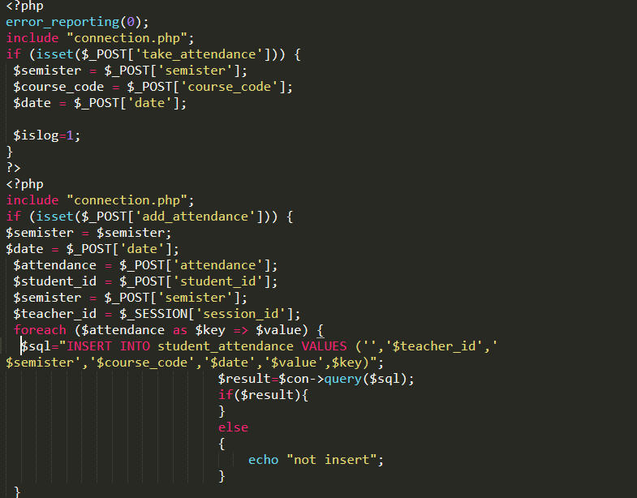

FIG A.12: Take attendance.

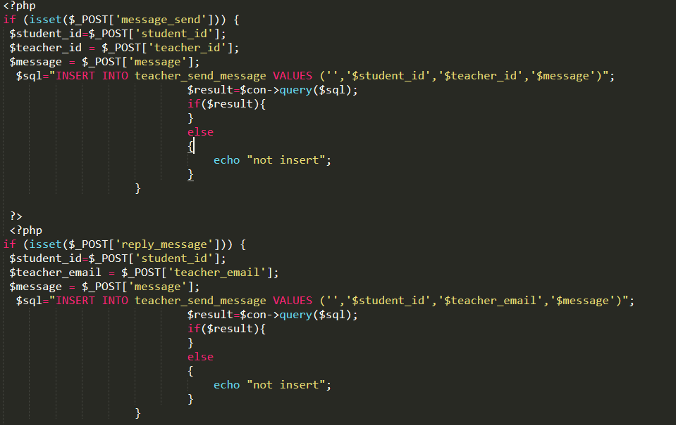

FIG A.13: Message between teacher and parents.

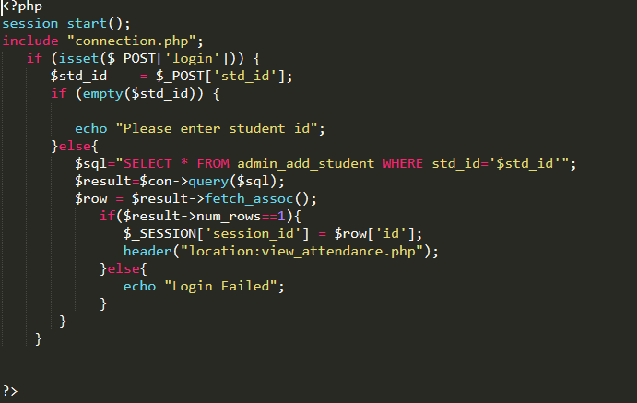

FIG A.14: Parents login.

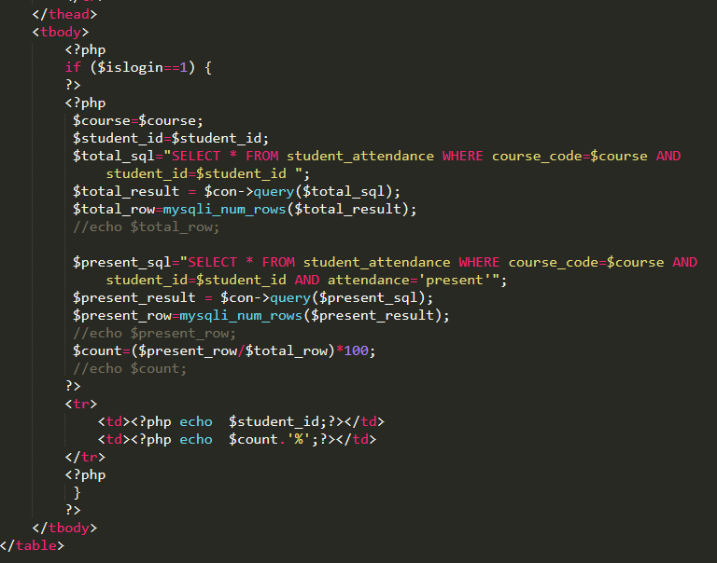

FIG A.15: Attendance view.

**REFERENCES**

[1] Topic: Follow design, Available on: https://meeraacademy.com/student-attendance-management-system-project-in-c-net/, Accessed Date: 03.05.1028.

[2] Topic: Project idea (some features), Available on: https://www. academia.edu/7760318/ STUDENTS__MANAGEMENT_SYSTEM_MINI_PROJECT_REPORT_MASTER_OF_COMPUTER_APPLICATIONS /, Accessed Date: 03.06.1028.

[3] Topic: Project idea (some features), Available on: https://www.phptpoint.com/online-attendance-management-system/, Accessed Date: 03-07-2018.

[4] Topic: Collect information, Available on: http://www.iisjaipur.org/iiim-current-08/mca_iv_sem_pro_eva/15.project%20attendence%20managemnt%20system.pdf/, Accessed Date: 03-08-2018.

[5] Topic: Collect information, Available on: https://www.ijraset.com/fileserve.php?FID=4096/, Accessed Date: 12-08-2018.

[6] Topic: Report idea, Available on: https://www.scribd.com/doc/131466248/STUDENT-ATTENDANCE-MANAGEMENT-SYSTEM/, Accessed Date: 19-09-2018.

[7] Topic: Report idea, Available on: https://www.researchgate.net/ publication/ 323511629_Student_Attendance_Management_System/, Accessed Date: 01-10-2018.

[8]Topic: About System, Available on: https://www.academia.edu/7760318/ STUDENTS_ATTENDANCE_MANAGEMENT_SYSTEM_MINI_PROJECT_REPORT_MASTER_OF_COMPUTER_APPLICATIONS/, Accessed Date: 10-09-2018.

[10] Topic: Literature Review, Available on: https://www.scribd.com/doc/131466248/STUDENT-ATTENDANCE-MANAGEMENT-SYSTEM/, Accessed Date: 10-10-2018.

[11] Topic: Literature Review, Available on: http://ignousupport.blogspot.com/p/student-attendance-management-system.html/,Accessed Date: 10-10-2018.

[12] Topic: Report idea (system analysis), Available on: http://eprints.utar.edu.my/1829/1/IA-2015-1304584-1.pdf/, Accessed Date: 03-08-2018.

[13] Topic: Design /Development, Available on: https://www.w3schools.com/, Accessed Date: 03-02-2018.

[14] Topic: Use-case diagram, Available on: https://whatis.techtarget.com/definition/use-case-diagram/, Accessed Date: 05-10-2018.

[15] Topic: Data flow diagram, Available on: https://en.wikipedia.org/wiki/Data_flow_diagram/, Accessed Date: 10-10-2018.

[16] Topic: ER diagram, Available on: https://www.smartdraw.com/entity-relationship-diagram/, Accessed Date: 18-10-2018.

[17] Topic: About Software/Platform, Available on: https://en.wikipedia.org/wiki/Sublime_Text/, Accessed Date: 19-10-2018.

[18] Topic: Agile Model, Available on: https://www.tutorialspoint.com/sdlc/sdlc_agile_model.htm?fbclid=IwAR30gTIIPqINEbMSLRuVYU7L5YJsn6IzcPM_UsgEXQTG0KWWgZlpmg1kLwo/, Accessed Date: (20-10-2018)

[19] Topic: Feasibility Study, Available on: https://en.wikipedia.org/wiki/Feasibility_study?fbclid=IwAR0T_N4uMEybUXfL-oC4PL2o5f4Elmxz0RQLDluzASegqyWAjQ60mMeOCn4/, Accessed Date: (20-10-2018)