**ORACLE MASTER DATA MANAGEMENT**

Master Data is the critical business information supporting the transactional and analytical operations of the enterprise. Master Data Management (MDM) is a combination of applications and technologies that consolidates, cleans, and augments this corporate master data, and synchronizes it with all applications, business processes, and analytical tools. This results in significant improvements in operational efficiency, reporting, and fact based decision-making.

Master Data Management has two architectural components:

* The technology to profile, consolidate and synchronize the master data across the enterprise
* The applications to manage, cleanse, and enrich the structured and unstructured master data

**MASTER DATA MANAGEMENT PROCESSES**

Now that we have identified the nature of master data and its place in information architecture, we need to identify the key processes that MDM solutions must support.

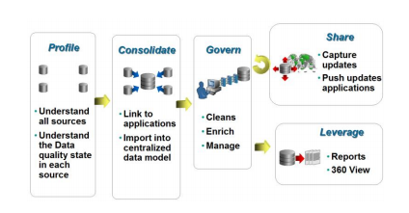

These are the key processes for any MDM system.

* **Profile** the master data. Understand all possible sources and the current state of data quality in each source.
* **Consolidate** the master data into a central repository and link it to all participating applications.
* **Govern** the master data. Clean it up, deduplicate it, and enrich it with information from 3rd party systems. Manage it according to business rules.
* **Share** **it**. Synchronize the central master data with enterprise business processes and the connected applications. Insure that data stays in sync across the IT landscape.
* **Leverage** the fact that a single version of the truth exists for all master data objects by supporting business intelligence systems and reporting

**Master Data**

Master data is the core data that is essential to operations in a specific business or business unit.

**BVT (Best Version of Truth)**

Best Version of Truth (or BVT) refers to the golden record generated after the consolidation process in MDM from the best and most-trustworthy cell values from the source records.

Eg. Suppose you have three source records, your golden record contains the cell values from all three like Name from source1, SSN from source2 and PhoneNo. from source3.

It may be the case that the golden record contains cell values from only 2 or one source. In that case those will the latest or most trusted values.

**SVT (Single Version of Truth)**

In computerized business management, **single version of the truth** (**SVOT**), is a technical concept describing the data warehousing ideal of having either a single centralized database, or at least a distributed synchronized database, which stores all of an organisation's data in a consistent and non-redundant form. This contrasts with the related concept of single source of truth (SSOT), which refers to a data storage principle to always source a particular piece of information from one place.

**Informatica MDM contains two major components**

* **Master database**: Application configuration data.
* **ORS (Operation Reference Source)**: The data which the application deals with.

**Flow in MDM**

* Batch Flow
* Realtime Flow

Whenever we are creating Staging, in background 4 tables are created by default.

* RAW
* REJ
* OPL
* PRL

IF we have 20 source systems then there will be only one landing table and 20 staging tables will be created.

Naming convention will be like below.

* For landing table: C_lan_table
* For Staging table: C_stg_table