Invoking a web service with HTTP Basic authentication – OSB 11g

To invoke the webservice that is protected with basic authentication, the Service account needs to be created and attached to the outbound business service (the service that calls the webservice)

This post explains the steps required to invoke the basic authentication enabled service.

* Login to sbconsole
* Create the Service AccountA service account provides a user name and password that proxy services and business services use for outbound authentication or authentication to a local or remote resource, such as an FTP server or a JMS server. For example, if a business service is required to supply a user name and password for transport-level authentication with a Web Service, you create a service account that specifies the user name and password and then you configure the business service to include the service-account credentials in its outbound requests.
* Select **Project Explorer** and then select a project or folder in which to add the service account

[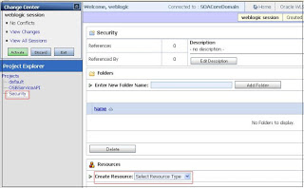](http://1.bp.blogspot.com/-kxVDSe6pP2I/UJOaOYB3X_I/AAAAAAAACJ8/LW8E1RHY26I/s1600/untitled.JPG)

* From the **Create Resource** drop-down list, select **Service Account** to display the **Create a New Service Account**page

[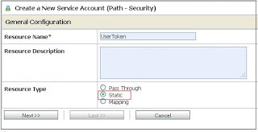](http://4.bp.blogspot.com/-bGR6IEr-Kbs/UJOaarJKSFI/AAAAAAAACKE/r23ir0ufRsI/s1600/untitled.JPG)

* + To create a service account that provides the user names and passwords that it receives from incoming client requests, select **Pass Through**.
  + To create a service account that provides a user name and password that you save with the service account configuration, select **Static**.
  + To create a service account that maps the user name from one or more authenticated clients to user names and passwords that you specify, select **Mapping**.

                This scenario I have chosen the static option to provide the predefined username/password.

[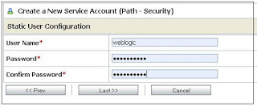](http://2.bp.blogspot.com/-oh59laJt0dY/UJOatv974rI/AAAAAAAACKM/Y2AwoL4k6Xk/s1600/untitled.JPG)

* Click Last and Finish.
* Create the Business Service that invokes the webservice and select the Authentication as Basic and Service Account as Security/UserToken.

[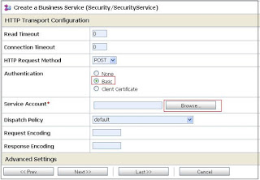](http://2.bp.blogspot.com/-wtK3rPvXyB0/UJObB-xn_OI/AAAAAAAACKU/3h1_HVov4Ak/s1600/untitled.JPG)

[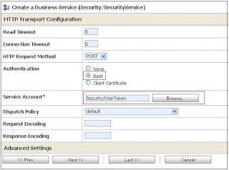](http://3.bp.blogspot.com/-NQbVIQvP-v4/UJObJv7q0_I/AAAAAAAACKc/TuZiV0T-iQ4/s1600/untitled.JPG)

[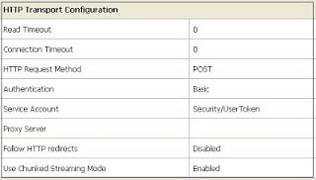](http://1.bp.blogspot.com/-T-6tEN-LonU/UJObSO8UxcI/AAAAAAAACKk/Lh2t0lUD3rA/s1600/untitled.JPG)

* Create a proxy service that invokes the Business service created in the previous step.

**Test the Proxy service**:

Correct username and password.

[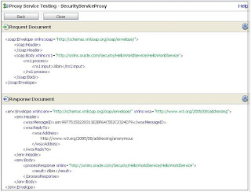](http://2.bp.blogspot.com/-OclAcHBCcgM/UJObdE1SjII/AAAAAAAACKs/sRQJaNbHsPA/s1600/untitled.JPG)

Wrong username and password.

[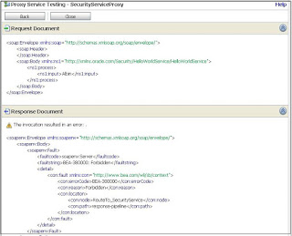](http://3.bp.blogspot.com/-WNvlyq3Lbxw/UJObnqW8VAI/AAAAAAAACK0/aNJs1-4siQ4/s1600/untitled.JPG)

To invoke the webservice that is protected with basic authentication, the Service account needs to be created and attached to the outbound business service (the service that calls the webservice)

This post explains the steps required to invoke the basic authentication enabled service.

* Login to sbconsole
* Create the Service AccountA service account provides a user name and password that proxy services and business services use for outbound authentication or authentication to a local or remote resource, such as an FTP server or a JMS server. For example, if a business service is required to supply a user name and password for transport-level authentication with a Web Service, you create a service account that specifies the user name and password and then you configure the business service to include the service-account credentials in its outbound requests.
* Select **Project Explorer** and then select a project or folder in which to add the service account

[](http://1.bp.blogspot.com/-kxVDSe6pP2I/UJOaOYB3X_I/AAAAAAAACJ8/LW8E1RHY26I/s1600/untitled.JPG)

* From the **Create Resource** drop-down list, select **Service Account** to display the **Create a New Service Account**page

[](http://4.bp.blogspot.com/-bGR6IEr-Kbs/UJOaarJKSFI/AAAAAAAACKE/r23ir0ufRsI/s1600/untitled.JPG)

* + To create a service account that provides the user names and passwords that it receives from incoming client requests, select **Pass Through**.
  + To create a service account that provides a user name and password that you save with the service account configuration, select **Static**.
  + To create a service account that maps the user name from one or more authenticated clients to user names and passwords that you specify, select **Mapping**.

                This scenario I have chosen the static option to provide the predefined username/password.

[](http://2.bp.blogspot.com/-oh59laJt0dY/UJOatv974rI/AAAAAAAACKM/Y2AwoL4k6Xk/s1600/untitled.JPG)

* Click Last and Finish.
* Create the Business Service that invokes the webservice and select the Authentication as Basic and Service Account as Security/UserToken.

[](http://2.bp.blogspot.com/-wtK3rPvXyB0/UJObB-xn_OI/AAAAAAAACKU/3h1_HVov4Ak/s1600/untitled.JPG)

[](http://3.bp.blogspot.com/-NQbVIQvP-v4/UJObJv7q0_I/AAAAAAAACKc/TuZiV0T-iQ4/s1600/untitled.JPG)

[](http://1.bp.blogspot.com/-T-6tEN-LonU/UJObSO8UxcI/AAAAAAAACKk/Lh2t0lUD3rA/s1600/untitled.JPG)

* Create a proxy service that invokes the Business service created in the previous step.

**Test the Proxy service**:

Correct username and password.

[](http://2.bp.blogspot.com/-OclAcHBCcgM/UJObdE1SjII/AAAAAAAACKs/sRQJaNbHsPA/s1600/untitled.JPG)

Wrong username and password.

[](http://3.bp.blogspot.com/-WNvlyq3Lbxw/UJObnqW8VAI/AAAAAAAACK0/aNJs1-4siQ4/s1600/untitled.JPG)