[**Only six digits numeric, shouldn't start with `0`**](https://stackoverflow.com/questions/33865525/indian-pincode-validation-regex-only-six-digits-shouldnt-start-with-0)

^[1-9][0-9]{5}$

**Explanation:**

1. ^: Starts with anchor
2. [1-9]: Matches exactly one digit from 1 to 9
3. [0-9]{5}: Matches exactly five digits in the inclusive range 0-9
4. $: Ends with anchor

[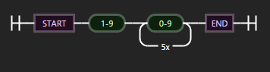](https://i.stack.imgur.com/Yt3c8.png)

**Only five digits numeric**

^[0-9]{5}$

**Only eight digits numeric without all zeros**

^(?!0{8})[0-9]{8}$

**Only null to eight digits numeric without all zeros**

^(?!0{8})[0-9]{0,8}$