1. How to break text into lines in ORACLE SOA.

&#x0A;

Ex : concat('my name&#x0A;is&#x0A;khan’,xp20:current-date())

1. How to send both plain text and html code in email body.

string(ora:toCDATA(concat('',$inputVariable.payload/ns1:body)))

1. OSB prespective and OSB Resource missing from Eclipse OEPE Plugin

Copy the file named ‘oracle.osb.ide.link’ from ‘C:\Oracle\Middleware11g\oepe_11.1.1.8.0\dropins’ to ‘C:\Oracle\Middleware11g\Oracle_OSB1\eclipse150’

1. Not able to start weblogic server due to heap memory issue.

Add a system variable in environment variables.

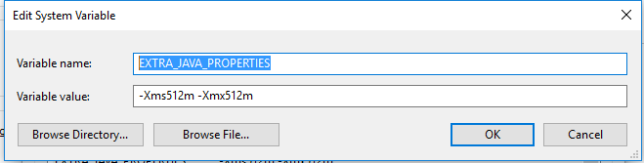

1. Managed Server ERROR: transport error 202: bind failed: Address already in use

Take backup of  C:\Oracle\Middleware11g\user_projects\domains\local_domain\bin\setDomainEnv.cmd

Find code

if "%DEBUG_PORT%"=="" (

set DEBUG_PORT=8453

)

if "%SERVER_NAME%"=="" (

set SERVER_NAME=AdminServer

)

Add the below code under the below code

if "%SERVER_NAME%"=="soa_server1" (

set DEBUG_PORT="7453"

)

if "%SERVER_NAME%"=="osb_server1" (

set DEBUG_PORT="7454"

)

1. When child bpel process want to commit using XA datasource in parent child bpel process the add the following code in child bpel process component tab of composite.xml

<property name="bpel.config.transaction" type="xs:string" many="true">requiresNew</property>

<property name="bpel.config.oneWayDeliveryPolicy" type="xs:string"

many="true">sync</property>

1. How to crate and use variable in xslt mapping file.

**Creation of variable**

<xsl:variable name="varDeptno" select="top:deptno"/>

**Use variable to assign value**

<imp1:deptno>

<xsl:value-of select="$varDeptno"/>

</imp1:deptno>

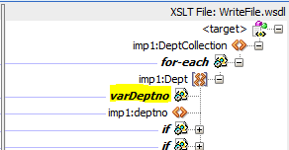

1. What is polling in DB Adapter?

Oracle SOA Database Adapters provide a polling mechanism that will periodically query a table to see if a there is a new or changed record.  If so, it can trigger a BPEL process.

1. What is tokenizer in Oracle SOA.

Token configurations which really can help administrators in configuring or overriding external Web Service Reference parameters like the protocol ( http, oramds or https ),  the remote host etc. And more important if you do it right you can kick out the all those Soa Suite deployment plan

1. What is minimum file age in DB/FTP adapter?

The minimum file age of files to retrieve. For example, this polling parameter enables a large file to be completely copied into the directory before it is retrieved for processing. The age is determined by the last modified time stamp. For example, if you know that it takes three to four minutes for a file to be written, then set the minimum age to five minutes. If a file is detected in the input directory and its modification time is less than five minutes older than the current time, then the file is not retrieved because it is still potentially being written to.