**Create Domain Value Maps**

You can create a domain value map by using the Create Domain Value Map(DVM) File dialog in Oracle JDeveloper.

**To create a domain value map:**

1. In the Application Navigator, right-click the project in which you want to create a domain value map and select **New**.

The New Gallery dialog is displayed.

1. Expand the **SOA Tier** node, and then select the **Transformations** category.
2. In the **Items** list, select **Domain Value Map(DVM)** and click **OK**.

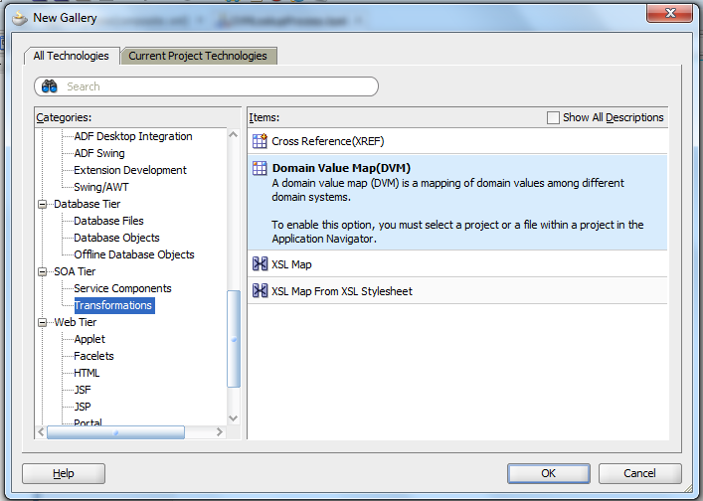

The Create Domain Value Map(DVM) File dialog is displayed.

1. In the **File Name** field, enter the name of the domain value map file. For example, specify CityCodes to identify a domain value map for city names and city codes.
2. In the **Description** field, enter a description for the domain value map. For example, Mappings of city names and city codes. This field is optional.
3. In the **Domain Name** field, enter a name for each domain. For example, you can enter CityCode in one **Domain Name** field and CityName in another. Each domain name must be unique in a domain value map.
4. In the **Domain Value** field, enter a value corresponding to each domain. For example, enter BO for the CityCode domain and Boston for the CityName domain, as shown in Figure.

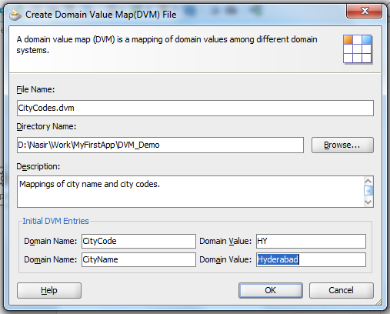

1. Click **OK**.
2. The Domain Value Map Editor is displayed. Click on ‘+’ symbol to add more values.

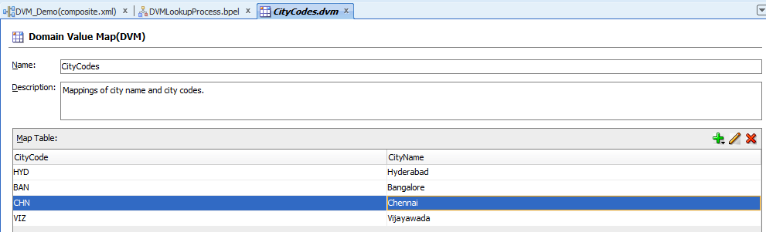

1. A file with extension .dvm is created and appears in the Application Navigator, as shown in Figure.

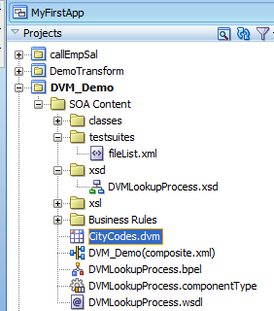

1. Go to the bpel and use the dvm created.

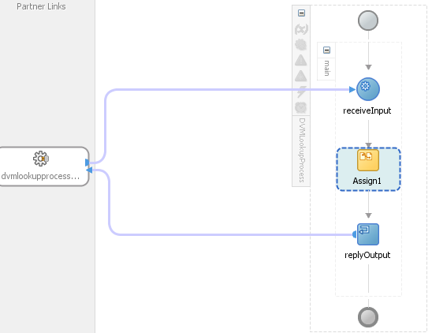

1. Assign the output as dvm:lookupValue('CityCodes.dvm','CityCodes',$inputVariable.payload/client:input, 'CityNames','CouldNotBeFound')

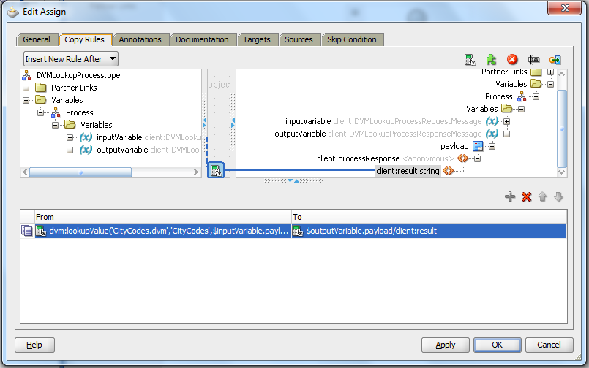

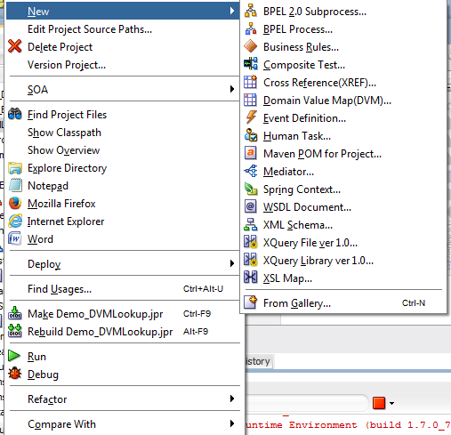

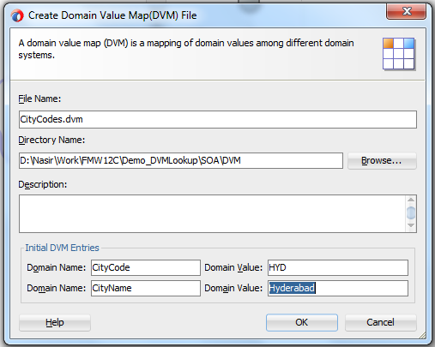

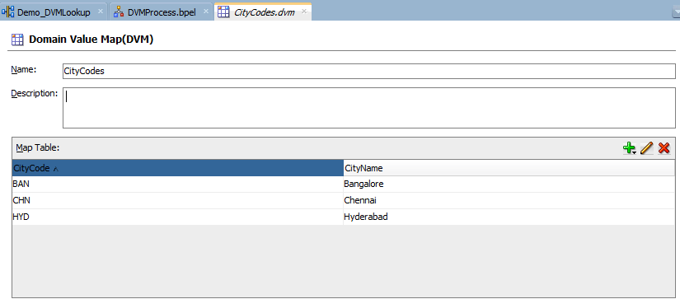

dvm:lookupValue('DVM/CityCodes.dvm','CityCode',bpws:getVariableData('inputVariable','payload','/client:process/client:input'),'CityName','No data matched')

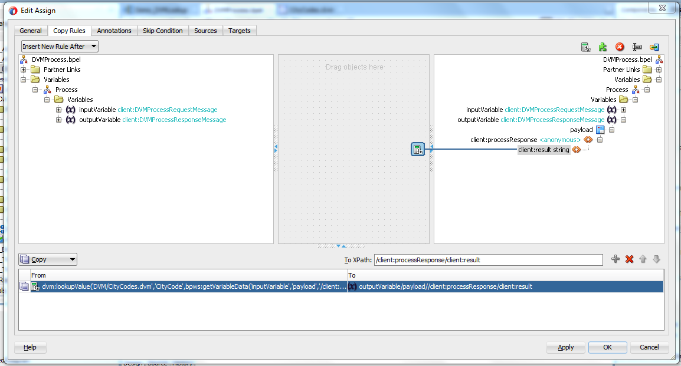

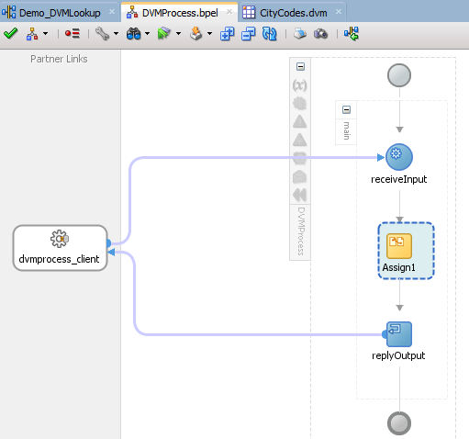

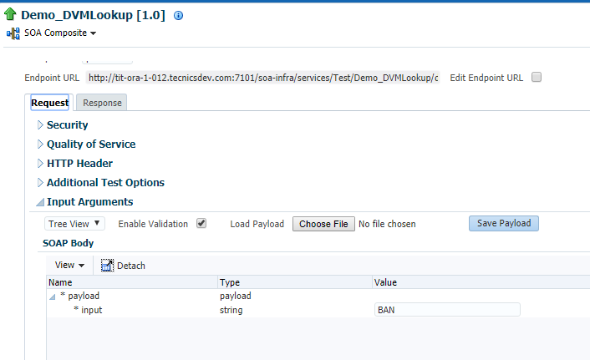

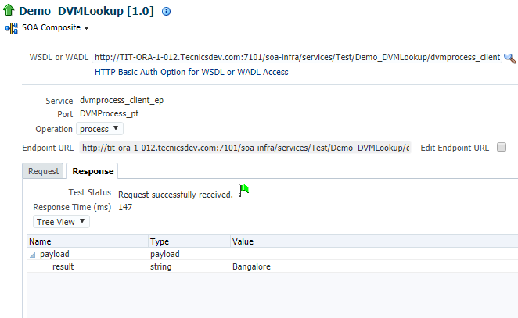

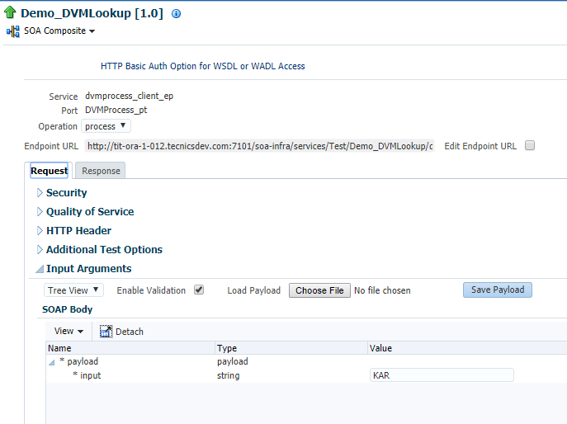

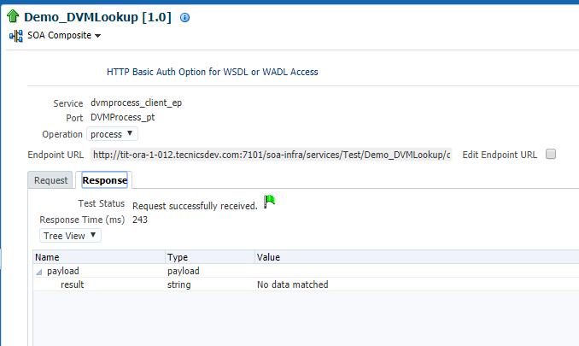



### Use Domain Value Map Functions in Transformations

The domain value map functions can be used for transformations with a BPEL process service component or an Oracle Mediator service component. Transformations are performed by using the XSLT Mapper, which is displayed when you create an XSL file to transform the data from one XML schema to another.

For information about the XSLT Mapper, see [Chapter 37, "Creating Transformations with the XSLT Mapper."](https://docs.oracle.com/cd/E25054_01/dev.1111/e10224/bp_xslt_mpr.htm#CIHCCGFJ)

**To use the lookupValue1M function in a transformation:**

1. In the Application Navigator, double-click an XSL file to open the XSLT Mapper.
2. In the XSLT Mapper, expand the trees in the **Source** and **Target** panes.
3. In the Component Palette, click the down arrow, and then select **Advanced**.
4. Select **DVM Functions**, as shown in [Figure 44-4](https://docs.oracle.com/cd/E25054_01/dev.1111/e10224/med_dvm.htm#CACGFCAA).

***Figure 44-4 Domain Value Map Functions in the Component Palette***

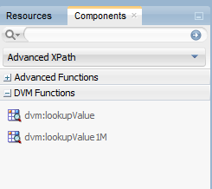

1. Drag and drop **lookupValue1M** onto the line that connects the source to the target.

A **dvm:lookupValue1M** icon appears on the connecting line.

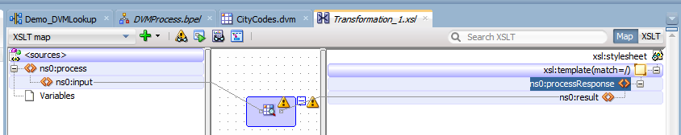

1. Double-click the **lookupValue1M** icon.

The Edit Function – lookupValue1M dialog is displayed, as shown in [Figure 44-5](https://docs.oracle.com/cd/E25054_01/dev.1111/e10224/med_dvm.htm#CACIFFJI).

***Figure 44-5 Edit Function – lookupValue1M Dialog***

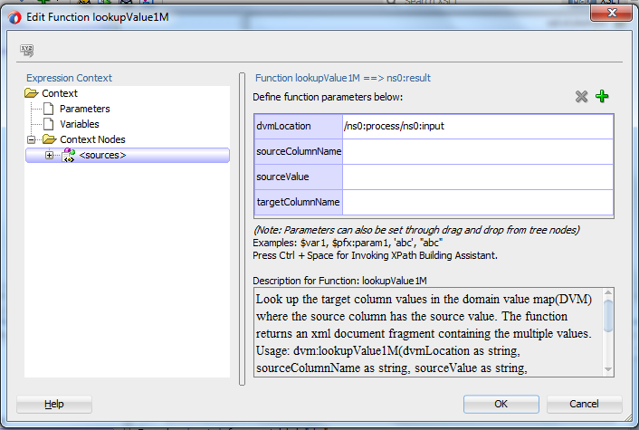

Specify values for the following fields in the Edit Function – lookupValue1M dialog:

1. In the **dvmLocation** field, enter the location URI of the domain value map file or click **Browse** to the right of the **dvmLocation** field to select a domain value map file. You can select an already deployed domain value map from the metadata service (MDS) and also from the shared location in MDS. This can be done by selecting the Resource Palette.
2. In the **sourceColumnName** field, enter the name of the domain value map column that is associated with the source element value, or click **Browse** to select a column name from the columns defined for the domain value map you previously selected.
3. In the **sourceValue** field, enter a value or press **Ctrl-Space** to use the XPath Building Assistant. Press the up and down arrow keys to locate an object in the list, and press **Enter** to select an item.
4. In the **targetColumnName** field, enter the name of the domain value map column that is associated with the target element value, or click **Browse** to select the name from the columns defined for the domain value map you previously selected.
5. Click **Add** to add another column as the target column and then enter the name of the column.

A populated Edit Function - lookupValue1M dialog is shown in Figure.

***Figure 44-6 Populated Edit Function – lookupValue1M Dialog***

