E-COMMERCE WEB APPLICATION
MANUAL QA TEST REPORT
Functional, Negative & Boundary Testing

Tester | Nasira
Application | nopCommerce Demo Store
Testing Type | Manual Functional Testing
Test Area | User Registration

1. Project Overview
This project demonstrates manual quality assurance testing of an e-commerce web application. The objective is to evaluate core registration functionality, validate user input handling, execute positive and negative test scenarios, perform boundary-value testing, and document test results using industry-style QA artifacts.

2. Testing Objectives
- Validate successful user registration.
- Verify required-field validation.
- Verify invalid email handling.
- Validate password length requirements.
- Perform boundary-value testing around the minimum password length.
- Verify password confirmation behavior.
- Capture objective test evidence.
- Document expected and actual results.

3. Test Scope
The current test cycle focuses on the User Registration workflow, including:
- Valid registration
- Required-field validation
- Invalid email format
- Password minimum-length validation
- Minimum valid password boundary
- Password confirmation mismatch

4. Test Environment
Application | nopCommerce Demo Store
Test Type | Manual Functional Testing
Test Method | Positive, Negative & Boundary Testing
Browser | Chrome

5. Test Execution Summary
Test ID | Test Case | Expected | Actual | Status
TC-REG-001 | Successful User Registration | Registration succeeds | Registration completed successfully | PASS
TC-REG-002 | Required Field Validation | Validation prevents submission | Validation errors displayed | PASS
TC-REG-003 | Invalid Email Format | Invalid email rejected | Invalid email rejected with validation message | PASS
TC-REG-004 | Password Below Minimum Length | Password rejected | Password rejected with 6–64 character rule | PASS
TC-REG-005 | Minimum Valid Password | 6-character password accepted | Registration completed successfully | PASS
TC-REG-006 | Password Confirmation Mismatch | Mismatched passwords rejected | Mismatch validation displayed | PASS
Total Tests Executed: 6 | Passed: 6 | Failed: 0 | Pending: 0

6. Detailed Test Cases & Evidence

TC-REG-001 — Successful User Registration
Objective: Verify that a new user can successfully register using valid information.
Preconditions: User is not logged in and a unique email address is available.
Test Data: Valid first name, last name, unique email, valid password, matching confirmation password.
Test Steps:
- Navigate to the registration page.
- Enter valid first and last name.
- Enter a unique valid email address.
- Enter a valid password.
- Confirm the password.
- Click Register.
Expected Result: The user should be successfully registered.
Actual Result: The user registration completed successfully.
Status: PASS
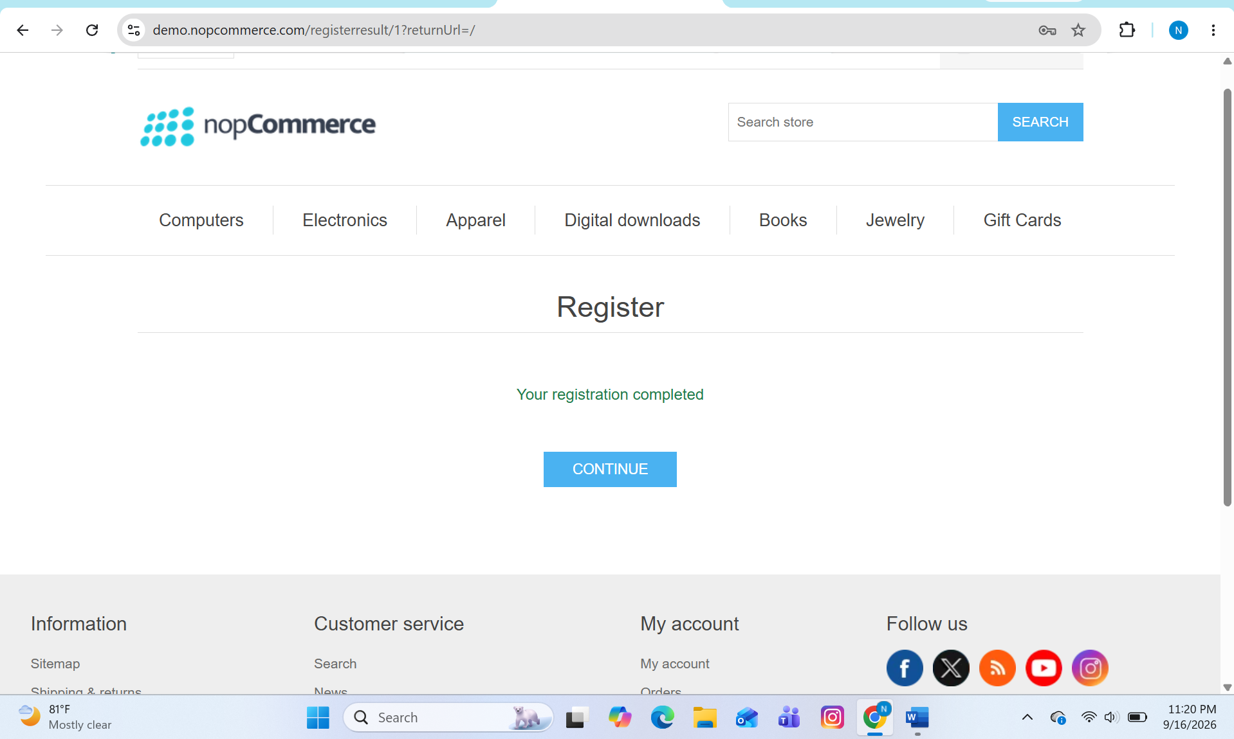

TC-REG-002 — Required Field Validation
Objective: Verify that registration cannot be completed when required fields are empty.
Preconditions: User is on the registration page.
Test Data: All required fields left blank.
Test Steps:
- Navigate to the registration page.
- Leave all required fields blank.
- Click Register.
Expected Result: Registration should be prevented and validation messages should be displayed for required fields.
Actual Result: The application prevented registration and displayed validation errors.
Status: PASS

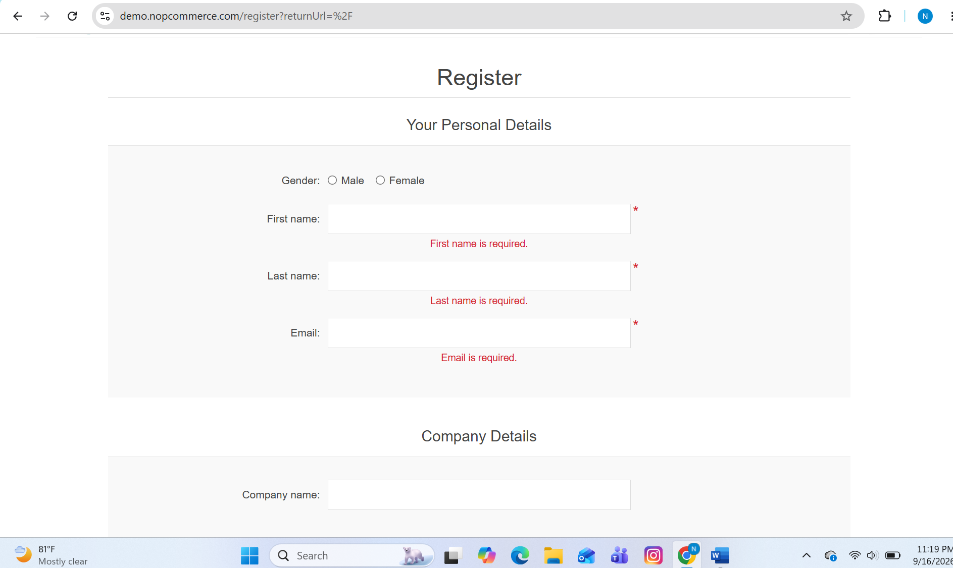
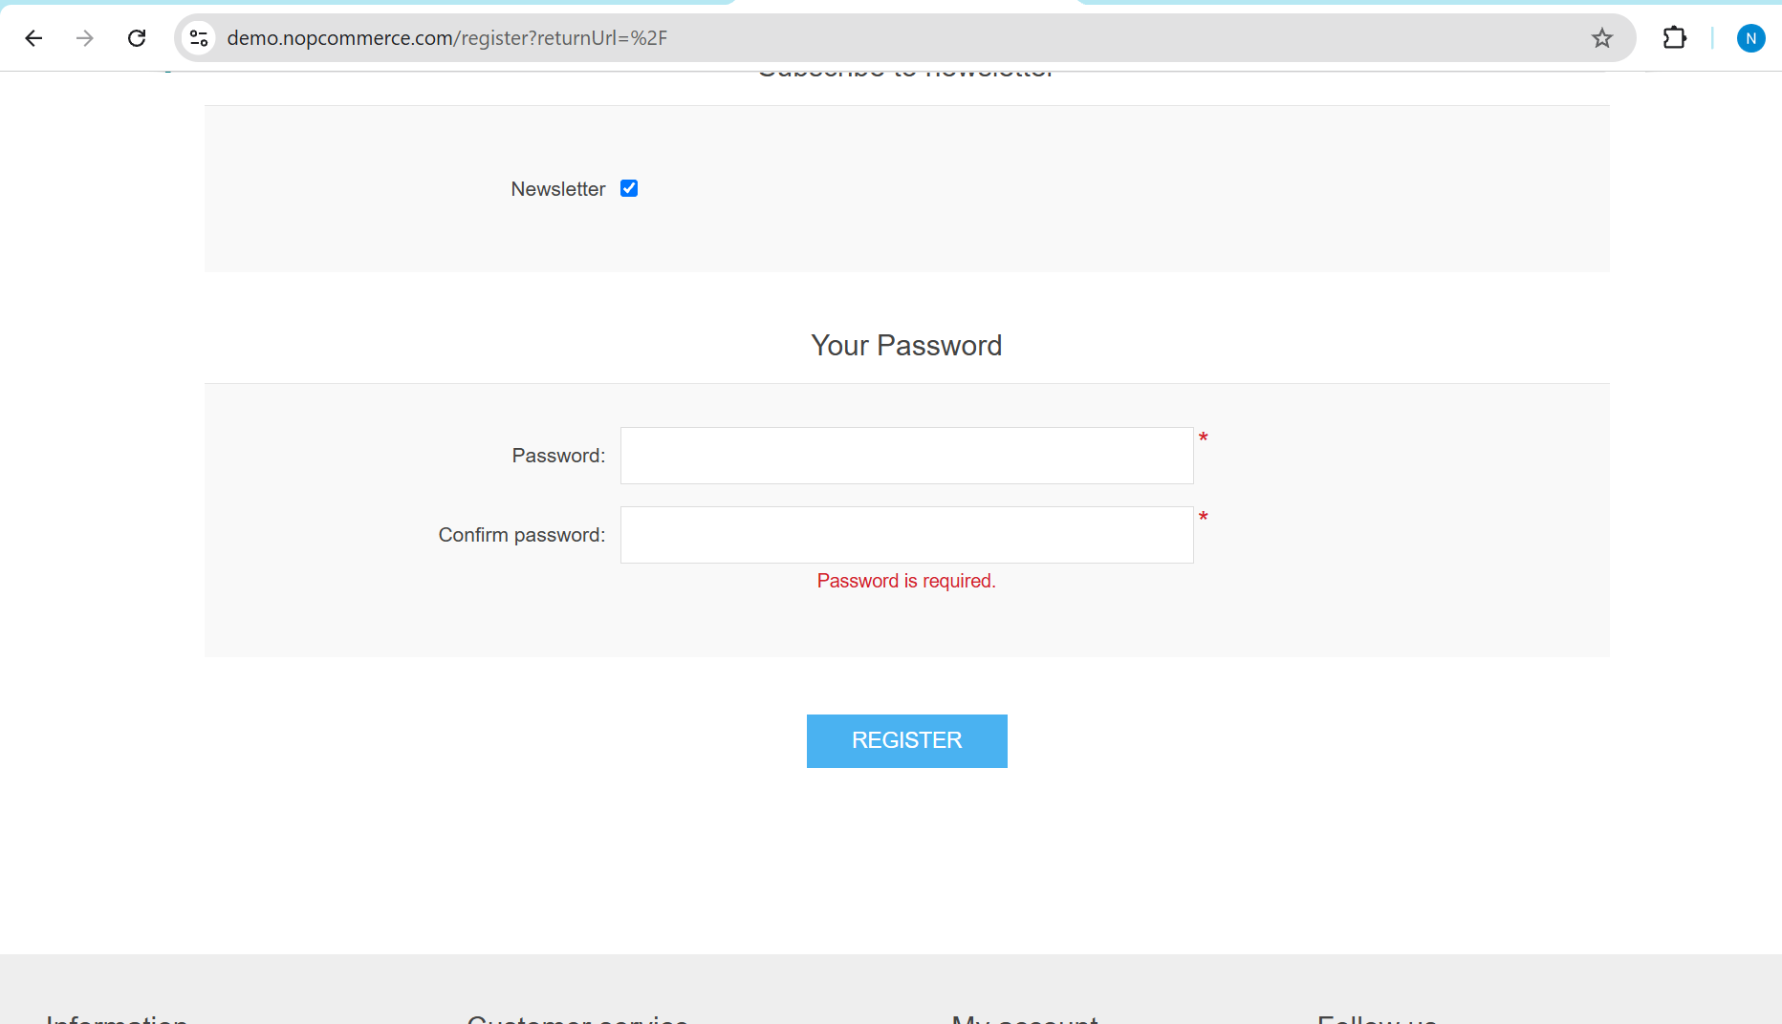

TC-REG-003 — Invalid Email Format
Objective: Verify that the application rejects an invalid email address.
Preconditions: User is on the registration page.
Test Data: Email: qa-test
Test Steps:
- Enter valid information in the required fields.
- Enter qa-test in the email field.
- Click Register.
Expected Result: The application should reject the invalid email format and display an appropriate validation message.
Actual Result: The application rejected the invalid email address and displayed: “Please enter a valid email address.”
Status: PASS

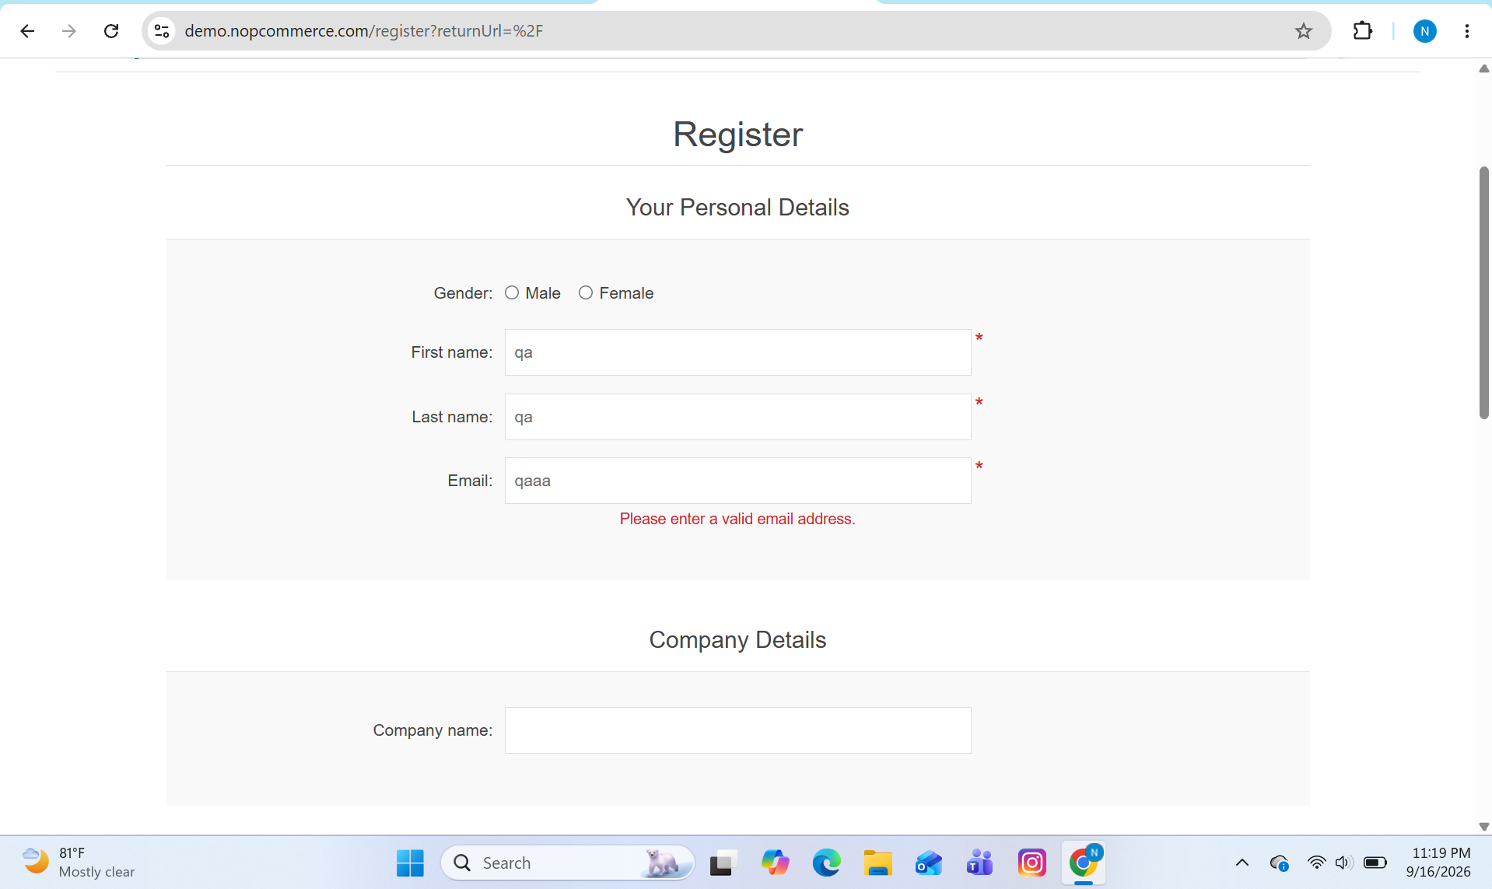

TC-REG-004 — Password Below Minimum Length
Objective: Verify that passwords shorter than the minimum required length are rejected.
Preconditions: User is on the registration page.
Test Data: Password: 123; Confirmation: 123
Test Steps:
- Enter valid registration information.
- Enter 123 as the password.
- Enter 123 as the confirmation password.
- Submit the form.
Expected Result: The application should reject the password because it does not meet the minimum length requirement.
Actual Result: The application rejected the password and displayed: “Password must meet the following rules: must have at least 6 characters and not greater than 64 characters.”
Status: PASS
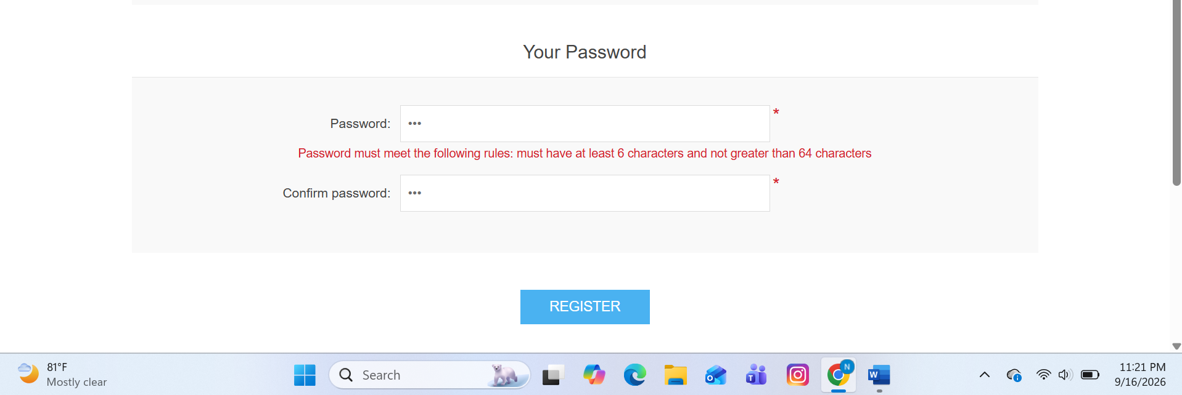

TC-REG-005 — Minimum Valid Password
Objective: Verify that a password containing exactly six characters is accepted.
Preconditions: User is on the registration page.
Test Data: Password: 123456; Confirmation: 123456
Test Steps:
- Enter valid registration information.
- Enter 123456 as the password.
- Enter 123456 as the confirmation password.
- Submit the registration form.
Expected Result: A six-character password should be accepted because the application specifies a minimum length of six characters.
Actual Result: The six-character password was accepted and registration completed successfully.
Status: PASS

TC-REG-006 — Password Confirmation Mismatch
Objective: Verify that registration is prevented when the password and confirmation password do not match.
Preconditions: User is on the registration page.
Test Data: Password: 123456; Confirmation: 123457
Test Steps:
- Enter valid registration information.
- Enter 123456 as the password.
- Enter 123457 as the confirmation password.
- Submit the registration form.
Expected Result: Registration should be prevented and an appropriate password mismatch validation message should be displayed.
Actual Result: The application prevented registration and displayed: “The password and confirmation password do not match.”
Status: PASS
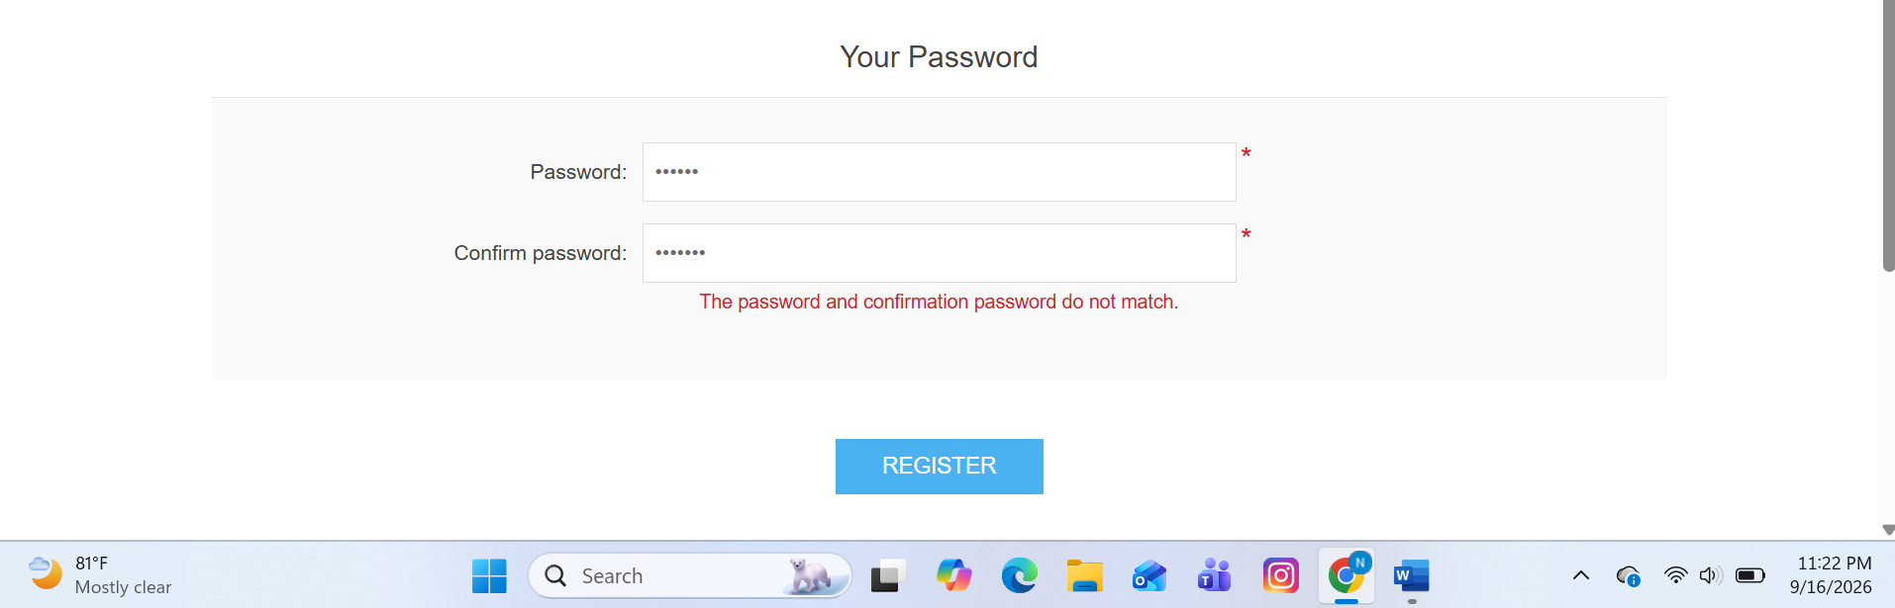

7. Key Findings
The registration workflow successfully handled the six executed positive, negative, and boundary test scenarios. Validation behavior observed during execution was consistent with the expected requirements for required fields, email format, password length, and password confirmation.

8. Test Completion Summary
Six registration test cases were executed during the current test cycle. All six tests passed. No defects were identified within the scenarios executed during this cycle.

9. QA Notes
- Test results reflect behavior observed during the testing session.
- Screenshots should be inserted into the evidence sections above.
- Additional testing should be performed for login, product search, shopping cart, checkout, and exploratory scenarios.
- Future test cycles can include regression testing after any application changes.

10. Evidence File Naming Convention
Recommended screenshot names:
- TC-REG-001-successful-registration.png
- TC-REG-002-required-field-validation.png
- TC-REG-003-invalid-email.png
- TC-REG-004-password-validation.png
- TC-REG-005-minimum-password.png
- TC-REG-006-password-mismatch.png

