Cyber Abuse Detection using Machine Learning for Roman Urdu
Software Requirements Specification

Version 1.0



Group Id: S25PROJECT3AA42
Student Id: BC200405041
Supervisor Name : Tayyab Waqar

Revision History

Date (dd/mm/yyyy) | Version | Description | Author
10/05/2025 | 1.0 | This Software Requirements Specification (SRS) document outlines the scope, functional and non-functional requirements, and methodology for the project. It includes use case diagrams, usage scenarios, and an analysis of the adopted software development methodologies such as the VU Process-Model, Spiral Model, and Waterfall Model. Additionally, the document provides a detailed work plan to ensure proper implementation and timely completion of the project. The structured approach will guide the project’s development lifecycle, ensuring all requirements are met efficiently. | BC200405041

Table of Contents

Scope of Project: 4
Functional and non Functional Requirements: 5
Functional Requirements 5
Non-Functional Requirements 6
Use Case Diagram(s): 7
Usage Scenarios: 8
Use Case ID: UC01 – Collect Data 8
Use Case ID: UC02 – Label Data 9
Use Case ID: UC03 – Pre-process Data 9
Use Case ID: UC04 – Extract Features 9
Use Case ID: UC05 – Train Model 10
Use Case ID: UC06 – Test Model 10
Use Case ID: UC07 – Deploy Web Interface 11
Use Case ID: UC08 – Evaluate Model Performance 11
Adopted Methodology 11
VU Process Model 12
Spiral Model: 14
Waterfall Model 14
Work Plan 16

SRS Document

Scope of Project:

The scope of the "Cyber Abuse Detection using Machine Learning for Roman Urdu" project revolves around developing an efficient system that detects cyber abuse in Roman Urdu text from social media platforms. The primary goal is to create a machine learning-based model that can accurately classify comments as either "Abusive" or "Non-Abusive" using natural language processing (NLP) techniques. This system will help in the early detection and moderation of harmful content, which is increasingly prevalent in online spaces.
Data collection, preparation, and pre-processing form a crucial part of the project's scope. The student will collect a custom dataset of at least 5,000 comments in Roman Urdu, ensuring a diverse representation of both abusive and non-abusive language. After collecting the data, it will undergo labeling, cleaning, and pre-processing to ensure it is ready for machine learning. This includes handling missing values, removing duplicates, and normalizing the data. Feature extraction will then transform the textual data into a structured format that machine learning models can work with, using methods like TF-IDF, Bag of Words, or Word Embeddings.
The machine learning aspect of the project will involve selecting and implementing multiple classification models to detect cyber abuse. The models will be evaluated based on metrics such as accuracy, precision, recall, F1-score, and confusion matrices to compare their effectiveness. The project will also require an analysis of the most suitable machine learning algorithm for the task, considering factors such as the informal nature of Roman Urdu and its contextual variations.
Finally, the project will extend beyond the model development phase to include a web interface. This interface will allow users to input real-time comments and evaluate the model’s performance in detecting cyber abuse. The web interface will be developed using Flask or Django, enabling users to interact with the model through a simple HTML/CSS frontend. This addition ensures that the system is user-friendly and can be practically applied in real-world scenarios to detect and manage online abuse.

Functional and non Functional Requirements:

Functional Requirements
The functional requirements of the "Cyber Abuse Detection using Machine Learning for Roman Urdu" system outline the essential features and tasks that the system must be able to perform. These requirements ensure that the system meets its intended purpose and can function effectively in real-world scenarios.
- Data Collection
  - The system must allow the collection of a custom dataset of at least 5,000 comments from social media platforms (e.g., Facebook, Twitter, YouTube, or Instagram).
  - The dataset must focus specifically on Roman Urdu, as this is the primary language for the detection of cyber abuse.
  - The student will be responsible for ensuring that the dataset is original and not taken from pre-existing repositories.
- Data Labeling
  - Each collected comment must be labeled manually as either "Abusive (A)" or "Non-Abusive (NA)".
  - This step requires a review of each comment to ensure the labels are correct and align with the context of the text.
- Data Pre-Processing
  - The system must handle the cleaning of the data, which involves:
    - Identifying and addressing missing values (either by removal or imputation).
    - Removing duplicate entries to avoid bias in the data.
    - Identifying and eliminating noise or outliers that could affect the model’s performance.
    - Normalizing the text and removing stop words to improve model accuracy.
- Feature Extraction
  - The system must employ feature extraction techniques to convert the textual data into a numerical format that machine learning models can process.
  - Techniques such as Term Frequency-Inverse Document Frequency (TF-IDF), Bag of Words, or Word Embeddings (Word2Vec, FastText, GloVe) should be applied.
  - The student must justify the chosen method for feature extraction based on its suitability for Roman Urdu text.
- Model Training and Testing
  - The dataset will be split into training (75%) and testing (25%) subsets.
  - The system must be capable of training multiple machine learning models, including classifiers such as Naïve Bayes, Support Vector Machine (SVM), Decision Tree, and Random Forest.
  - The system should evaluate these models using the confusion matrix and other evaluation metrics (accuracy, precision, recall, F1-score).
- Evaluation of Model Performance
  - For each model, the system must generate a confusion matrix and evaluate its performance based on metrics like True Positives (TP), True Negatives (TN), False Positives (FP), and False Negatives (FN).
  - The system should compare the models to determine which is the most effective at detecting cyber abuse in Roman Urdu.
- Real-Time Web Interface
  - The system must provide a user-friendly web interface where users can input Roman Urdu comments and receive immediate classification (Abusive or Non-Abusive).
  - The interface will be integrated with the trained machine learning models and must function in real time to give immediate feedback.
  - The system should be able to run the classification process without significant delay.

Non-Functional Requirements
Non-functional requirements define the overall quality attributes and constraints of the system. These are essential to ensure that the system is efficient, reliable, and scalable.
- Performance
  - The system must provide near-instant classification results for input comments, ensuring minimal delay for real-time feedback.
  - The machine learning models should be optimized for speed and efficiency, allowing for fast processing even with large datasets.
- Scalability
  - The system should be designed to handle an increasing volume of data over time, allowing additional comments to be added to the dataset for further training.
  - As more users interact with the web interface, the system should scale to accommodate increasing traffic and requests without performance degradation.
- Usability
  - The web interface must be intuitive and easy to navigate, with a clean and simple design for users to input comments and view results.
  - The user experience should be smooth, with clear instructions and appropriate error handling in case of invalid inputs.
- Security
  - The system must ensure that any data collected from users is handled securely and in accordance with privacy regulations.
  - It should also prevent unauthorized access to the model and user input data, ensuring the integrity and confidentiality of the system.
- Reliability
  - The system must be reliable, with minimal downtime or errors during operation. It should be able to classify comments accurately and consistently.
  - The system should have an error-handling mechanism to manage unexpected failures, ensuring smooth user interaction even in the event of occasional issues.

Use Case Diagram(s):
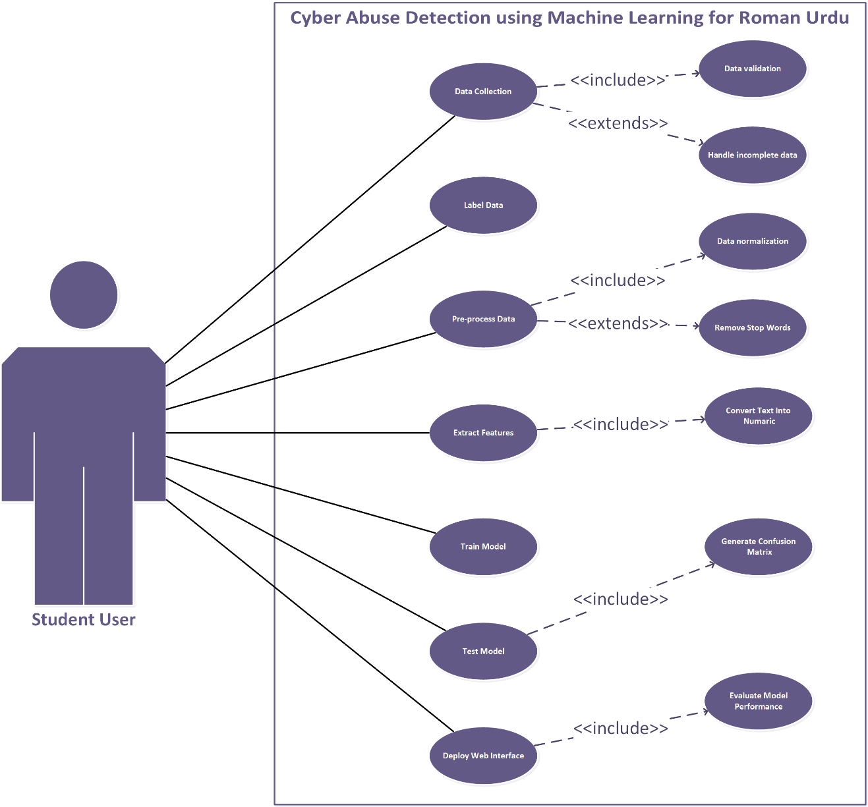

Usage Scenarios:

Use Case ID: UC01 – Collect Data

Heading | Description
Use Case Title | Collect Data
Actor | Student User
Actions | Student collects Roman Urdu comments from social media platforms manually.
Description | In this use case, the Student gathers a dataset of 5,000 Roman Urdu comments.
Alternative Paths | Use different platforms (YouTube, Facebook, etc.) if one fails.
Pre-Conditions | Access to social media platforms and appropriate tools to collect comments.
Post-Conditions | A raw dataset in Roman Urdu is available for further processing.
Exceptions | Incomplete or non-Roman Urdu data; connectivity issues during data collection.
Author | BC200405041

Use Case ID: UC02 – Label Data

Heading | Description
Use Case Title | Label Data
Actor | Student User
Actions | Manually assign labels ("Abusive" or "Non-Abusive") to each comment.
Description | Student reviews the dataset and labels each entry based on its content.
Alternative Paths | Use a basic keyword filter as a temporary support to assist labeling.
Pre-Conditions | Raw dataset must be available and understandable.
Post-Conditions | A clean, labeled dataset ready for machine learning.
Exceptions | Ambiguous comments that are hard to classify; human error during labeling.
Author | BC200405041

Use Case ID: UC03 – Pre-process Data

Heading | Description
Use Case Title | Pre-process Data
Actor | Student User
Actions | Clean data by removing duplicates, handling missing values, normalizing text.
Description | Student applies preprocessing to prepare data for feature extraction.
Alternative Paths | Use different strategies for handling missing values (fill/remove).
Pre-Conditions | Labeled dataset is available.
Post-Conditions | Cleaned and normalized dataset is ready.
Exceptions | Errors during preprocessing scripts; unhandled encoding issues.
Author | BC200405041

Use Case ID: UC04 – Extract Features

Heading | Description
Use Case Title | Extract Features
Actor | Student User
Actions | Apply TF-IDF, BoW, or Word Embeddings to convert text to vectors.
Description | Transform preprocessed text data into machine-readable format using selected techniques.
Alternative Paths | Try alternative methods like n-grams or FastText if initial method is ineffective.
Pre-Conditions | Cleaned and normalized dataset available.
Post-Conditions | Feature matrix created for model training.
Exceptions | Dimensionality explosion; memory issues with large feature sets.
Author | BC200405041

Use Case ID: UC05 – Train Model

Heading | Description
Use Case Title | Train Model
Actor | Student User
Actions | Select ML models and train them using the training dataset.
Description | Student chooses algorithms and trains models for abuse detection.
Alternative Paths | Apply cross-validation or grid search for tuning.
Pre-Conditions | Feature set and labels prepared.
Post-Conditions | Trained ML models are stored and ready for testing.
Exceptions | Overfitting, underfitting, or training interruptions.
Author | BC200405041

Use Case ID: UC06 – Test Model

Heading | Description
Use Case Title | Test Model
Actor | Student User
Actions | Evaluate models using testing dataset; generate confusion matrix.
Description | Student tests models and assesses performance using key metrics.
Alternative Paths | Use different test sets or cross-validation.
Pre-Conditions | Trained models available.
Post-Conditions | Performance metrics for each model generated.
Exceptions | Low test accuracy; mislabeled or skewed data leading to false results.
Author | BC200405041

Use Case ID: UC07 – Deploy Web Interface

Heading | Description
Use Case Title | Deploy Web Interface
Actor | Student User
Actions | Create frontend and backend interface for real-time comment classification.
Description | Student integrates model with Flask/Django and provides input/output UI.
Alternative Paths | Switch between Flask or Django based on ease.
Pre-Conditions | Final trained model and UI mockups available.
Post-Conditions | A working web app capable of classifying live user comments.
Exceptions | Server errors, integration bugs, model loading issues.
Author | BC200405041

Use Case ID: UC08 – Evaluate Model Performance

Heading | Description
Use Case Title | Evaluate Model Performance
Actor | Student User
Actions | Compare metrics (accuracy, precision, etc.) and select best model.
Description | Student analyses test results to determine the most effective algorithm.
Alternative Paths | Perform more fine-tuning on poorly performing models.
Pre-Conditions | Results from model testing available.
Post-Conditions | Final model selected for deployment.
Exceptions | Confusion in interpretation; inconsistent test metrics across models.
Author | BC200405041

Adopted Methodology

Water Fall Model and Spiral Model are two models which are combined to each other and make VU Process Model. It is also called hybrid approach of system development. This Process model takes advantages and minimizes the drawbacks of both approaches. This is a linear model to solve many problems.
REASONS FOR CHOSEN METHODOLOGY
Following are the basic reasons for choosing VU Process Model for our project.
- Testing is inherent to every phase
- It is an enforced disciplined approach because to having stage development cycle and every phase has defined start and end date.
- It is documentation driven which means documentation is produced at every stage.
- Emphasis on requirement and design before writing code ensure minimal wastage of time and efforts.
- Our project is divided into different phases which we have to complete in sequence and submit to our supervisor.
- If some mistakes are found than he suggest us to correct those mistakes and improve our project.
- This process will be adopted due to its spiral nature.

VU Process Model

VU PROCESS MODEL The adopted methodology is VU Process Model which is a combination of Waterfall and Spiral Model.

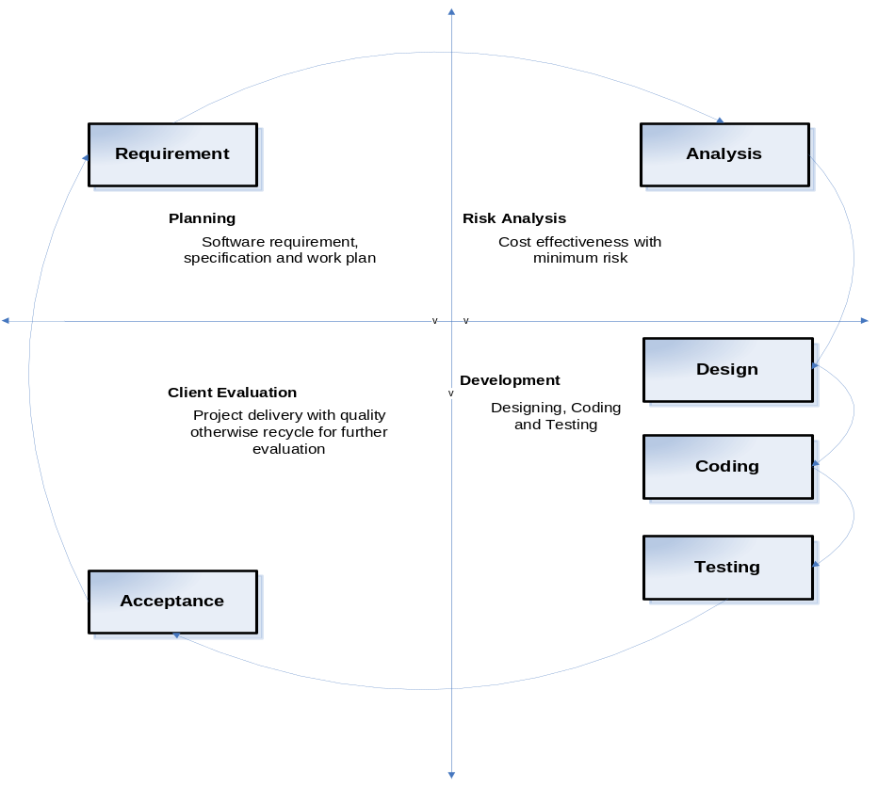

STRUCTURE OF VU PROCESS MODEL

It has four phases and which are Gathering and analyzing requirement, planning, analysis and design, development and final report

1. Gathering & Analyzing Requirement: In this phase we gathered information regarding functional and non- functional requirements of our Project and also prepared Use case diagrams to understand Actors and Uses cases of project and develop usages scenario diagrams to understand all those situations which will come across while using this applications
2. Planning Phase: In this phase we adopted methodology to complete the project different Phase also prepared the Schedule using Gant chart to know which phase will be completed in how many days.
3. Analysis and Design Phase: In this phase consist of two design documents. In Design document 1, we will develop the Activity Diagram, Sequence diagrams, Collaboration Diagram, Architecture Design Diagram and DFD diagram. And Design document II we develop the Object model, Class diagram, interface design, database design, test cases, Deployment diagram and Component diagram.
4. Development & Final Project Report: In this phase we will write necessary code for implementation of our application. Coding will be completed in iterations.

Spiral Model:

The spiral model is a risk-driven process model generator for software projects. Based on the unique risk patterns of a given project, the spiral model guides a team to adopt elements of one or more process models, such as waterfall. It combines the idea of iterative development with the systematic, controlled aspects of the waterfall model. It is a combination of iterative development process model and sequential linear development model i.e. the waterfall model with a very high emphasis on risk analysis. It allows incremental releases of the product or incremental refinement through each iteration around the spiral

Diagram of Spiral Model
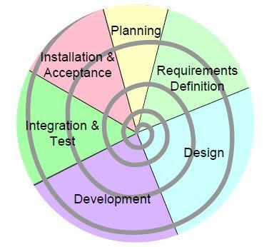

Waterfall Model

The Waterfall Model was the first Process Model to be introduced. It is also referred to as a linear-sequential life cycle model. It illustrates the software development process in a linear sequential flow. It is very simple to understand and use. In a waterfall model, each phase must be completed before the next phase can begin and there is no overlapping in the phases. The Waterfall model is the earliest SDLC approach that was used for software development.
This means that any phase in the development process begins only if the previous phase is complete. In this waterfall model, the phases do not overlap.
The waterfall model is a sequential (non-iterative) design process, used in software development processes, in which progress is seen as flowing steadily downwards (like a waterfall) through the phases of conception, initiation, analysis, design, construction, testing, production/implementation and maintenance. Despite the development of new software development process models, the Waterfall method is still the dominant process model with over a third of software developers still using it.

This model is depicted in the following diagram.

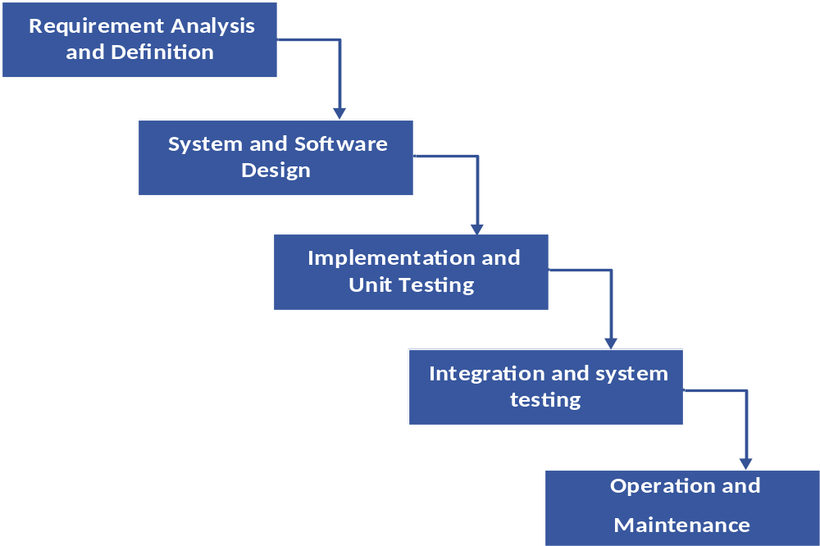

Work Plan

The work plan is a document that consulting firms use to organize a project. It outlines the plan by which the company plans to complete a quality project within a given amount of time and in compliance with a set budget.
Gantt charts are useful tools for planning and scheduling projects. They allow you to assess how long a project should take, determine the resources needed and layout the order in which tasks need to be carried out. They are useful in managing the dependencies between tasks.

