

Online shoping

Group Member: Nasir Ali



**ER-Diagram**

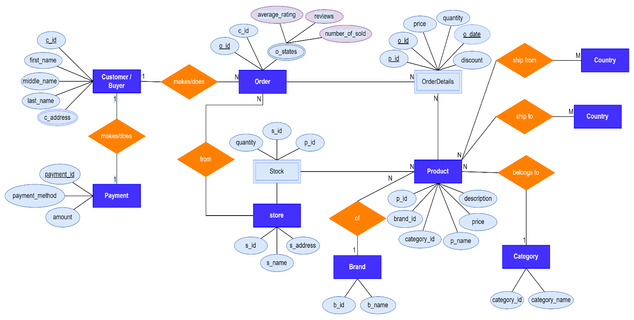

**Schema**

|  |
| --- |
| DROP DATABASE IF EXISTS dbms_project_online_shoping;  CREATE DATABASE dbms_project_online_shoping;  USE dbms_project_online_shoping;  SHOW TABLES;  -- -------------------  -- Customers  -- -------------------  CREATE TABLE customers  (c_id int(20) NOT NULL UNIQUE auto_increment,  first_name varchar(15),  middle_name varchar(15),  last_name varchar(15),  c_address varchar(100),  PRIMARY KEY(c_id)  );  -- -------------------  -- Ordes  -- -------------------  CREATE TABLE orders  (o_id int(20) NOT NULL UNIQUE auto_increment,  c_id int(20) NOT NULL,  PRIMARY KEY(o_id),  FOREIGN KEY(c_id) REFERENCES customers(c_id)  );  -- -------------------  -- Category  -- -------------------  CREATE TABLE categories  (category_id int(10) NOT NULL UNIQUE auto_increment,  category_name varchar(20) NOT NULL UNIQUE,  PRIMARY KEY(category_id)  );  -- -------------------  -- Brands  -- -------------------  CREATE TABLE brands  (b_id int(10) NOT NULL UNIQUE auto_increment,  b_name varchar(20) NOT NULL UNIQUE,  PRIMARY KEY(b_id)  );  -- -------------------  -- Products  -- -------------------  CREATE TABLE products  (p_id int(30) NOT NULL UNIQUE auto_increment,  b_id int(10) NOT NULL,  category_id int(5) NOT NULL,  p_name varchar(20),  price numeric(10,2),  desc_ varchar(100),  PRIMARY KEY(p_id),  FOREIGN KEY(b_id) REFERENCES brands(b_id),  FOREIGN KEY(category_id) REFERENCES categories(category_id)  );    -- -------------------  -- Stores  -- -------------------  CREATE TABLE stores  (store_id int(20) NOT NULL auto_increment,  store_name varchar(70) NOT NULL UNIQUE,  PRIMARY KEY(store_id)  );  -- -------------------  -- Order Details  -- -------------------  CREATE TABLE order_details  (p_id int(3) NOT NULL,  o_id int(20) NOT NULL,  o_date date NOT NULL,  price numeric(10,2),  discount int NOT NULL CHECK (discount BETWEEN 1 and 100),  PRIMARY KEY(p_id, o_id, o_date)  );  -- DESCRIBE order_details;  -- -------------------  -- Stock  -- -------------------  CREATE TABLE stock  (stock_id int(20) NOT NULL auto_increment,  p_id int(30) NOT NULL,  quantity int(20),  PRIMARY KEY(stock_id),  FOREIGN KEY(p_id) REFERENCES products(p_id)  );  -- SHOW TABLES;    -- Inserting Data into Categories  INSERT INTO categories  VALUES  (1,"Laptop"),  (2, "Phone"),  (3, "Camera"),  (4, "Watch");    -- Inserting data into brands  INSERT INTO brands  VALUES  (1,"Xiaomi"),  (2, "iPhone"),  (3, "Samsung"),  (4, "Sony");  -- Inserting data into products  INSERT INTO products  VALUES  (1,1,2,"Samsung S7", 90000, "None"),  (2,1,2,"Samsung S5", 40000, "None"),  (3,2,1,"MacBook Air", 100000, "None");  -- Inserting data into customers  INSERT INTO customers  VALUES  (1,"Aslam", "Ali", "Khan", "Azizabad, Khan Road, Sukkur");  INSERT INTO customers(first_name, middle_name, last_name, c_address)  VALUES  ("Shoaib", "Ali", "Rana", "Military Road, Sukkur"),  ("Ali", "Hyder", "Shaikh", "Military Road, Sukkur");  -- Inserting data into orders  SELECT * FROM orders;  SELECT * FROM categories; |