What is the 12-Factor App?

The 12-Factor App is not a tool.
It is a set of principles for building modern, cloud-native applications.

Goal:
App jo:
- easily deploy ho
- easily scale ho
- easily maintain ho
- environment change se na tootay.
Agar app 12-factor follow karti hai → DevOps friendly hoti hai.

12-Factor App = rules for making apps behave well in the cloud
Cloud ko pasand hai:
- Automation
- stateless systems
- Repeatability
- fast scaling
12-Factor app ye sab ensure karti hai.

All 12 Factors
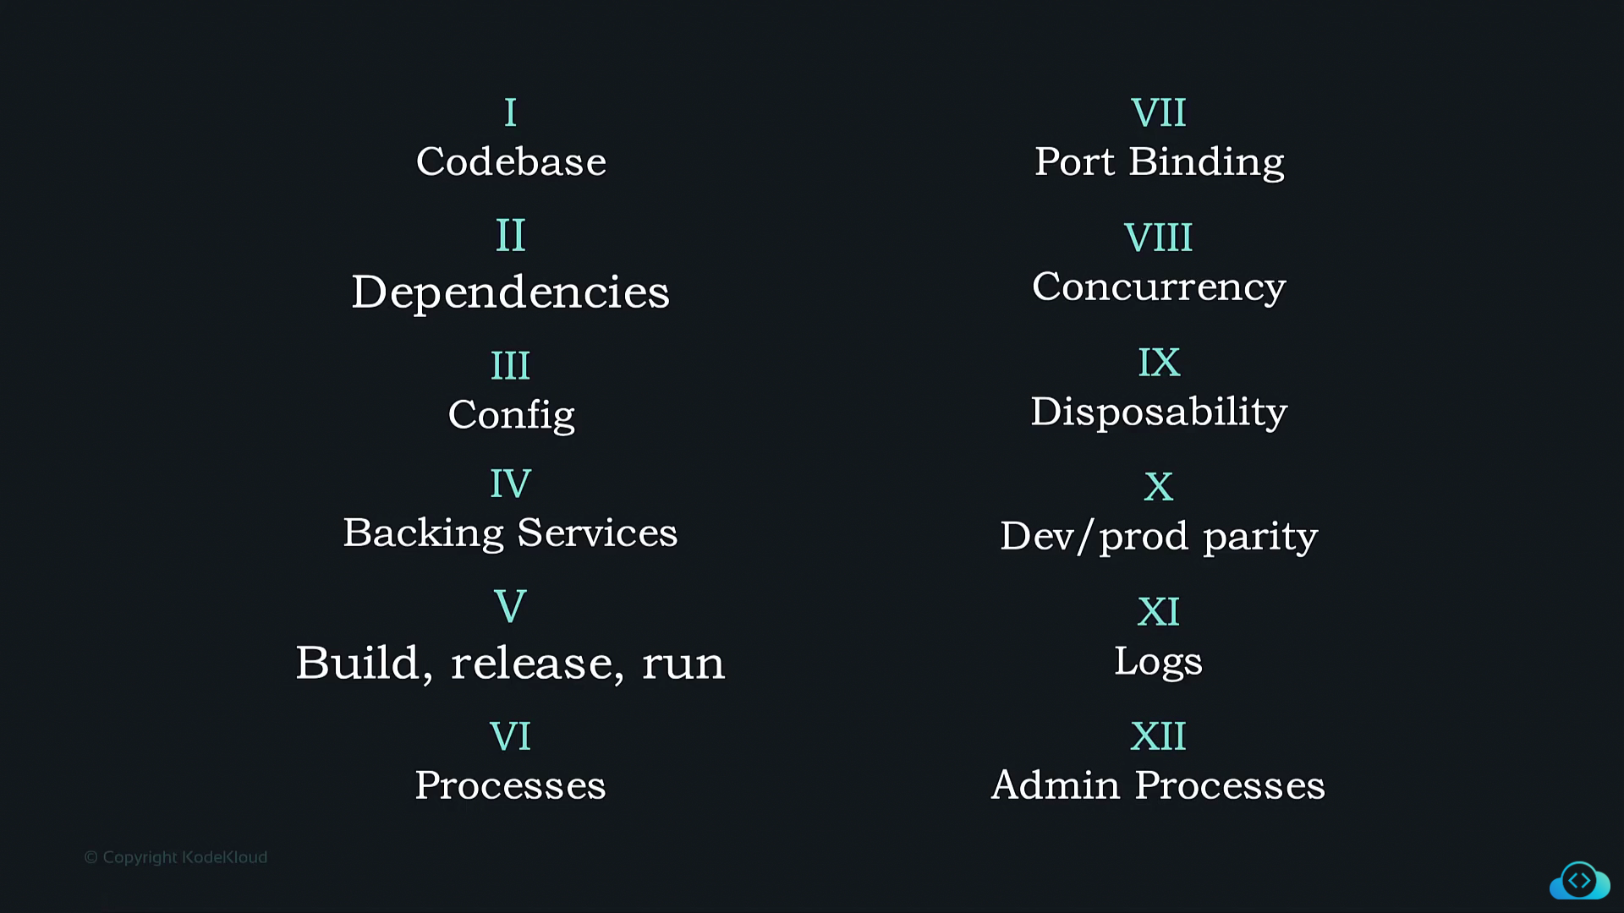

- Codebase — One App, One Codebase

Each app must have one codebase, tracked in one version control system (Git).

Multiple environments (dev, staging, prod)
same code, different configs.

Real-World Example
- One GitHub repo
- Same code runs in:
- Dev
- Staging
- Production

Wrong
- One repo, multiple apps inside
- Or one app copied into many folders

Right
- One repo = one app
- Env difference handled via config

One app = one brain (codebase)

- Dependencies — Declare Everything Explicitly

Your app must explicitly declare all dependencies.
No “it works on my machine” nonsense.

Real-World Example
- Python → requirements.txt
- Node → package.json
- Docker → everything baked into image

Exact versions declared.
App runs same everywhere.
App apni zindagi khud le kar aaye.

- Config — Store Config in Environment Variables

Config = anything that changes per environment.

Examples:
- DB URL
- API keys
- Secrets

Wrong:
- Hard-coding configs in code
- Separate config files per env

Right:
- Environment variables only

Code stays same, environment speaks differently

- Backing Services — Treat Them as Attached Resources

Databases, caches, queues → are external services.

App should not care:
- Where they run
- Who provides them

Real-World Example
Today:
- Local MySQL
Tomorrow:
- AWS RDS

App code remain unchanged.

DB is a plug __ unplug, replace, continue

- Build, Release, Run — Strict Separation

