

ASSIGNMENT # 1

**SCD**



**AHMAD ALI ->BSE193044**

**NASIR NIAZ -> BSE193078**

**TALAL ANSAR -> BSE193145**

**Question 1:**

Control structures are programming blocks that can change the path we take through those instructions.

There are three kinds of control structures:

**1. Conditional Branches**, which we use for choosing between two or more paths. Types in Java:

**If/else/else if**:

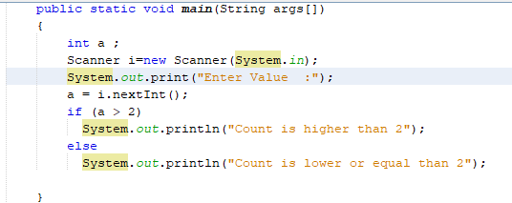

**Switch:**

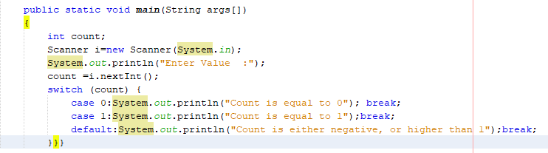

**2. Loops** that are used to iterate through multiple values/objects and repeatedly run specific code blocks. The basic loop types in Java are for, while and do while.

**3. Branching Statements**, which are used to alter the flow of control in loops. There are two types in Java: break and continue.

**Question 2:**

**Code:**

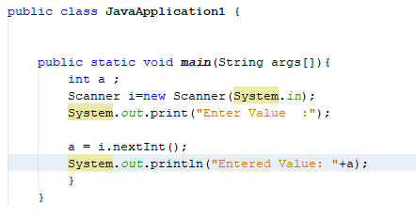

**Output:**

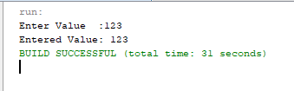

**Question 3:**

**(A):-**

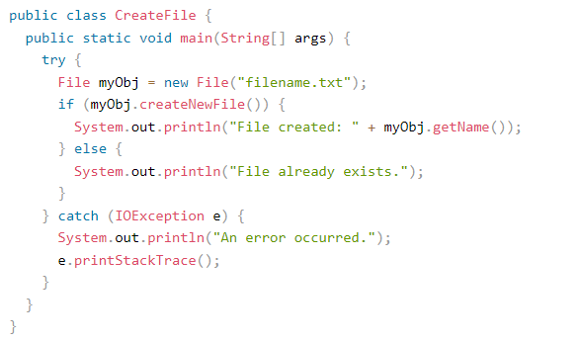

**(B):-**

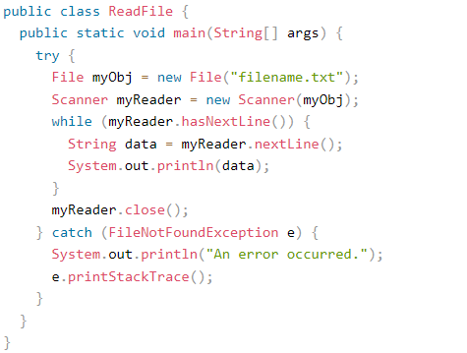

**(C):-**

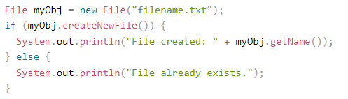

**(D):-**

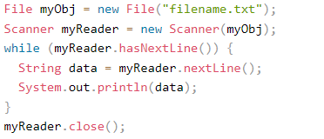

**Question 4:**

**Code:**

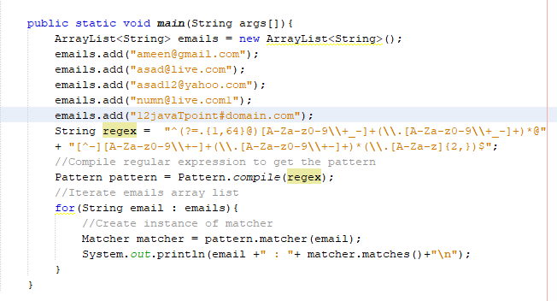

**Output:**

