Università degli Studi di Torino
Requirements Analysis
Library Management System
Submitted by
Nasir Shahzad Yasin
Student ID: 1236376
Master's Degree in Computer Science
Advanced Techniques and Architectures for Software Development
Instructor
Professor Claudia Picardi

1. Introduction
This document presents the requirements analysis for the Library Management System project, following the Domain-Driven Design approach adopted in the course. In line with the feedback received on the initial project proposal, this analysis focuses on the business domain and precedes any architectural or technology decision. No microservices, frameworks, or deployment choices are defined here. Instead, the document works through the practical DDD activities carried out in the course: user stories describing the behaviour expected by the two main roles, CRC cards modelling the main domain objects and their responsibilities, and a strategic analysis identifying the bounded contexts that make up the domain and how they relate to one another. The outcome of this analysis will be discussed at the first Project Review and will inform, without predetermining, the microservices architecture to be presented at the second Project Review.

2. Business Domain Description
The business is a library that lends books to its registered members. A member can browse the library's collection, check whether a book is available, and borrow a copy for a limited period. When a member is finished with a book, they return it, which makes it available again for other members. If a book a member wants is currently out on loan, the member can place a reservation on it. When a copy of that book is returned, the library sets it aside and notifies the member who is next in the reservation queue, giving that member priority to borrow it. Librarians are the staff members responsible for maintaining the library's collection: they add new books and authors, keep availability up to date, and oversee the borrowing activity, including tracking loans that are overdue. The value the library provides to its members is timely, fair access to the books it holds, and the value the analysis must protect is precisely this circulation process, from search to borrowing, return, and reservation.

3. User Stories
The following user stories describe the behaviour the system must support, expressed from the point of view of the two roles identified in the domain: the Member, who borrows and reserves books, and the Librarian, who manages the collection and monitors circulation. Together, the stories require coordination between several areas of the domain, for instance a reservation being fulfilled depends on both the catalog and the lending activity, and this is intentional: it is this coordination that the strategic analysis in Section 5 needs to account for.
ID | Role | User story (As a ..., I want to ..., so that ...)
US1 | Member | register for a library account, so that I can borrow and reserve books.
US2 | Member | log into my account, so that the system knows who I am when I browse or borrow books.
US3 | Member | search and browse the catalog by title, author, or subject, so that I can find books I am interested in.
US4 | Member | see whether a book is currently available, so that I know if I can borrow it right away or need to reserve it.
US5 | Member | borrow an available book, so that I can read it.
US6 | Member | return a book I have borrowed, so that it becomes available to other members.
US7 | Member | reserve a book that is currently unavailable, so that I am given priority when a copy is returned.
US8 | Member | view my current and past borrowing history, so that I can keep track of what I have read and what I still have out.
US9 | Member | be notified when a book I reserved becomes available, so that I know I can go and borrow it.
US10 | Librarian | add new books and authors to the catalog, so that members can find and borrow them.
US11 | Librarian | update the availability of a book, so that the catalog always reflects how many copies can be borrowed.
US12 | Librarian | view all active loans and their due dates, so that I can monitor the circulation of the library's books.
US13 | Librarian | see which loans are overdue, so that I can follow up with the members concerned.
US14 | Librarian | view the reservation queue for a book, so that I know who has priority once a copy is returned.

4. CRC Cards
The CRC (Class, Responsibility, Collaborator) cards below identify the main domain objects that emerge from the user stories, the responsibilities each one owns, and the other objects it needs to collaborate with to fulfil them.
Class | Responsibilities | Collaborators
Member | • Register and maintain personal account details  • Request to borrow an available book  • Return a borrowed book  • Request a reservation on an unavailable book  • View own borrowing history and active reservations | Loan, Reservation, Book
Librarian | • Add and update books and authors in the catalog  • Update the availability of a book  • Monitor active loans and overdue items  • View the reservation queue for a book | Book, Author, Loan, Reservation
Book | • Hold bibliographic information (title, author, ISBN)  • Track number of copies and current availability  • Be searched and browsed by members | Author, Loan, Reservation
Author | • Hold author information associated with one or more books | Book
Loan | • Represent the borrowing of a specific book copy by a member  • Track borrow date, due date, and return date  • Determine whether a loan is overdue | Member, Book
Reservation | • Represent a member's request for a currently unavailable book  • Maintain the waiting list order for a book  • Trigger a notification when the reserved book becomes available | Member, Book, Notification
Notification | • Inform a member that a reserved book is now available  • Inform a member of an approaching or passed due date | Member, Reservation, Loan

5. Strategic Domain-Driven Design

5.1 Subdomains
Looking at the domain as a whole, four subdomains can be distinguished by the kind of value they provide.
Subdomain | Type | Description
Lending and Reservation Management | Core | Borrowing, returning, and reserving books. This is where the library creates value for its members and is the primary focus of the analysis.
Catalog Management | Supporting | Maintaining the collection of books, authors, and copy availability that the core domain depends on.
Identity and Access Management | Generic | Registering and authenticating members and librarians, and assigning roles. A well understood problem not specific to libraries.
Notification | Generic | Informing members about reservation and due date events. A well understood problem not specific to libraries.

5.2 Bounded Contexts
Each subdomain is addressed by one bounded context, within which domain terms have a single, unambiguous meaning.
Identity and Access Context
Registers members and librarians, authenticates them, and assigns their role. Every other context relies on this context to know who is acting, but does not need to know how authentication is carried out.
Ubiquitous language: Member, Librarian, Account, Credential, Role.
Catalog Context
Owns the collection of books and authors, and is the authority on how many copies of a book exist and how many are currently available.
Ubiquitous language: Book, Author, Title, ISBN, Copy, Availability.
Lending Context
Owns the lifecycle of a loan, from the moment a book is borrowed to the moment it is returned, including due dates and overdue tracking.
Ubiquitous language: Loan, Borrower, Due Date, Return, Overdue.
Reservation Context
Owns the waiting list for books that are not currently available, and is responsible for deciding who should be notified when a copy is returned.
Ubiquitous language: Reservation, Waiting List, Notification Trigger.

5.3 Context Map
The diagram below shows how the four bounded contexts relate to one another. Identity and Access is a generic subdomain that acts as an Open Host Service, publishing a simple, stable representation of a member or librarian's identity that the other three contexts consume without needing to know how accounts and credentials are managed internally. The Lending and Reservation contexts are each in a Customer/Supplier relationship with the Catalog context, since they both depend on it to know whether a book is available, but neither of them owns that information. Lending and Reservation are in a Partnership: a book being returned in the Lending context and a member being next in line in the Reservation context are two sides of the same business event, and the two contexts need to evolve together to keep that event consistent.
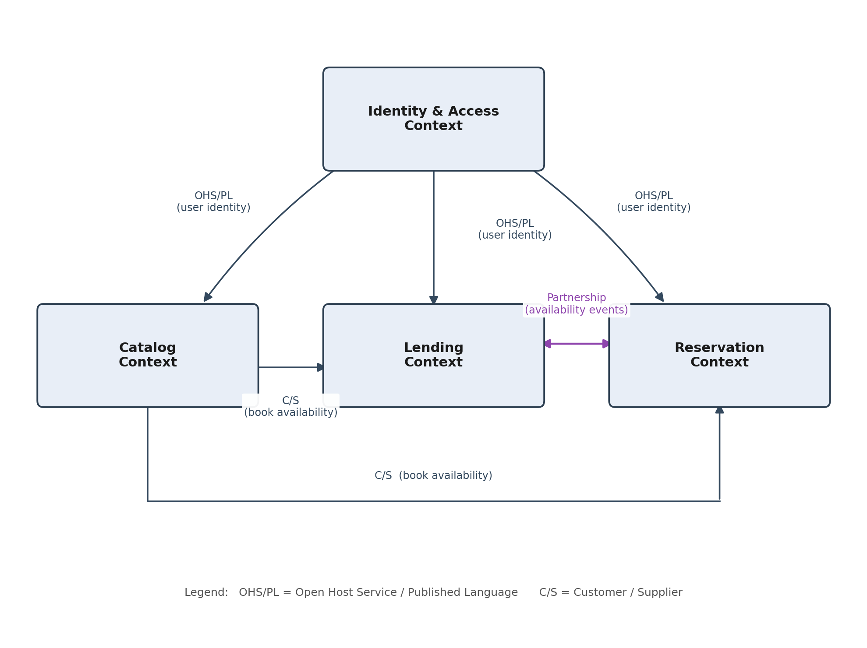
Figure 1. Context map of the Library Management System domain.

6. Next Steps
This requirements analysis will be presented and discussed at the first Project Review. No microservices or technical architecture have been defined at this stage, as agreed. The bounded contexts identified in Section 5 give a business-driven starting point for the architectural design to be carried out afterward, where each context is expected to inform, but not automatically dictate, the identification of the services to be presented at the second Project Review.

