**iOS:**

**Adventuresciefibutik**

This will be an e-commerce type application (similar to Amazon) specialized in selling fantasy, adventure or science fiction movie, toy or other products. It will be a complete front end iOS app written in Swift3 and iOS10.

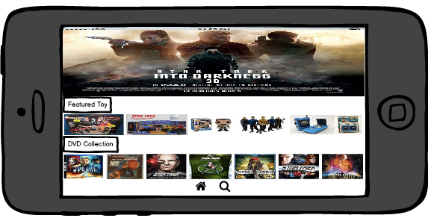

Page 1 : Home page

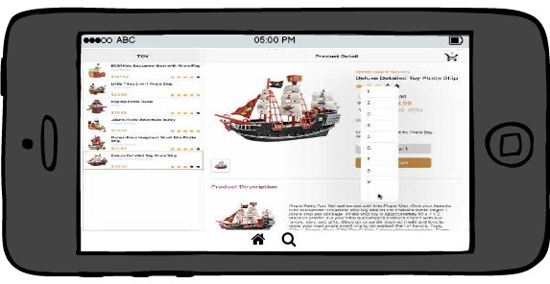

Page 2: Product details and sho

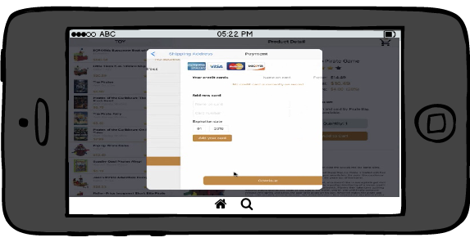

Page2_pupup: Sample credit card information

Requirement:

Functional:

* Multipage app (2 pages)
* Has sliding in functionalities
* Can scroll through the different products
* Has shopping cart
* Display price
* Can count total number of items added in the cart
* Update the shopping cart after selection
* This app will use all kinds of view functionalities that current iOS/Xcode can provide (split view, table view, master view etc)
* Display credit card functionalities
* Has animation
* Has popup functionalities
* shipping address and credit card form functionalities

Non- functional:

* User friendly: User’s input can be saved to avoid retyping same information
* Reliability/availability: 99% case available /reliable
* Scalability: The app is scalable and will be possible to increase data volume
* Performance: The app will perform fast, eg., loading time less than 5 sec for each function/button

PS. I also plan to build android version with slightly different theme (eg. Agriculture, Medicine products) or design.