Key Findings Summary

Findings 1:

What year did the bank push more post online?

Source | Year | Frequency
Facebook | 2022 | 1604
Instagram | 2022 | 1709
Twitter | 2022 | 1530
LinkedIn | 2022 | 1486

We observe that most post we are posted post covid year 2022, and Instagram has the highest frequency.

Findings 2:

What is correlation between Impressions and Engagements of a post:

Source | Correlation score | Statistically significant
Facebook | 24% | Yes
Instagram | 5% | Yes
Twitter | 62% | Yes
LinkedIn | 68% | Yes

We observe that LinkedIn has a trend of the higher the people see your post, the more likely they engage by 68%, Twitter 62%, Facebook 24%, and Instagram 5%. It will make more sense the company prioritize more ads on LinkedIn, Twitter so they can have more engagement.

Findings 3:

What is the most engaging type of post across each platform?

Source | Content type
Facebook | Text
Instagram | Video
Twitter | Photo
LinkedIn | Photo

The bank should prioritize making post with text content on Facebook, Video on Instagram, and Photo for both Twitter and LinkedIn to make wider reach for engagement.

Findings 4:

Which day of week has the highest peak for post engagements?

Source | Day of Week
Facebook | Thursday
Instagram | Friday
Twitter | Monday
LinkedIn | Thursday

The most active days for customer engagement on post are differs, but it shows that none of them is during weekend (Saturday or Sunday). The best day to post on Facebook, and LinkedIn are Thursday respectively. Twitter is Monday, and Instagram on Friday. The bank having a standard content on Monday posted on Twitter and summary of the week on Instagram will boost the engagement of their posts.

Findings 5:

What is the peak hour of the day for post engagements?

Source | Hour
Facebook | 5:00 PM
Instagram | 10:00 AM
Twitter | 5:00 PM
LinkedIn | 12:00 Noon

Facebook, and Twitter are during the business closing hours, Instagram is during the early work hours and LinkedIn during break time.

Findings 6:
Which social media manager post derives more engagement?

Source | Sent By
Facebook | Unknown, Aramide Salami
Instagram | Unkown, Aramide Salami
Twitter | Damilare Oyekanmi, Kemi Amoo
LinkedIn | Unknown, Damilare Oyekanmi
Aramide Salami post is a top-notch on Facebook and Instagram, while Damilare Oyekanmi is top-notch on Twitter and LinkedIn.

Findings 7:

The length of post relationship with engagements

Source | Length type
Facebook | Shorter Post
Instagram | Short post
Twitter | Longer post (Not too long)
LinkedIn | Longer post (Not too long)

Facebook post requires a more summarize text to deliver messages, Instagram also did not require long post. Twitter and LinkedIn need a more detailed post to derives engagements.

Findings 8:

Hashtags in a post relationship with engagements?

Source | Hashtags
Facebook | Decreases Engagement
Instagram | Increase Engagement
Twitter | Decreases Engagement
LinkedIn | Increases Engagement

The post on Facebook and Twitter most avoids Hashtags as much as possible, while it is required to always use relative hashtags on Instagram and LinkedIn for engagements.

Findings 9:

Sentiment Analysis on post to monitor company brand?

Source | Positive | Neutral | Negative | NSS
Facebook | 70.77% | 21.42% | 7.81% | 62.95%
Instagram | 73.42% | 19.26% | 7.32% | 66.10%
Twitter | 69.94% | 22.19% | 7.87% | 62.08%
LinkedIn | 75.84% | 16.79% | 7.37% | 68.48%

Findings 10:
Content Creator Sentiment Assessment?

Source | Sentiment Assestment
Facebook | Kemi Amoo
Instagram | Damilare Oyekanmi
Twitter | Damilare Oyekanmi
LinkedIn | Damilare Oyekanmi

Damilare Oyekanmi is a leading content creator per excellence.

Findings 11:

Engagement Insight by Content Mood?

Source | Content mood
Facebook | Neutral
Instagram | Neutral
Twitter | Negative
LinkedIn | Neutral

Neutral mood content drives more engagements quality on Facebook, Instagram, and LinkedIn. While Negative mood derives more engagement on Twitter.

Findings 12:

Engagement Overview across Platforms Rank?

Source | Quantity | Quality
Facebook | 1st Rank | 1st Rank
Instagram | 2nd Rank | 3rd Rank
Twitter | 3rd Rank | 2nd Rank
LinkedIn | 4th Rank | 4th Rank

Facebook is the most engaging platform in both of quantity and quality, while LinkedIn has the least engagement in terms of quantity and quality.

Findings 13:

Top 10 Topic Themes mostly posted.

Topic | Theme | Rank
1 | Investment of money, and child fund | 2nd
2 | Insurance and policy | 1st
3 | Call to action advertisement | 3rd
4 | Financial wellbeing | 10th
5 | Financial planning for workers and retiree | 4th
6 | Weekend Content | 6th
7 | Motivational Content | 8th
8 | Incentivized Banking | 9th
9 | Celebrations | 7th
10 | Mobile Acquisition Campaigns | 5th

Category of topic themes with respect to content created on the social media platforms as above. We observe that most post are focused on Insurance and Policy awareness and the least is financial well-being.

Findings 14:

Frequency of the Top 10 Topic Themes mostly posted on each social platform.

Topic | Theme | Facebook | Instagram | Twitter | LinkedIn
1 | Investment of money, and child fund | 2nd | 1st | 2nd | 2nd
2 | Insurance and policy | 1st | 2nd | 1st | 1st
3 | Call to action advertisement | 3rd | 4th | 4th | 3rd
4 | Financial wellbeing | 10th | 10th | 8th | 9th
5 | Financial planning for workers and retiree | 6th | 3rd | 5th | 5th
6 | Weekend Content | 4th | 7th | 3rd | 10th
7 | Motivational Content | 7th | 5th | 10th | 8th
8 | Incentivized Banking | 9th | 9th | 9th | 7th
9 | Celebrations | 8th | 8th | 7th | 6th
10 | Mobile Acquisition Campaigns | 5th | 6th | 6th | 4th

Findings 15:

Audience Interests and Preferences by dominant topics?

Topic | Theme | Quantity | Quality
1 | Investment of money, and child fund | 1st | 6th
2 | Insurance and policy | 3rd | 10th
3 | Call to action advertisement | 2nd | 1st
4 | Financial wellbeing | 9th | 5th
5 | Financial planning for workers and retiree | 6th | 8th
6 | Weekend Content | 4th | 4th
7 | Motivational Content | 10th | 9th
8 | Incentivized Banking | 7th | 3rd
9 | Celebrations | 5th | 2nd
10 | Mobile Acquisition Campaigns | 8th | 7th

Topic 3’s content is of high resonance across the platforms, and Mobile Acquisition Awareness needs to be re-evaluated and worked on.

Findings 16:

Top 20 words uses in post.

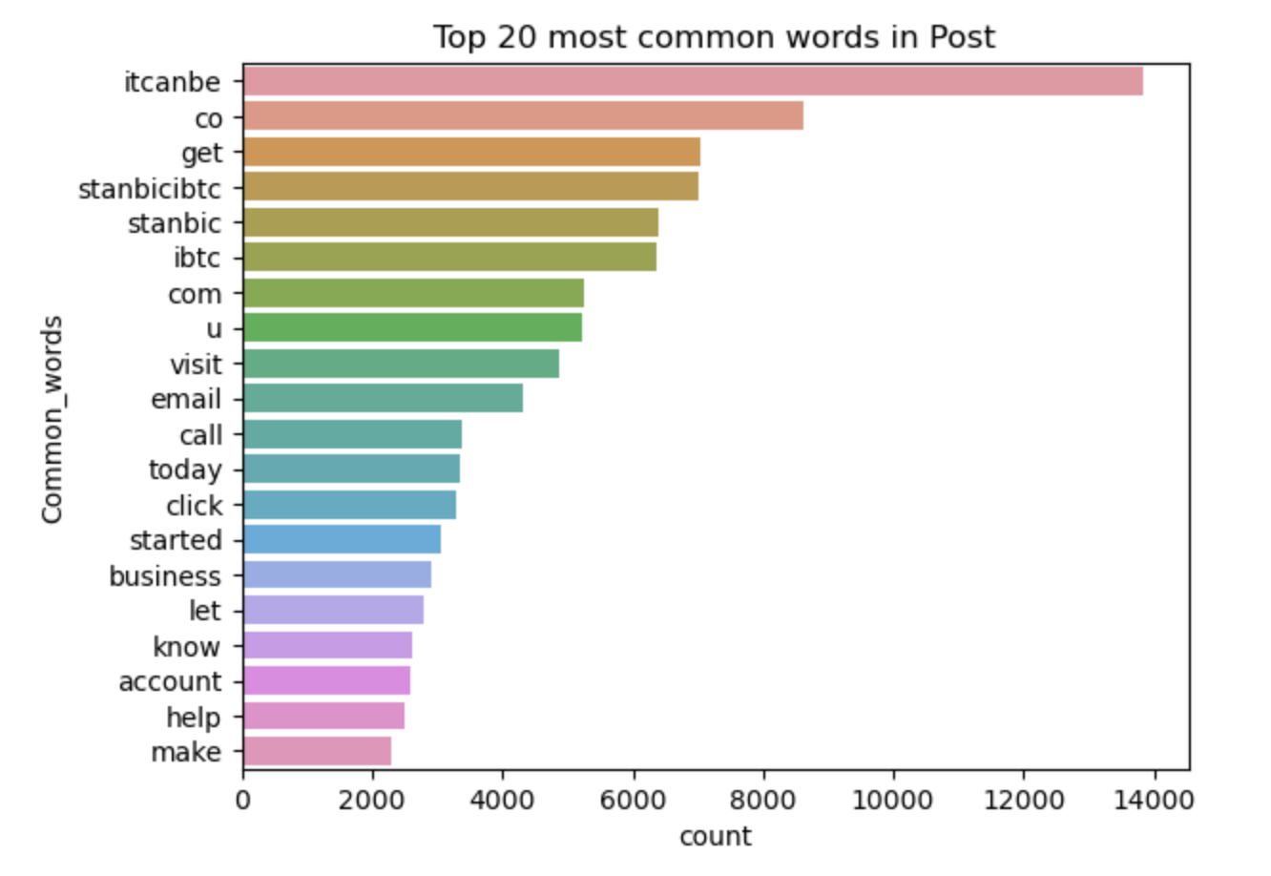

Findings 17:

Sentiment Analysis post pattern

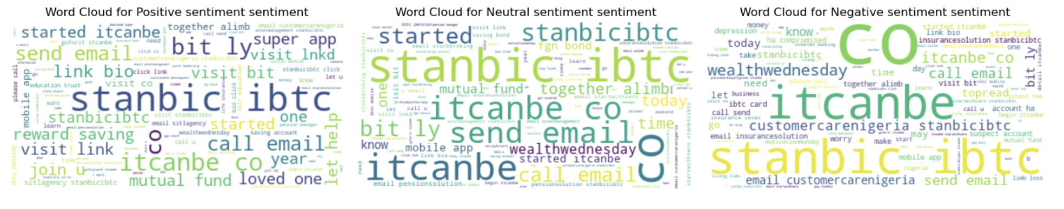

Findings 18:

Machine Learning model to classify post sentiment.

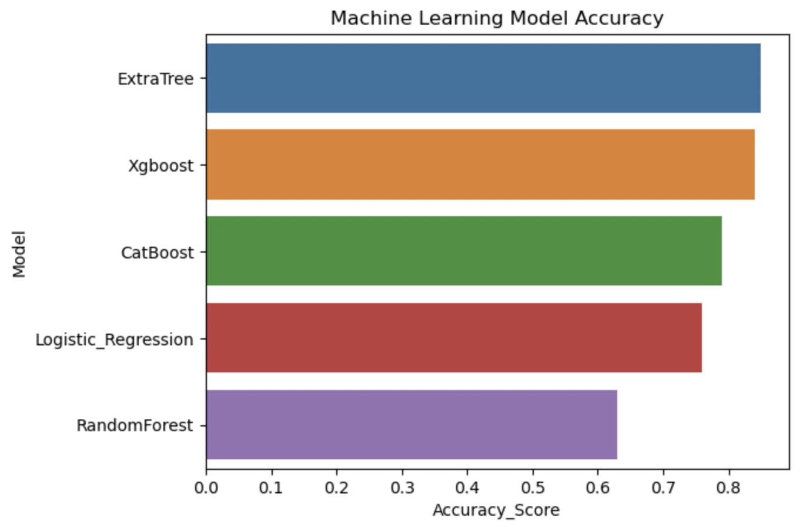

We have a model that has 85% accuracy of classifying post sentiment.

Findings 19:

Machine Learning Interpretable system.

This brings transparency and Trust to the machine learning model that is being used. It also helps in refining content strategy for each post.

