
BRAINWARE UNIVERSITY
398, Ramkrishnapur Road, Barasat, North 24 Parganas, Kolkata - 700 125
LEARNING RECOMMENDER SYSTEM

A PROJECT REPORT

Submitted by
Roll Number | Registration Number | Student Code | Student Name
24103460061 | 24103002842 | BWU/BCA/24/063 | Priya Naskar

in partial fulfilment for the award of the degree
of

BACHELOR OF COMPUTER APPLICATIONS (HONS)

In
DEPARTMENT OF COMPUTATIONAL SCIENCES

BRAINWARE UNIVERSITY
398, Ramkrishnapur Road, Barasat, North 24 Parganas,
Kolkata - 700 125

November (2026-2027)



BRAINWARE UNIVERSITY
398, Ramkrishnapur Road, Barasat, North 24 Parganas, Kolkata - 700 125

DEPARTMENT OF COMPUTATIONAL SCIENCES

BONAFIDE CERTIFICATE

Certified that the project report titled “LEARNING RECOMMENDER SYSTEM” is the Bonafide work of “PRIYA NASKAR” (Roll Number: 24103460061, Student Code:
BWU/BCA/24/063) , carried out in partial fulfilment of the requirements for the
Bachelor of Computer Applications (Hons) degree, under the supervision of the faculty member assigned by the Department of Computational Sciences.

SIGNATURE SIGNATURE
DR. RAAHUL KUMAR GHOSH
ASSOCIATE PROFESSOR
COMPUTATIONAL SCIENCES
BRAINWARE UNIVERSITY
DR. JAYANTA AICH

HEAD OF THE DEPARTMENT

COMPUTATIONAL SCIENCES

BRAINWARE UNVERSITY

ACKNOWLEDGEMENT
I would like to express my profound gratitude to all those who have been instrumental in the successful completion of this project report. Their continuous support and encouragement have played a vital role in shaping my learning experience.
I extend my sincere thanks to our esteemed project supervisor, Dr. Raahul Kumar Ghosh, Associate Professor, whose constant guidance, valuable suggestions, and insightful feedback have been instrumental throughout the development of this project. His expertise, patience and motivation helped us overcome challenges and understand the core concepts effectively.
I also deeply thankful to Dr. Jayanta Aich, Head of the Department of Computational Sciences, for providing a supportive academic environment and the necessary facilities that enabled us to complete this work successfully.
My sincere appreciation goes to all the faculty members of the Department of Computational Sciences for sharing their knowledge, advice, and encouragement during my project. Their teachings have significantly contributed to strengthening my technical understanding and skills.
Finally, we express my profound gratitude to our families and friends, whose constant support, understanding, and motivation inspired us to stay committed and focused during every phase of this project. Without their encouragement, this achievement would not have been possible.

SIGNATURE :-
PRIYA NASKAR (BWU/BCA/24/063)
ABSTRACT

The Learning Recommender System is a machine-learning application that ranks next-course recommendations from learner profile data. The Streamlit dashboard accepts either an existing learner ID or a manually entered learner profile, compares the profile with similar learners, and presents recommended course codes with match scores and supporting explanations.

The project uses data/learning_path_dataset.csv as its source dataset. The data contains learner attributes and recorded nextcourse labels. It does not contain individual learning-material identifiers, resource descriptions, activity types, or resource URLs; therefore, the system recommends courses rather than videos, quizzes, or other learning materials.

The recommendation engine uses scikit-learn's DictVectorizer to transform categorical and numeric profile features and a brute-force nearest-neighbour index with cosine distance to identify similar learners. Similarity-weighted votes over their recorded next-course labels are used to rank candidate courses. The current evaluation reports a Top-5 hit rate of 53.15%, compared with 45.45% for the popularity baseline, on a holdout set of 143 learners. These results indicate a modest improvement on this dataset and should not be interpreted as proof of general real-world effectiveness.

The dashboard also presents dataset information, exploratory dataanalysis charts, recommendation results, and an explanation of the available data limitations. The project demonstrates an end-to-end workflow involving data validation, feature engineering, nearestneighbour recommendation, evaluation, and interactive deployment.

INDEX

- ACKNOWLEDGEMENT
- ABSTRACT
- LIST OF SCREENSHOTS

  - INTRODUCTION………………………………………………… 5-6
  - LITERATURE SURVEY………………………………6-7
  - PROBLEM STATEMENT AND OBJECTIVES……………7-8
  - DATASET DESCRIPTION AND PREPARATION…………9-12
  - SYSTEM ANALYSIS AND DESIGN…………………………13-15 6. METHODOLOGY AND RECOMMENDATION
ALGORITHM………………………………………………16-17
  - IMPLEMENTATION AND APPLICATION WORKFLOW………………18-19
  - EXPLORATORY DATA ANALYSIS AND VISUAL RESULTS…………….19-20
  - TRAINING, TESTING AND EVALUATION…………………………………...21
10.LIMITATIONS AND RESPONSIBLE INTERPRETATION…….22
  - CONCLUSION AND FUTURE SCOPE………………………...22-23
  - REFERENCES……………………………………………….23

INTRODUCTION

1.1 Background
Digital learning environments offer learners a wide range of courses. Choosing a suitable next course can be difficult when learners have different levels, preferences, completedcourse histories, study hours, and performance scores.
A recommender system can help rank possible next courses by identifying patterns among learners with similar profile.

1.2 Project Overview
The Learning Recommender System is a data-driven application that compares a learner profile with profiles in a historical dataset. It identifies a neighbourhood of similar learners and uses their recorded next-course recommendations to generate a ranked list of course codes.

1.3 Scope
Accepts an existing learner ID or a manually entered learner profile. Uses course history, learning level, learning preference, study hours, and performance score as profile features.
Finds similar learners using cosine distance.
Ranks next-course codes using similarity-weighted voting.
Displays match scores and short explanations in a Streamlit dashboard.
Provides dataset audit information, EDA charts, and model evaluation metrics.

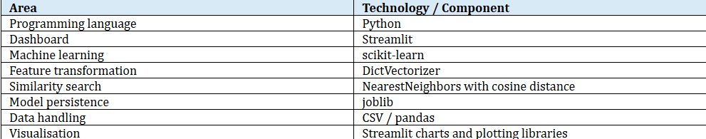
1.4
Technologies Used

1.5 Project Structure
The project separates dashboard presentation, data preparation, feature engineering, validation, exploratory analysis, recommendation logic, and model training into dedicated modules. This makes the application easier to maintain and retrain.

2. LITERATURE SURVEY

Recommender systems are commonly used to help users discover relevant items from a larger catalogue. Collaborative-filtering approaches use patterns in useritem interactions or similarities between users to estimate which items may be relevant to a target user. Neighbour-based methods are a practical form of collaborative filtering: they identify users with similar profiles or histories and aggregate their observed preferences.
This project applies a neighbour-based approach to learner profiles. Unlike a content catalogue recommender, it does not compare course descriptions or learning-resource metadata. Instead, it uses the learner attributes available in the supplied CSV and the recorded Next_Course_Recommendation target. Feature representation is important because categorical and numeric variables must be represented consistently for similarity calculations. DictVectorizer converts dictionary-style profile features into a numerical feature matrix. Cosine distance is then used to locate nearby learner profiles. Evaluation on a held-out subset provides an estimate of how well the ranked recommendations recover the recorded next-course label.
The literature-informed design is intentionally modest: the system demonstrates a transparent nearest-neighbour ranking method reports measured performance rather than claiming that recommendations guarantee improved learning outcomes.

3. PROBLEM STATEMENT AND OBJECTIVES

3.1 Problem Statement
Learners may find it difficult to identify an appropriate next course from their current learning profile. The project addresses this by building a machine-learning system that uses historical learner data to rank likely next-course codes for a new or existing learner profile.

3.2 Objectives

Load and validate learner-profile data from a CSV file.
Convert learner attributes and course history into a consistent feature representation.
Identify similar learners using cosine-distance nearest-neighbour search.
Generate ranked next-course recommendations using similarity-weighted votes.
Exclude the learner's current course and already completed courses from candidates.
Evaluate ranking performance against a simple popularity baseline.
Present learner inputs, dataset information, EDA, and recommendations in a Streamlit dashboard.

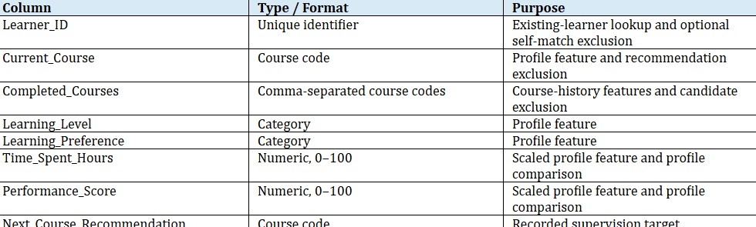
3.3
Existing and Proposed System

4. DATASET DESCRIPTION AND PREPARATION

4.1 Dataset Source
The current project uses data/learning_path_dataset.csv. This is the actual source specified by the project documentation. The project is not built on the Open University Learning Analytics Dataset (OULAD).

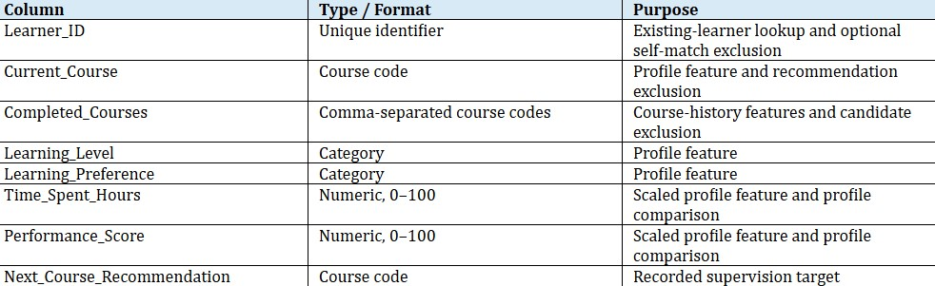
4.2
Required Dataset Columns

4.3 Data Validation and Cleaning

Reads the CSV and verifies that all required columns are present.
Removes surrounding whitespace from string values.
Converts Time_Spent_Hours and Performance_Score to numeric values.
Rejects missing values, blank required strings, and duplicate learner IDs.
Checks that study hours and performance scores fall within the 0–100 range.
Parses comma-separated completed course codes into a normalized list.

4.4 Filtering Trainable Rows
Before training, filter_trainable_rows excludes a record when its recorded next-course target is the learner's current course or is already present in the learner's completed-course list. The current saved metrics report 286 excluded records and 714 retained records from the original 1,000-row dataset.

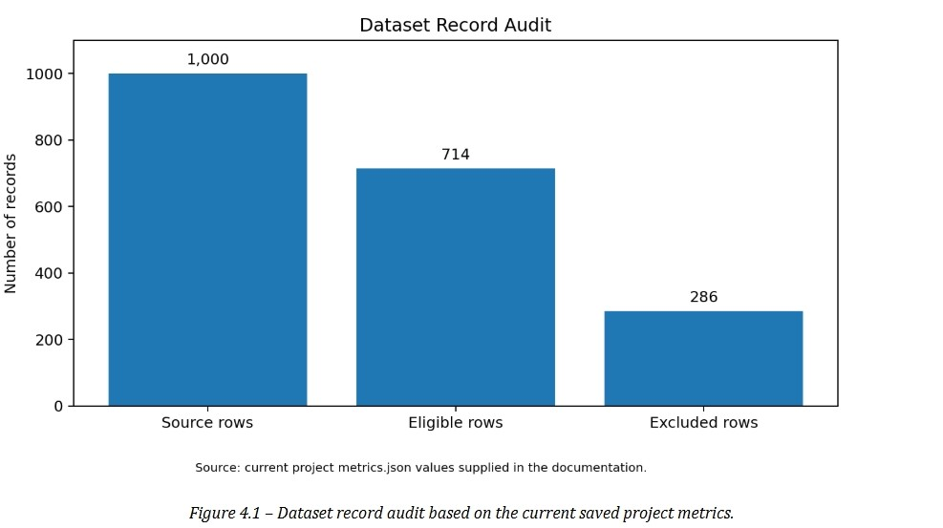

The chart shows record counts only. Detailed distributions for learning level, learning preference, score ranges, study-hour ranges, and course frequencies require the actual CSV values and are not fabricated in this report.

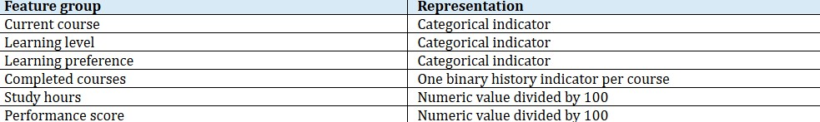
4.5
Feature Preparation

5. SYSTEM ANALYSIS AND DESIGN

5.1 Functional Requirements
The dashboard must load the configured CSV dataset.
The user must be able to select an existing learner or enter a manual profile.
The system must validate the profile before generating recommendations.
The model must identify similar learners while excluding the selected learner from their own neighbour list.
The system must remove the current and completed courses from candidate recommendations. The dashboard must show ranked course codes, match scores, and supporting reasons.

5.2 Non-Functional Requirements
Maintainable modular Python source code.
Consistent feature generation between training and inference.
Transparent reporting of evaluation metrics and limitations.
Clear validation messages and readable dashboard outputs.
Reproducible model training using the documented random state.

5.3 System Architecture
The architecture connects the Streamlit interface with profile validation, feature generation, the saved recommendation bundle, the source CSV, and the recommendation-ranking process. The training script creates the reusable model bundle and metrics file.
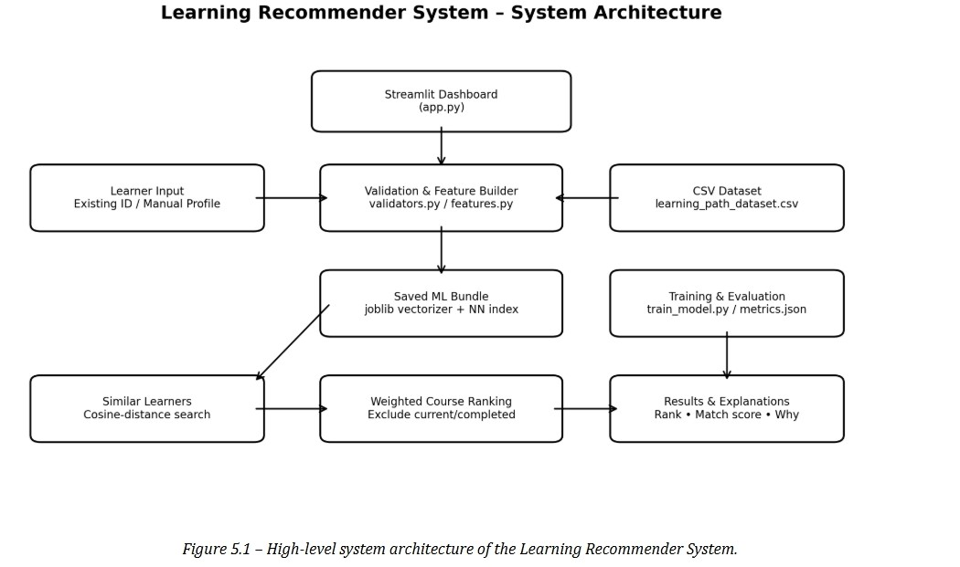

5.4 Main Modules
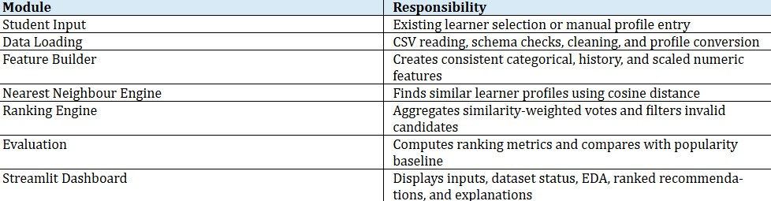

6. METHODOLOGY AND RECOMMENDATION ALGORITHM

6.1 Feature Vectorisation
The feature builder converts each learner into a dictionary containing categorical indicators, completed-course history indicators, and scaled numeric values. DictVectorizer transforms these dictionaries into a numerical matrix. The same feature-building logic is used during training and when a live learner profile is submitted.

6.2 Nearest-Neighbour Search
The recommender fits a brute-force nearest-neighbour index using cosine distance. The default neighbourhood size is 20 learners. For an existing learner lookup, the selected learner's own ID is excluded from the returned neighbours so that the learner does not match with themselves.

6.3 Similarity-Weighted Voting
Each neighbour contributes a vote to the course code recorded in
Next_Course_Recommendation. A neighbour's vote is weighted by its similarity to the target learner. Candidate courses that match the learner's current course or completed-course history are removed. Remaining candidates are ordered by their accumulated vote weight.

6.4 Match Score and Explanation
Match Score: accumulated vote weight for a course divided by the total similarity weight of the selected neighbours.
Why Recommended: number of similar learners who selected the course and their average performance score.

6.5 RECOMMENDATION PROCESS
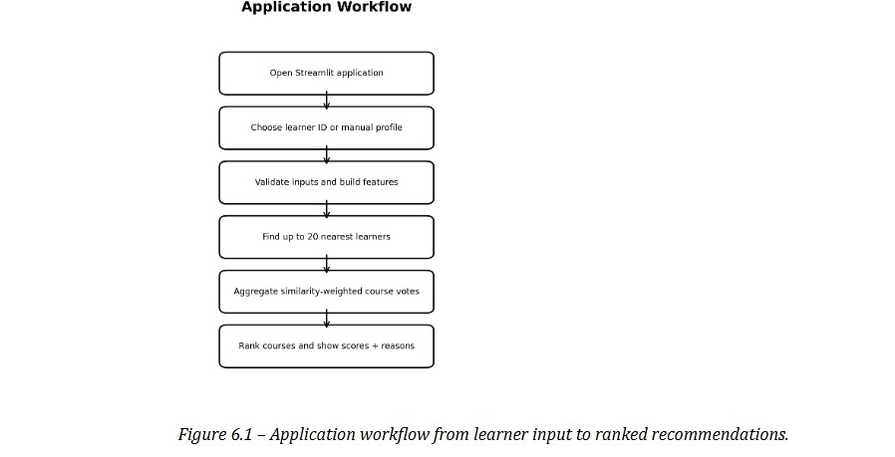

7. IMPLEMENTATION AND APPLICATION

WORKFLOW

7.1 Dashboard Sections

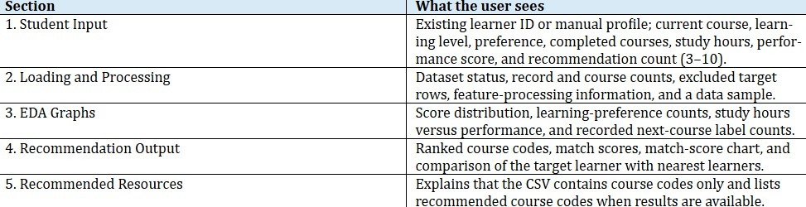

7.2 Navigation and Validation
A sticky navigation bar links to the numbered dashboard sections. Validation messages are shown in the Student Input section. The recommendation count can be selected from 3 to 10.

7.3 Training the Model
From the project root, run the following command: python train_model.py
Training uses a stratified 80/20 split of eligible rows with random_state=42. The script evaluates recommendations on the holdout set, calculates ranking metrics and a popularity baseline, and then fits the saved recommendation bundle on all eligible rows.

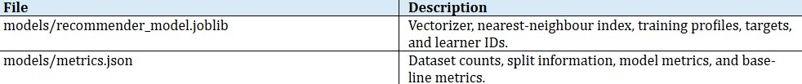
7.4
Generated Model Files

7.5 Running the Dashboard

Install dependencies, train the model, and launch Streamlit: python -m pip install -r requirements.txt python train_model.py streamlit run app.py
For Windows PowerShell, create and activate a virtual environment:
py -m venv .venv
.\.venv\Scripts\Activate.ps1
For macOS or Linux, use: python3 -m venv .venv source .venv/bin/activate

8. EXPLORATORY DATA ANALYSIS AND VISUAL RESULTS

8.1 EDA Views Included in the Dashboard
The dashboard is designed to display four EDA views: performance-score distribution, learning-preference counts, study hours versus performance, and counts of recorded next-course recommendation labels. These plots are generated from the loaded dataset at runtime.
The exact category counts, score distribution, and study-hour relationship are not included in the project facts supplied for this report. Therefore, no synthetic category or score values have been added. The dashboard's runtime EDA charts should be captured from the running application and inserted here as final evidence.
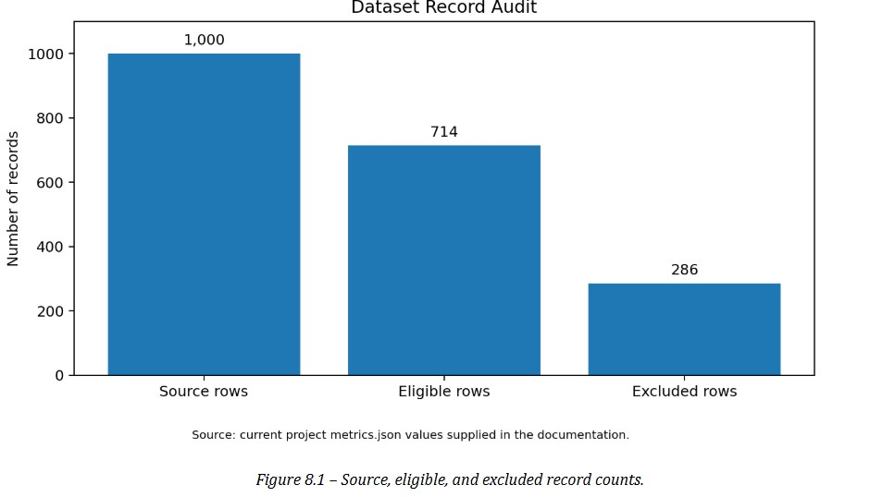
8.2
Dataset Record Distribution

8.3 Recommendation Performance Visualisation
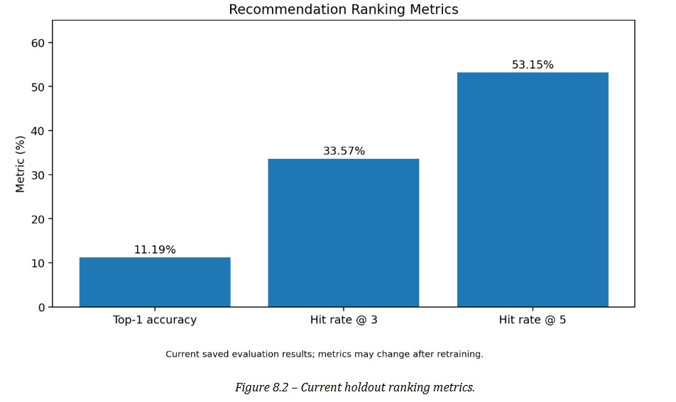

8.4 Model and Baseline Comparison
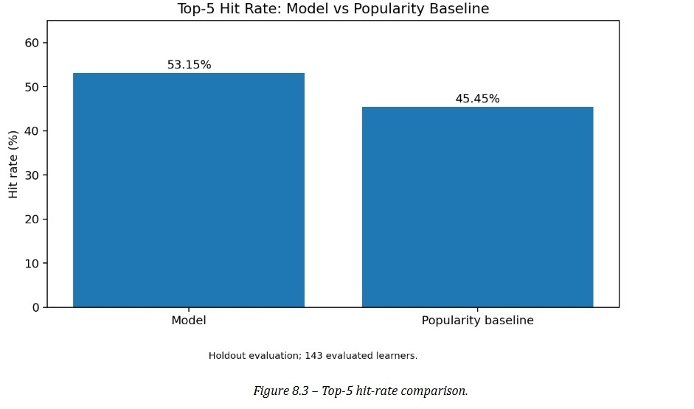

8.5 Application Screenshots to Insert
The following figures reproduce the supplied screenshots from the running Streamlit dashboard. They document the actual student input, data processing, exploratory analysis, and recommendation output.
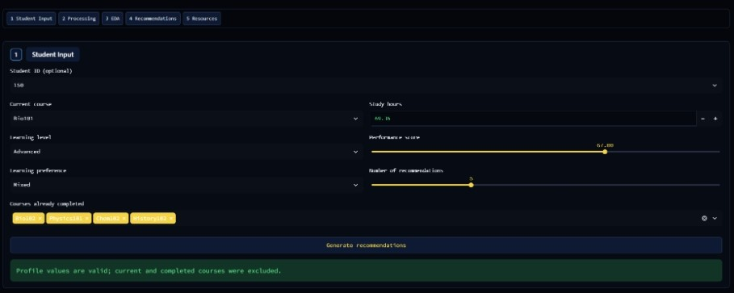

Figure 8.4 – Student Input section
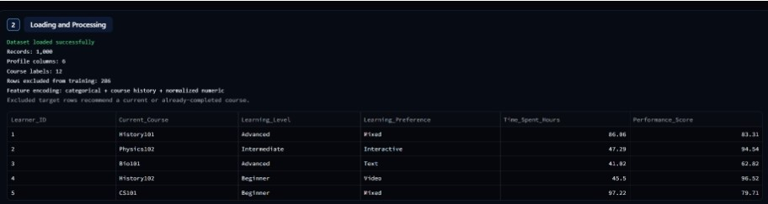
Figure 8.5 – Loading and Processing section
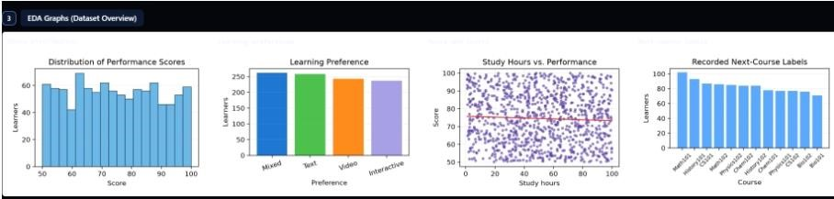
Figure 8.6 – EDA Graphs section
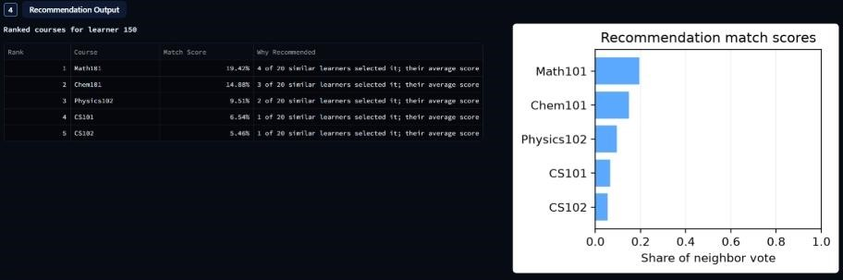

Figure 8.7 – Recommendation Output section

9. TRAINING, TESTING AND EVALUATION
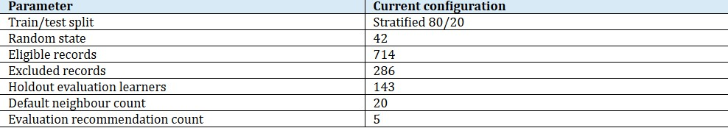
9.1
Training Configuration

9.2 Current Saved Evaluation Results
The current Top-5 hit rate is approximately 7.7 percentage points higher than the popularity baseline. This is a modest improvement on the current dataset. It should not be presented as evidence of broad real-world effectiveness.
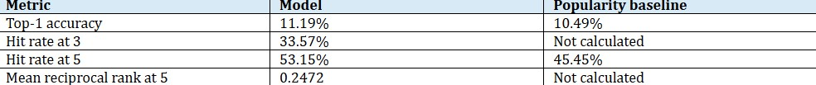
9.3
Interpretation

Top-1 accuracy measures how often the first-ranked recommendation matches the recorded next-course label.
Hit rate at K measures how often the recorded target appears among the first K recommendations.
Mean reciprocal rank at 5 rewards a correct target more when it appears closer to the top of the ranked list.
The popularity baseline provides a simple reference point for judging whether profile-based ranking adds value.

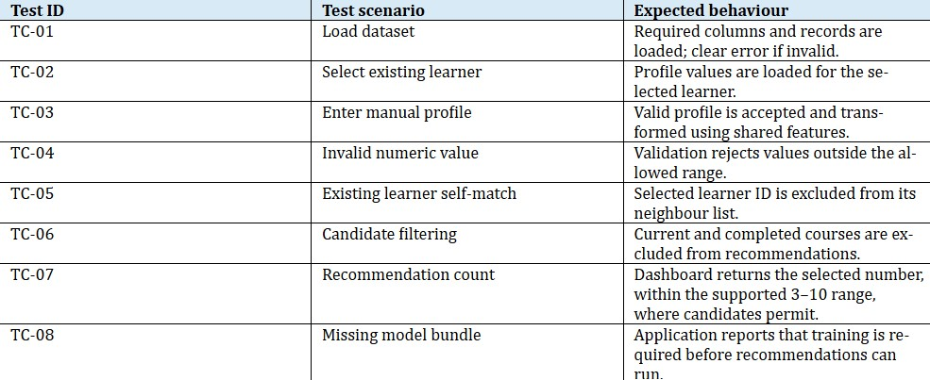
9.4
Testing Checklist

The table describes recommended functional test cases based on the documented design. Mark each case Pass/Fail only after executing it in the actual application.

10. LIMITATIONS AND RESPONSIBLE INTERPRETATION

The system recommends course codes, not links to courses, quizzes, videos, or other learning materials.
The target is the dataset's recorded Next_Course_Recommendation; the project does not establish that a recommended course causes better learning outcomes.

Recommendations depend on patterns in this one dataset and may not generalize to other learners or institutions.
More than one quarter of source rows are excluded because their target conflicts with the learner's current or completed course history. This rule should be reviewed if target semantics change.
Holdout metrics are modest. Retrain and re-evaluate after any dataset or feature change, and report the current metrics rather than assuming improvement.
Detailed EDA distributions must be generated from the actual CSV; they should not be inferred from aggregate row counts.

11. CONCLUSION AND FUTURE SCOPE

11.1 Conclusion
The Learning Recommender System demonstrates an end-to-end machinelearning workflow for ranking next-course recommendations from learner profile data. It validates a CSV dataset, prepares categorical and numeric features, identifies similar learners using cosine distance, and ranks course codes through similarity-weighted voting. The Streamlit dashboard brings the workflow together with learner input, dataset status, EDA views, recommendation scores, and explanations.
The current saved evaluation reports a Top-5 hit rate of 53.15%, compared with 45.45% for the popularity baseline, on 143 holdout learners. This represents a modest improvement on the supplied dataset. The result should be interpreted cautiously and rechecked after retraining or data changes.

11.2 Future Scope
Add verified course metadata such as titles, descriptions, prerequisites, and course URLs so course codes can be presented with richer information.
Use a larger and more diverse learner dataset to test generalisation across courses and learner groups.
Explore alternative recommendation methods and compare them using the same holdout protocol.
Add more robust cross-validation and confidence or coverage analysis.
Monitor recommendation quality after deployment and retrain when the underlying data changes.

12. REFERENCES

Project source dataset: data/learning_path_dataset.csv (local project data file).
Scikit-learn documentation – DictVectorizer: https://scikitlearn.org/stable/modules/generated/sklearn.feature_extraction.DictV ectorizer.html
Scikit-learn documentation – Nearest Neighbors: https://scikitlearn.org/stable/modules/neighbors.html
Scikit-learn documentation – Model evaluation: https://scikitlearn.org/stable/modules/model_evaluation.html
Streamlit documentation: https://docs.streamlit.io/
Joblib documentation: https://joblib.readthedocs.io/
Python documentation: https://docs.python.org/3/
Project-specific implementation details and saved evaluation figures are based on the project documentation supplied for this report. The actual CSV and source-code files should be used to verify or update all data-derived values before final academic submission.

13. PROJECT OUTPUT SUMMARY
The supplied dashboard screenshots show a working end-to-end flow. In the illustrated example, learner 150 has current course Bio101, Advanced learning level, Mixed learning preference, 69.36 study hours, and a performance score of
67. The learner's completed courses are excluded from candidate recommendations.
The displayed top-five recommendations are Math101 (19.42%), Chem101 (14.88%), Physics102 (9.51%), CS101 (6.54%), and CS102 (5.46%). These percentages are the displayed shares of similarity-weighted neighbour votes for that example learner; they are not model accuracy.
The processing panel reports 1,000 source records, 6 profile columns, 12 course labels, and 286 rows excluded because their recorded target is the current or an already-completed course. This leaves 714 eligible rows.
The saved holdout evaluation reports 143 evaluated learners, Top-1 accuracy of
11.19%, Hit Rate@3 of 33.57%, Hit Rate@5 of 53.15%, and Mean Reciprocal
Rank@5 of 0.2472. The popularity baseline has Top-1 accuracy of 10.49% and Hit Rate@5 of 45.45%. Results are dataset-specific and should be rechecked after retraining.

