Complementary Threat Knowledge in Federated Android Malware Detection
  - A Controlled-Exposure Study
Salaheddine Naslouby^{1,*}, Mohamed Lachgar², Hamid Hrimech¹
¹ Hassan First University
National School of Applied Sciences (ENSA), LAMSAD Laboratory
Berrechid, Morocco
² Cadi Ayyad University
Higher Normal School (ENS), L2IS Laboratory
Marrakech, Morocco
* Corresponding author: Salaheddine Naslouby
Email: naslouby.salahe@gmail.com; ORCID: 0009-0002-7295-7816
Mohamed Lachgar: m.lachgar@uca.ac.ma
Hamid Hrimech: hamid.hrimech@uhp.ac.ma

Abstract
Collaborative malware detection may improve through additional training data or exposure to families missing locally. This chapter separates these contributions through controlled family exposure in four constructed Android application domains. The study uses group-aware partitions, matched training sample counts across exposure conditions, client-specific calibration, and ten confirmatory seeds. At a nominal 5% false-positive rate (FPR), FedAvg peer-present training improves federation-wide unseen-family recall by 11.96 percentage points over absence-everywhere training (95% confidence interval: 9.15–15.21). The residual collaboration effect is estimated at 1.51 points, with uncertainty spanning zero. On own-domain malware, peer-present training improves unseen-family recall by 3.26 points over local learning but reduces nonhidden-malware recall by 3.61 points. In fresh-seed extensions, a wrong-family placebo recovers almost none of the gain, and complementary gain rises with the exact number of peer examples. Local-versus-federated comparisons alone cannot show how much of a collaborative gain depends on which families peers hold.

Introduction
An Android malware detector can have substantial training data yet lack examples of an important malware family. This is a gap in threat coverage, not necessarily in data volume. Application collections differ in malicious lineages, benign software, and class composition, so a locally unseen family must be detected through features learned from other malware. Peers may possess relevant examples, but their availability alone does not establish a collaborative benefit. The question is whether these examples improve detection beyond collaboration on other available data.
Federated learning trains across distributed datasets through exchanged model updates; FedAvg aggregates locally trained parameters into a common model (McMahan et al., 2017). A conventional federated-versus-local comparison changes the training population, benign examples, family exposure, and optimization process together. It cannot distinguish the contribution of peer-held families from these other changes. Conversely, poor aggregate performance can coexist with useful detection gains on locally missing threats.
CTK-Android defines complementary threat knowledge (CTK) through three conditions. A selected family is withheld from a target client's training data. Local-only learning provides the reference; collaborative learning either excludes the selected hidden families everywhere or retains their examples at peers. The peer-present minus absence-everywhere recall contrast measures CTK, while absence-everywhere minus local measures the residual collaboration effect, labeled pooling in the equations, tables, and figures. Together they decompose the total peer-present minus local gain. CTK denotes the measured response to the exposure intervention.
The decomposition distinguishes additional detection capability from recovery of collaboration losses. Pooling other malware may improve recall through transferable features. Alternatively, pooling may reduce recall and complementary exposure may repair that negative transfer, leaving little net improvement over local learning. Reporting all three contrasts reveals both the family-dependent contribution and its practical value relative to the local detector.
The study uses LAMDA features linked to AndroZoo metadata. Four constructed market/era domains serve as experimental clients. Binary detection is evaluated on families withheld from target fit data, with thresholds calibrated on each client's benign observations. Grouped partitions prevent package identities and identical primary feature vectors from crossing fit, calibration, and test roles. These domains provide a controlled exposure benchmark rather than independently administered organizations or a chronological deployment evaluation.
Across ten confirmatory seeds, complementary exposure raises FedAvg federation-wide unseen-family recall by 11.96 percentage points (95% BCa interval 9.15–15.21). The results distinguish this gain from net own-domain improvement and document losses in nonhidden-malware recall, client variation, and family-specific failures.
The contribution is a controlled empirical framework for decomposing collaborative Android malware detection gains. Matched client budgets and explicit family-exposure interventions support local, absence-everywhere, and peer-present comparisons under client-specific calibration and paired statistical evaluation. Family/client analyses, negative controls, and dose experiments examine heterogeneity and specificity; learner, partition, support, and representation comparisons test sensitivity. The study uses established learning algorithms to examine when peer exposure adds detection capability and when it repairs collaboration losses.
Recall differences are reported in percentage points; recall and FPR levels are percentages. Nominal FPR is the calibration target, while realized FPR is the error rate on benign test applications. Unless specified otherwise, intervals reported for mean effects are 95% BCa intervals.

Background and Related Work

Android Malware Detection and Family Generalization
Android malware detection has long combined application analysis with statistical classification. DREBIN represents applications using static properties obtained from manifests and code, including permissions and API-related features, and couples detection with explanatory feature evidence (Arp et al., 2014). This approach makes efficient comparisons across large application collections possible. It also illustrates why family generalization is not equivalent to memorizing family labels: a binary detector can respond to malicious properties shared by multiple families. In CTK-Android, family annotations determine which examples are withheld and which test cases are evaluated; the learning target remains malware versus benign. A family may therefore be locally unseen yet partially detectable before collaboration.
Representation choices affect what can transfer. MaMaDroid abstracts API calls and models their sequences through Markov chains, emphasizing behavioral structure and resilience to API evolution (Mariconti et al., 2017). Its abstraction of API packages or families should not be confused with withholding malware families. For CTK, shared malicious structure can be expressed differently by different feature spaces. A failure to benefit from peer examples in one static representation cannot establish that the family is intrinsically unlearnable. Equally, a richer representation does not automatically improve the particular low-FPR decision boundary needed by the study. The representation extension therefore compares aligned applications rather than treating an increase in feature count as evidence of progress.
Family annotations introduce uncertainty into exposure experiments. AVClass2 extracts structured tags from antivirus labels using a taxonomy and rules for interpreting noisy vendor descriptions (Sebastián & Caballero, 2020). LAMDA uses automated family labeling in its construction. Such labels are valuable for organizing exposure experiments, but they are not equivalent to independently verified behavioral categories. Shared advertising components, related variants, and naming conventions can influence apparent family similarity. CTK-Android consequently interprets results with respect to the supplied family annotations. It does not infer that every named family corresponds to a distinct attack mechanism or that all applications sharing a label have identical malicious behavior.

Federated Learning and Complementary Exposure
FedAvg iteratively aggregates locally trained models (McMahan et al., 2017). FedProx adds a proximal term constraining local departure from the global model to address statistical and systems heterogeneity (Li et al., 2020). These established methods underpin the learner comparisons. Their joint objectives can produce client tradeoffs, so improvement on locally missing Android families remains an empirical question.
Android FL studies address several aspects of that question. Ciaramella et al. (2026) compare federated and centralized detection using application-code images and convolutional architectures under different data distributions and aggregation choices. Gálvez et al. (2021) investigate privacy-respecting classification, while Patel et al. (2026) study adaptation to local concept drift. M2FD combines federated mobile malware detection with drift monitoring and selective retraining on KronoDroid (Augello et al., 2025). Droidware integrates static feature modeling with authenticated updates, anomaly filtering, and aggregation designed for adversarial conditions (Prasad & Kumar, 2026). These studies provide context on heterogeneous, evolving, and hostile environments; the present experiment isolates an exposure contrast within a fixed benchmark.
Missing-threat detection is already explicit in the broader security literature. CELEST trains collaborative HTTP threat detectors across organizations and evaluates families missing in one network but represented in another (Ongun et al., 2025). Its controlled scenarios, active learning, and poisoning defenses establish relevant precedents. CTK-Android adds a volume-matched absence-everywhere comparison for Android detection, with multiple recall populations and seed-level uncertainty intervals. CELEST's operational and adversarial evaluations address additional properties beyond this chapter's scope.
CyberForce is a close conceptual precedent: Feng et al. (2025) vary the fraction of clients missing particular malware in federated reinforcement learning for Internet of Things (IoT) malware mitigation. Their evaluation includes an all-clients-missing condition, local references, and alternative aggregators. Its moving-target-defense task and missing-client sweep differ from CTK-Android's matched-budget recall decomposition. The present study extends this line of work with Android exposure controls, exact peer doses, and a wrong-family placebo; it does not originate the missing-threat problem.
Related missing-class studies further establish the problem's importance. Shen et al. (2024) evaluate knowledge distillation when individual intrusion-detection clients lack an attack class; Popoola et al. (2022) study federated detection of previously unseen botnet traffic. Shao et al. (2026) show that missing positive-class support can sustain bias despite apparent convergence. These tasks motivate measuring what collaboration contributes when relevant threats are absent locally, while their class definitions and interventions differ from the family withholding used here.

Dataset Quality and Evaluation Validity
AndroZoo supplies a large application collection and associated metadata that enable research beyond small, fixed malware corpora (Allix et al., 2016). Metadata can support meaningful domain construction, but a market field is an observational attribute rather than an organizational identity. Restricting to applications with one market reduces ambiguity about assignment while changing the population under study. A federation formed from the retained market domains is a controlled benchmark construction; it does not establish how well these domains reproduce the collection practices, user populations, or labeling policies of real collaborating defenders.
LAMDA extends the temporal coverage of Android benchmarking and supports analyses of drift and family variation (Haque et al., 2026). McNdroid aligns static, graph-based, and dynamic-report modalities over a longitudinal application collection (Kamol et al., 2026). These resources motivate the dataset and representation choices, but their original benchmark questions differ from CTK-Android's controlled exposure question. The chapter uses the frozen 925-feature LAMDA release, rather than assuming that every LAMDA release has the same dimensionality. The overlapping McNdroid applications support representation comparison rather than independent-corpus validation.
TESSERACT demonstrates how spatial and temporal bias can inflate malware-classification results (Pendlebury et al., 2019). Arp et al. (2022) identify broader pitfalls in data collection, leakage, experimental design, and interpretation. CTK-Android addresses exact identity leakage through grouping and ambiguous collaboration claims through exposure controls. Its date-based client boundary does not impose chronological train/test ordering. Patel et al. (2026) evaluate chronological Android data under FL; the grouped partitions here instead test held-out identities under controlled family exposure.
The specific distinction is the matched-budget three-arm decomposition in federated Android detection. Combining a local reference with peer-present and absence-everywhere conditions separates complementary exposure from residual collaboration effects. Population, dose, and control analyses then test the interpretation. The study builds on existing missing-threat research.

Research Problem and Questions
A seed specifies a group-aware partition and selected families' target assignments. For learner m, R(m,P) is a specified recall metric when targets lack their assigned families and peers retain them; R(m,A) is the same metric when all selected hidden families are absent from every client's fit data. R(L,P) is the recall of the local learner on the same target-family task, although peer data do not enter its training. All quantities share the seed, nominal operating point, and evaluation population:
$CTK(m) = R(m,P) − R(m,A)$
$Pooling(m) = R(m,A) − R(L,P)$
$Total(m) = R(m,P) − R(L,P) = CTK(m) + Pooling(m)$
These identities hold within each paired seed before effects are averaged. CTK and pooling can each be negative. The two collaborative exposure conditions use the same learner, training schedule, and client sample counts, but removing families changes which replacement examples are selected. CTK therefore measures the fitted and calibrated response to this exposure intervention. Several families are manipulated within a run, so a family's response is conditional on the other exposure changes. Pooling also compares different training procedures: FedAvg performs twenty rounds of two local epochs, while the local reference trains for ten epochs. Its residual gain includes those optimization differences and cannot be attributed solely to additional data volume.
The first research question asks whether peer-family exposure improves unseen-family recall after separating generic pooling. The primary contrast is FedAvg federation-wide unseen-family recall at nominal 5% FPR. The second asks how the gain varies across families and target clients, including whether a positive CTK component merely compensates for negative pooling. The third asks how learning strategy and operating point affect benefits and costs: unseen recall must be considered alongside nonhidden-malware recall, realized FPR, and the worst client. The fourth asks whether the pattern persists under alternative partitions, support levels, family sets, model classes, and representations. Each question has a different evidential role; a descriptive answer to heterogeneity is not a new confirmatory test.
Full exposure lifts deliberate withholding under the same budget and learner configuration. This finite reference is not a theoretical ceiling: sampling and optimization can allow a model to exceed it on a particular family. The additional headroom-recovery ratio uses centralized full-exposure recall, whereas family tables may show the corresponding learner's full-exposure recall. These references are not interchangeable.
CTK and pooling shares divide mean component effects by mean total gain. They can exceed one when the other component is negative and become unstable near zero total gain. The statistical configuration requires sufficient total gain before calculating a share interval. Absolute recall differences and uncertainty remain the principal summaries when benefits and costs offset.

Controlled-Exposure Study Design

Data Sources and Constructed Clients
The primary source is the LAMDA var_thresh_0.01 release, containing 1,008,381 application rows and 925 static feature columns. CTK-Android reads the configured feature columns and converts positive entries to binary presence indicators. It does not repeat feature discovery or optimize a new vocabulary for this chapter. The source labeling rules designate applications with at least four VirusTotal detections as malware and those with zero detections as benign; intermediate counts are not part of the intended labeled source population. The LAMDA resource covers applications from 2013 through 2025, excluding 2015 (Haque et al., 2026). Its longitudinal coverage makes domain differences available for study, but the present experiment uses its own grouping and partition protocol rather than adopting the provider's original train/test assignments.
Applications are linked to AndroZoo by SHA-256, with checks for unique metadata links and agreement in VirusTotal counts. The frozen linkage audit records all 1,008,381 source applications as matched, with no unmatched rows. Package names and market membership then support identity grouping and client construction. Only applications associated with a single market are retained for assignment to the selected markets. Anzhi and AppChina each form one client. Google Play applications are divided into play-early, before June 2019, and play-late, from June 2019 onward. Applications outside these assignment rules do not enter the four-client study. Table 1 reports the resulting population, which comprises 832,165 applications: 257,564 malware and 574,601 benign applications.
Table 1
Retained Applications in the Four Constructed Clients
Client | Applications | Malware | Benign | Malware (%)
anzhi | 104,287 | 90,801 | 13,486 | 87.07
appchina | 88,282 | 73,578 | 14,704 | 83.34
play-early | 319,122 | 75,985 | 243,137 | 23.81
play-late | 320,474 | 17,200 | 303,274 | 5.37
Note. Corpus counts before grouped splitting and fit-budget selection. Client labels denote constructed market/era domains; percentages describe this selected corpus.
Table 1 shows sharply different class balances, with malware dominating Anzhi and AppChina but forming a minority in the two Google Play domains. Retaining this heterogeneity avoids imposing identical class proportions and exposes a global model to distinct local decision problems. An equal recall gain can therefore have different consequences across domains. These selected-corpus proportions are not estimates of current market malware prevalence.
The retained corpus exceeds the actual fitting samples. Each client contributes at most 6,000 fit rows per arm in the primary configuration and 1,500 in the lower-support sensitivity. Calibration and test sets retain their grouped-partition observations. The fit budget matches training volume across collaborative conditions while permitting composition changes. Pre-budget peer support can consequently be much larger than the dose actually fitted.

Identity Grouping and Partition Construction
The primary identity rule links applications sharing a package name or an identical binary feature vector. Connected components of these links define indivisible groups. Transitive closure matters: two applications can belong to one component through a chain of package and feature matches even if they do not share both identities directly. The grouping is applied across the retained population, so an identity can connect applications assigned to different clients. A component receives one role for the entire experiment. This protects against exact primary-feature and package overlap between fitting, calibration, and testing, while preserving differences among the client populations within each role.
The nominal fit/calibration/test proportions are 60%/20%/20%. Group ordering is generated from the seed, partition salt, and attempt number; cumulative group sizes determine assignment to the role boundaries. Because groups are indivisible, exact row fractions need not equal the nominal proportions. For each seed and salt, the implementation evaluates 16 candidate assignments and retains the one with the largest combined number of eligible controlled and natural-scarcity client-family pairs. Ties retain the earlier candidate. This selection uses support and eligibility information rather than learned prediction quality. Across confirmatory seeds, the selected partitions contain 57–60 eligible client-family pairs, compared with a median of 52.5–56 across their candidate partitions. Selection increases the mean eligible-pair count by approximately 9% relative to the candidate median without using test performance. It nevertheless conditions the experiment on support-rich partitions, which is a selection feature relevant to external validity.
The primary partition is therefore group-aware and seeded, not strictly chronological. The early/late Google Play distinction defines two client domains, but each domain still participates in grouped fit, calibration, and test assignment. An application date does not impose a universal training-before-test ordering. The results measure controlled generalization to held-out identities within these domains, rather than detection on future applications. The package-only sensitivity weakens the identity rule by removing the identical-feature linkage. It is useful for assessing dependence on the grouping choice, but agreement with that sensitivity does not prove the absence of every possible form of leakage.

Family Selection and Target Assignment
Family-level analysis excludes empty, unknown, benign, and singleton-prefixed family labels from target eligibility. These exclusions govern the family exposure task; they do not imply that all corresponding malware is discarded from binary learning. Candidate families must have at least 600 applications across the retained corpus and occur in at least two clients. Families are ranked by support, with alternating ranks assigned to primary and replication sets of up to eight. This deterministic procedure favors adequately supported families rather than a random sample of the malware taxonomy. The primary candidate set contains eight names, including frmy; the effective primary controlled analysis contains seven eligible hidden families. The replication analysis contains eight.
For a controlled target-family pair, the primary profile requires at least 20 fit examples at the target before withholding, at least 150 fit examples at its peers, at least 50 federation-wide test examples, and at least 500 target fit examples remaining after removal. The last constraint also applies cumulatively as additional families are assigned to a target. Eligible target clients are considered in seeded random order for each family, and one suitable target is chosen. Different seeds can therefore assign a family to different clients. The support thresholds refer to candidate fit pools before the final budget cap; the exposure validations additionally require some peer training examples to survive in the ordinary peer-present arm.
Own-domain reporting has a separate support requirement. A client must contribute at least 15 own-domain hidden-family test observations to enter that recall summary. The controlled eligibility rule does not impose that threshold on every individual hidden-family pair. This distinction prevents the family-selection criteria from being mistaken for a guarantee of plentiful own-domain evidence. It also explains why the number of contributing clients and seeds varies in detailed client analyses. Federation-wide evaluation can retain a target whose own domain has little test support because its assigned family has sufficient test applications elsewhere in the federation. The two populations answer related but nonidentical questions.

Exposure Conditions and Comparison Designs
Figure 1 defines peer-present, absence-everywhere, and full-exposure conditions. After exclusions, seeded client orderings select training rows and available replacements refill each budget. Thus sample counts are matched while composition can change. Full exposure lifts exclusions within the same finite budget and schedule.
Figure 1
Controlled Family Exposure Across Target and Peer Clients
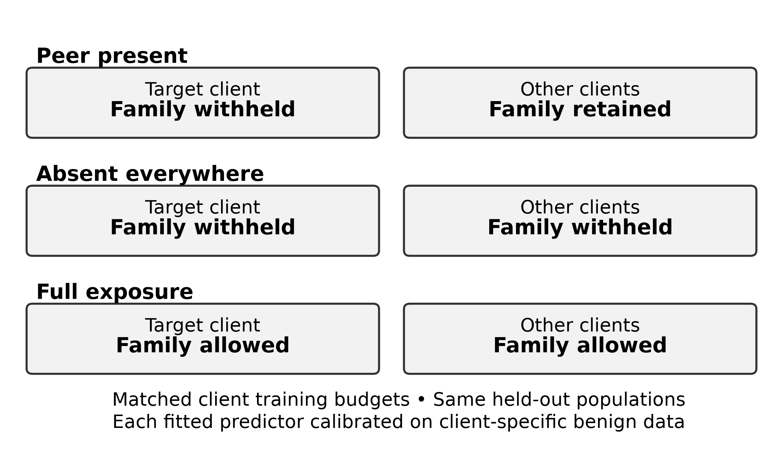
Note. The schematic illustrates one target-family pair. Each run can assign several families to different targets. In the peer-present condition, a selected family is withheld only from its assigned target, which may retain other selected families. In the absent-everywhere condition, all selected families are withheld from every client. Replacement examples preserve the 6,000-sample training budget per client. Full exposure removes the deliberate exclusions but retains the budget.
Several hidden families can affect the same run and target. Replacing their examples preserves client sample counts but can change the proportions of other malware and benign applications. Each fitted arm is also recalibrated using the same benign-score rule, so numerical thresholds may differ. The CTK contrast includes these composition and calibration effects; it does not isolate the contribution of an individual family.
The natural-scarcity comparison uses families whose target holds no more than 5% of their federation fit support, with at least 150 peer fit examples and 15 own-domain test examples. It does not artificially force the target count to zero. A naturally scarce family can have some local training examples. This comparison tests whether peer exposure helps when the family is scarce locally. It changes the selected target-family population as well as the exposure definition and therefore provides a sensitivity analysis, not an interchangeable estimate of the primary controlled task.
Prospective extensions examine quantity and specificity. Exact dose sets 0, 10, 25, 50, 100, and 200 effective peer examples per hidden family, verifying target absence and realized support. The placebo substitutes another coherent malware family using support-based matching and allocation. Both remain conditional on selected families, budgets, and replacement availability.

Aligned Representation Extension
The representation study intersects the retained LAMDA applications with all required McNdroid sources by application hash. It contains 554,136 applications, of which 170,256 are malware and 383,880 benign. The aligned inputs comprise 925 LAMDA static features, 2,390 McNdroid static features, 2,793 call-graph columns, and 17,483 report-JSON columns. The graph inputs are provider-supplied graph-derived features, not a newly trained graph neural network. The report representation uses a signed logarithmic transform, followed by arm-specific fitting of the configured input transformation. The comparison therefore concerns these processed modalities and does not cover every possible use of McNdroid.
All representations retain the original label and client definitions on the common application population. The grouping identities derive from the primary representation and package structure and are restricted to the overlap. This creates a useful matched-application comparison but does not independently group duplicate patterns in every alternative modality. The extension evaluates priority families hiddad, gappusin, and revmob; contrast families leadbolt, airpush, and dowgin; and adwo separately. These groups were selected to investigate earlier response patterns, so their results are later evidence. Because the applications overlap the original corpus and the families were selected based on earlier results, this analysis does not provide independent external validation.

Learning and Evaluation Protocol

Learners and Frozen Training
The principal model is a multilayer perceptron (MLP) with hidden layers of 256 and 64 units, rectified linear activations, and dropout probability 0.1. Binary cross-entropy on logits is optimized with Adam, a learning rate of 0.001, batch size 256, and zero weight decay. A local model trains for ten epochs on its client's budgeted fit sample. The centralized model trains for twenty epochs on the union of the four budgeted client samples. These schedules are frozen experimental settings, not evidence that each learner has reached its globally optimal configuration. Table 2 collects the conditions most important for interpreting the comparisons.
Table 2
Conditions of the Primary Controlled Study
Component | Setting
Source and representation | LAMDA var_thresh_0.01; 925 binary features
Partition | Package/feature connected components; 60/20/20 fit/calibration/test; best support among 16 attempts
Training volume | 6,000 fit rows per client; 1,500 in lower-support sensitivity
Primary eligibility | Target fit ≥20; peer fit ≥150; federation test ≥50; remaining target fit ≥500
MLP and optimization | 256/64 hidden units; rectified linear activation; dropout 0.1; Adam; learning rate 0.001; batch 256
Training schedule | Local 10 epochs; central 20; federated 20 rounds × 2 local epochs
Adaptation | FedProx μ = 0.1; fine-tuning 2 epochs; equal probability blend
Operating points | Nominal FPR 5% primary; 1% and 10% sensitivity
Primary inference | Seeds 100–109; paired effects; 9,999 BCa resamples; exact Wilcoxon; Holm across three contrasts
Note. Support requirements refer to pre-budget pools. Family-macro, own-domain, and worst-client summaries use distinct denominators. Hyperparameters and statistical procedures were frozen before confirmatory evaluation. The stored resolved configurations of all confirmatory runs match the frozen run-level protocol.
FedAvg runs twenty rounds with two local epochs per round and full participation by all four clients. Clients start each round from the global parameters, fit locally, and return parameters for sample-count-weighted aggregation. Because all four clients contribute exactly 6,000 fit examples, each client receives equal aggregation weight. A new Adam optimizer is initialized for each client's local training call; optimizer state is not carried between rounds. FedProx follows the same schedule with proximal strength 0.1. Fine-tuning starts from the fitted FedAvg model and performs two additional epochs on each client's local fit data. The blended predictor averages local and FedAvg predicted probabilities with equal weights. Each predictor is calibrated independently on the applicable client's benign calibration observations.
Centralized training is a pooled reference. Federated arms distribute fitting across experimental clients; fine-tuning adapts to target data that still lack the withheld family, and blending combines local and shared predictions. The development grid considered local duration, fine-tuning duration, and proximal strength. Confirmatory settings were frozen rather than selected from test performance; the resulting learner tradeoffs are evaluated in Results.
Alternative-model studies use a linear binary classifier and histogram-based gradient-boosted trees. Trees use up to 100 iterations, maximum depth six, and learning rate 0.1, with local and centralized arms only. Their exposure contrast tests a different model class, not federated tree aggregation. The linear study includes FedAvg and tests whether complementary gains persist without the nonlinear architecture.
For the alternative graph and report inputs, transformations are fitted using the arm's selected fit observations. A local model estimates transformation parameters from its own fit rows; shared learners use their pooled fit rows. The report input also applies the configured minimum positive prevalence of 1% when selecting columns. Calibration and test observations do not fit these transformations. However, the provider's original feature vocabulary and primary LAMDA feature reduction precede the experiment. This remains a benchmark representation assumption, rather than a demonstration that the entire feature-engineering pipeline could be estimated from an isolated future deployment's training stream.

Calibration and Metric Definitions
For each client and arm, the threshold is the empirical (1 − alpha) quantile of benign calibration scores, using the higher observed quantile value. An application is flagged only when its score is strictly greater than that threshold. The primary alpha is 0.05; sensitivities use 0.01 and 0.10. Calibration is marked insufficient when the benign calibration count multiplied by alpha is below ten. Score ties and differences between calibration and test populations can cause realized test FPR to depart from alpha. The run-level tolerance check allows an absolute two-percentage-point deviation in the client-macro FPR at the primary operating point. It is not a two-point bound on every individual client's FPR, and valid calibration support does not imply that this tolerance check passes.
Own-domain unseen-family recall counts correctly flagged test malware belonging to the families withheld from that client, using only test applications assigned to that domain. Rates are calculated per eligible client and averaged equally across clients meeting the own-domain support threshold. Federation-wide unseen-family recall instead evaluates the same target detector on test applications of its hidden families from all four domains, then averages the target-client recalls. A target can therefore be evaluated on applications outside its own market or era domain. This larger population improves support for the controlled family question but does not directly represent that client's natural incoming application stream.
Family-macro unseen recall averages the recall of the eligible target-family entries on the federation-wide population, giving each entry equal weight. It differs from first pooling hidden-family hits within each client and then averaging clients. Micro-pooled recall divides pooled hits by pooled trials and weights entries according to support. The chapter uses the original client-macro estimand for the headline confirmatory contrast and explicitly identifies the family-macro quantities in dose and family summaries. Since larger families and clients can have different responses, these weighting choices can change the reported mean without creating a numerical inconsistency.
Nonhidden-malware recall, stored as known-family recall in the results, is the equally weighted mean client recall on own-domain test malware outside the assigned hidden-family set. This population may include malware without an eligible target-family annotation; previous training exposure is not verified for every family label. Realized FPR is the mean of each client's false-positive fraction on its own benign test applications. Worst-client FPR is the maximum such fraction. Worst-client unseen recall is the minimum federation-wide hidden-family recall among contributing target clients within a seed. Its identity can change between arms, so a difference between minima is not automatically the improvement of one fixed client.
AUROC and average precision summarize binary discrimination on each client's complete own-domain test population, with client results averaged equally. Average precision is computed using scikit-learn's average_precision_score and retained under the label AUPRC in the stored artifacts. It weights precision by increments in recall rather than applying trapezoidal integration to the precision–recall curve. It also depends on the test population's class composition. Neither measure isolates the withheld families at the calibrated operating point. Their comparison with unseen-family recall therefore concerns different populations and summaries of the score distribution.

Statistical Inference and Evidence Status
The original confirmatory seeds are 100–109. Each contributes paired arm differences under the same partition and target assignment. The stored summaries include means, medians, positive-seed counts, and standardized paired effects. Confidence intervals for mean differences use 9,999 bias-corrected and accelerated (BCa) bootstrap resamples over seed differences at 95% confidence. The three primary contrasts contain no zero differences or tied absolute ranks and use exact two-sided Wilcoxon signed-rank tests. This test assesses symmetry of the difference distribution around zero; it is not a direct test of the arithmetic mean. Holm adjustment applies to the three FedAvg federation-wide decomposition contrasts at alpha 0.05 (Holm, 1979). Other learners, populations, families, and later diagnostics are outside that primary multiple-testing family.
The three-percentage-point practical CTK threshold and two-point tolerance for loss in nonhidden-malware recall are decision margins, distinct from zero-effect tests. BCa mean intervals and signed-rank tests answer different questions; disagreement does not justify replacing either procedure. A component bootstrap over held-out observations separately checks test-application dependence. Its within-seed uncertainty cannot replace the interval over paired training seeds.
Four evidence categories organize the interpretation. Class A is original confirmatory evidence; class B is prespecified robustness or sensitivity evidence; class C is post-confirmatory analysis of stored runs. Class D comprises separately frozen prospective extensions and their explicitly identified later diagnostics. The permutation extension uses seeds 200–209; the expanded-family study uses 300–309; exact dose uses 310–319; placebo and aggregation controls use 320–329; and representation comparisons use 330–339. These blocks are kept separate from the original confirmatory seeds. When an extension pools primary and replication family sets within a seed, its inferential count remains ten, not twenty independent seeds.
The associated CTK-Android repository contains the source code, configurations, machine-readable results, and provenance records: https://github.com/naslouby-salahe/ctk-android. The evidence package records execution and analysis revision f6302f7906824945731dadbbeb44357f3d025aaf, with matching revisions and clean analysis sources. The reported results come from the final deterministic execution, after GPU dropout seeding and deterministic kernels were enabled. Two earlier executions used the same confirmatory configuration but were not bit-reproducible; both produced a FedAvg CTK estimate of approximately 11.7 points. These earlier executions are not pooled into the final reported statistics. Source-data fingerprints, run manifests, validation records, and artifact digests identify the inputs and outputs. Raw datasets are external; the repository README documents the required sources and reproduction commands. These records support traceability, while access to the specified data and a compatible environment remains necessary to reproduce training. The seed intervals describe variation in the implemented experiment conditional on this corpus, not uncertainty over independently sampled organizations or future malware populations.

Experimental Results

Primary Controlled-Exposure Results
The original confirmatory comparison supports a substantial contribution from complementary peer exposure. FedAvg federation-wide unseen-family recall rises from 52.41% when the selected families are absent everywhere to 64.36% when peers retain them. The local reference is 50.90%, and FedAvg under full exposure reaches 67.64%. Realized mean FPR is 5.04% in the absence-everywhere condition, 5.09% with peer exposure, and 5.04% under full exposure. These similar averages support the comparison at a common calibration target. They conceal client variation: the peer-present mean worst-client FPR is 6.60%, and the maximum worst-client FPR across the ten seeds is 9.89%. Table 3 and Figure 2 report the paired recall effects and their uncertainty.
Table 3
Primary Paired FedAvg Decomposition at Nominal 5% FPR
Contrast | Mean (pp) | 95% BCa CI (pp) | Holm p | Positive seeds
CTK | +11.96 | [+9.15, +15.21] | 0.00586 | 10/10
Pooling | +1.51 | [−4.15, +6.10] | 0.32227 | 7/10
Total | +13.46 | [+8.82, +17.04] | 0.00586 | 10/10
Note. Ten confirmatory seeds, 100–109. CTK = peer present − absent everywhere; pooling = absent everywhere − local; total = peer present − local. Realized FPR: local 4.99%, absent 5.04%, peer 5.09%, full exposure 5.04%. Intervals summarize seed-paired mean differences; p values are exact two-sided signed-rank results adjusted across these three contrasts. pp = percentage points.
Figure 2
Complementary Exposure and Generic Pooling in the Primary FedAvg Comparison
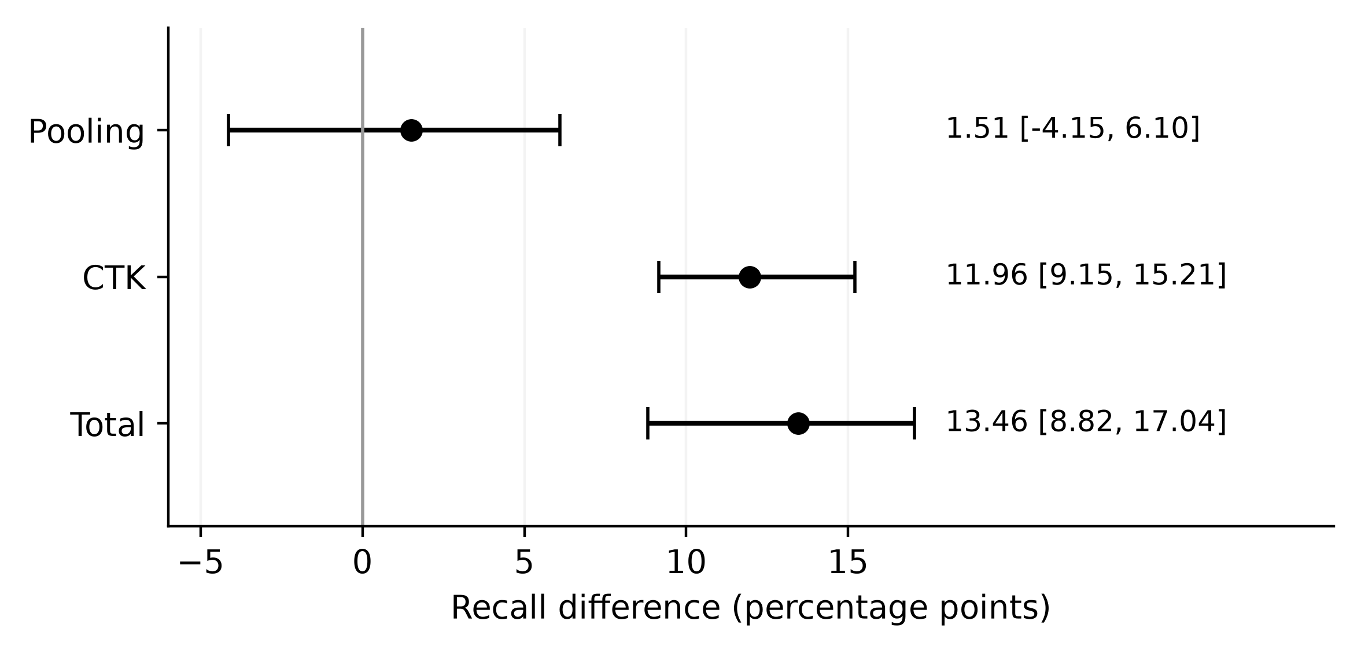
Note. Point estimates and 95% BCa intervals in percentage points. Federation-wide client-macro unseen recall, nominal 5% FPR, seeds 100–109.
Table 3 and Figure 2 show a positive CTK effect and total gain in all ten confirmatory seeds, whereas the residual collaboration effect remains compatible with either a modest benefit or harm. The displayed CTK and pooling estimates sum to 13.47 points because of rounding; their unrounded sum equals the 13.46-point total. The CTK contrast includes the training-composition change described in Figure 1: across seeds, approximately 2,073 of the 24,000 fitted examples differ between the peer-present and absent-everywhere arms.
Family-permutation, wrong-family placebo, and exact-dose studies test whether the gain depends on relevant family exposure. Their results are reported below with the original and fresh-seed evidence kept separate.
The central pooled reference gives peer-present federation-wide recall of 66.07%, compared with 52.97% in its absence-everywhere condition and 70.19% under full exposure. Central and federated learners have different training schedules, so these means do not establish superiority under matched conditions. Peer-present recall remains below the full-exposure mean under the tested procedure. Full exposure is a finite reference, and the ordering can vary across families and seeds.
On own-domain unseen malware, FedAvg peer-present training improves recall by 10.85 points over absence-everywhere training (interval 6.97–15.25). The residual collaboration effect is −7.60 points (−11.81 to −4.03), leaving a total gain over local learning of 3.26 points (1.26–5.63). Thus, much of the complementary exposure effect offsets a loss in the absence-everywhere condition. The 11.96-point headline CTK effect uses federation-wide hidden-family test malware and compares peer-present with absence-everywhere training; the 3.26-point net gain uses own-domain hidden-family test malware and compares peer-present with local training. These own-domain findings are secondary population results, outside the primary Holm-adjusted comparisons.
Family-macro CTK is 12.44 points, with interval 10.09–15.55, while the total family-macro gain is 10.57 points. The worst-client metric yields CTK of 18.49 points, with interval 13.88–26.29, and total gain of 14.88 points. Weighting every hidden-family test application equally produces a smaller but still positive effect: micro-pooled CTK is 6.58 points (interval 4.64–8.65), positive across all ten confirmatory seeds. Under this weighting, pooling contributes 4.00 points and the total gain is 10.58 points. Much of the difference from the client-macro estimate comes from dowgin, which contributes approximately 47% of the hidden-family test applications but has almost no CTK gain. Excluding dowgin raises micro-pooled CTK to 12.24 points. These values use their own aggregation rules. In particular, the worst-client comparison subtracts arm-specific minima; it does not mean that a single consistently worst client improves by that amount. FedAvg federation-wide CTK remains positive at both alternative operating points, reaching 7.85 points at 1% nominal FPR and 13.78 points at 10%, compared with 11.96 points at the primary 5% operating point. Operating-point sensitivity therefore matters even when the direction of the exposure effect remains positive.

Learning-Strategy Comparisons
Table 4 compares six peer-present strategies. The post-confirmatory FedProx-minus-FedAvg difference in federation-wide unseen recall is 0.19 points (−1.12 to 2.94), leaving superiority unresolved. Complementary exposure remains positive in all ten seeds for each alternative collaborative learner: mean CTK is 13.10 points for centralized training, 13.20 for FedProx, 8.20 for fine-tuned FedAvg, and 7.60 for blending. Learner choice changes the magnitude and tradeoffs of CTK without reversing its direction in these configurations. Centralization has the highest descriptive federation-wide mean, under a different training and information-sharing arrangement.
Table 4
Peer-Present Learner Performance at Nominal 5% FPR
Learner | Federation unseen | Own-domain unseen | Worst client | Nonhidden | FPR
Local | 50.90 | 50.67 | 28.92 | 73.06 | 4.99
Central | 66.07 | 56.27 | 41.42 | 72.92 | 5.10
FedAvg | 64.36 | 53.93 | 43.79 | 69.46 | 5.09
FedProx | 64.55 | 55.98 | 37.90 | 72.13 | 5.09
Fine-tuned FedAvg | 62.16 | 51.64 | 40.35 | 69.33 | 5.03
Blend | 63.66 | 57.21 | 37.63 | 74.77 | 5.12
Note. All entries are percentages averaged over ten confirmatory seeds. Worst client is the within-seed minimum federation-wide unseen recall. Other recall and FPR columns follow the macro definitions in the protocol. Arm rankings are descriptive; table levels are not confidence intervals or adjusted pairwise superiority tests.
Nonhidden-malware recall changes the ranking. FedAvg loses 3.61 points relative to local learning (−4.50 to −2.85), and fine-tuning loses 3.74 (−5.31 to −2.82); both mean losses exceed the frozen two-point tolerance. FedProx loses 0.93, central learning 0.14, and blending gains 1.70. The tolerance indicator compares means with a practical margin. It is neither an interval-based equivalence test nor a guarantee for every client.
Figure 3 retains the distinction between mean and worst-client recall. FedAvg has the highest descriptive mean of within-seed minima, despite its loss in nonhidden-malware recall; FedProx and blending preserve more nonhidden-malware recall but have lower minima. These rankings reveal why federation-wide mean recall alone is insufficient for learner selection. The relevant tradeoff depends on acceptable losses and the intended test population.
Figure 3
Mean and Worst-Client Unseen Recall Across Learners
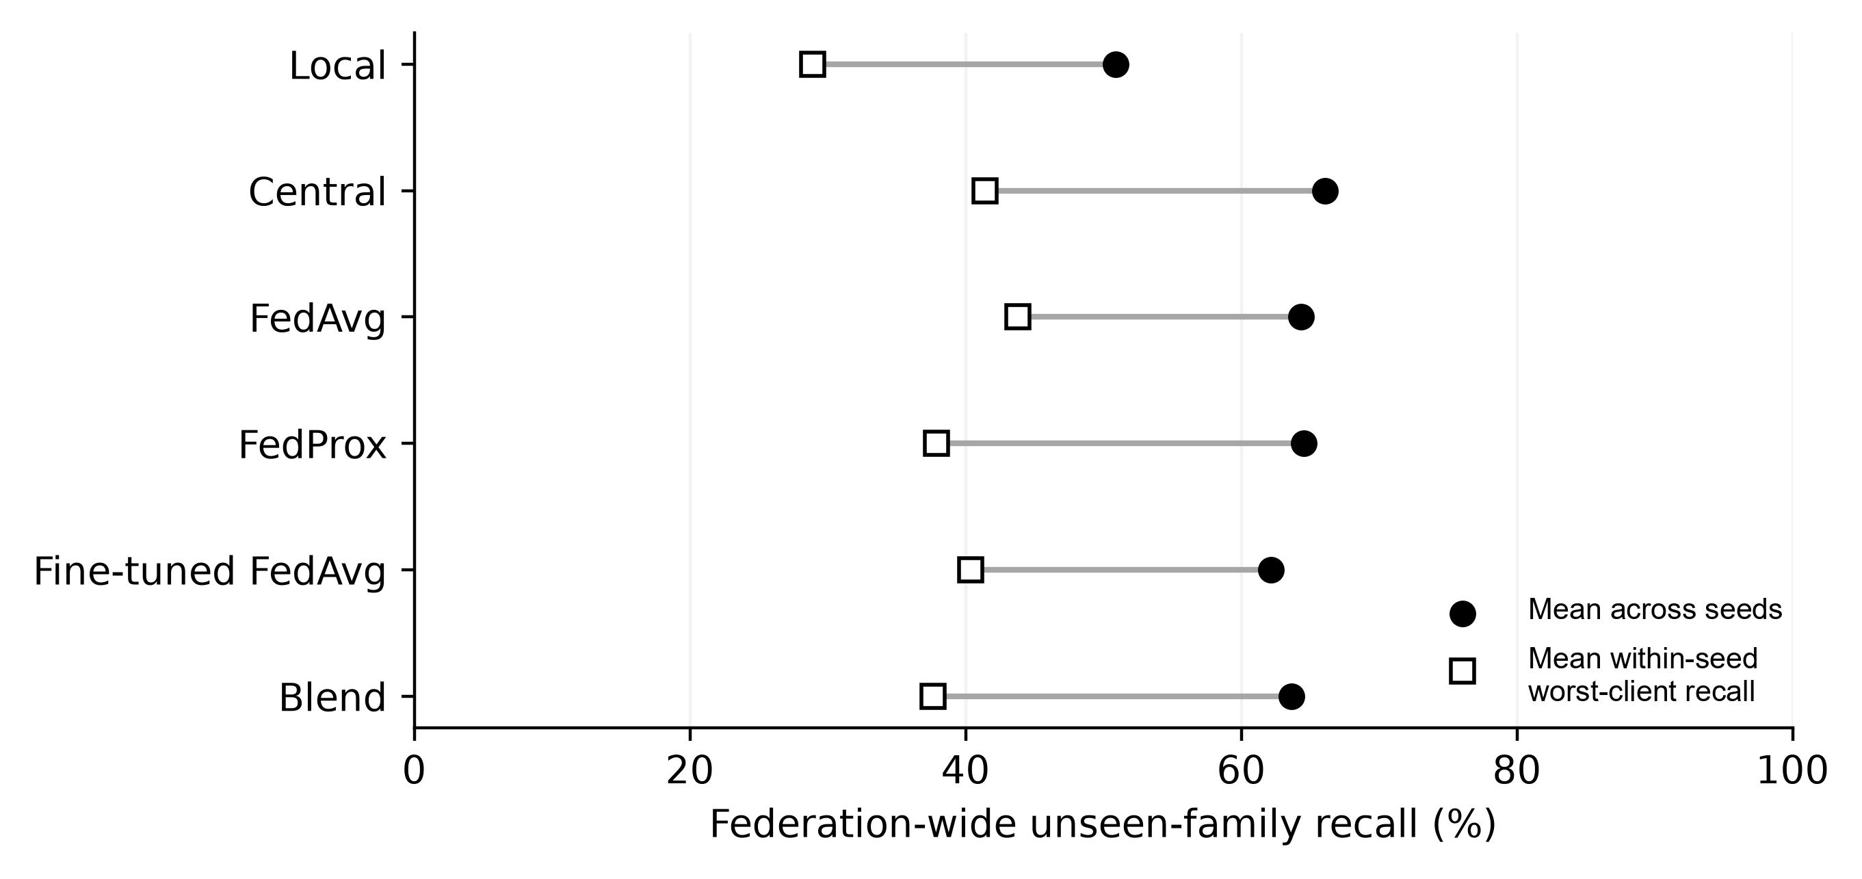
Note. Peer-present condition, nominal 5% FPR, seeds 100–109. Points show means across seeds; no uncertainty interval is implied. Worst-client identity can change across arms.
Overall discrimination declines despite improved hidden-family coverage. Post-confirmatory FedAvg-minus-local changes are −0.01166 in mean AUROC and −0.02011 in mean average precision. These metrics summarize complete own-domain test populations across thresholds, whereas the targeted recall effect concerns selected hidden families. Both outcomes are needed to assess the detector.

Malware-Family and Client Heterogeneity
Figure 4 compares primary-family recall across the four exposure conditions. Revmob and leadbolt have the largest mean CTK gains, 33.38 and 27.75 points, with substantial improvements over local learning. Revmob nevertheless remains below 60% recall even under full-exposure FedAvg. A large exposure gain therefore need not imply adequate absolute detection.
Figure 4
Family-Specific Recall Across Exposure Conditions
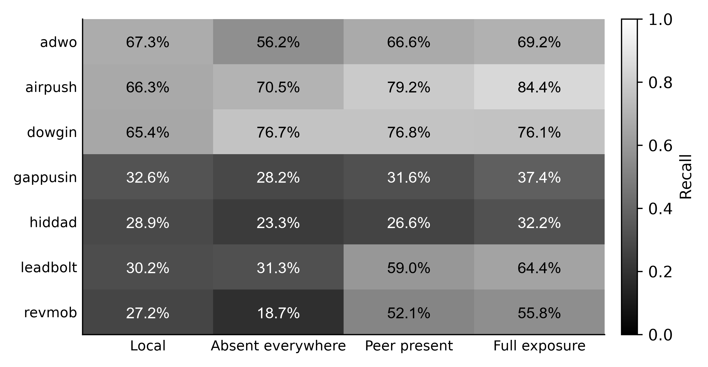
Note. Cells show mean recall percentages to one decimal place at nominal 5% FPR across seeds 100–109. Full exposure refers to FedAvg and is a finite reference. The grayscale bar expresses the same recall values as proportions.
Dowgin benefits chiefly from pooling: its CTK is only 0.14 points despite a substantial local-to-collaborative gain. Adwo shows repair of negative transfer: the 10.37-point CTK effect recovers most of the absence-everywhere loss, but peer-present recall remains below local recall. The plotted levels distinguish these mechanisms without treating both families as equivalent complementary-exposure successes.
Gappusin and hiddad show limited response in the primary static representation. Their CTK means are 3.46 and 3.25 points, respectively, but peer-present recall remains only 31.63% and 26.57%. Both final recalls are below their local means. The full-exposure central recalls, 42.38% for gappusin and 28.68% for hiddad, also remain low. This pattern motivates a representation question rather than supporting a claim that additional exposure always solves local absence. Airpush occupies an intermediate position, with CTK of 8.71 points and peer-present recall of 79.24%. The primary family estimates are descriptive summaries over the frozen seed-specific target assignments, not seven independently adjusted confirmatory discoveries.
Replication includes losses: dnotua has mean CTK of −8.24 points and zdtad −2.06, compared with positive means of 13.63 for inmobi and 12.04 for domob. Utchi and zdtad contribute six seeds rather than ten. The positive aggregate replication result therefore coexists with families with negative CTK estimates and unequal precision; it is not a uniformly supported ranking of all eight names.
Client-level decomposition is class C evidence. Federation-wide FedAvg CTK averages 8.35 points at Anzhi, 7.58 at AppChina, 9.18 at play-early, and 32.03 at play-late. The corresponding contributing seed counts are eight, ten, ten, and six. The especially large play-late mean is therefore conditional on fewer contributing seeds and selected family assignments. Anzhi's total gain is only 1.34 points despite its positive CTK, whereas its nonhidden-malware recall falls by 6.93 points in the client diagnostic. The own-domain total gain also differs substantially across clients: −2.80 points for Anzhi, −0.40 for AppChina, 6.48 for play-early, and 13.61 for play-late. The first two estimates have intervals spanning zero. The positive own-domain aggregate is therefore not shared uniformly across the four domains, and the play-late estimate is based on approximately 107 hidden-family test applications per contributing seed. Unequal support across clients prevents attributing the difference in gains solely to market identity.

Peer Exposure and Dose Response
Requested peer caps differ markedly from fitted exposure. Caps of 100 and 1,000 applications per family yield mean effective FedAvg doses of 9.03 and 79.39 because budget selection follows capping. The all-available condition reaches 296.19 examples and family-macro CTK of 12.44 points; it alone averages at least 100 fitted peer examples per family. The requested caps therefore overstate the exposure actually used in training.
The later exact-dose study sets the number of peer examples actually fitted. Across the pooled primary and replication family sets, FedAvg family-macro federation-wide CTK is 2.92, 4.90, 7.83, 12.48, and 14.49 points at 10, 25, 50, 100, and 200 peer examples, respectively. Figure 5 shows these means and their 95% BCa confidence intervals. At every dose, the effect is positive in all ten extension seeds. The interval at ten examples is 2.31–3.64 points, crossing the three-point practical threshold; the interval at twenty-five is 3.87–5.89. A positive effect does not necessarily exceed the practical threshold.
Figure 5
Exact Peer Dose and Complementary Gain
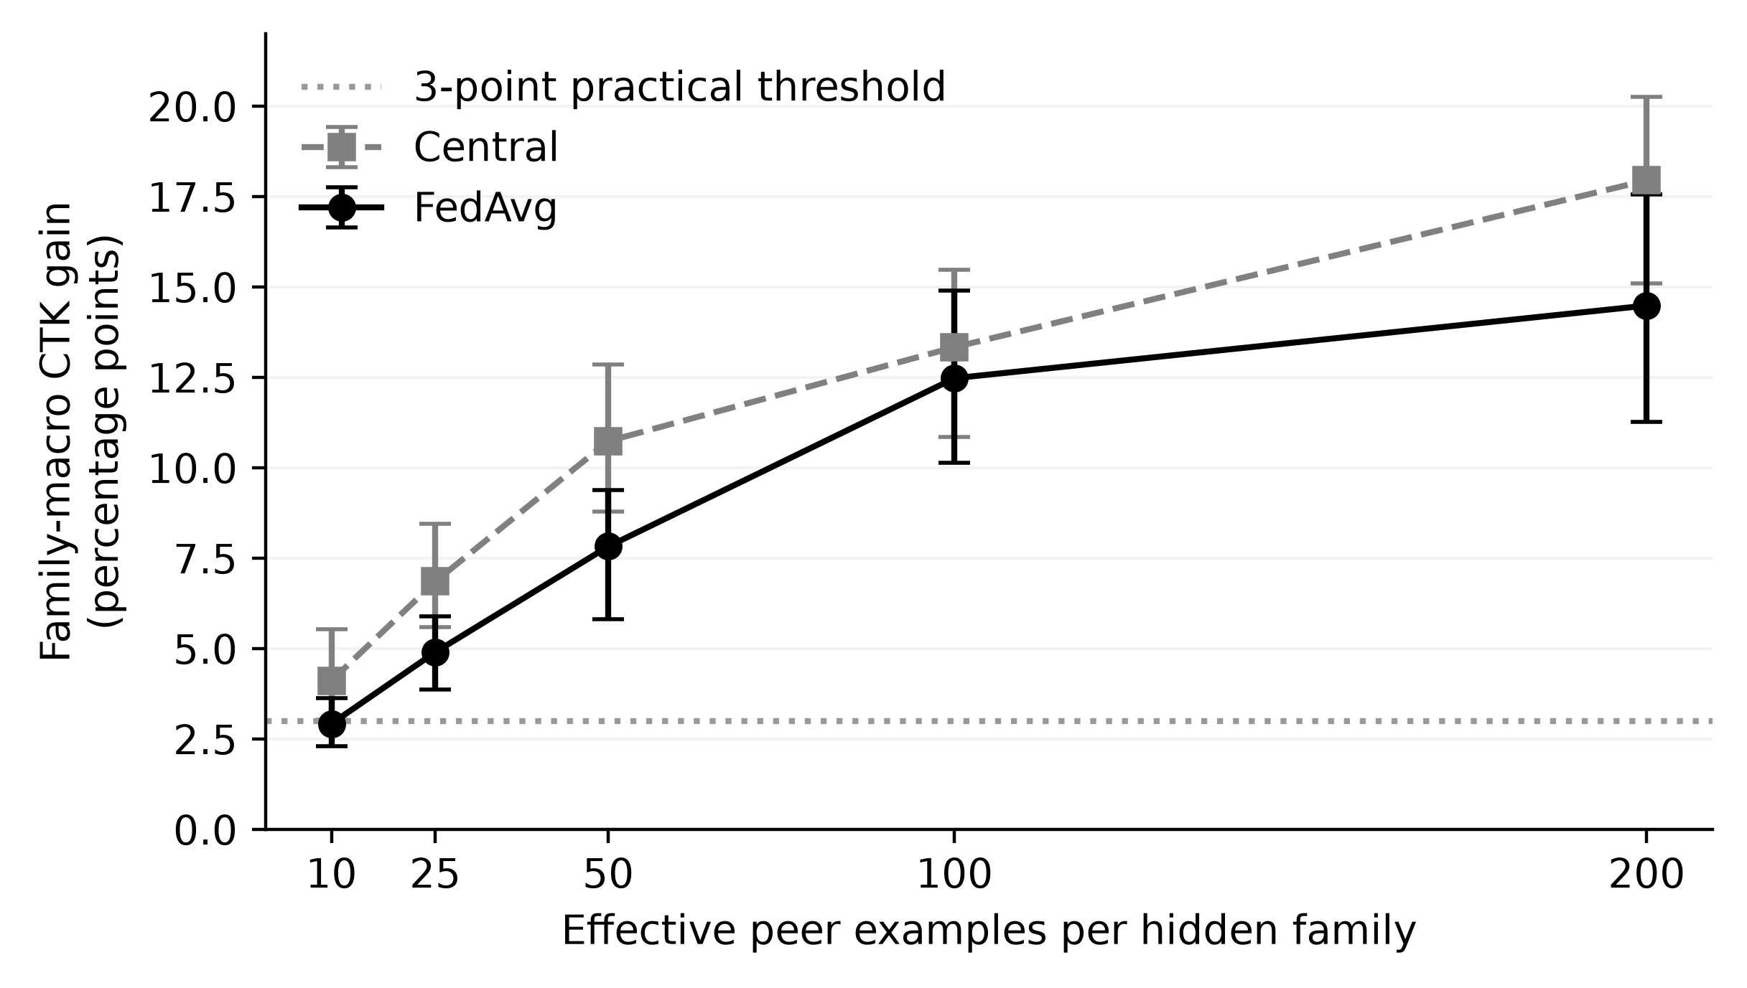
Note. Prospective extension, seeds 310–319. Family-macro federation-wide effects pooled within seed across primary and replication sets at nominal 5% FPR; 95% BCa intervals. The dotted line marks a practical threshold, not a universal dose requirement.
The mean curve increases, but the final increment does not establish a precise saturation boundary. The 100-to-200 increment is 2.01 points with interval −0.06 to 4.06, whereas the 50-to-100 increment is 4.65 with interval 2.43–7.09. The pooled increment combines different family-set responses. Between 100 and 200 peer examples, CTK increases by 4.23 points (interval 2.53–6.55) in the primary set, compared with 0.03 points (−3.91 to 2.54) in the replication set. The primary-set gain therefore continues across the tested range, while the replication-set response is approximately flat. The evidence does not establish a common saturation point or universal minimum dose. Families differ: the stored dose diagnostic shows dowgin remaining near zero or slightly negative even at the highest level. The exact zero-dose and absence-everywhere arms have identical observed effects in the frozen consistency results.

Negative Controls, Replication, and Robustness
The family-permutation control disrupts correspondence between family annotations and application features while retaining binary malware labels. Original FedAvg federation-wide CTK at nominal 5% FPR is 0.30 points, with interval −0.36 to 1.02, within the predefined ±3-point equivalence band. The own-domain interval extends to 3.04 points and remains unresolved under that rule. In the separate extension, federation-wide CTK is −0.21 points and own-domain CTK is −0.07; both intervals lie within the band. The fresh-seed results strengthen the control evidence, although the original own-domain result remains unresolved.
Table 5 reports the wrong-family placebo and CTK-minus-placebo effects; the latter is positive in all ten extension seeds. Substituting another sufficiently supported family does not reproduce the selected family's benefit. Support matching and necessary reallocation across peers do not match every behavioral property, however. The control supports specificity under this replacement scheme rather than a perfect semantic counterfactual.
The disjoint-family replication in Table 5 has eight positive seeds; its 5.08-point mean exceeds the practical threshold, but the interval's lower bound does not. Linear FedAvg, centralized trees, lower training support, low/high family support, package-only grouping, and three alternative partition salts retain positive mean CTK. These checks broaden the tested configurations within the same corpus and construction.
Table 5
Selected Replication, Sensitivity, and Control Effects
Comparison | Class | Mean (pp) | 95% BCa CI (pp)
Disjoint family set | A | +5.08 | [+2.28, +7.10]
Natural scarcity | B | +11.19 | [+9.46, +12.59]
Linear FedAvg | B | +9.37 | [+7.54, +10.97]
Centralized trees | B | +10.18 | [+7.59, +13.70]
Lower training support | B | +10.99 | [+8.71, +13.52]
Lower family support | B | +14.01 | [+11.46, +16.22]
Higher family support | B | +11.59 | [+9.17, +13.75]
Package-only grouping | B | +11.32 | [+8.60, +13.29]
Wrong-family placebo | D | −0.54 | [−1.36, +0.20]
CTK minus placebo | D | +10.04 | [+8.35, +12.28]
Note. A = original confirmatory; B = prespecified sensitivity; D = prospective extension. First eight rows are CTK effects on the client-macro federation-wide metric, seeds 100–109. Last two are family-macro effects pooled within seeds across family sets, seeds 320–329. These rows are not one multiple-testing family and are not pooled into the primary test. A positive mean above three points need not have an interval entirely above that practical threshold.
Natural scarcity also gives a positive effect (Table 5), but changes local exposure, eligible targets, and pooling. In the placebo/aggregation extension, pooled CTK is 9.50 points under mean aggregation, 9.16 under trimmed mean, and 13.76 under the implemented median. With four clients, trimming removes one value from each coordinate's tails; tensor median uses the lower middle value. These are honest-client aggregation checks, with no malicious updates or poisoning-defense test.

Representation and Expanded-Family Analyses
The aligned representation extension separates improvements in full-exposure recognition from changes in the CTK contrast. For the priority-family macro average, McNdroid static features improve centralized full-exposure recall by 7.57 points relative to the aligned LAMDA baseline, with interval 2.76–12.85. Their FedAvg CTK increment is 8.01 points, with interval 3.56–10.54. Call-graph features increase the CTK contrast by 9.03 points, with interval 5.53–12.35, but their full-exposure recall increment is only 2.52 points, with interval −0.86 to 7.77. A larger CTK contrast therefore need not mean a clearly higher full-exposure recall level; changes in the absence-everywhere baseline also matter.
Report-JSON reduces both full-exposure recall and CTK on the same priority-family summary. Its full-exposure recall difference is −14.54 points, with interval −18.63 to −8.66, and its CTK difference is −6.12 points, with interval −9.91 to −3.87. Family results also differ: McNdroid static improves full-exposure recall for gappusin by 16.93 points and adwo by 33.60, but the hiddad estimate is −6.21 with interval −18.02 to 6.29. The interval does not establish an improvement in hiddad recall.
These comparisons use a common nominal calibration target, not identical realized FPRs. The extension diagnostics record macro-FPR tolerance failures in exact-dose primary seed 317, LAMDA-static and McNdroid-static representation seed 333, and call-graph seed 334; one call-graph central peer-present client reaches 15.32% FPR. The stored post-hoc equal-test-FPR diagnostic retains the priority-macro full-exposure direction for static features (+7.28 points) and report-JSON (−14.27 points); the call-graph interval still includes zero. Because this diagnostic uses benign test scores to equalize FPR, it is a descriptive sensitivity, not an independently calibrated deployment result. The findings concern these processed features and the frozen learner, rather than the intrinsic utility of an entire modality.
The 32-family extension asks whether a distance-based novelty descriptor helps explain transfer variation. The mean family CTK is 6.51 points, but five families have negative point estimates, including feiwo at −5.89 and baiduprotect at −4.41. The descriptor measures distance to the nearest sufficiently supported known-family feature centroid; it is not a direct measure of behavioral novelty. Across all 32 families, the stored Spearman association is .408, with family-bootstrap interval .088–.662 and permutation p = .0214. This is suggestive extension evidence, not a validated predictive model for selecting future federation partners or estimating a new family's gain.
Eligibility stability materially weakens that association. Restricting to the 27 families eligible in every fresh seed gives ρ = .294, interval −.076 to .589, and p = .136. The restriction changes both precision and the analyzed population. The full-sample association is therefore sensitive to eligibility, leaving novelty uncertain as an explanation of CTK. The expanded set also overlaps previously studied families. It broadens the family analysis on fresh seeds; the 32 families are not all new independent cases. Fourteen of the 32 families overlap the primary or replication sets. For the 18 newly examined families, seed-level family-macro CTK averages 3.47 points (interval 2.45–4.45), compared with 10.67 points for the overlapping families. The newly examined subset has a positive mean in all ten fresh seeds, although its magnitude is considerably smaller than the primary estimate. This post hoc subdivision is descriptive and does not represent an additional confirmatory test. Later rank and influence diagnostics remain exploratory. The results establish heterogeneity, but provide limited evidence that centroid distance explains which families benefit most.

Discussion and Practical Implications

What the Controlled Contrast Establishes
The matched-budget contrast in Figure 1 estimates the combined effects of selected-family exposure, replacement sampling, and arm-specific calibration. Holding collaborative training schedules and client sample counts constant makes this contrast more informative than a local-versus-federated comparison alone.
The decomposition asks two distinct questions: whether collaboration helps without the selected threats, and what relevant peer exposure adds to that setting. Most primary benefit lies in the latter component. Smaller positive effects in the disjoint replication and newly examined families limit generalization of the primary magnitude. Own-domain negative pooling is a form of negative transfer that offsets much of CTK. A participant therefore needs both the final comparison with its local detector and the decomposition explaining that change.
The family patterns distinguish recovery from additional capability. Adwo largely recovers a pooling loss; revmob and leadbolt improve beyond local learning; dowgin benefits mainly without direct family exposure; and hiddad remains difficult. These are responses under the tested corpus and representations, not permanent family properties.

Evaluating Collaboration as a Set of Tradeoffs
Organizations evaluating collaborative detection should specify the population on which benefit matters before comparing algorithms. A federation-wide hidden-family test asks whether a target model can recognize a family across multiple source domains. An own-domain test asks whether that model improves on the applications associated with its own domain. Both are useful, but the larger federation-wide estimate should not be substituted for a local operational benefit. Likewise, a family-macro average answers a different question from a sample-weighted rate. Equal family weighting prevents large families from dominating; it does not estimate the number of real incidents that would be prevented.
Learner selection requires unseen-family recall, nonhidden-malware recall, realized FPR, and performance at the least successful client. FedAvg has a comparatively strong minimum-client mean while losing nonhidden-malware recall. FedProx reduces that recall loss without establishing an improvement in mean unseen recall. Fine-tuning and blending change the balance again. An organization would need to define acceptable losses before choosing among these tradeoffs and then validate the choice on its own application stream.
The observed FPR variation also matters operationally. The primary mean is close to the nominal target, but individual clients can exceed it substantially, and some extension runs fail the macro-level tolerance check. A 5% benign FPR may itself create an unacceptable alert burden. The experiment does not measure triage costs or analyst workload, so even an operating point that meets the benchmark tolerance is not established as suitable for deployment. Calibration would need to be checked on the intended population and reassessed as that population changes.
AUROC and average precision alone can conceal targeted coverage gains; hidden-family recall alone can conceal losses elsewhere. Detection claims should therefore identify their population, threshold rule, and client aggregation. Reporting these together allows a useful exposure effect to be recognized without implying overall classifier superiority.

Exposure, Representation, and Remaining Questions
Effective peer support must be measured after exclusions and budget selection. Nominal caps can greatly overstate fitted exposure and distort conclusions about data efficiency. The exact-dose results support auditable exposure accounting, but their family-dependent responses do not prescribe how many examples a new domain or representation needs to achieve a particular recall.
Representation results further limit a simple more-data explanation. For some families, additional static features improve recognition; for others, the tested richer modalities do not help. The call-graph contrast demonstrates that CTK can increase without a clearly established improvement in full-exposure recall. This follows from the estimand: both the peer-present and absence-everywhere baselines can move. Representation evaluation should therefore compare levels as well as differences, and should keep the application population aligned where possible. The present comparison provides that alignment but remains tied to overlapping source data and a common family-label system.
Privacy and adversarial resilience require separate evidence. This experiment implements no formal privacy mechanism or accounting; shared preprocessing also leaves work before a fully distributed deployment. Positive CTK under trimmed or median aggregation concerns honest clients, not resistance to poisoning or evasion. Related systems investigate these additional properties, but controlled detection performance alone cannot establish them.
The uncertain novelty association also limits partner-selection implications. Centroid distance can reflect support, representation, and eligibility as well as complementarity. Controlled exposure comparisons provide stronger evidence of useful peer contributions than assuming that distance predicts benefit. Independent domains, prospective families, chronological evaluation, and operational cost measurements remain necessary to extend the findings to deployment.

Threats to Validity

Construct and Internal Validity
CTK measures recall under supplied family annotations. Automated labels can merge or split behavior, and the selected, partly adware-oriented families do not represent all Android threats. Locally unseen means absent from target fit data, not globally or temporally novel; natural scarcity permits limited exposure. Poor response can reflect labels, representation, support, or the fitted decision rule, without identifying any one as the sole cause.
Matched counts permit changes in class and family composition. Simultaneous family interventions and replacement examples can interact, and arm-specific calibration contributes to the response. The contrast therefore concerns the complete fitted intervention. Grouping removes exact package and primary-feature overlap, but cannot exclude near-duplicate variants, shared libraries, or duplicate patterns in alternative modalities. Provider-level vocabularies and feature reduction also precede the split.
Selecting the best-supported of 16 partitions and assigning targets by eligibility conditions the analysis on support-rich client-family pairs. The four market/era domains represent constructed clients rather than independently administered organizations. The multimodal intersection further selects applications with every required view. These choices enable controlled comparisons while restricting the population represented by the estimates.

Statistical and Dataset Validity
Ten paired seeds describe partition, assignment, and training variability on one fixed corpus, with limited subgroup precision. Leave-one-seed-out mean CTK ranges from 11.06 to 12.65 points, always above the three-point threshold; this sensitivity supports stability but does not replace the BCa interval. Recurring families and clients are not independent datasets, and some subgroups contribute fewer seeds. Seeds remain the inferential units. BCa intervals concern means; signed-rank tests concern a symmetric difference distribution under the null. Holm adjustment covers only the declared primary contrasts. Family, client, representation, and association diagnostics outside that family are not additional adjusted confirmatory findings.
Worst-client summaries depend on contributing clients and on which arm-specific client attains the minimum. Unequal subgroup support limits comparisons and prediction for a new organization. The expanded-family association likewise depends on eligibility. The positive aggregate results coexist with families that have negative CTK estimates, losses in nonhidden-malware recall, unresolved controls, and representation changes that fail to improve detection.
LAMDA's collection and labeling procedures produce a research benchmark rather than a probability sample of contemporary Android use. Market filtering further changes its population. The provider's antivirus-derived benign designation is not a proof that every retained benign application is harmless, and family annotations may change under another labeling system. McNdroid overlap cannot provide independent external replication. Reproducible artifacts and validated fingerprints establish which frozen evidence was used, but they cannot remove these underlying sampling and label limitations. The chapter makes no claim that its observed class proportions or family mix reflect a current production environment.

External and Operational Validity
This offline study fixes features, budgets, hyperparameters, and full participation. It does not measure client dropout, communication or energy costs, latency, analyst workload, or Android application integration. Privacy leakage, poisoning, evasion, and secure aggregation are untested. Positive CTK supports complementary exposure in the benchmark; deployment claims require evidence about intended domains, operating costs, threat models, and data governance.

Conclusion
CTK-Android finds that complementary peer exposure increases FedAvg federation-wide unseen-family recall by 11.96 percentage points relative to absence-everywhere training (95% BCa interval 9.15–15.21). The matched-budget three-arm design separates this contribution from a small, uncertain residual collaboration effect and explains more than a local-versus-federated comparison alone.
Family heterogeneity and learner tradeoffs qualify the benefit. Some families improve beyond local learning, others recover pooling losses, and some remain difficult. Relative to local learning, FedAvg gains 3.26 points in own-domain unseen-family recall but loses 3.61 points in nonhidden-malware recall; overall AUROC and average precision also decline. Learner selection consequently depends on the intended population and acceptable costs, including worst-client performance.
Permutation and wrong-family placebo controls strengthen the family-specific interpretation. Separately frozen exact-dose experiments show increasing mean gains across tested peer-support levels, while primary and replication responses differ at the upper end. These controls support the importance of relevant exposure without prescribing a universal dose. Mixed representation effects and the weakened novelty association under stable eligibility further restrict generalization.
The contribution is a reproducible empirical framework for attributing collaborative detection gains while exposing their costs. Within an offline benchmark of constructed clients, matched exposure, client-specific calibration, and paired evaluation distinguish additional recognition from recovery of negative transfer. This decomposition makes the source and scope of collaborative benefit explicit and supports transparent comparison of learning strategies.

References
Allix, K., Bissyandé, T. F., Klein, J., & Le Traon, Y. (2016). AndroZoo: Collecting millions of Android apps for the research community. In Proceedings of the 13th International Conference on Mining Software Repositories (pp. 468–471). ACM. https://doi.org/10.1145/2901739.2903508
Arp, D., Quiring, E., Pendlebury, F., Warnecke, A., Pierazzi, F., Wressnegger, C., Cavallaro, L., & Rieck, K. (2022). Dos and don'ts of machine learning in computer security. In 31st USENIX Security Symposium (pp. 3971–3988). USENIX Association. https://www.usenix.org/conference/usenixsecurity22/presentation/arp
Arp, D., Spreitzenbarth, M., Hübner, M., Gascon, H., & Rieck, K. (2014). Drebin: Effective and explainable detection of Android malware in your pocket. In Proceedings of the Network and Distributed System Security Symposium. Internet Society. https://doi.org/10.14722/ndss.2014.23247
Augello, A., De Paola, A., & Lo Re, G. (2025). M2FD: Mobile malware federated detection under concept drift. Computers & Security, 152, Article 104361. https://doi.org/10.1016/j.cose.2025.104361
Ciaramella, G., Martinelli, F., Peluso, C., Santone, A., & Mercaldo, F. (2026). A method for real-world privacy-preserving Android malware detection through federated machine learning. Information and Software Technology, 189, Article 107892. https://doi.org/10.1016/j.infsof.2025.107892
Feng, C., Huertas Celdrán, A., Sánchez Sánchez, P. M., Kreischer, J., von der Assen, J., Bovet, G., Martínez Pérez, G., & Stiller, B. (2025). CyberForce: A federated reinforcement learning framework for malware mitigation. IEEE Transactions on Dependable and Secure Computing, 22(4), 4398–4411. https://doi.org/10.1109/TDSC.2025.3547005
Gálvez, R., Moonsamy, V., & Diaz, C. (2021). Less is more: A privacy-respecting Android malware classifier using federated learning. Proceedings on Privacy Enhancing Technologies, 2021(4), 96–116. https://doi.org/10.2478/popets-2021-0062
Haque, M. A., Hossain, I., Kamol, M. M., Alam, M. J., Amalapuram, S. K., Talukder, S., & Rahman, M. S. (2026). LAMDA: A longitudinal Android malware benchmark for concept drift analysis. In The Fourteenth International Conference on Learning Representations. https://openreview.net/forum?id=1FnCrZtBNQ
Holm, S. (1979). A simple sequentially rejective multiple test procedure. Scandinavian Journal of Statistics, 6(2), 65–70. https://www.jstor.org/stable/4615733
Kamol, M. M., Lopez, J., Nowmi, S. R., Rivas, E., Haque, M. A., Raff, E., Piplai, A., & Rahman, M. S. (2026). McNdroid: A longitudinal multimodal benchmark for robust drift detection in Android malware [Preprint]. arXiv. https://doi.org/10.48550/arXiv.2605.06894
Li, T., Sahu, A. K., Zaheer, M., Sanjabi, M., Talwalkar, A., & Smith, V. (2020). Federated optimization in heterogeneous networks. In I. Dhillon, D. Papailiopoulos, & V. Sze (Eds.), Proceedings of Machine Learning and Systems (Vol. 2, pp. 429–450). https://proceedings.mlsys.org/paper_files/paper/2020/hash/1f5fe83998a09396ebe6477d9475ba0c-Abstract.html
Mariconti, E., Onwuzurike, L., Andriotis, P., De Cristofaro, E., Ross, G., & Stringhini, G. (2017). MaMaDroid: Detecting Android malware by building Markov chains of behavioral models. In Proceedings of the Network and Distributed System Security Symposium. Internet Society. https://doi.org/10.14722/ndss.2017.23353
McMahan, B., Moore, E., Ramage, D., Hampson, S., & Agüera y Arcas, B. (2017). Communication-efficient learning of deep networks from decentralized data. In A. Singh & J. Zhu (Eds.), Proceedings of the 20th International Conference on Artificial Intelligence and Statistics (Vol. 54, pp. 1273–1282). PMLR. https://proceedings.mlr.press/v54/mcmahan17a.html
Ongun, T., Boboila, S., Oprea, A., Eliassi-Rad, T., Hiser, J., & Davidson, J. (2025). CELEST: Federated learning for globally coordinated threat detection. IEEE Transactions on Information Forensics and Security, 20, 10434–10448. https://doi.org/10.1109/TIFS.2025.3614442
Patel, A., Tomar, D. S., Pateriya, R. K., & Haripriya, R. (2026). FL-MalDrift: A federated learning framework for malware detection under local concept drift. Scientific Reports, 16, Article 1821. https://doi.org/10.1038/s41598-025-31592-z
Pendlebury, F., Pierazzi, F., Jordaney, R., Kinder, J., & Cavallaro, L. (2019). TESSERACT: Eliminating experimental bias in malware classification across space and time. In 28th USENIX Security Symposium (pp. 729–746). USENIX Association. https://www.usenix.org/conference/usenixsecurity19/presentation/pendlebury
Popoola, S. I., Ande, R., Adebisi, B., Gui, G., Hammoudeh, M., & Jogunola, O. (2022). Federated deep learning for zero-day botnet attack detection in IoT-edge devices. IEEE Internet of Things Journal, 9(5), 3930–3944. https://doi.org/10.1109/JIOT.2021.3100755
Prasad, A., & Kumar, S. (2026). Droidware: A security hardened federated framework for robust Android malware detection. Engineering Applications of Artificial Intelligence, 181, Article 115638. https://doi.org/10.1016/j.engappai.2026.115638
Sebastián, S., & Caballero, J. (2020). AVClass2: Massive malware tag extraction from AV labels. In Annual Computer Security Applications Conference (pp. 42–53). ACM. https://doi.org/10.1145/3427228.3427261
Shao, X., Otani, A., Yamakawa, K., Hirasuka, Y., & Wai Shiang, C. (2026). Objective mismatch in federated learning under missing class support. IEICE Transactions on Fundamentals of Electronics, Communications and Computer Sciences. Advance online publication. https://doi.org/10.1587/transfun.2026EAP1060
Shen, J., Yang, W., Chu, Z., Fan, J., Niyato, D., & Lam, K.-Y. (2024). Effective intrusion detection in heterogeneous Internet-of-Things networks via ensemble knowledge distillation-based federated learning. In ICC 2024 – IEEE International Conference on Communications (pp. 2034–2039). IEEE. https://doi.org/10.1109/ICC51166.2024.10622262

Key Terms and Definitions
Complementary Threat Knowledge: The detection benefit associated with peer exposure to selected malware families, measured here by comparing matched collaborative conditions with and without those families.
Federated Learning: Joint model training in which participants fit models on their respective data and combine updates through an aggregation process.
Android Malware Family: A supplied grouping of malicious Android applications treated as related for the purposes of exposure selection and evaluation.
Locally Unseen Family: A selected malware family absent from a target client's fit sample, regardless of whether its examples occur at peers or share features with other malware.
Controlled Exposure: An experimental manipulation of which clients' training samples contain selected family examples while preserving specified comparison conditions.
Residual Collaboration Effect (Pooling): The recall difference between collaboration without the selected hidden families anywhere and the corresponding local learner, including differences in training composition and optimization schedules.
Negative Transfer: A reduction in a specified target performance measure after a defined transfer or collaboration intervention, relative to its stated reference.
Realized False-Positive Rate: The proportion of benign test applications flagged as malware by the calibrated predictor, distinct from the nominal calibration target.
Effective Peer Dose: The number of selected hidden-family examples actually used to fit peer models after exclusions, availability limits, and training budgets are applied.
Family-Macro Recall: An average that gives each eligible evaluated target-family entry equal weight, rather than weighting it by its number of test applications.

