Complementary Threat Knowledge in Federated Android Malware Detection
  - A Controlled-Exposure Study

Abstract
Collaborative malware detection may improve through additional training data or exposure to families missing locally. This chapter separates these contributions through controlled family exposure in four constructed Android application domains. The study uses group-aware partitions, matched training sample counts across exposure conditions, client-specific calibration, and ten confirmatory seeds. At a nominal 5% false-positive rate (FPR), FedAvg gains 11.96 percentage points in federation-wide unseen-family recall from complementary peer exposure, with a 95% confidence interval of 9.15–15.21 points. Generic pooling contributes 1.51 points, with uncertainty spanning zero. Own-domain total gain is 3.26 points, while known-family recall falls by 3.61 points relative to local learning. Separate dose, placebo, and representation extensions examine effect heterogeneity and specificity. The findings support exposure-aware evaluation within the tested offline populations and operating conditions.

An Android malware detector can be well trained on the applications encountered by its own organization and still have little evidence about an important malware family. The absence need not imply a small local dataset. Two substantial application collections can contain different malicious lineages, different benign software, and different proportions of both. A detector trained in one domain must then distinguish a previously unobserved family using features learned from other malware. Another organization may already possess relevant examples. Collaboration offers a plausible route to better detection, but the existence of additional examples at a peer is only the beginning of an empirical argument. The question is whether those examples improve detection beyond what would have been achieved by pooling other available training data.
Federated learning provides a way to train across distributed datasets through exchanged model updates. FedAvg aggregates locally trained parameters into a common model (McMahan et al., 2017). For mobile security, participants may wish to benefit from diverse observations while retaining application collections within their own environments. Yet the usual comparison between a federated model and a local model changes several things simultaneously. The shared learner receives a larger training population, encounters additional benign applications, observes different malware families, and follows a different optimization process. Better performance in that comparison cannot by itself determine how much benefit depends on the particular families available at peers. Conversely, worse aggregate performance does not prove that collaboration contributes no useful detection capability for locally missing threats.
This chapter studies complementary threat knowledge, abbreviated CTK, as an experimentally defined detection gain. The term describes an exposure contrast, rather than a claim that semantic knowledge can be read directly from model parameters. For a selected target client, a malware family is removed from its training data. In one collaborative condition, other clients retain examples of that family. In a matched condition, the selected hidden families are absent from training everywhere. The difference in recall between these conditions measures the contribution of complementary exposure under the implemented training and evaluation protocol. A local-only reference permits a second comparison: how much collaboration achieves when no client has the selected family. These contrasts decompose the observed collaboration gain into generic pooling and CTK components.
The three comparisons can lead to different practical conclusions. Suppose a model gains on a hidden family after receiving more examples of other malware. That result can reflect transferable features without direct exposure to the hidden family. Suppose instead that collaboration without the family reduces recall, while restoring its peer examples recovers the lost performance. The CTK contrast is then positive even if the final collaborative detector barely exceeds the local baseline. The two patterns imply different practical benefits. Reporting only a positive peer-versus-absence contrast would hide the cost of the pooling condition; reporting only the final local-versus-collaborative comparison would hide the family-specific contribution that repaired it. The study therefore retains all three arms and interprets their arithmetic jointly.
CTK-Android examines this problem using a frozen collection of completed experiments on LAMDA application features linked to AndroZoo metadata. Four domains are constructed from market membership and a Google Play era boundary. These domains are experimental clients, not participating organizations or installed Android applications. The principal analysis evaluates binary malware detection on families deliberately withheld from a target client's fit data. It measures recall at thresholds calibrated on that client's benign calibration population. The group-aware split prevents package identities and identical primary feature vectors from crossing fit, calibration, and test roles. This design addresses a controlled exposure question; it does not estimate future performance under a strictly chronological deployment.
The main result is that complementary exposure contributes substantially to the average federation-wide unseen-family recall of the tested FedAvg model. Across ten confirmatory seeds, the CTK gain is 11.96 percentage points, whereas the pooling estimate is 1.51 points and its interval includes both loss and benefit. These averages are accompanied by important qualifications. The total own-domain benefit is much smaller because the pooling component is negative. Some families respond strongly, others barely respond, and some client-level benefits coexist with losses on known malware. Alternative learners change these tradeoffs. Fresh-seed extensions establish useful exposure and representation patterns without converting those later analyses into original confirmatory discoveries.
The study contributes a controlled decomposition of collaborative performance under matched client sample counts. It evaluates this contrast on target-domain and federation-wide test populations, then examines variation across families and clients. Comparisons across learners, operating points, partitions, support levels, and representations test how strongly the interpretation depends on those choices. Negative controls and fresh-seed studies examine family specificity and exposure quantity. The contribution is an evaluation design and its empirical findings; the study uses established optimizers and does not test privacy guarantees or adversarial resilience.
The chapter defines the estimands after reviewing related work, then describes the study design and presents the results. The evidence is separated into original confirmatory comparisons, prespecified sensitivities, analyses of stored runs, and prospective extensions. Recall differences are expressed in percentage points; recall and FPR levels are expressed as percentages. Nominal FPR denotes the calibration target, whereas realized FPR denotes the error rate observed on benign test applications.

Background and Related Work

Android Malware Detection and Family Generalization
Android malware detection has long combined application analysis with statistical classification. DREBIN represents applications using static properties obtained from manifests and code, including permissions and API-related features, and couples detection with explanatory feature evidence (Arp et al., 2014). This approach makes efficient comparisons across large application collections possible. It also illustrates why family generalization is not equivalent to memorizing family labels: a binary detector can respond to malicious properties shared by multiple families. In CTK-Android, family annotations determine which examples are withheld and which test cases are evaluated; the learning target remains malware versus benign. A family may therefore be locally unseen yet partially detectable before collaboration.
Representation choices affect what can transfer. MaMaDroid abstracts API calls and models their sequences through Markov chains, emphasizing behavioral structure and resilience to API evolution (Mariconti et al., 2017). Its abstraction of API packages or families should not be confused with withholding malware families. For CTK, shared malicious structure can be expressed differently by different feature spaces. A failure to benefit from peer examples in one static representation cannot establish that the family is intrinsically unlearnable. Equally, a richer representation does not automatically improve the particular low-FPR decision boundary needed by the study. The representation extension therefore compares aligned applications rather than treating an increase in feature count as evidence of progress.
Family annotations introduce uncertainty into exposure experiments. AVClass2 extracts structured tags from antivirus labels using a taxonomy and rules for interpreting noisy vendor descriptions (Sebastián & Caballero, 2020). LAMDA uses automated family labeling in its construction. Such labels are valuable for organizing exposure experiments, but they are not equivalent to independently verified behavioral categories. Shared advertising components, related variants, and naming conventions can influence apparent family similarity. CTK-Android consequently interprets results with respect to the supplied family annotations. It does not infer that every named family corresponds to a distinct attack mechanism or that all applications sharing a label have identical malicious behavior.

Federated Learning and Complementary Exposure
FedAvg established iterative aggregation of locally trained models as a practical federated learning approach (McMahan et al., 2017). FedProx adds a proximal term that constrains local departure from the global model and addresses statistical and systems heterogeneity (Li et al., 2020). These works provide the algorithmic foundations for the learner comparisons here. Neither foundation makes improvement on a locally missing Android family inevitable. A shared model minimizes a joint training objective, and its tradeoff among clients can differ from the priorities of any individual participant. The relevant empirical question is therefore conditional: what do these established learners gain from a controlled change in the malware exposure of their peers?
Recent Android-specific research addresses related but distinct questions. Ciaramella et al. (2026) investigate federated malware detection using image representations derived from application code and convolutional architectures. Their evaluation compares federated and centralized learning under different data distributions and examines aggregation choices. That work establishes a relevant setting for collaborative Android classification. CTK-Android instead holds attention on a three-arm exposure comparison: local detection, collaborative detection without selected families anywhere, and collaborative detection with those families at peers. The two studies therefore estimate different aspects of collaborative performance. Classification performance under heterogeneous partitions should not be relabeled as a direct estimate of the CTK component unless the corresponding exposure controls are present.
The broader security literature already contains explicit examples of learning about threats missing locally. CELEST trains collaborative HTTP threat detectors across organizations and evaluates families encountered for the first time in one network but represented at another (Ongun et al., 2025). Its controlled scenarios show why local-versus-global comparisons can be informative about missing-family detection. It also reports active learning and poisoning defenses. Building on that evidence, CTK-Android adds a volume-matched absence-everywhere comparison and decomposes the resulting gain, while examining Android applications, several recall populations, and frozen uncertainty estimates. CELEST's operational and adversarial evaluations concern properties that CTK-Android does not test.
CyberForce provides an especially close conceptual comparison. Feng et al. (2025) vary the fraction of clients missing particular malware and evaluate mitigation of that malware using federated reinforcement learning. Their study includes a condition in which all clients lack the malware, local references, and different aggregators. It therefore cannot fairly be characterized as ignoring missing threats or relying exclusively on aggregate accuracy. Its task is selecting moving-target defenses for Internet of Things (IoT) malware, however, and its missing-client sweep does not implement the matched-budget Android recall decomposition examined here. The present study also tests exact peer sample doses and a wrong-family placebo. The Android exposure controls and recall decomposition extend this earlier work on missing threats.

Dataset Quality and Evaluation Validity
AndroZoo supplies a large application collection and associated metadata that enable research beyond small, fixed malware corpora (Allix et al., 2016). Metadata can support meaningful domain construction, but a market field is an observational attribute rather than an organizational identity. Restricting to applications with one market reduces ambiguity about assignment while changing the population under study. This selection must remain visible when results are interpreted. A federation formed from the retained market domains is a controlled benchmark construction; it should not be assumed to reproduce the collection practices, user populations, or labeling policies of real collaborating defenders.
LAMDA extends the temporal coverage of Android benchmarking and supports analyses of drift and family variation (Haque et al., 2026). McNdroid aligns static, graph-based, and dynamic-report modalities over a longitudinal application collection (Kamol et al., 2026). These resources motivate the dataset and representation choices, but their original benchmark questions differ from CTK-Android's controlled exposure question. The chapter uses the frozen 925-feature LAMDA release, rather than assuming that every LAMDA release has the same dimensionality. McNdroid is cited as a preprint, and its overlapping applications support representation comparison rather than independent-corpus validation. These broader benchmark capabilities should not be attributed to the narrower experiment reported here.
Evaluation design can also affect the apparent benefit of a detector. TESSERACT demonstrates how spatial and temporal bias can inflate malware-classification results and develops constraints for more realistic evaluation (Pendlebury et al., 2019). Arp et al. (2022) identify broader pitfalls involving data collection, leakage, experimental design, and interpretation in security machine learning. CTK-Android responds to identity leakage through grouping and to ambiguous collaboration claims through exposure controls. It does not satisfy a forward-in-time deployment evaluation merely because two clients are divided by date. Grouped random partitions and chronological partitions answer different questions; neither should be described as the other.
Prior work establishes that collaboration can help detect threats missing locally. CTK-Android examines that question through matched client sample counts, an explicit absence-everywhere condition, and a local reference in an Android benchmark. The combination separates complementary exposure from the residual collaboration gain and tests whether the result persists across evaluation populations, doses, and controls. This is a specific methodological distinction from the cited studies, not a claim that missing-threat detection is new or that the selected literature is exhaustive.

Research Problem and Questions
Let a seed specify a group-aware partition and the assignment of selected families to target clients. For learner m, let R(m,P) denote a specified recall metric when the target lacks its assigned families and peers retain them. Let R(m,A) denote the same metric when all selected hidden families are absent from every client's fit data. Let R(L,P) denote the local learner evaluated under the peer-present exposure definition. Although peer data do not enter the local learner, this condition identifies the same target-family task. Each quantity refers to the same seed, nominal operating point, and evaluation population. The implemented decomposition is:
$CTK(m) = R(m,P) − R(m,A)$
$Pooling(m) = R(m,A) − R(L,P)$
$Total(m) = R(m,P) − R(L,P) = CTK(m) + Pooling(m)$
These identities hold within each paired seed before effects are averaged. CTK and pooling can each be negative. The two collaborative exposure conditions use the same learner, training schedule, and client sample counts, but removing families changes which replacement examples are selected. CTK therefore measures the fitted and calibrated response to this exposure intervention. Several families are manipulated within a run, so a family's response is conditional on the other exposure changes. Pooling also compares different training procedures: FedAvg performs twenty rounds of two local epochs, while the local reference trains for ten epochs. Its residual gain includes those optimization differences and cannot be attributed solely to additional data volume.
The first research question asks whether peer-family exposure improves unseen-family recall after separating generic pooling. The primary contrast is FedAvg federation-wide unseen-family recall at nominal 5% FPR. The second asks how the gain varies across families and target clients, including whether a positive CTK component merely compensates for negative pooling. The third asks how learning strategy and operating point affect benefits and costs: unseen recall must be considered alongside known-family recall, realized FPR, and the worst client. The fourth asks whether the pattern persists under alternative partitions, support levels, family sets, model classes, and representations. Each question has a different evidential role; a descriptive answer to heterogeneity is not a new confirmatory test.
Full exposure removes the deliberate withholding restrictions and provides a finite reference under the same budget and learner configuration. It is not a theoretical upper bound. The decomposition implementation uses centralized full-exposure recall when computing the additional headroom-recovery ratio, while family tables can report the corresponding learner's own full-exposure recall. Because these quantities differ, the chapter avoids treating every full-exposure value as interchangeable. A model may exceed a finite reference on a particular family without contradicting the design. Budgeted sampling, optimization, and interactions among training examples can all affect that ordering.
CTK and pooling shares divide their mean effects by the mean total gain. These accounting ratios can exceed one when another component is negative, and become unstable when total gain is near zero. The statistical configuration therefore requires sufficient total gain before calculating a share interval. Absolute recall differences and their uncertainty are the main quantities reported here; they are easier to interpret when collaboration has offsetting benefits and costs.

Controlled-Exposure Study Design

Data Sources and Constructed Clients
The primary source is the LAMDA var_thresh_0.01 release, containing 1,008,381 application rows and 925 static feature columns. CTK-Android reads the configured feature columns and converts positive entries to binary presence indicators. It does not repeat feature discovery or optimize a new vocabulary for this chapter. The source labeling rules designate applications with at least four VirusTotal detections as malware and those with zero detections as benign; intermediate counts are not part of the intended labeled source population. The LAMDA resource covers applications from 2013 through 2025, excluding 2015 (Haque et al., 2026). Its longitudinal coverage makes domain differences available for study, but the present experiment uses its own grouping and partition protocol rather than adopting the provider's original train/test assignments.
Applications are linked to AndroZoo by SHA-256, with checks for unique metadata links and agreement in VirusTotal counts. The frozen linkage audit records all 1,008,381 source applications as matched, with no unmatched rows. Package names and market membership then support identity grouping and client construction. Only applications associated with a single market are retained for assignment to the selected markets. Anzhi and AppChina each form one client. Google Play applications are divided into play-early, before June 2019, and play-late, from June 2019 onward. Applications outside these assignment rules do not enter the four-client study. Table 1 reports the resulting population, which comprises 832,165 applications: 257,564 malware and 574,601 benign applications.
Table 1
Retained Applications in the Four Constructed Clients
Client | Applications | Malware | Benign | Malware (%)
anzhi | 104,287 | 90,801 | 13,486 | 87.07
appchina | 88,282 | 73,578 | 14,704 | 83.34
play-early | 319,122 | 75,985 | 243,137 | 23.81
play-late | 320,474 | 17,200 | 303,274 | 5.37
Note. Corpus counts before grouped splitting and fit-budget selection. Client labels denote constructed market/era domains; percentages describe this selected corpus.
These client populations differ sharply in class composition. Anzhi contains 90,801 malware applications among 104,287 rows, whereas play-late contains 17,200 among 320,474. The resulting learning problem includes both family exposure differences and substantial variation in benign-to-malware composition. Retaining this heterogeneity avoids manufacturing identical class proportions at all clients. However, it also means that a single global model faces different local decision problems, and that the same recall gain can imply different operational consequences across domains. The chapter reports these counts as properties of the retained corpus, not estimates of malware prevalence in the contemporary application markets.
The complete retained population is larger than the actual model-fitting samples. In the primary configuration, each client contributes at most 6,000 fit rows to an arm; the lower-support sensitivity uses 1,500. Calibration and test observations are obtained from the grouped partition and are not reduced to that training budget. Consequently, the study is not equivalent to training a detector on every retained application. The budget constraint is part of the intervention design: it keeps collaboration conditions comparable in training volume while allowing exposure composition to change. This distinction also explains why a large pre-budget peer support count need not become a large realized training dose.

Identity Grouping and Partition Construction
The primary identity rule links applications sharing a package name or an identical binary feature vector. Connected components of these links define indivisible groups. Transitive closure matters: two applications can belong to one component through a chain of package and feature matches even if they do not share both identities directly. The grouping is applied across the retained population, so an identity can connect applications assigned to different clients. A component receives one role for the entire experiment. This protects against exact primary-feature and package overlap between fitting, calibration, and testing, while preserving differences among the client populations within each role.
The nominal fit/calibration/test proportions are 60%/20%/20%. Group ordering is generated from the seed, partition salt, and attempt number; cumulative group sizes determine assignment to the role boundaries. Because groups are indivisible, exact row fractions need not equal the nominal proportions. For each seed and salt, the implementation evaluates 16 candidate assignments and retains the one with the largest combined number of eligible controlled and natural-scarcity client-family pairs. Ties retain the earlier candidate. This selection uses support and eligibility information rather than learned prediction quality. It nevertheless conditions the experiment on support-rich partitions, which is a selection feature relevant to external validity.
The primary partition is therefore group-aware and seeded, not strictly chronological. The early/late Google Play distinction defines two client domains, but each domain still participates in grouped fit, calibration, and test assignment. An application date does not impose a universal training-before-test ordering. Results should be read as controlled generalization to held-out identities within these domains, not as a forecast of detection on future applications. The package-only sensitivity weakens the identity rule by removing the identical-feature linkage. It is useful for assessing dependence on the grouping choice, but agreement with that sensitivity does not prove the absence of every possible form of leakage.

Family Selection and Target Assignment
Family-level analysis excludes empty, unknown, benign, and singleton-prefixed family labels from target eligibility. These exclusions govern the family exposure task; they do not imply that all corresponding malware is discarded from binary learning. Candidate families must have at least 600 applications across the retained corpus and occur in at least two clients. Families are ranked by support, with alternating ranks assigned to primary and replication sets of up to eight. This deterministic procedure favors adequately supported families rather than a random sample of the malware taxonomy. The primary candidate set contains eight names, including frmy; the effective primary controlled analysis contains seven eligible hidden families. The replication analysis contains eight.
For a controlled target-family pair, the primary profile requires at least 20 fit examples at the target before withholding, at least 150 fit examples at its peers, at least 50 federation-wide test examples, and at least 500 target fit examples remaining after removal. The last constraint also applies cumulatively as additional families are assigned to a target. Eligible target clients are considered in seeded random order for each family, and one suitable target is chosen. Different seeds can therefore assign a family to different clients. The support thresholds refer to candidate fit pools before the final budget cap; the exposure validations additionally require some peer training examples to survive in the ordinary peer-present arm.
Own-domain reporting has a separate support requirement. A client must contribute at least 15 own-domain hidden-family test observations to enter that recall summary. The controlled eligibility rule does not impose that threshold on every individual hidden-family pair. This distinction prevents the family-selection criteria from being mistaken for a guarantee of plentiful own-domain evidence. It also explains why the number of contributing clients and seeds varies in detailed client analyses. Federation-wide evaluation can retain a target whose own domain has little test support because its assigned family has sufficient test applications elsewhere in the federation. The two populations answer related but nonidentical questions.

Exposure Conditions and Comparison Designs
Figure 1 summarizes the intervention. In the peer-present condition, every selected family is removed from its assigned target's fit data and may remain at other clients. In the family-absent-everywhere condition, all selected hidden families are removed from all clients' fit data. In full exposure, deliberate exclusions are lifted. Training rows are drawn from seeded client orderings after the relevant exclusions, and available replacements fill the same client budget. Thus the collaborative conditions differ in which examples are seen, rather than simply differing in the number of training rows. The full-exposure model still uses a finite budget and fixed training schedule; it is a reference condition rather than an optimized best possible detector.
Figure 1
Controlled Family Exposure Across Target and Peer Clients
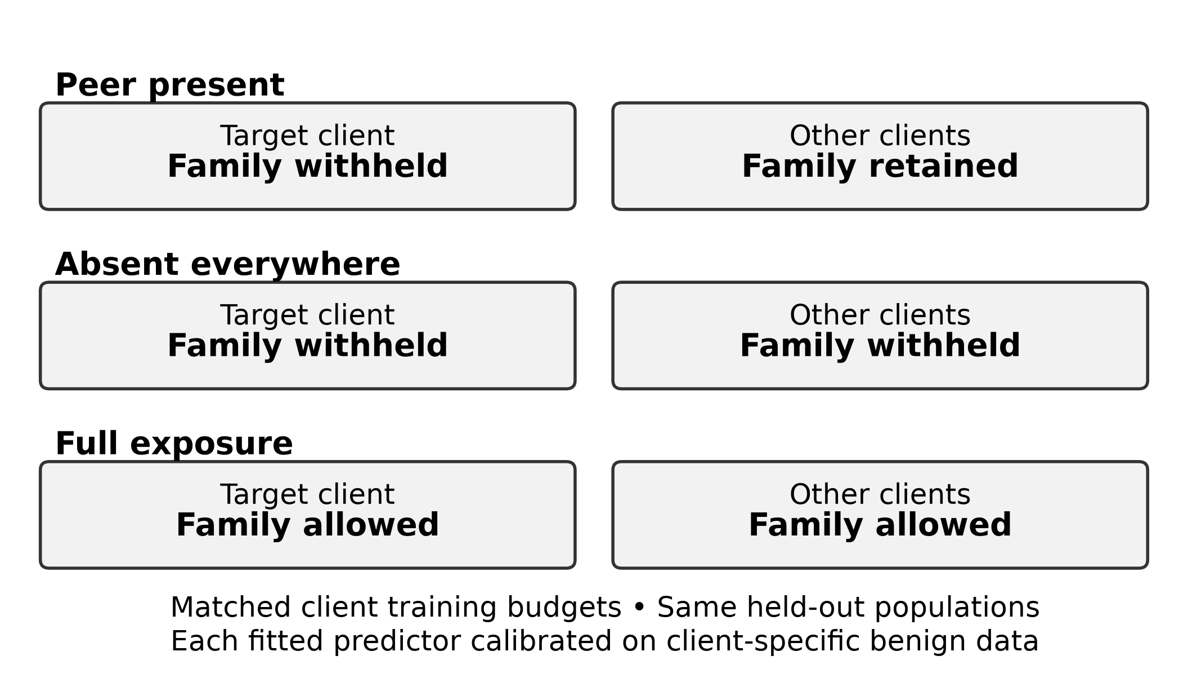
Note. Schematic of the implemented exposure conditions. Several families can be assigned to different targets within a run. Full exposure lifts deliberate exclusions but remains budgeted.
Several hidden families can affect the same run and target. Replacing their examples preserves client sample counts but can change the proportions of other malware and benign applications. Each fitted arm is also recalibrated using the same benign-score rule, so numerical thresholds may differ. The CTK contrast includes these composition and calibration effects. It measures the implemented exposure intervention rather than isolating the causal contribution of an individual feature or malware family.
The natural-scarcity comparison uses families whose target holds no more than 5% of their federation fit support, with at least 150 peer fit examples and 15 own-domain test examples. It does not artificially force the target count to zero. A naturally scarce family can have some local training examples, so calling every such case locally unseen would be inaccurate. This comparison tests whether the exposure effect persists in a less absolute form of local deprivation. It changes the selected target-family population as well as the exposure definition and therefore provides a sensitivity analysis, not an interchangeable estimate of the primary controlled task.
Two later designs address exposure quantity and specificity. The exact-dose extension constructs levels of 0, 10, 25, 50, 100, and 200 effective peer examples per hidden family, with checks that targets retain none and that realized doses match the requested levels. The placebo extension substitutes another coherent malware family for the hidden family's peer support, using support-based matching and allocation rules. Both designs belong to the prospective extensions. Their interpretation remains conditional on the selected families, budget constraints, and available replacement applications. They strengthen particular aspects of the exposure argument without establishing a universal dose law.

Aligned Representation Extension
The representation study intersects the retained LAMDA applications with all required McNdroid sources by application hash. It contains 554,136 applications, of which 170,256 are malware and 383,880 benign. The aligned inputs comprise 925 LAMDA static features, 2,390 McNdroid static features, 2,793 call-graph columns, and 17,483 report-JSON columns. The graph inputs are provider-supplied graph-derived features, not a newly trained graph neural network. The report representation uses a signed logarithmic transform, followed by arm-specific fitting of the configured input transformation. The comparison therefore concerns these processed modalities and does not cover every possible use of McNdroid.
All representations retain the original label and client definitions on the common application population. The grouping identities derive from the primary representation and package structure and are restricted to the overlap. This creates a useful matched-application comparison but does not independently group duplicate patterns in every alternative modality. The extension evaluates priority families hiddad, gappusin, and revmob; contrast families leadbolt, airpush, and dowgin; and adwo separately. These groups were selected to investigate earlier response patterns, so their results are later evidence. Overlap with the original corpus and targeted family selection preclude describing this analysis as an independent external validation.

Learning and Evaluation Protocol

Learners and Frozen Training
The principal model is a multilayer perceptron (MLP) with hidden layers of 256 and 64 units, rectified linear activations, and dropout probability 0.1. Binary cross-entropy on logits is optimized with Adam, a learning rate of 0.001, batch size 256, and zero weight decay. A local model trains for ten epochs on its client's budgeted fit sample. The centralized model trains for twenty epochs on the union of the four budgeted client samples. These schedules are frozen experimental settings, not evidence that each learner has reached its globally optimal configuration. Table 2 collects the conditions most important for interpreting the comparisons.
Table 2
Conditions of the Primary Controlled Study
Component | Setting
Source and representation | LAMDA var_thresh_0.01; 925 binary features
Partition | Package/feature connected components; 60/20/20 fit/calibration/test; best support among 16 attempts
Training volume | 6,000 fit rows per client; 1,500 in lower-support sensitivity
Primary eligibility | Target fit ≥20; peer fit ≥150; federation test ≥50; remaining target fit ≥500
MLP and optimization | 256/64 hidden units; rectified linear activation; dropout 0.1; Adam; learning rate 0.001; batch 256
Training schedule | Local 10 epochs; central 20; federated 20 rounds × 2 local epochs
Adaptation | FedProx μ = 0.1; fine-tuning 2 epochs; equal probability blend
Operating points | Nominal FPR 5% primary; 1% and 10% sensitivity
Primary inference | Seeds 100–109; paired effects; 9,999 BCa resamples; exact Wilcoxon; Holm across three contrasts
Note. Support requirements refer to pre-budget pools. Family-macro, own-domain, and worst-client summaries use distinct denominators. Hyperparameters and statistical procedures were frozen before the confirmatory evaluation.
FedAvg runs twenty rounds with two local epochs per round and full participation by all four clients. Clients start each round from the global parameters, fit locally, and return parameters for sample-count-weighted aggregation. A new Adam optimizer is initialized for each client's local training call; optimizer state is not carried between rounds. FedProx follows the same schedule with proximal strength 0.1. Fine-tuning starts from the fitted FedAvg model and performs two additional epochs on each client's local fit data. The blended predictor averages local and FedAvg predicted probabilities with equal weights. Each predictor is calibrated independently on the applicable client's benign calibration observations.
These arms expose different tradeoffs. Centralized learning is a pooled reference, not a privacy-preserving implementation. FedAvg and FedProx distribute model fitting conceptually across clients in the experimental workflow. Fine-tuning can adapt the shared model to the target domain, but that domain still lacks its withheld family. Blending retains both local and shared predictions and may protect locally useful distinctions at the cost of diluting a shared response. None of these mechanisms is assumed to dominate in advance. The development grid considered local training duration, fine-tuning duration, and proximal strength; the confirmatory studies use the frozen choices rather than selecting configurations after seeing their test results.
Alternative model-family experiments include a linear binary classifier and histogram-based gradient-boosted trees. The tree configuration uses up to 100 iterations, maximum depth six, and learning rate 0.1. The tree comparison contains local and centralized learners; it does not instantiate federated tree aggregation. Consequently, its positive exposure contrast supports the importance of family examples for a different model class, rather than directly replicating FedAvg. The linear comparison does include federated learning and provides a closer optimizer-level sensitivity. Comparing these models helps distinguish a pattern tied solely to one nonlinear architecture from one that persists under other fitted decision functions.
For the alternative graph and report inputs, transformations are fitted using the arm's selected fit observations. A local model estimates transformation parameters from its own fit rows; shared learners use their pooled fit rows. The report input also applies the configured minimum positive prevalence of 1% when selecting columns. Calibration and test observations do not fit these transformations. However, the provider's original feature vocabulary and primary LAMDA feature reduction precede the experiment. This remains a benchmark representation assumption, rather than a demonstration that the entire feature-engineering pipeline could be estimated from an isolated future deployment's training stream.

Calibration and Metric Definitions
For each client and arm, the threshold is the empirical (1 − alpha) quantile of benign calibration scores, using the higher observed quantile value. An application is flagged only when its score is strictly greater than that threshold. The primary alpha is 0.05; sensitivities use 0.01 and 0.10. Calibration is marked insufficient when the benign calibration count multiplied by alpha is below ten. Score ties and differences between calibration and test populations can cause realized test FPR to depart from alpha. The run-level tolerance check allows an absolute two-percentage-point deviation in the client-macro FPR at the primary operating point. It is not a two-point bound on every individual client's FPR, and valid calibration support does not imply that this tolerance check passes.
Own-domain unseen-family recall counts correctly flagged test malware belonging to the families withheld from that client, using only test applications assigned to that domain. Rates are calculated per eligible client and averaged equally across clients meeting the own-domain support threshold. Federation-wide unseen-family recall instead evaluates the same target detector on test applications of its hidden families from all four domains, then averages the target-client recalls. A target can therefore be evaluated on applications outside its own market or era domain. This larger population improves support for the controlled family question but does not directly represent that client's natural incoming application stream.
Family-macro unseen recall averages the recall of the eligible target-family entries on the federation-wide population, giving each entry equal weight. It differs from first pooling hidden-family hits within each client and then averaging clients. Micro-pooled recall divides pooled hits by pooled trials and weights entries according to support. The chapter uses the original client-macro estimand for the headline confirmatory contrast and explicitly identifies the family-macro quantities in dose and family summaries. Since larger families and clients can have different responses, these weighting choices can change the reported mean without creating a numerical inconsistency.
Known-family recall is the equally weighted mean client recall on own-domain test malware outside the assigned hidden-family set. In implementation, this complement may include malware without an eligible target-family annotation. The name therefore denotes the operational nonhidden population rather than guaranteeing a verified prior example for every family label. Realized FPR is the mean of each client's false-positive fraction on its own benign test applications. Worst-client FPR is the maximum such fraction. Worst-client unseen recall is the minimum federation-wide hidden-family recall among contributing target clients within a seed. Its identity can change between arms, so a difference between minima is not automatically the improvement of one fixed client.
AUROC and average precision summarize binary discrimination on each client's complete own-domain test population, with client results averaged equally. Average precision is computed using scikit-learn's average_precision_score and retained under the label AUPRC in the stored artifacts. It weights precision by increments in recall rather than applying trapezoidal integration to the precision–recall curve. It also depends on the test population's class composition. Neither measure isolates the withheld families at the calibrated operating point. Their comparison with unseen-family recall therefore concerns different populations and summaries of the score distribution.

Statistical Inference and Evidence Status
The original confirmatory seeds are 100–109. Each contributes paired arm differences under the same partition and target assignment. The stored summaries include means, medians, positive-seed counts, and standardized paired effects. Confidence intervals for mean differences use 9,999 bias-corrected and accelerated (BCa) bootstrap resamples over seed differences at 95% confidence. The three primary contrasts contain no zero differences or tied absolute ranks and use exact two-sided Wilcoxon signed-rank tests. This test assesses symmetry of the difference distribution around zero; it is not a direct test of the arithmetic mean. Holm adjustment applies to the three FedAvg federation-wide decomposition contrasts at alpha 0.05 (Holm, 1979). Other learners, populations, families, and later diagnostics are outside that primary multiple-testing family.
A practical CTK threshold of three percentage points is distinguished from a zero-effect significance test. Likewise, a known-family loss tolerance of two points expresses a practical constraint rather than a universal safety standard. The stored BCa interval and the signed-rank test answer related but different statistical questions; occasional disagreement is not resolved by silently replacing one procedure with another. A component-based bootstrap over held-out observations provides a separate check on dependence among test applications. It does not create additional independent training seeds, and its within-seed uncertainty should not be substituted for the between-seed effect interval.
Four evidence categories organize the interpretation. Class A is original confirmatory evidence; class B is prespecified robustness or sensitivity evidence; class C is post-confirmatory analysis of stored runs. Class D comprises separately frozen prospective extensions and their explicitly identified later diagnostics. The permutation extension uses seeds 200–209; the expanded-family study uses 300–309; exact dose uses 310–319; placebo and aggregation controls use 320–329; and representation comparisons use 330–339. These blocks are kept separate from the original confirmatory seeds. When an extension pools primary and replication family sets within a seed, its inferential count remains ten, not twenty independent seeds.
The associated CTK-Android repository contains the source code, configurations, machine-readable results, and provenance records: https://github.com/naslouby-salahe/ctk-android. The evidence package records execution and analysis revision f6302f7906824945731dadbbeb44357f3d025aaf, with matching revisions and clean analysis sources. Source-data fingerprints, run manifests, validation records, and artifact digests identify the inputs and outputs. Raw datasets are external; the repository README documents the required sources and reproduction commands. These records support traceability, while access to the specified data and a compatible environment remains necessary to reproduce training. The seed intervals describe variation in the implemented experiment conditional on this corpus, not uncertainty over independently sampled organizations or future malware populations.

Experimental Results

Primary Controlled-Exposure Results
The original confirmatory comparison supports a substantial contribution from complementary peer exposure. FedAvg federation-wide unseen-family recall rises from 52.41% when the selected families are absent everywhere to 64.36% when peers retain them. The local reference is 50.90%, and FedAvg under full exposure reaches 67.64%. Realized mean FPR is 5.04% in the absence-everywhere condition, 5.09% with peer exposure, and 5.04% under full exposure. These similar averages support the comparison at a common calibration target. They conceal client variation: the peer-present mean worst-client FPR is 6.60%, and the maximum worst-client FPR across the ten seeds is 9.89%. Table 3 and Figure 2 report the paired recall effects and their uncertainty.
Table 3
Primary Paired FedAvg Decomposition at Nominal 5% FPR
Contrast | Mean (pp) | 95% BCa CI (pp) | Holm p | Positive seeds
CTK | +11.96 | [+9.15, +15.21] | 0.00586 | 10/10
Pooling | +1.51 | [−4.15, +6.10] | 0.32227 | 7/10
Total | +13.46 | [+8.82, +17.04] | 0.00586 | 10/10
Note. Ten confirmatory seeds, 100–109. CTK = peer present − absent everywhere; pooling = absent everywhere − local; total = peer present − local. Realized FPR: local 4.99%, absent 5.04%, peer 5.09%, full exposure 5.04%. Intervals summarize seed-paired mean differences; p values are exact two-sided signed-rank results adjusted across these three contrasts. pp = percentage points.
Figure 2
Complementary Exposure and Generic Pooling in the Primary FedAvg Comparison
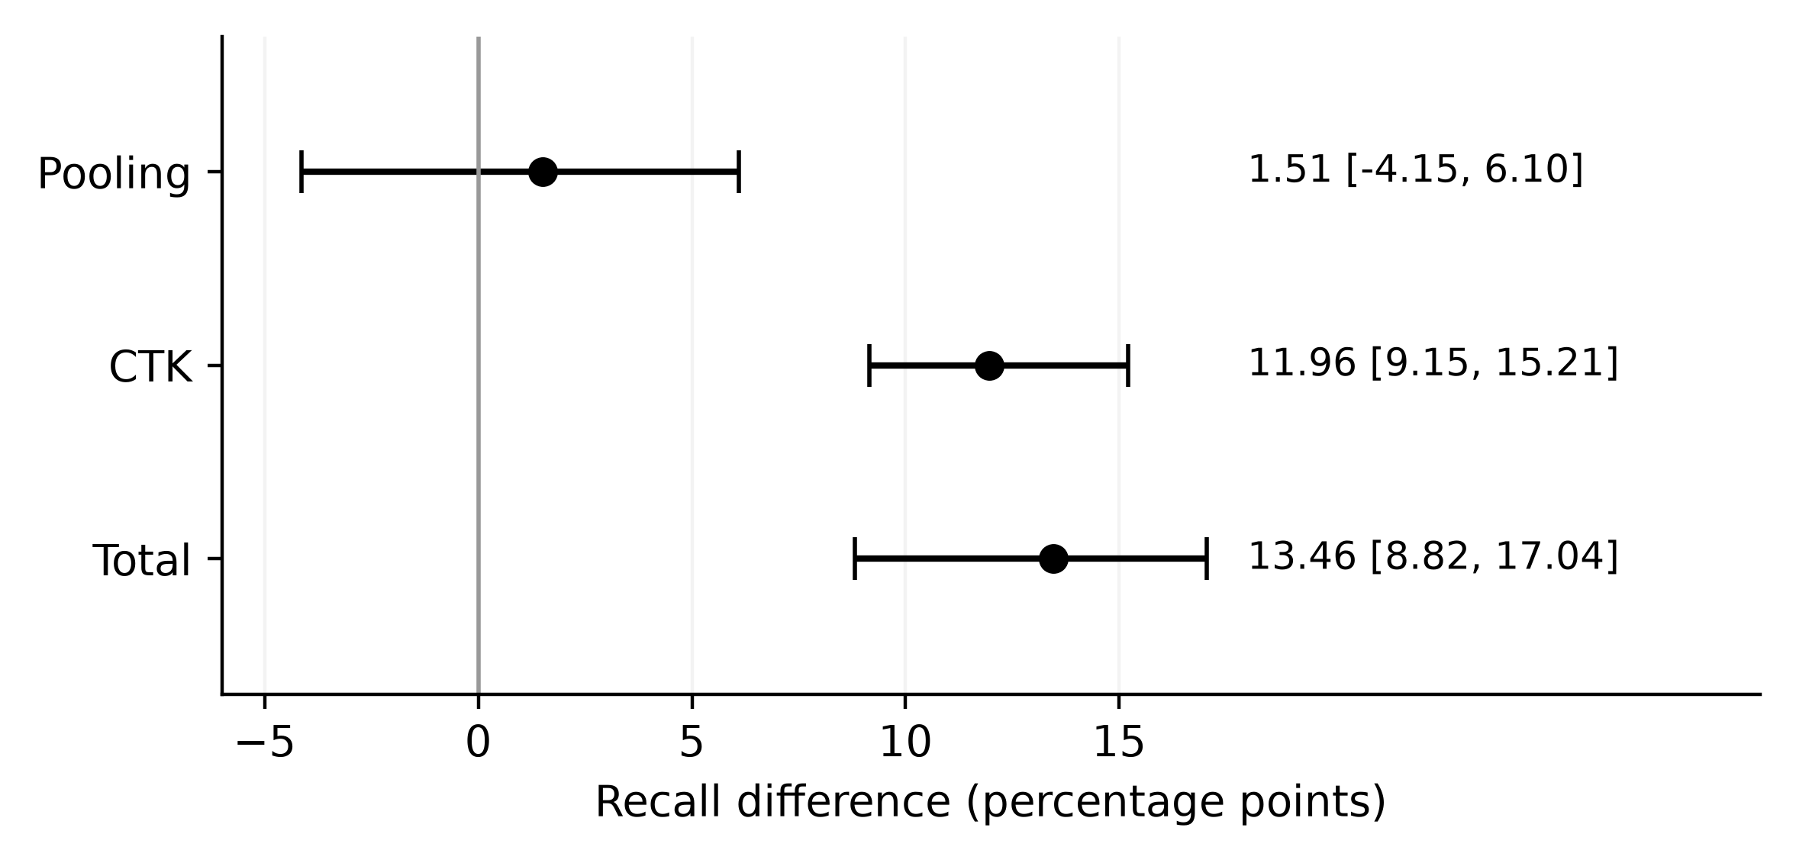
Note. Point estimates and 95% BCa intervals in percentage points. Federation-wide client-macro unseen recall, nominal 5% FPR, seeds 100–109.
The CTK mean is 11.96 percentage points, with a 95% BCa interval of 9.15–15.21 points. Every confirmatory seed has a positive difference. The total peer-versus-local gain is 13.46 points, with interval 8.82–17.04, also positive in all ten seeds. Both have Holm-adjusted p = .00586 across the three primary contrasts. Generic pooling contributes 1.51 points, with interval −4.15 to 6.10 and adjusted p = .32227. This interval neither establishes a positive pooling benefit nor establishes that pooling is exactly ineffective. It permits both modest benefit and modest harm. The evidence is strongest for the complementary exposure contrast and for the combined collaboration gain in this specified population.
The central pooled reference gives peer-present federation-wide recall of 66.07%, compared with 52.97% in its absence-everywhere condition and 70.19% under full exposure. The higher central mean does not establish that centralized learning is superior under otherwise matched conditions. The central and federated learners have different training schedules, and full exposure is a finite comparison under those schedules. The remaining gap to a full-exposure reference shows that access to peers does not reproduce every advantage of allowing examples at the target. It does not quantify an irreducible limit, and the relative ordering need not hold for every family or every seed.
The own-domain results show a smaller net benefit. On own-domain unseen malware, FedAvg CTK is 10.85 points, with interval 6.97–15.25. Generic pooling is −7.60 points, with interval −11.81 to −4.03, leaving total gain of 3.26 points, with interval 1.26–5.63. The same intervention therefore has a large complementary component but a much smaller net benefit within target domains. These are secondary population results, not additional Holm-adjusted primary discoveries. In this comparison, peer examples can repair damage introduced by the shared model's exposure to other data, so the CTK component should not be equated with the final improvement over local training.
Family-macro CTK is 12.44 points, with interval 10.09–15.55, while the total family-macro gain is 10.57 points. The worst-client metric yields CTK of 18.49 points, with interval 13.88–26.29, and total gain of 14.88 points. These values use their own aggregation rules. In particular, the worst-client comparison subtracts arm-specific minima; it does not mean that a single consistently worst client improves by that amount. At the stricter 1% nominal FPR, the FedAvg federation-wide CTK estimate is 7.85 points, smaller than at 5%. Operating-point sensitivity therefore matters even when the direction of the exposure effect remains positive.

Learning-Strategy Comparisons
Table 4 compares all six peer-present learning strategies at the primary operating point. FedAvg and FedProx have similar mean federation-wide unseen recall, 64.36% and 64.55%, respectively. The stored post-confirmatory paired FedProx-minus-FedAvg difference is only 0.19 points, with interval −1.12 to 2.94. This does not establish that FedProx improves that metric. Fine-tuning reaches 62.16%, and blending reaches 63.66%, both below the FedAvg mean. The central model has the highest peer-present federation-wide value, 66.07%, but that comparison does not account for the different information-sharing arrangements a deployment might require.
Table 4
Peer-Present Learner Performance at Nominal 5% FPR
Learner | Federation unseen | Own-domain unseen | Worst client | Known family | FPR
Local | 50.90 | 50.67 | 28.92 | 73.06 | 4.99
Central | 66.07 | 56.27 | 41.42 | 72.92 | 5.10
FedAvg | 64.36 | 53.93 | 43.79 | 69.46 | 5.09
FedProx | 64.55 | 55.98 | 37.90 | 72.13 | 5.09
Fine-tuned FedAvg | 62.16 | 51.64 | 40.35 | 69.33 | 5.03
Blend | 63.66 | 57.21 | 37.63 | 74.77 | 5.12
Note. All entries are percentages averaged over ten confirmatory seeds. Worst client is the within-seed minimum federation-wide unseen recall. Other recall and FPR columns follow the macro definitions in the protocol. Arm rankings are descriptive; table levels are not confidence intervals or adjusted pairwise superiority tests.
Known-family recall reveals a different ranking. Relative to local learning, FedAvg loses 3.61 points, with interval −4.50 to −2.85. Fine-tuning loses 3.74 points, with interval −5.31 to −2.82. Both mean losses exceed the frozen two-point tolerance. FedProx loses 0.93 points, central learning loses 0.14, and blending gains 1.70. The tolerance indicator in the frozen tradeoff table compares mean changes with the practical margin; it is not a formal equivalence test based on the entire interval. In particular, a mean within tolerance should not be described as a guarantee that every client or every plausible effect is within that range.
The learner tradeoff also appears in worst-client recall. FedAvg's peer-present minimum-client mean is 43.79%, versus 37.90% for FedProx, 40.35% for fine-tuning, and 37.63% for blending. Central learning reaches 41.42%. Figure 3 contrasts each learner's mean with its worst-client outcome. These descriptive values caution against selecting an arm solely for its federation-wide mean or its known-family preservation. A learner can retain more known-family recall while providing less protection at the least successful target. The chapter therefore does not designate one universally best method. Choice depends on which losses are unacceptable and on whether the relevant population resembles the federation-wide or own-domain task.
Figure 3
Mean and Worst-Client Unseen Recall Across Learners
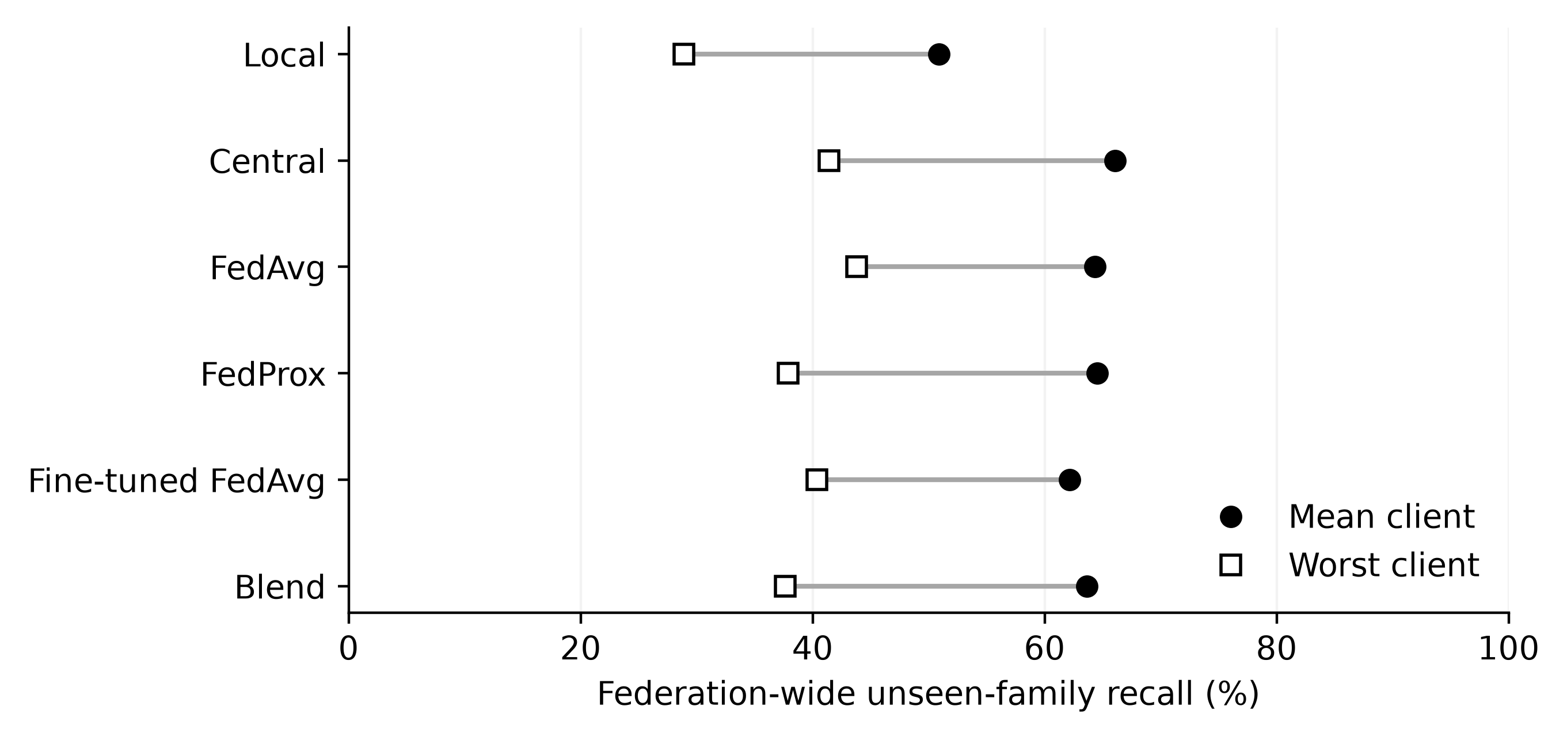
Note. Peer-present condition, nominal 5% FPR, seeds 100–109. Points show means across seeds; no uncertainty interval is implied. Worst-client identity can change across arms.
Aggregate discrimination declines despite the unseen-family gain. The post-confirmatory analysis records FedAvg-minus-local changes of −0.01166 in mean AUROC and −0.02011 in mean average precision, alongside a 13.46-point gain in federation-wide unseen-family recall. The aggregate metrics evaluate the complete own-domain test population across thresholds, whereas the recall contrast concerns selected hidden families. Deterioration on other cases can therefore coexist with improved hidden-family coverage. These results show why both overall discrimination and the targeted recall benefit need to be reported.

Malware-Family and Client Heterogeneity
Figure 4 shows the primary families under local, absence-everywhere, peer-present, and full-exposure conditions for FedAvg. Revmob and leadbolt have the largest mean CTK gains, 33.38 and 27.75 points. Their local recalls are 27.20% and 30.23%, while peer-present recalls are 52.12% and 59.03%. These are cases where peer exposure supplies a substantial improvement that remains visible against the local baseline. Yet revmob remains below 60% even under the displayed full-exposure FedAvg condition. A large gain and an adequate absolute detection level are different criteria; the former does not establish the latter.
Figure 4
Family-Specific Recall Across Exposure Conditions
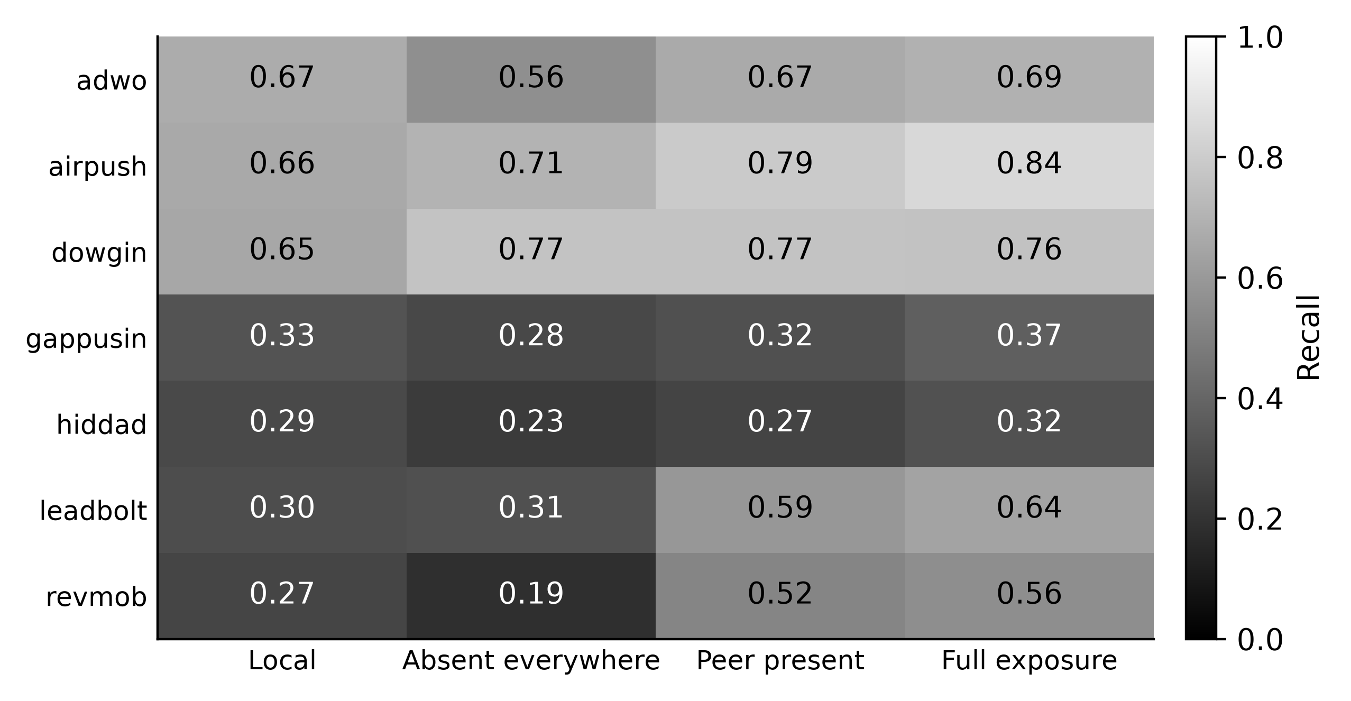
Note. Entries are mean recall proportions, nominal 5% FPR, seeds 100–109. Full exposure refers to FedAvg here; it is not a theoretical ceiling.
Dowgin illustrates a contrasting pattern. Local recall is 65.45%, the absence-everywhere model reaches 76.68%, and peer-present recall is 76.82%. Its CTK component is only 0.14 points, while most of its total gain is already present through pooling without direct examples of the hidden family. Adwo provides a repair-dominated case: recall falls from 67.34% locally to 56.23% under absence-everywhere pooling, then returns to 66.60% with peer exposure. The CTK gain is 10.37 points, but the final peer-present model remains slightly below the local reference. Describing both families simply as beneficiaries of complementary knowledge would obscure these different explanations.
Gappusin and hiddad show limited response in the primary static representation. Their CTK means are 3.46 and 3.25 points, respectively, but peer-present recall remains only 31.63% and 26.57%. Both final recalls are below their local means. The full-exposure central recalls, 42.38% for gappusin and 28.68% for hiddad, also remain low. This pattern motivates a representation question rather than supporting a claim that additional exposure always solves local absence. Airpush occupies an intermediate position, with CTK of 8.71 points and peer-present recall of 79.24%. The primary family estimates are descriptive summaries over the frozen seed-specific target assignments, not seven independently adjusted confirmatory discoveries.
The replication set includes unfavorable cases as well. Dnotua has mean FedAvg CTK of −8.24 points and zdtad −2.06 points in the family-level artifact; inmobi and domob have positive means of 13.63 and 12.04 points. The contributing seed count is not uniformly ten for all replication families: utchi and zdtad contribute six. These values should therefore not be treated as an equally precise ranking of the eight names. They establish that the positive aggregate replication result coexists with family-level losses and incomplete eligibility. The broader family extension later revisits variability under a different family selection and fresh seed block.
Client-level decomposition is class C evidence. Federation-wide FedAvg CTK averages 8.35 points at Anzhi, 7.58 at AppChina, 9.18 at play-early, and 32.03 at play-late. The corresponding contributing seed counts are eight, ten, ten, and six. The especially large play-late mean is therefore conditional on fewer contributing seeds and selected family assignments. Anzhi's total gain is only 1.34 points despite its positive CTK, whereas its known-family recall falls by 6.93 points in the client diagnostic. Anzhi therefore illustrates the known-family cost of collaboration. Unequal support across clients prevents attributing the difference in gains solely to market identity.

Peer Exposure and Dose Response
The original dose study distinguishes requested caps from examples actually selected for fitting. At a nominal cap of 100 peer applications per hidden family, the mean effective FedAvg dose is only 9.03; at a cap of 1,000, it is 79.39. Budget selection takes place after the family-level cap, so many permitted examples never enter the training sample. The all-available condition yields mean effective support of 296.19 and family-macro CTK of 12.44 points. It is the only displayed level meeting the configured mean effective-dose criterion of at least 100. A nominal cap must therefore not be used as the horizontal coordinate for a claim about exact exposure quantity.
The later exact-dose study removes that ambiguity within its own design. Across the pooled primary and replication family sets, FedAvg family-macro federation-wide CTK is 2.92, 4.90, 7.83, 12.48, and 14.49 points at 10, 25, 50, 100, and 200 peer examples, respectively. Figure 5 presents those means and the frozen intervals. At every dose, the effect is positive in all ten extension seeds. The interval at ten examples is 2.31–3.64 points, crossing the three-point practical threshold; the interval at twenty-five is 3.87–5.89. Evidence for a positive effect and evidence that an effect exceeds the practical threshold should consequently remain distinct.
Figure 5
Exact Peer Dose and Complementary Gain
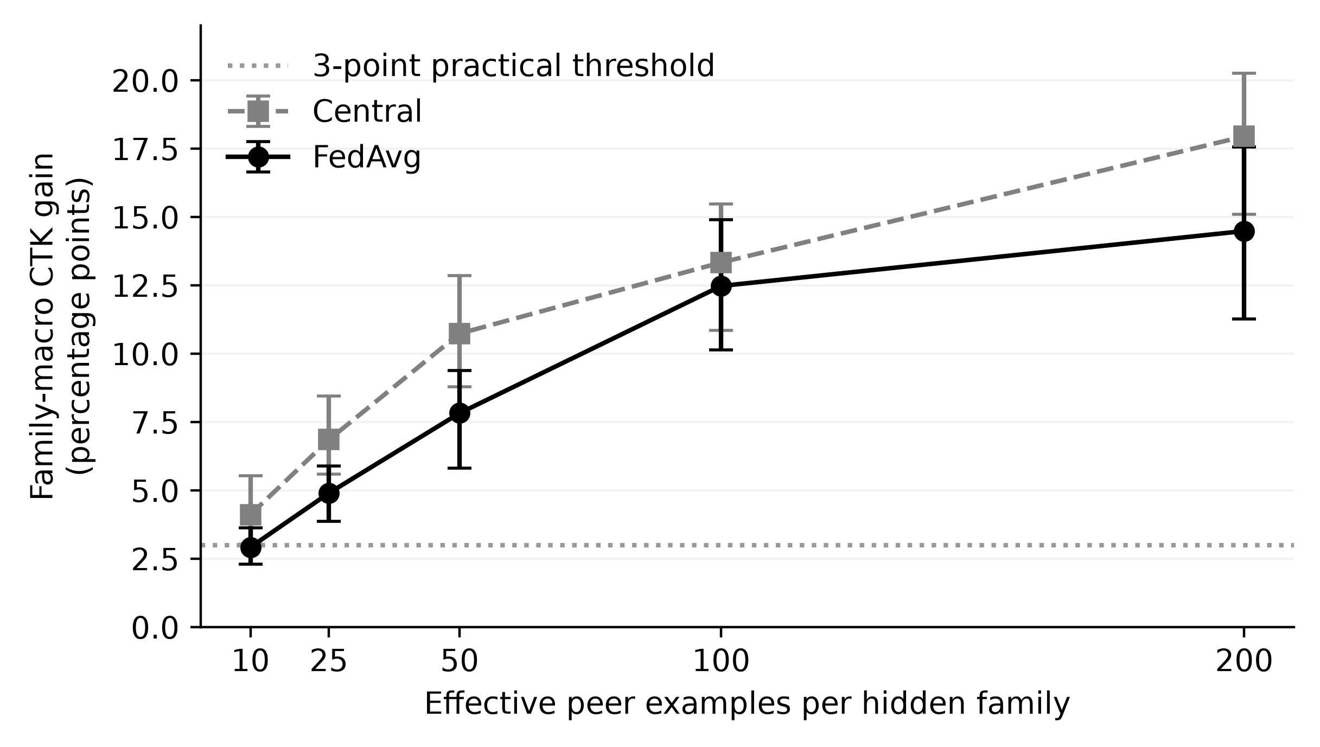
Note. Prospective extension, seeds 310–319. Family-macro federation-wide effects pooled within seed across primary and replication sets at nominal 5% FPR; 95% BCa intervals. The dotted line marks a practical threshold, not a universal dose requirement.
The mean curve increases, but the final increment does not establish a precise saturation boundary. The 100-to-200 increment is 2.01 points with interval −0.06 to 4.06, whereas the 50-to-100 increment is 4.65 with interval 2.43–7.09. These estimates are consistent with diminishing gains at the upper tested range, but neither prove a plateau nor justify a universal minimum dose. Families differ: the stored dose diagnostic shows dowgin remaining near zero or slightly negative even at the highest level. The exact zero-dose and absence-everywhere arms have identical observed effects in the frozen consistency results. These extensions clarify the exposure manipulation without being pooled into the original confirmatory test.

Negative Controls, Replication, and Robustness
The family-permutation control disrupts correspondence between family annotations and application features while retaining binary malware labels. Original FedAvg federation-wide CTK at nominal 5% FPR is 0.30 points, with interval −0.36 to 1.02, within the predefined ±3-point equivalence band. The own-domain interval extends to 3.04 points and remains unresolved under that rule. In the separate extension, federation-wide CTK is −0.21 points and own-domain CTK is −0.07; both intervals lie within the band. The fresh-seed results strengthen the control evidence while leaving the original unresolved result visible.
The coherent-family placebo addresses a different alternative explanation. In the extension pooled across family sets, its federation-wide effect is −0.54 points, with interval −1.36 to 0.20. The CTK-minus-placebo effect is 10.04 points, with interval 8.35–12.28. These observations argue against explaining the entire gain as the effect of substituting any sufficiently supported named malware family. They do not establish that the placebo matches every behavioral property of the hidden family. Allocation can redistribute examples across peers when necessary, and matching is based on support. The control is therefore evidence for specificity within the implemented replacement scheme, not a perfect semantic counterfactual.
Table 5 summarizes the main robustness and extension effects. The prespecified disjoint-family replication produces FedAvg CTK of 5.08 points, with interval 2.28–7.10 and eight positive seeds. Its mean exceeds the three-point practical threshold, but its lower interval bound does not. The linear FedAvg sensitivity yields 9.37 points, while the centralized tree sensitivity yields 10.18. Lower training support, low and high family-support profiles, package-only grouping, and the three alternative partition salts also retain positive mean effects. These are convergent checks within the same underlying corpus and construction, not a collection of independent deployment replications.
Table 5
Selected Replication, Sensitivity, and Control Effects
Comparison | Class | Mean (pp) | 95% BCa CI (pp)
Disjoint family set | A | +5.08 | [+2.28, +7.10]
Natural scarcity | B | +11.19 | [+9.46, +12.59]
Linear FedAvg | B | +9.37 | [+7.54, +10.97]
Centralized trees | B | +10.18 | [+7.59, +13.70]
Lower training support | B | +10.99 | [+8.71, +13.52]
Lower family support | B | +14.01 | [+11.46, +16.22]
Higher family support | B | +11.59 | [+9.17, +13.75]
Package-only grouping | B | +11.32 | [+8.60, +13.29]
Wrong-family placebo | D | −0.54 | [−1.36, +0.20]
CTK minus placebo | D | +10.04 | [+8.35, +12.28]
Note. A = original confirmatory; B = prespecified sensitivity; D = prospective extension. First eight rows are CTK effects on the client-macro federation-wide metric, seeds 100–109. Last two are family-macro effects pooled within seeds across family sets, seeds 320–329. These rows are not one multiple-testing family and are not pooled into the primary test. A positive mean above three points need not have an interval entirely above that practical threshold.
The natural-scarcity estimate is 11.19 points, with interval 9.46–12.59. Similarity to the primary CTK magnitude is useful, but it does not mean the entire decomposition is invariant: local exposure, eligible targets, and the pooling contribution differ. Robust aggregation provides another conditional check. In the placebo/aggregation extension, pooled CTK is 9.50 points under mean aggregation, 9.16 under trimmed mean, and 13.76 under the implemented median. With four clients, trimming removes one value from each tail per coordinate; the tensor median uses the lower middle value. These results do not constitute a poisoning-defense evaluation, because the experiment does not introduce malicious updates. They show only that the observed complementary benefit survives these alternative aggregation rules under the tested honest-client conditions.

Representation and Expanded-Family Analyses
The aligned representation extension separates improvements in full-exposure recognition from changes in the CTK contrast. For the priority-family macro average, McNdroid static features improve centralized full-exposure recall by 7.57 points relative to the aligned LAMDA baseline, with interval 2.76–12.85. Their FedAvg CTK increment is 8.01 points, with interval 3.56–10.54. Call-graph features increase the CTK contrast by 9.03 points, with interval 5.53–12.35, but their full-exposure recall increment is only 2.52 points, with interval −0.86 to 7.77. A larger CTK contrast therefore need not mean a clearly higher full-exposure recall level; changes in the absence-everywhere baseline also matter.
Report-JSON performs unfavorably on the same priority summary. Its full-exposure recall difference is −14.54 points, with interval −18.63 to −8.66, and its CTK difference is −6.12 points, with interval −9.91 to −3.87. Family results also differ: McNdroid static improves full-exposure recall for gappusin by 16.93 points and adwo by 33.60, but the hiddad estimate is −6.21 with interval −18.02 to 6.29. There is no demonstrated hiddad rescue.
These comparisons use a common nominal calibration target, not identical realized FPRs. The extension diagnostics record macro-FPR tolerance failures in exact-dose primary seed 317, LAMDA-static and McNdroid-static representation seed 333, and call-graph seed 334; one call-graph central peer-present client reaches 15.32% FPR. The stored post-hoc equal-test-FPR diagnostic retains the priority-macro full-exposure direction for static features (+7.28 points) and report-JSON (−14.27 points); the call-graph interval still includes zero. Because this diagnostic uses benign test scores to equalize FPR, it is a descriptive sensitivity, not an independently calibrated deployment result. The findings concern these processed features and the frozen learner, rather than the intrinsic utility of an entire modality.
The 32-family extension asks whether a distance-based novelty descriptor helps explain transfer variation. The mean family CTK is 6.51 points, but five families have negative point estimates, including feiwo at −5.89 and baiduprotect at −4.41. The descriptor measures distance to the nearest sufficiently supported known-family feature centroid; it is not a direct measure of behavioral novelty. Across all 32 families, the stored Spearman association is .408, with family-bootstrap interval .088–.662 and permutation p = .0214. This is suggestive extension evidence, not a validated predictive model for selecting future federation partners or estimating a new family's gain.
Eligibility stability materially weakens that association. Restricting to the 27 families eligible in every fresh seed gives ρ = .294, interval −.076 to .589, and p = .136. The restriction changes both precision and the analyzed population. It does not prove the full-sample association false, but it prevents presenting novelty as a firmly established explanation of CTK. The expanded set also overlaps previously studied families, so it should be described as a broader family analysis on fresh seeds, not 32 entirely new independent families. Later rank and influence diagnostics remain exploratory. The results establish heterogeneity, but provide limited evidence that centroid distance explains which families benefit most.

Discussion and Practical Implications

What the Controlled Contrast Establishes
In the constructed LAMDA federation, FedAvg gains substantially from peer examples of locally withheld families relative to its performance when those families are absent everywhere. Matching client sample counts and the collaborative training schedule narrows the explanation compared with a local-versus-federated comparison alone. The intervention still changes sample composition and recalibrates the fitted model. The result supports the usefulness of complementary exposure under those conditions; it does not identify the model parameters or features responsible for the gain.
Generic pooling and complementary exposure are different because they ask different counterfactual questions. Pooling asks whether access to other clients' data helps even without the selected threats. CTK asks what changes when relevant peer examples become available within that collaborative setting. The primary point estimates place most of the total benefit in the latter component, but the conclusion is conditional on the chosen learner, families, budget, and population. The own-domain result is especially informative: negative pooling offsets much of a positive CTK effect. The practical value of collaboration cannot be read from the CTK estimate alone. A participant needs the final comparison with its local detector as well as the reason for that change.
The family results distinguish recovery from additional detection capability. Adwo's complementary component largely restores the loss under absence-everywhere pooling. Revmob and leadbolt improve substantially beyond the local baseline, although absolute recall remains imperfect. Dowgin benefits mainly without direct peer examples of its own family. Hiddad remains difficult under the tested exposure and representation changes. These are observed response patterns in this corpus, not permanent properties of the families.

Evaluating Collaboration as a Set of Tradeoffs
Organizations evaluating collaborative detection should specify the population on which benefit matters before comparing algorithms. A federation-wide hidden-family test asks whether a target model can recognize a family across multiple source domains. An own-domain test asks whether that model improves on the applications associated with its own domain. Both are useful, but the larger federation-wide estimate should not be substituted for a local operational benefit. Likewise, a family-macro average answers a different question from a sample-weighted rate. Equal family weighting prevents large families from dominating; it does not estimate the number of real incidents that would be prevented.
Learner selection requires unseen-family recall, known-family recall, realized FPR, and performance at the least successful client. FedAvg has a comparatively strong minimum-client mean while losing known-family recall. FedProx reduces that known-family loss without establishing an improvement in mean unseen recall. Fine-tuning and blending change the balance again. An organization would need to define acceptable losses before choosing among these tradeoffs and then validate the choice on its own application stream.
The observed FPR variation also matters operationally. The primary mean is close to the nominal target, but individual clients can exceed it substantially, and some extension runs fail the macro-level tolerance check. A 5% benign FPR may itself create an unacceptable alert burden. The experiment does not measure triage costs or analyst workload, so even an operating point that meets the benchmark tolerance is not established as suitable for deployment. Calibration would need to be checked on the intended population and reassessed as that population changes.
Aggregate discrimination and unseen-family recall answer different evaluation questions. An evaluation that reports only AUROC or AUPRC can miss a targeted coverage improvement, while an evaluation reporting only hidden-family recall can omit losses elsewhere. The appropriate response is to align every claim with its denominator and decision rule. A statement that collaboration improves detection must identify whether it concerns all malware, selected hidden families, the mean client, or the least successful client. This makes apparently contradictory results interpretable and helps prevent a useful local improvement from being exaggerated into broad system superiority.

Exposure, Representation, and Remaining Questions
The exact-dose extension shows why effective support should be measured after all selection steps. A configured cap can greatly exceed the number of peer examples actually used. Reporting only nominal dose risks drawing a false lesson about data efficiency. Under the exact-dose construction, average CTK increases across the tested levels, but family variation and uncertainty in the final increment prevent a universal sample requirement. An organization could use this insight to demand auditable exposure accounting from an evaluation. The study does not establish that collecting a particular number of examples will achieve a specified recall in a new market, family, or feature space.
Representation results further limit a simple more-data explanation. For some families, additional static features improve recognition; for others, the tested richer modalities do not help. The call-graph contrast demonstrates that CTK can increase without a clearly established improvement in full-exposure recall. This follows from the estimand: both the peer-present and absence-everywhere baselines can move. Representation evaluation should therefore compare levels as well as differences, and should keep the application population aligned where possible. The present comparison provides that alignment but remains tied to overlapping source data and a common family-label system.
Privacy and adversarial resilience remain separate requirements. Federated parameter exchange can reduce the need to centralize raw training applications, but this experiment contains no formal privacy mechanism or privacy accounting. Shared preprocessing information in the representation experiments also illustrates that a research workflow is not automatically a complete distributed protocol. Similarly, positive CTK under trimmed or median aggregation does not prove resistance to poisoning, malicious clients, or evasion. Related systems such as CELEST and CyberForce investigate additional operational or adversarial questions, whereas the scope here is controlled detection performance. Those distinct properties should be evaluated directly before a collaborative detector is deployed.
The weak novelty association suggests restraint in turning a descriptive explanation into a partner-selection rule. Feature-centroid distance may capture some aspect of complementary exposure, but it can also reflect support, representation, and which families remain eligible. The stable-subset analysis leaves substantial uncertainty. A defensible practical implication is to measure complementarity through controlled comparisons where feasible, rather than assume that a high distance score predicts a useful peer. Independent domains, prospectively collected families, chronological evaluation, and operational cost measurements would address important remaining questions. They are future research needs, not evidence supplied by the completed study.

Threats to Validity

Construct and Internal Validity
CTK is an operational recall contrast under supplied family annotations. Automated labels can merge or split related behavior, and adware-oriented families may not represent the full range of Android threats. Locally unseen means absent from the target fit sample, not necessarily novel in a temporal, behavioral, or global sense. Natural scarcity permits limited local exposure and therefore changes that construct. Full exposure is a budgeted reference, not a theoretical ceiling. These distinctions limit the language used for both positive and negative results. A poor family response may arise from its representation, labels, support, or the fitted decision rule; the study does not identify one of these as the sole cause.
Matched budgets hold client sample counts stable across exposure arms, but do not hold class and family composition identical. Several families are manipulated together, and replacement examples can interact with each other. Model-specific calibration is part of the measured intervention. Grouping addresses exact package and primary-feature overlap across roles, but does not guarantee independence of near-duplicate variants, shared libraries, or every alternative representation. The provider-level vocabulary and feature reduction also precede the experimental split. These limitations do not invalidate the paired exposure contrast, but they constrain its interpretation as a clean intervention on one abstract knowledge variable.
Selecting the best-supported partition among 16 candidates increases feasibility while conditioning the population on eligibility. Target assignment also depends on available support and remaining fit data. As a result, the selected client-family pairs are not a random sample of all possible missing threats. The four domains combine market and era information without reproducing independently administered organizations. The representation study uses the common intersection of several modalities, excluding applications missing any required view. Such choices support controlled comparisons while restricting the population to which the estimates apply.

Statistical and Dataset Validity
Ten paired seeds quantify variability in the implemented partition, target-assignment, and training process on a fixed corpus. They provide limited precision for subgroup inference and do not constitute ten independent external datasets. Families and clients recur, and some subgroups contribute fewer seeds. The analysis treats seeds as experimental units rather than counting applications or family-client cells as independent repetitions. BCa mean intervals and signed-rank tests target different statistical properties; the latter also relies on symmetry under its null. Holm correction covers only its declared primary contrast family. Unadjusted family, client, representation, and association diagnostics remain exploratory.
The worst-client statistic is particularly sensitive to which clients contribute and to changes in the identity of the minimum. Detailed client intervals have unequal support and do not capture all uncertainty about a new organization. The expanded-family association depends on the family eligibility set, as the stable-subset analysis demonstrates. Multiple related summaries also create opportunities for selective interpretation. Reporting negative families, known-family losses, uncertain controls, and failed representation improvements is therefore part of the scientific interpretation rather than an optional supplement to the positive mean effect.
LAMDA's collection and labeling procedures produce a research benchmark rather than a probability sample of contemporary Android use. Market filtering further changes its population. The provider's antivirus-derived benign designation is not a proof that every retained benign application is harmless, and family annotations may change under another labeling system. McNdroid overlap cannot provide independent external replication. Reproducible artifacts and validated fingerprints establish which frozen evidence was used, but they cannot remove these underlying sampling and label limitations. The chapter makes no claim that its observed class proportions or family mix reflect a current production environment.

External and Operational Validity
The evaluation is offline, with fixed features, budgets, hyperparameters, and full client participation. It does not measure forward temporal generalization, client dropout, communication cost, mobile energy use, inference latency, analyst workload, or integration into an Android application. No privacy leakage, poisoning, adversarial evasion, or secure aggregation experiment is included. A positive mean CTK result therefore supports the value of complementary exposure in this benchmark, not the readiness of a deployed collaborative service. Extending the conclusion requires evidence about the intended domains, operating costs, threat model, and data-governance constraints. These are substantive limits on application of the findings, even when the within-study numerical and provenance checks are satisfied.

Conclusion
Complementary peer exposure makes a measurable contribution to Android malware detection in the controlled CTK-Android study. Under the primary FedAvg configuration, federation-wide unseen-family recall gains 11.96 percentage points from peer-held family examples, with a 95% interval of 9.15–15.21. The corresponding generic-pooling estimate is small and uncertain. This decomposition provides a more precise explanation than a single local-versus-federated comparison: it identifies how much of the observed benefit depends on the families supplied by peers under matched training budgets.
The benefit varies by family and client. Some families improve beyond local learning; others benefit chiefly from generic pooling, recover collaboration losses, or remain difficult despite full exposure. Own-domain net benefit is smaller than the federation-wide gain, and FedAvg loses known-family recall. Learner choice changes the balance between average recall, local adaptation, and the worst client. The observed declines in AUROC and average precision further show that better hidden-family recall need not improve overall discrimination.
Prespecified sensitivity studies and separately frozen extensions support the relevance of complementary exposure across several designs. Exact-dose results clarify the role of realized peer support, while permutation and placebo controls strengthen the family-specific interpretation. Representation comparisons remain mixed, and the expanded-family novelty association weakens under stable eligibility. Those qualifications preclude a universal dose requirement, a general predictor of transfer, or a guarantee that every participant benefits.
The study provides an evaluation approach that links collaborative performance to controlled changes in family exposure and reports both benefits and costs. Its scope is an offline benchmark with constructed clients and fixed representations. Within that scope, the decomposition identifies where peer exposure helps, where it repairs losses, and where detection remains poor. Chronological evaluation, independent domains, and operational validation are needed before extending these findings to a deployed service.

References
Allix, K., Bissyandé, T. F., Klein, J., & Le Traon, Y. (2016). AndroZoo: Collecting millions of Android apps for the research community. In Proceedings of the 13th International Conference on Mining Software Repositories (pp. 468–471). ACM. https://doi.org/10.1145/2901739.2903508
Arp, D., Quiring, E., Pendlebury, F., Warnecke, A., Pierazzi, F., Wressnegger, C., Cavallaro, L., & Rieck, K. (2022). Dos and don'ts of machine learning in computer security. In 31st USENIX Security Symposium (pp. 3971–3988). USENIX Association. https://www.usenix.org/conference/usenixsecurity22/presentation/arp
Arp, D., Spreitzenbarth, M., Hübner, M., Gascon, H., & Rieck, K. (2014). Drebin: Effective and explainable detection of Android malware in your pocket. In Proceedings of the Network and Distributed System Security Symposium. Internet Society. https://doi.org/10.14722/ndss.2014.23247
Ciaramella, G., Martinelli, F., Peluso, C., Santone, A., & Mercaldo, F. (2026). A method for real-world privacy-preserving Android malware detection through federated machine learning. Information and Software Technology, 189, Article 107892. https://doi.org/10.1016/j.infsof.2025.107892
Feng, C., Huertas Celdrán, A., Sánchez Sánchez, P. M., Kreischer, J., von der Assen, J., Bovet, G., Martínez Pérez, G., & Stiller, B. (2025). CyberForce: A federated reinforcement learning framework for malware mitigation. IEEE Transactions on Dependable and Secure Computing, 22(4), 4398–4411. https://doi.org/10.1109/TDSC.2025.3547005
Haque, M. A., Hossain, I., Kamol, M. M., Alam, M. J., Amalapuram, S. K., Talukder, S., & Rahman, M. S. (2026). LAMDA: A longitudinal Android malware benchmark for concept drift analysis. In The Fourteenth International Conference on Learning Representations. https://openreview.net/forum?id=1FnCrZtBNQ
Holm, S. (1979). A simple sequentially rejective multiple test procedure. Scandinavian Journal of Statistics, 6(2), 65–70. https://www.jstor.org/stable/4615733
Kamol, M. M., Lopez, J., Nowmi, S. R., Rivas, E., Haque, M. A., Raff, E., Piplai, A., & Rahman, M. S. (2026). McNdroid: A longitudinal multimodal benchmark for robust drift detection in Android malware [Preprint]. arXiv. https://doi.org/10.48550/arXiv.2605.06894
Li, T., Sahu, A. K., Zaheer, M., Sanjabi, M., Talwalkar, A., & Smith, V. (2020). Federated optimization in heterogeneous networks. In I. Dhillon, D. Papailiopoulos, & V. Sze (Eds.), Proceedings of Machine Learning and Systems (Vol. 2, pp. 429–450). https://proceedings.mlsys.org/paper_files/paper/2020/hash/1f5fe83998a09396ebe6477d9475ba0c-Abstract.html
Mariconti, E., Onwuzurike, L., Andriotis, P., De Cristofaro, E., Ross, G., & Stringhini, G. (2017). MaMaDroid: Detecting Android malware by building Markov chains of behavioral models. In Proceedings of the Network and Distributed System Security Symposium. Internet Society. https://doi.org/10.14722/ndss.2017.23353
McMahan, B., Moore, E., Ramage, D., Hampson, S., & Agüera y Arcas, B. (2017). Communication-efficient learning of deep networks from decentralized data. In A. Singh & J. Zhu (Eds.), Proceedings of the 20th International Conference on Artificial Intelligence and Statistics (Vol. 54, pp. 1273–1282). PMLR. https://proceedings.mlr.press/v54/mcmahan17a.html
Ongun, T., Boboila, S., Oprea, A., Eliassi-Rad, T., Hiser, J., & Davidson, J. (2025). CELEST: Federated learning for globally coordinated threat detection. IEEE Transactions on Information Forensics and Security, 20, 10434–10448. https://doi.org/10.1109/TIFS.2025.3614442
Pendlebury, F., Pierazzi, F., Jordaney, R., Kinder, J., & Cavallaro, L. (2019). TESSERACT: Eliminating experimental bias in malware classification across space and time. In 28th USENIX Security Symposium (pp. 729–746). USENIX Association. https://www.usenix.org/conference/usenixsecurity19/presentation/pendlebury
Sebastián, S., & Caballero, J. (2020). AVClass2: Massive malware tag extraction from AV labels. In Annual Computer Security Applications Conference (pp. 42–53). ACM. https://doi.org/10.1145/3427228.3427261

Key Terms and Definitions
Complementary Threat Knowledge: The detection benefit associated with peer exposure to selected malware families, measured here by comparing matched collaborative conditions with and without those families.
Federated Learning: Joint model training in which participants fit models on their respective data and combine updates through an aggregation process.
Android Malware Family: A supplied grouping of malicious Android applications treated as related for the purposes of exposure selection and evaluation.
Locally Unseen Family: A selected malware family absent from a target client's fit sample, regardless of whether its examples occur at peers or share features with other malware.
Controlled Exposure: An experimental manipulation of which clients' training samples contain selected family examples while preserving specified comparison conditions.
Generic Pooling Gain: The recall difference between collaboration without the selected hidden families anywhere and the corresponding local learner.
Negative Transfer: A reduction in a specified target performance measure after a defined transfer or collaboration intervention, relative to its stated reference.
Realized False-Positive Rate: The proportion of benign test applications flagged as malware by the calibrated predictor, distinct from the nominal calibration target.
Effective Peer Dose: The number of selected hidden-family examples actually used to fit peer models after exclusions, availability limits, and training budgets are applied.
Family-Macro Recall: An average that gives each eligible evaluated target-family entry equal weight, rather than weighting it by its number of test applications.

