NST31042 - Practical for Scaling and Connecting

SEU/IS/19/ICT/046

CA_1

1.

**VLAN 10 (192.84.10.0/29):**

PC1: 192.46.10.1

PC2: 192.46.10.2

PC3: 192.46.10.3

PC4: 192.46.10.4

Default gateway: 192.46.10.6

**VLAN 20 (192.46.20.0/29):**

PC5: 192.46.20.1

PC6: 192.46.20.2

Default gateway: 192.46.20.6

**VLAN 30 (192.46.30.0/29):**

PC7: 192.46.30.1

PC8: 192.46.30.2

Default gateway: 192.46.30.6

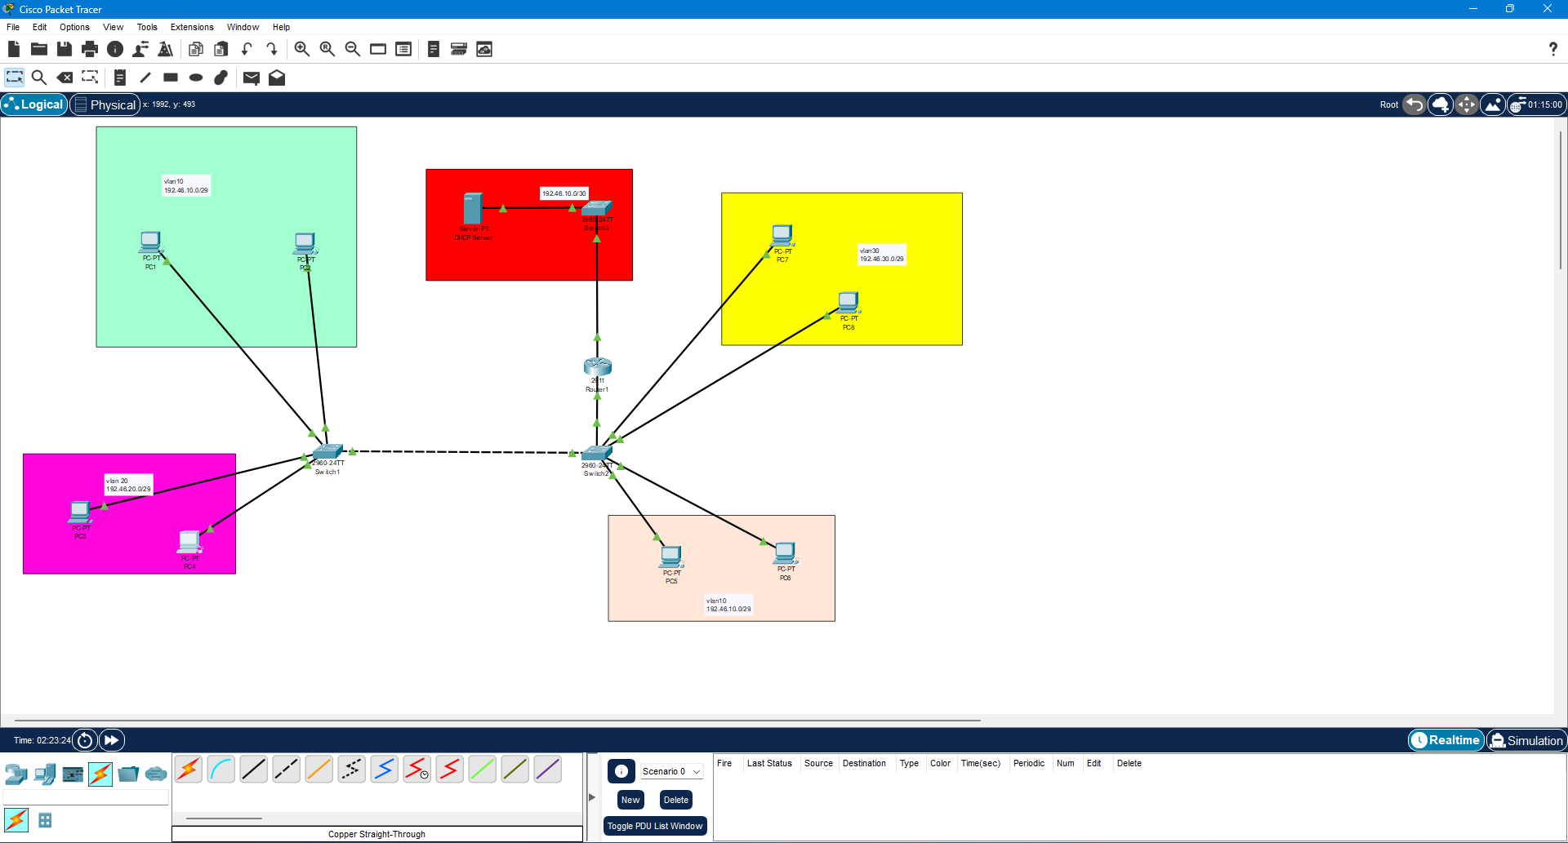

2.

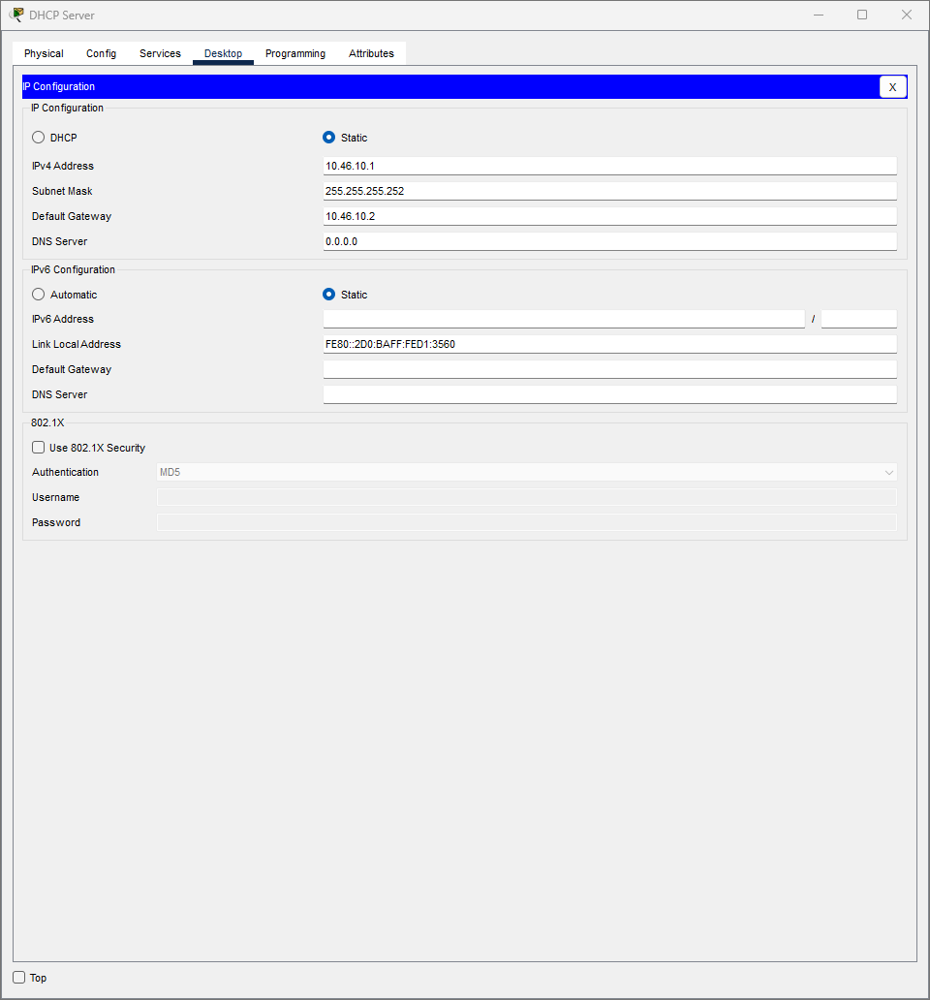

3.

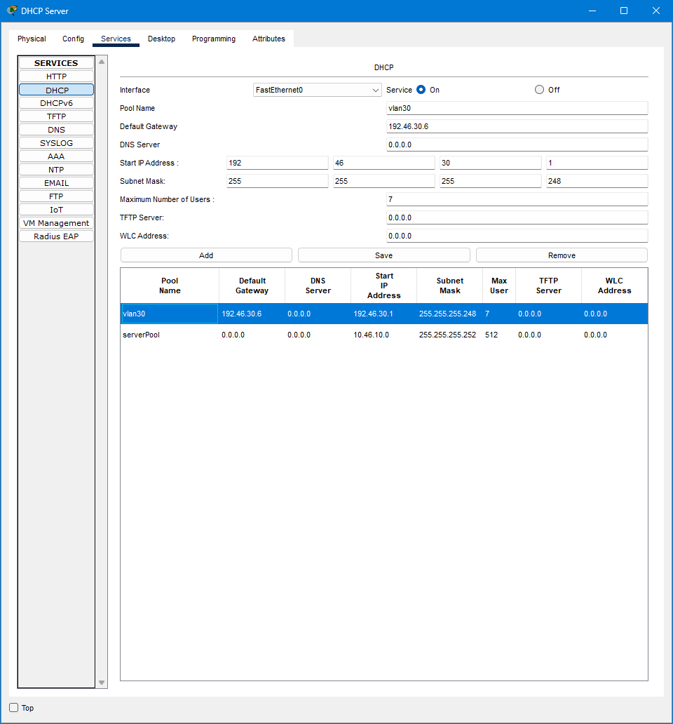

4.

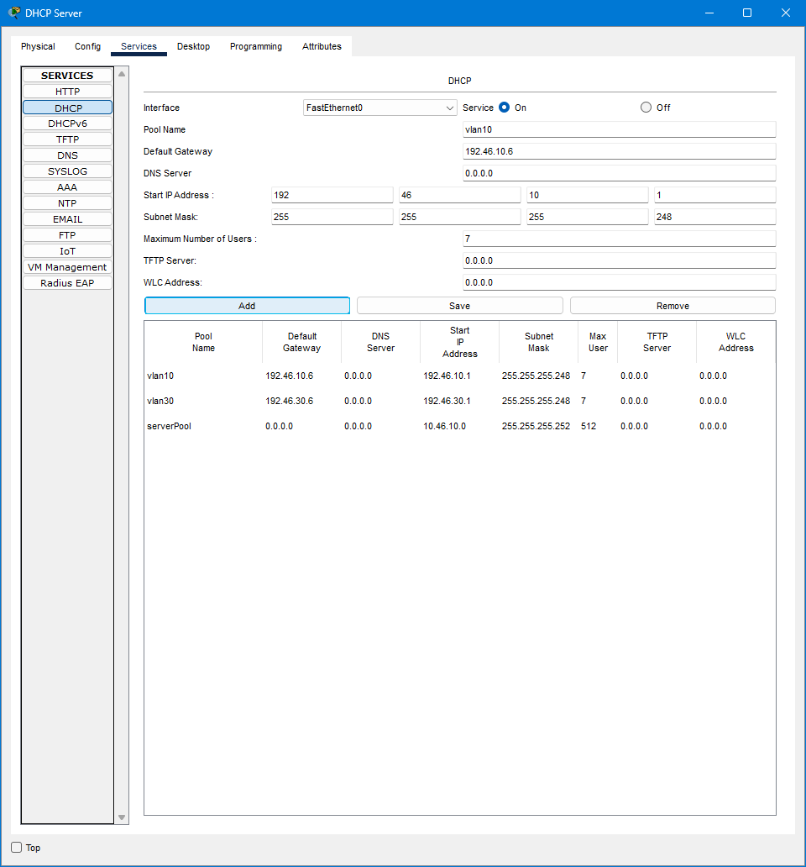

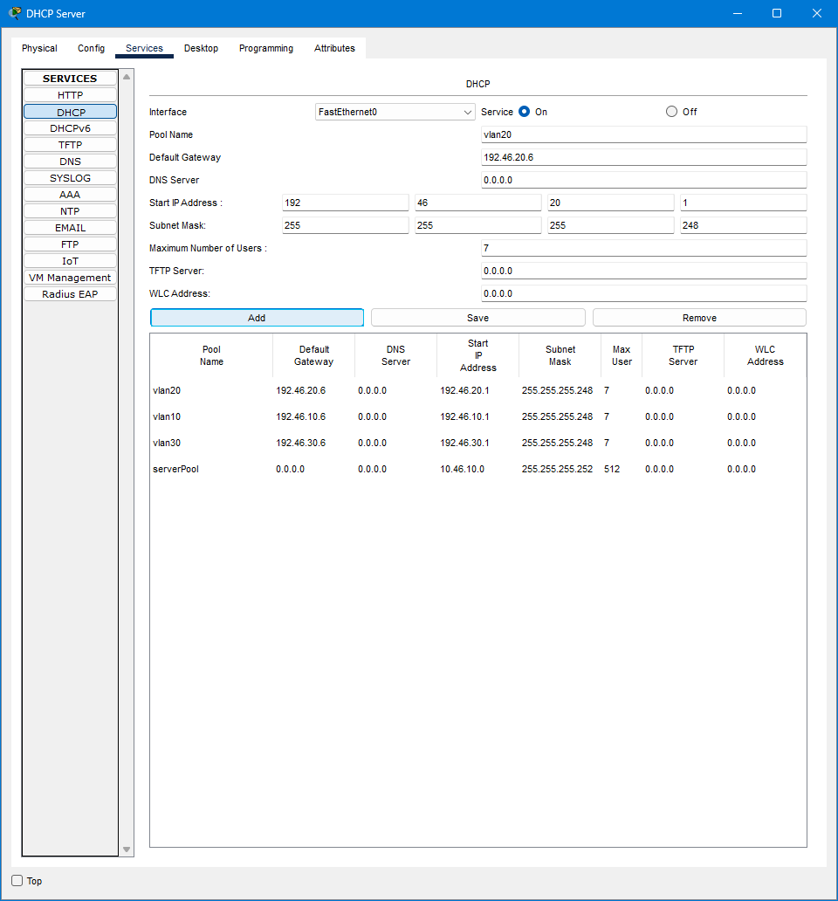

5.

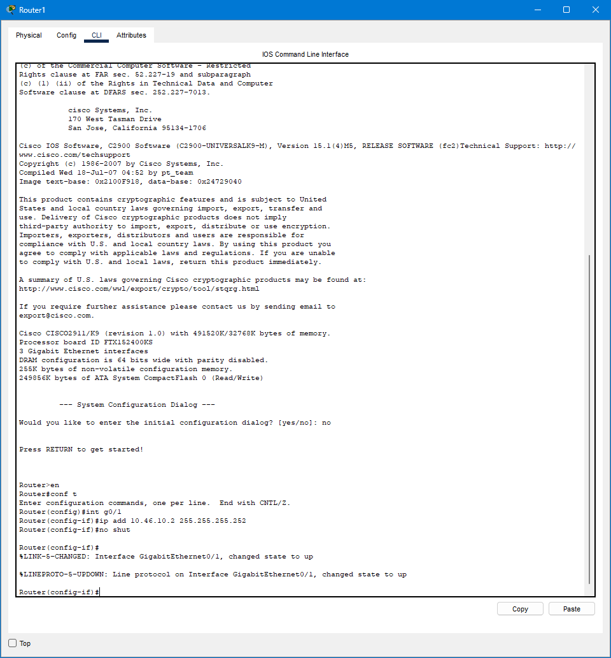

6.

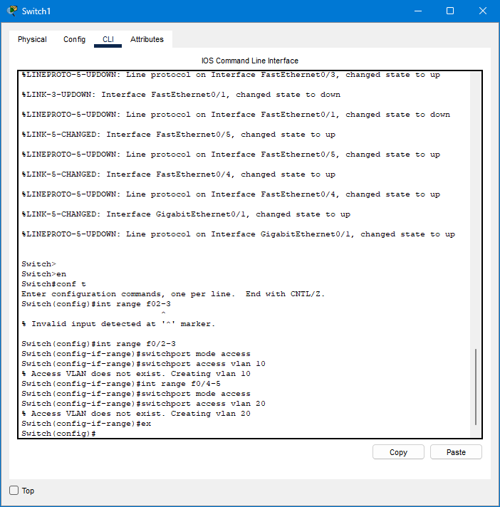

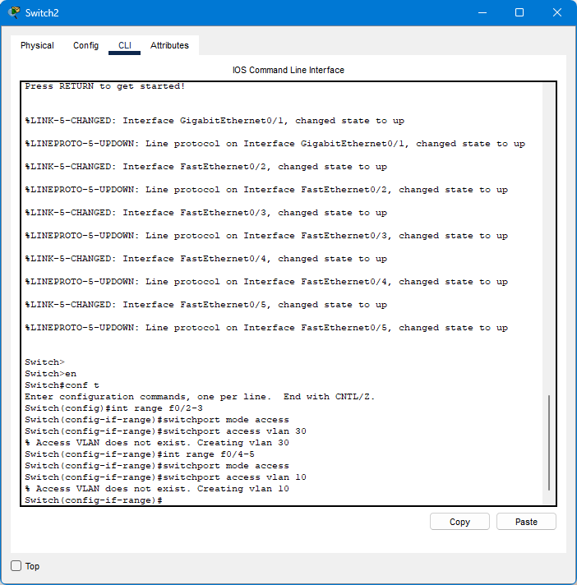

7.

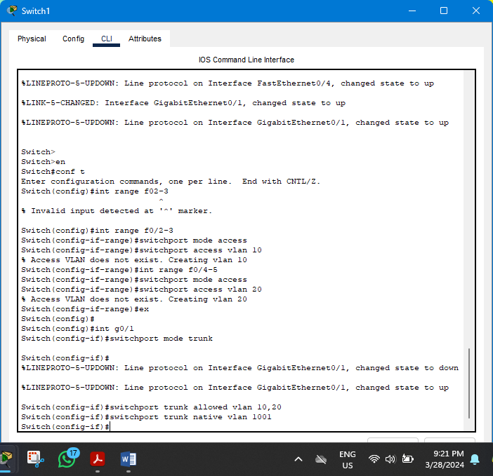

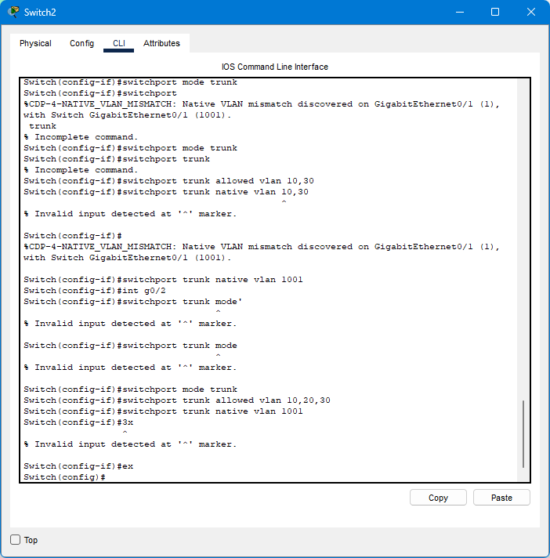

8.

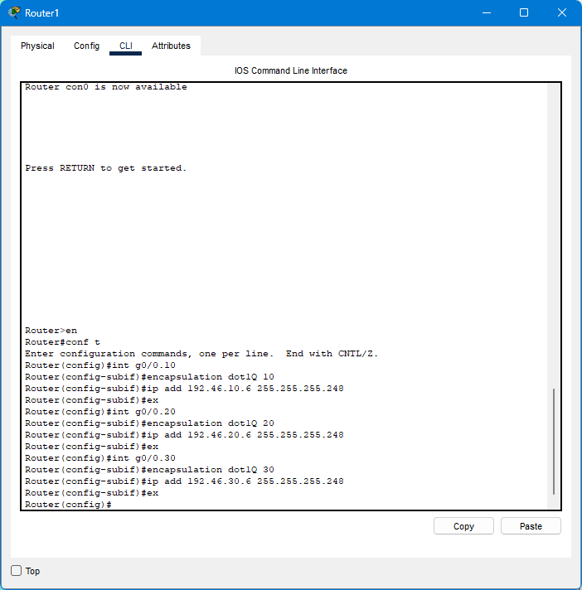

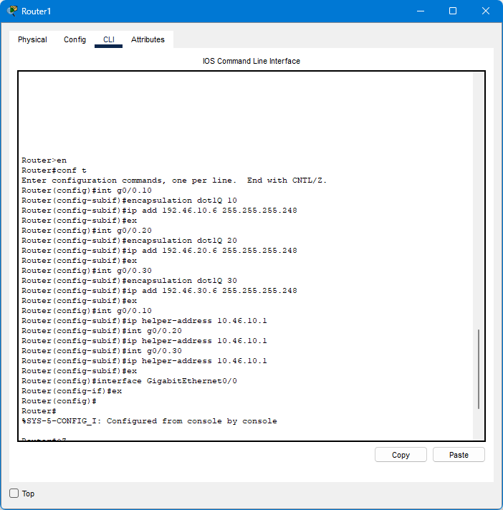

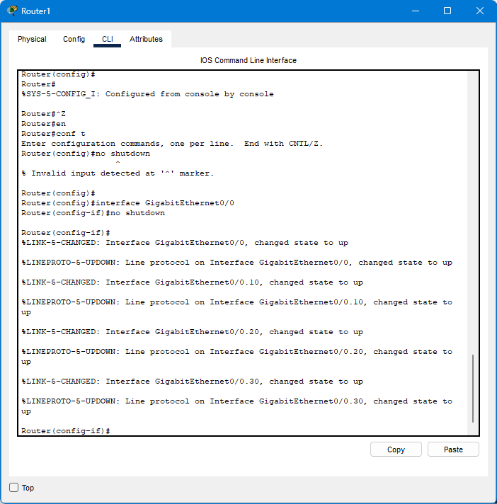

Vlan 30

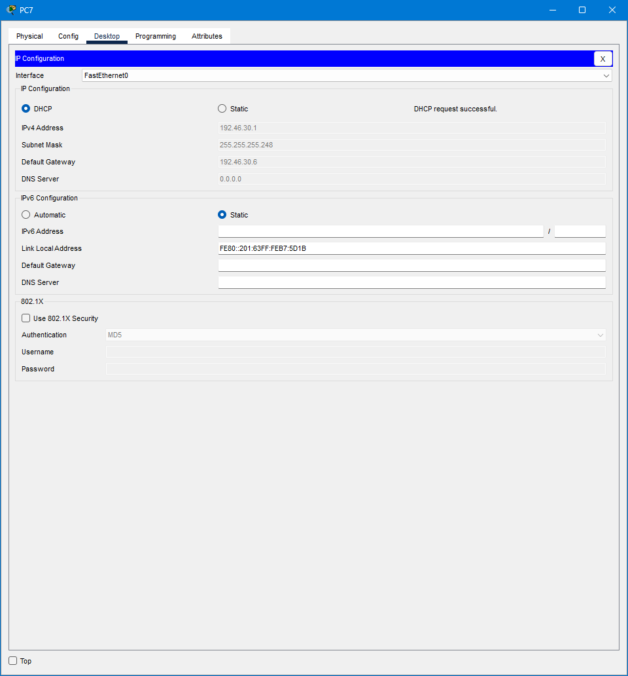

Vlan 10

