SEU_IS_19_ICT_046

**PRACTICAL FOR SCALING AND CONNECTING NETWORK**

**NST31042**

CA 5

1. Assign Ip address in each interface

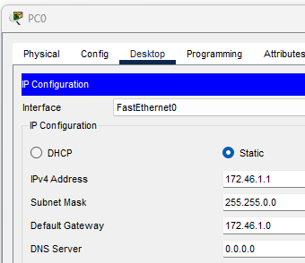

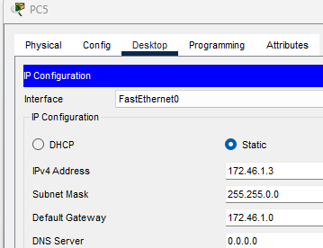

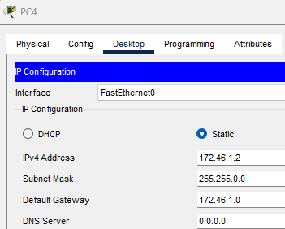

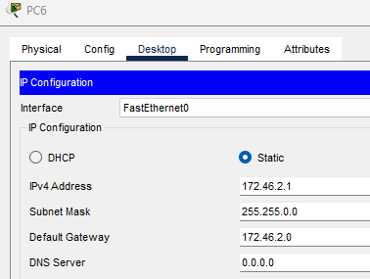

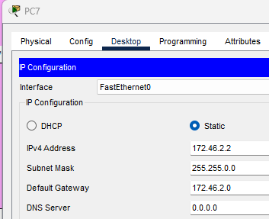

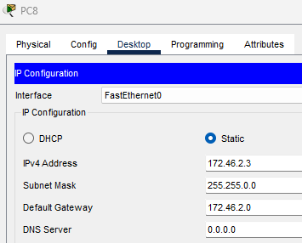

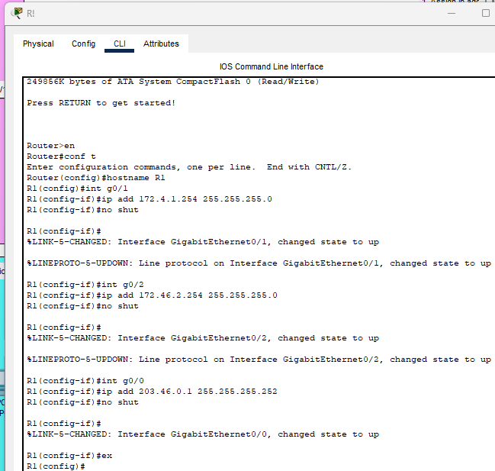

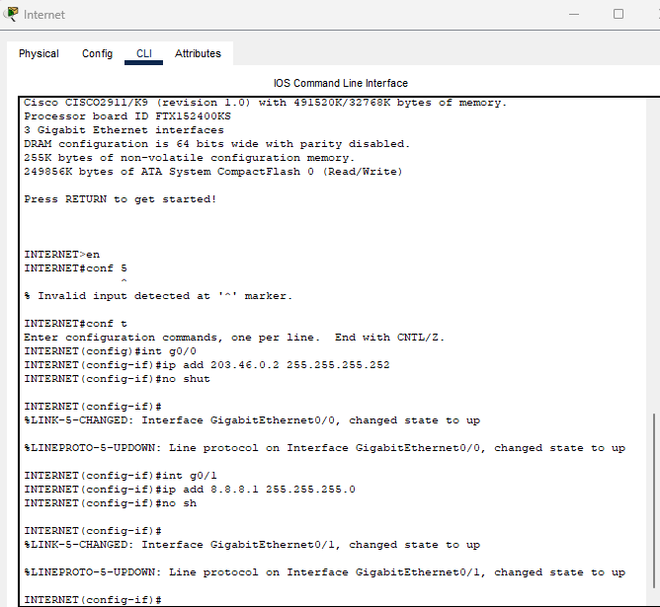

1. Create loopback interface in "INTERNET "and assign Ip address

"172.xxx.175.238/32

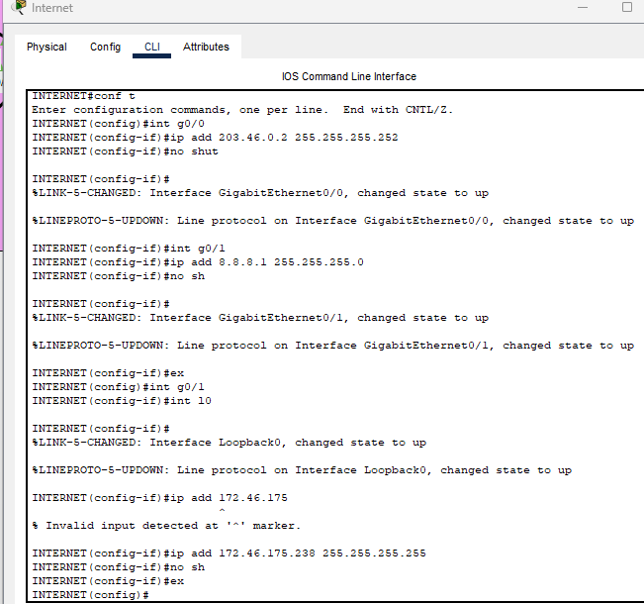

1. on DNS service and name-google.com Address-172.84.175.238

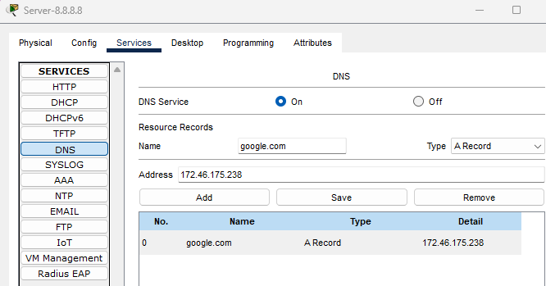

4. Create Ip route in R1 and INTERNET

> R1-0.0.0.0 0.0.0.0 203.84.113.2

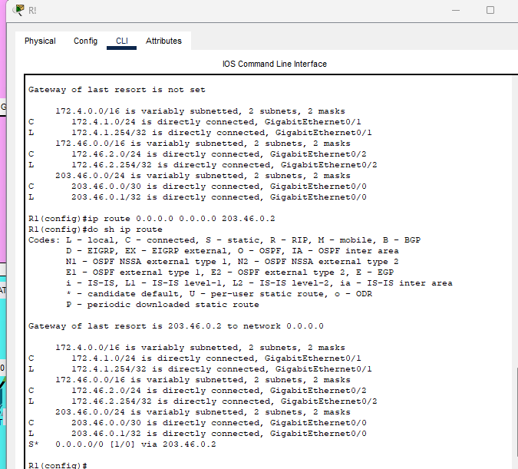

>Internet-100.84.0.0 255.255.255.0 203.0.113.1

> Internet-200.84.0.0 255.255.255.0 203.0.113.1

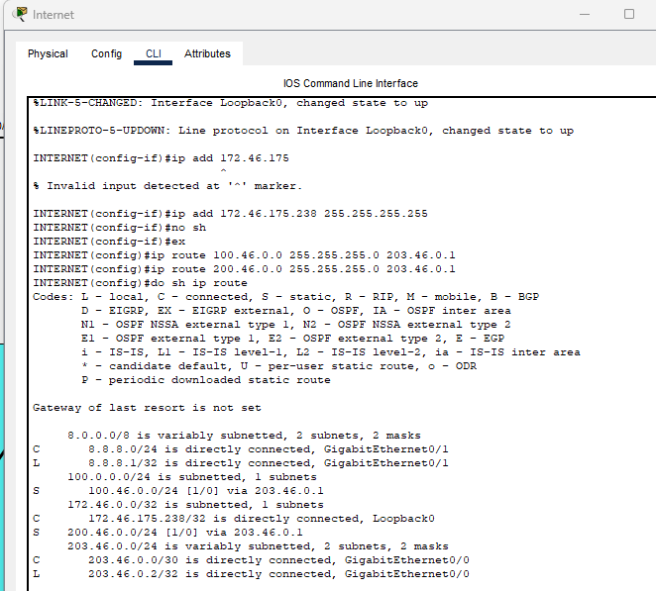

5. Attempt to ping from PC1 and PC4 to 8.8.8.8. Does the ping work?

>>> No

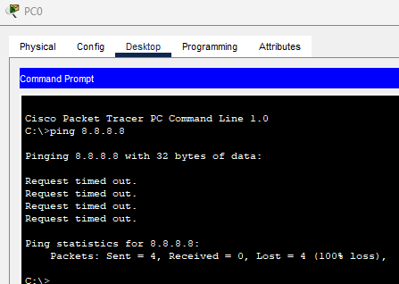

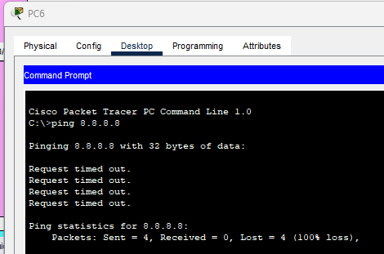

6. Configure Static NAT and Dynamic NAT on R1.

> Configure the appropriate inside/outside interfaces

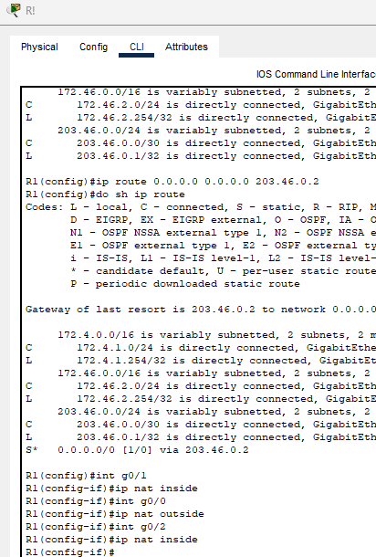

Static NAT

> Map the IP addresses of PC1, PC2, and PC3 to 100.xxx.0.0/24

Dynamic NAT

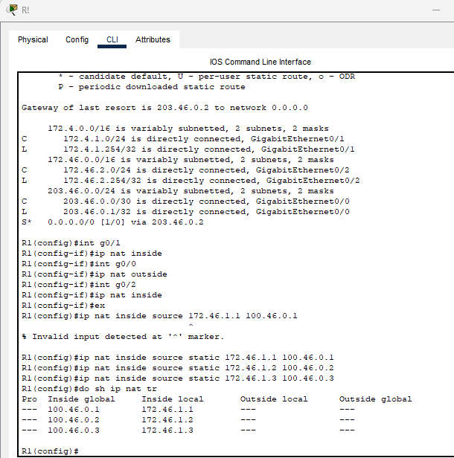

Dynamic NAT

> Create ACL for 172.xxx.2.0/24 Network

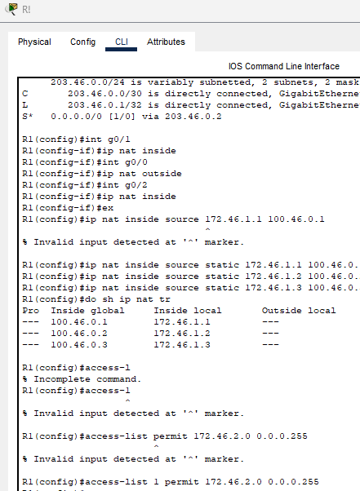

> Translate all traffic from 172.xxx.2.0/24

Create a pool of 200.xxx.0.1 to 200.xxx.0.10 from the 200.xxx.0.0/24 subnet



> Assign NAT to inside

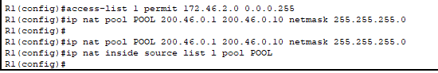

7. Ping 8.8.8.8 from PC1 & PC4 again. Does the ping work?

yes





8. Ping google.com from each PC, and then check the NAT translations on R1.

9. Clear the NAT translations on R1. Which entries remain?

static

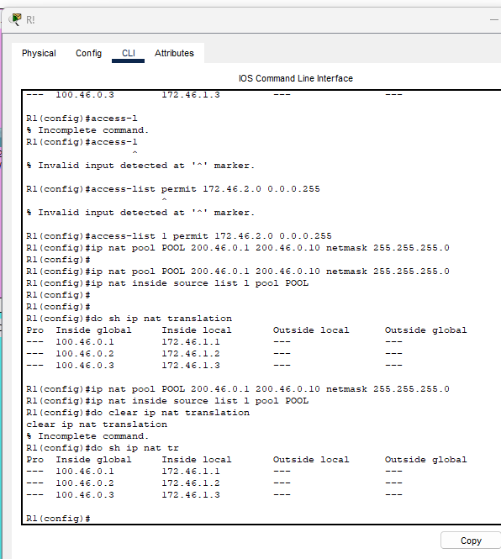

10.Print Statistics on R1?

