**NST31042 – Practical for Scaling and Connecting**

Lab Report-16

1. Registration number: SEU/IS/19/ICT/046
2. Academic Year: 2019/2020
3. Practical Number: 16

Title: NTP Configuration

Aim:

• Configure and Familiar with NTP

Task:

• Set Clock

• Configure Time zone

• Configure NTP Server

• Configure NTP Client



ROUTING HAS BEEN PRECONFIGURED

(default route on R1, OSPF on all routers with 'network 0.0.0.0 255.255.255.255 area 0')

click to server →go to service→ enable it NTP as on

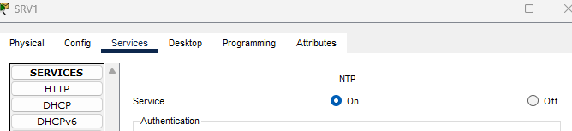

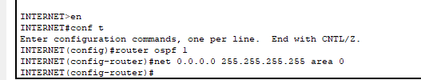

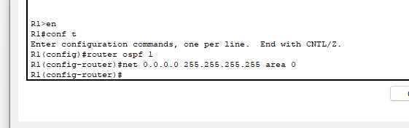

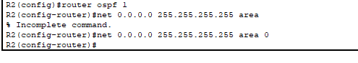

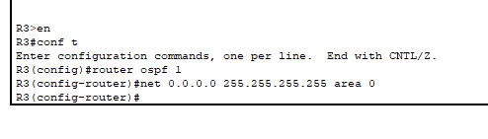

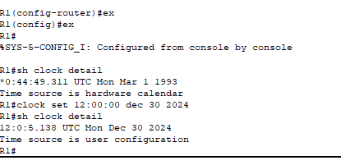

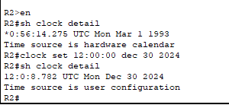

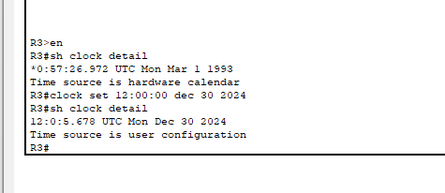

3. Configure R1 to synchronize to NTP server 1.1.1.1 over the Internet.

What stratum is 1.1.1.1? What stratum is R1?

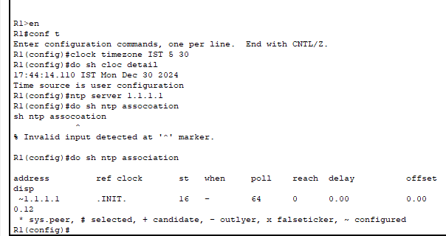

4. Configure R1 as a stratum 8 NTP master.

Synchronize R2 and R3 to R1 with authentication.

*the 'ntp source' command is not available in Packet Tracer, so just use

the physical interface IP addresses of R1.

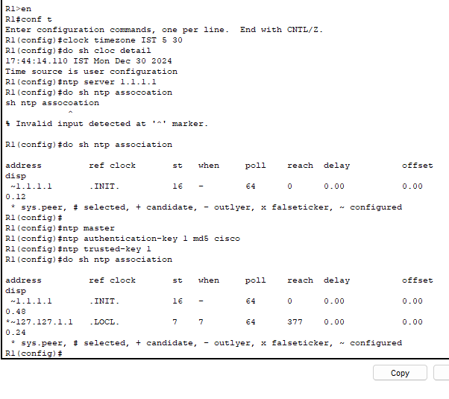

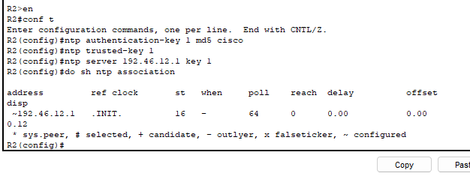

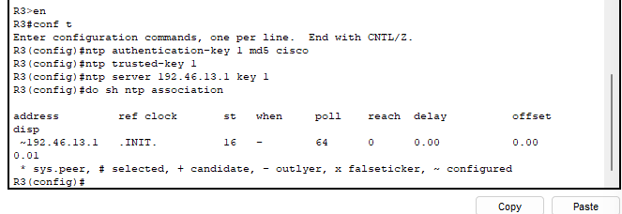

5. Configure NTP to update the hardware calendars of R1, R2, and R3.

*you can't view the calendar in Packet Tracer

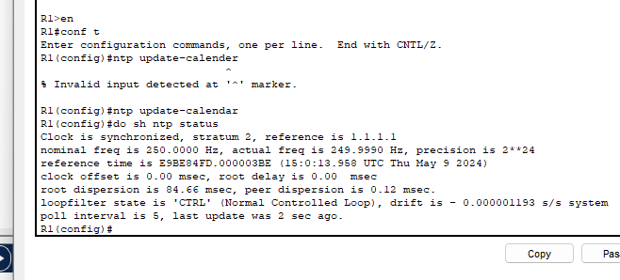

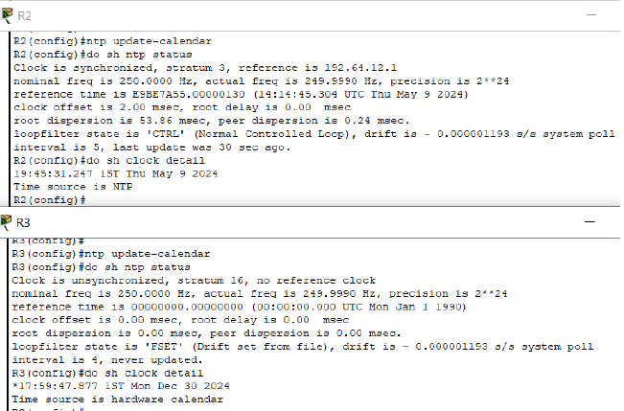

**Discussion**

* I have learnt the basic NTP configuration via this session. I set the Time clock Configure Time zone, Configure NTP Server and Configure NTP Clients.
* A device's internal clock is synchronized with an NTP server by configuration of the NTP (Network Time Protocol). This guarantees that the gadget is equipped with precise time data, which is essential for a number of network functions, security protocols, and logging endeavors. In order to configure the NTP server, it is usually necessary to set up authentication, specify the NTP server address, and modify other parameters pertaining to accuracy and intervals of time synchronization. Maintaining network security and efficiency requires proper NTP settings.

|  |
| --- |
| **Reference** |
|  |
| practical session of lecture (9th May 2024)  https://itexamanswers.net/lab-35-configuring-router-ntp-client.html |
|  |