**NST31042 – Practical for Scaling and Connecting**

Lab Report-17

1. Registration number: SEU/IS/19/ICT/046
2. Academic Year: 2019/2020
3. Practical Number: 17

Title:

SNMP Configuration

Aims:

• Configure and Familiar with SNMP

Tasks:

• Communities Creation

• Use GET and SET Operations

1. Configure the following SNMP communities on R1:

read-only: Cisco1

read/write: Cisco2

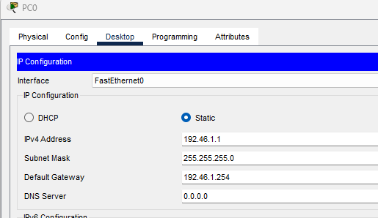

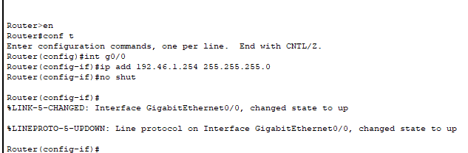

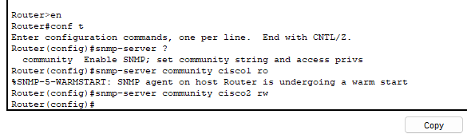

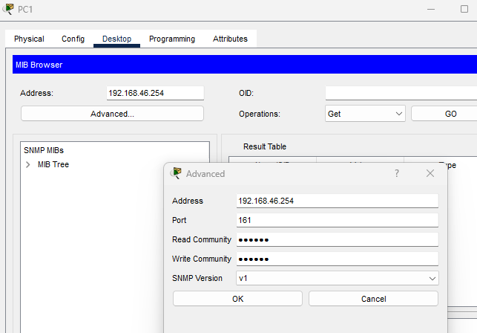

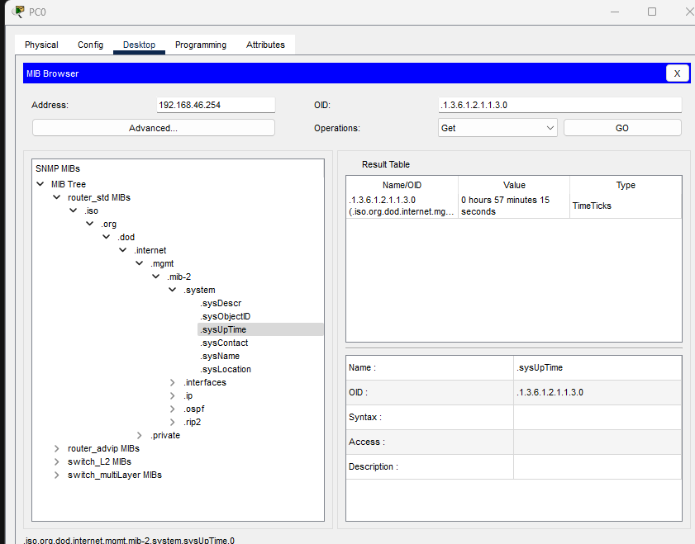

-What is the currently configured hostname on R1?

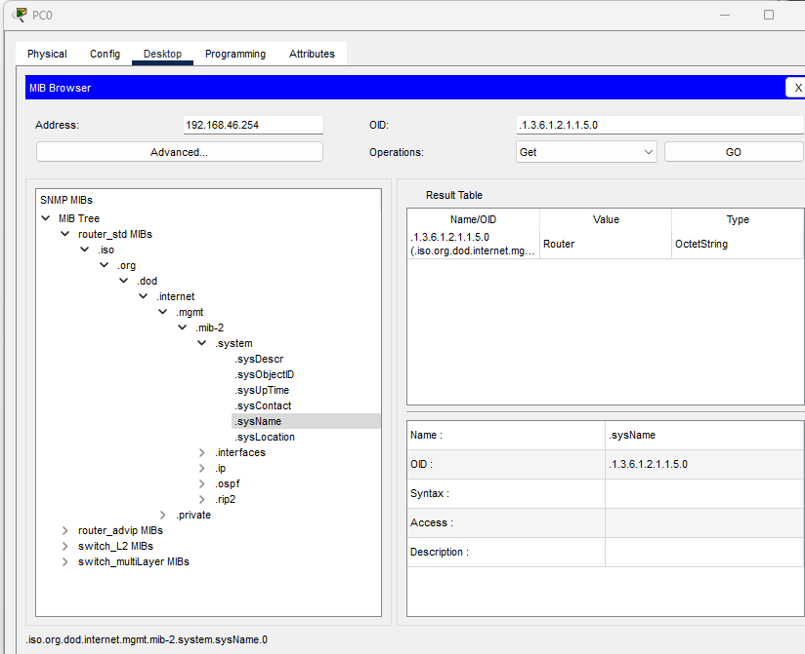

-How many interfaces does R1 have?

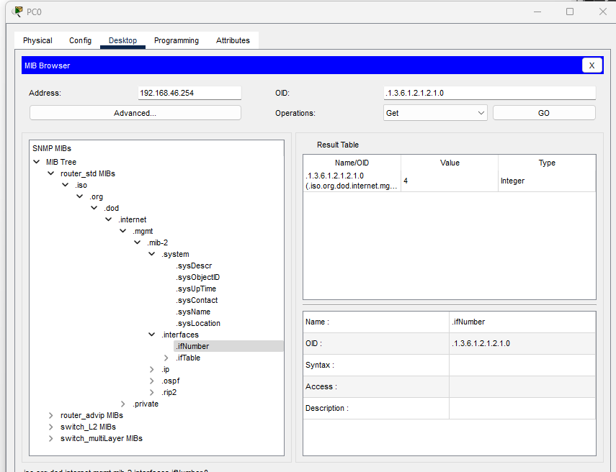

-What are those interfaces?

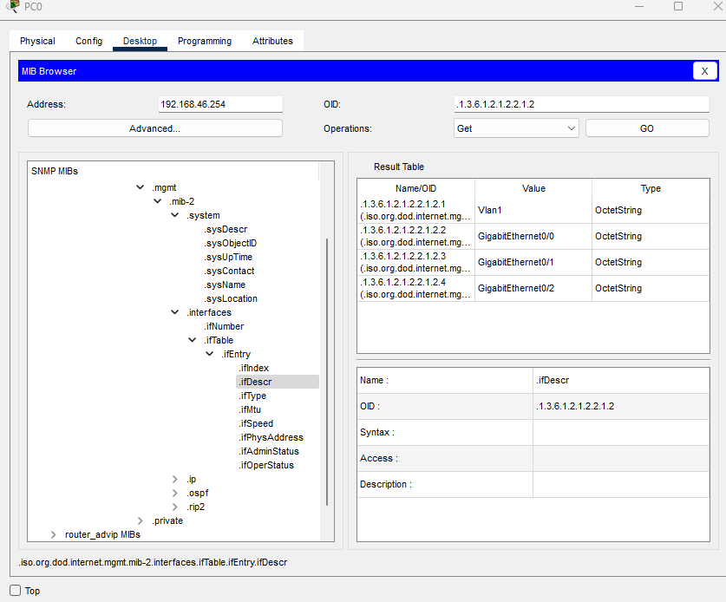

+check what other information you can learn about R1 via SNMP Get messages.

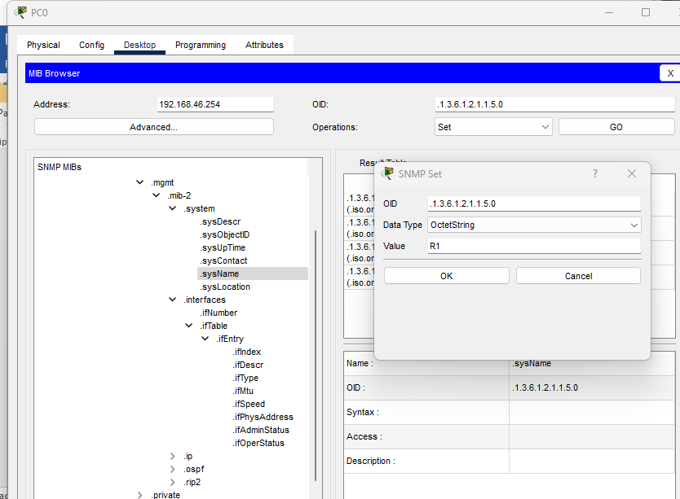

3. Use an SNMP 'Set' message from PC1 to change the hostname of R1.

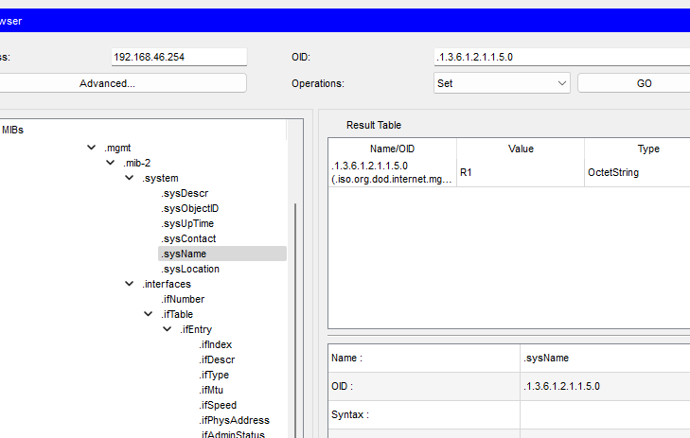

**Discussion: -**

* 1. In this practical session, I got the knowledge about SNMP Configuration.

1. The Simple Network Management Protocol (SNMP) is used for network monitoring and management. It is made up of 3 parts, the SNMP manager, SNMP agent and Management Information Base (MIB).
2. It allows network administrators to manage network performance, find and solve network problems, and plan for network growth.
3. Reference:

* practical session of lecture
* Configure SNMP Protocol on Cisco Packet Tracer – BT BLOG (wordpress.com)