**NST31042 - Practical for Scaling and Connecting**

Department of Information & Communication Technology Faculty of Technology, SEUSL

**Registration Nr: -SEU/IS/19/ICT/046**

**Academic year: -2019/2020**

**Lab Report: – 18**

**Title:**

Syslog Configuration

**Aim:**

• Configure and Familiar with Syslog

**Task:**

• Console Logging

• VTY Logging

• Buffer Logging

• External-Server Logging

**Introduction:**

Syslog is a protocol that computer systems use to send event data logs to a central location for storage. Logs can then be accessed by analysis and reporting software to perform audits, monitoring, troubleshooting, and other essential IT operational tasks.

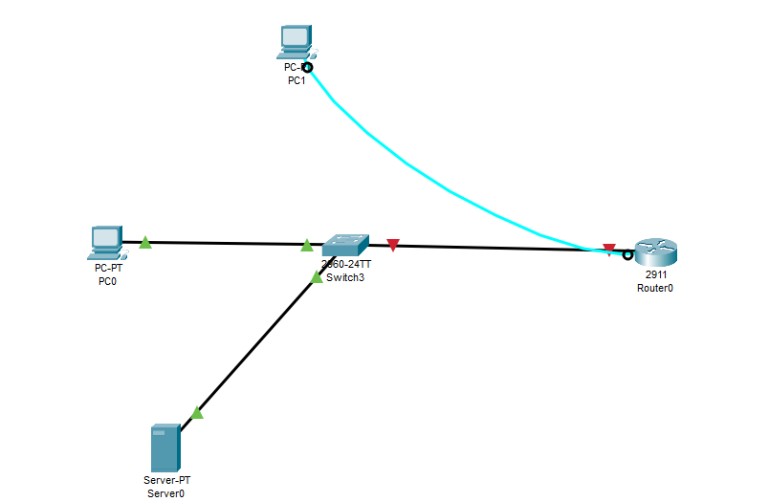

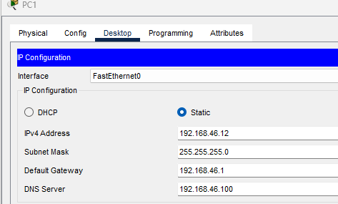

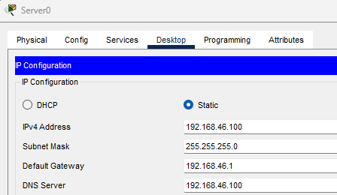

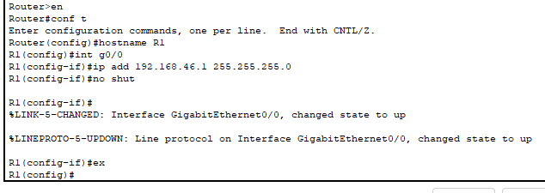

R1 username: cisco, PW: 1234, enable PW: 1234

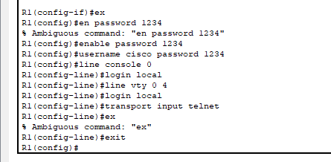

Create console line and VTY line (vty 0-4 and vty 5-15)

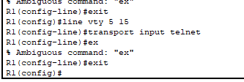

1. Connect to R1's console port using PC2: -Shut down the G0/0 interface -After you receive a syslog message, re-enable the interface. -What is the severity level of the syslog messages? -Enable timestamps for logging messages

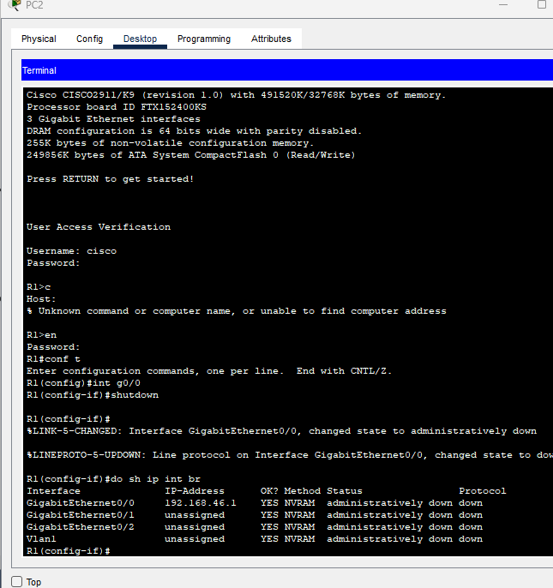

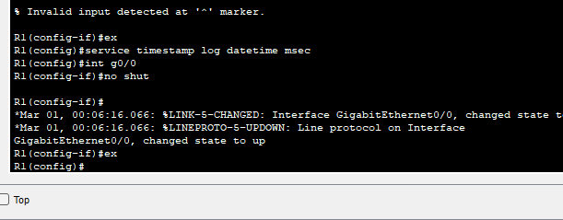

1. Telnet from PC1 to R1's G0/0 interface -Enable the unused G0/1 interface -Why does no syslog message appear? -Enable logging to the VTY lines for the current session. *there is no 'logging monitor' command in packet tracer, but it's enabled by default

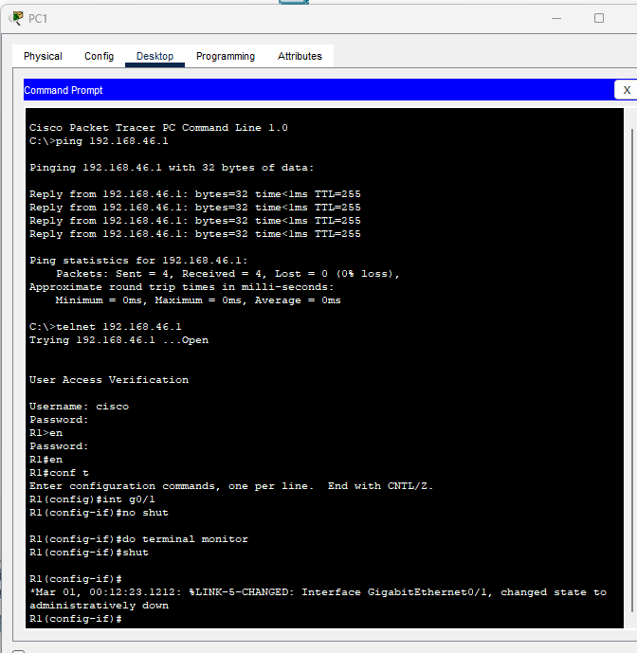

1. Enable logging to the buffer, and configure the buffer size to 8192 bytes.

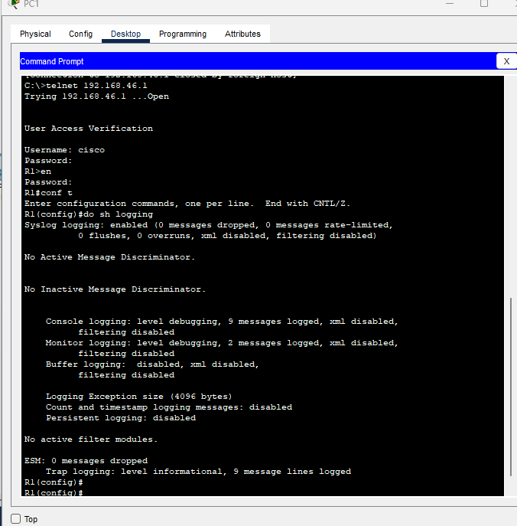

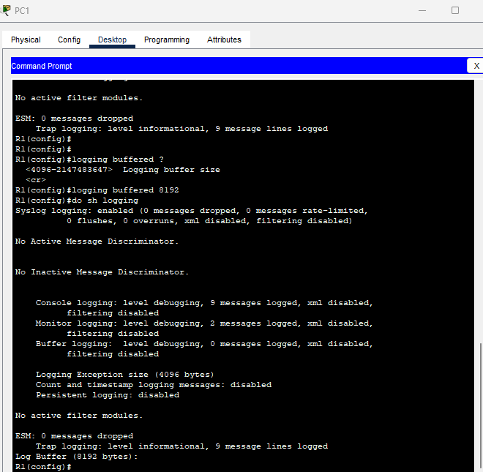

1. Enable logging to the syslog server SRV1 with a level of 'debugging'.

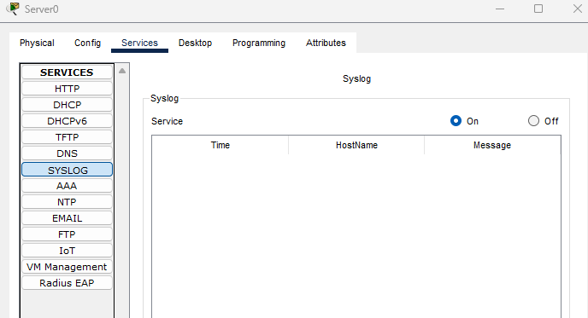

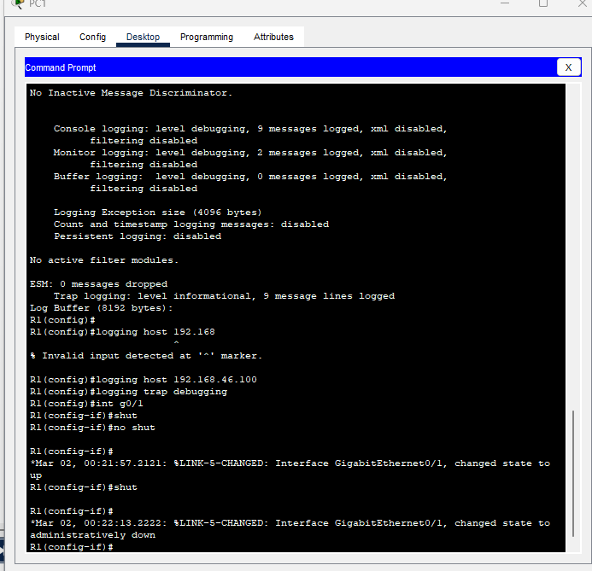

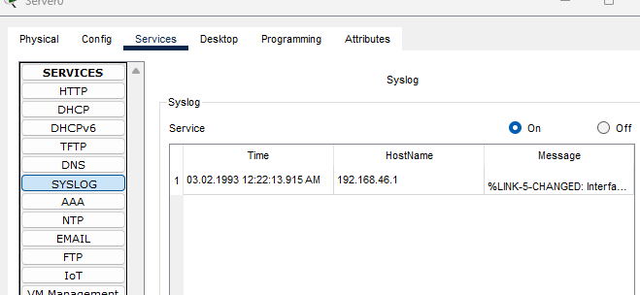

**Discussion**

Syslog configuration involves setting up the logging system on a device to send logs to a central logging server. This allows for centralized monitoring, analysis, and storage of logs from multiple devices in a network. Configuration typically involves defining the log format, specifying the log server's address, setting log levels, and filtering which logs should be sent. This configuration ensures that important events and errors are captured and can be easily analyzed for troubleshooting and security purposes.

**References:**

* practical session of lecture
* https://networkproguide.com/configure-syslog-cisco-ios-switch-router/