**NST31042 – Practical for Scaling and Connecting**

SEU-IS_19_ICT_046

4TH LABREPORT

Academic Year: 2019/2020

➢ Practical Number: 4

➢ Date: 14/03/2024

**Title:** EIGRP Configuration Lab

**Aim:**

1. Understand the basic configuration and operation of EIGRP.
2. Implement EIGRP routing protocol in a small network topology.
3. Verify EIGRP neighbor relationships and routing table entries.

**Task:**

1. Topology Setup
2. EIGRP Configuration
3. Neighbor Verification
4. Routing Table Verification
5. Testing and Observation

**Introduction:**

1. EIGRP is an advanced distance-vector routing protocol used in computer networks.
2. It offers features like rapid convergence, reduced bandwidth consumption, and minimal routing updates.
3. The aim of this lab is to gain hands-on experience with configuring and verifying EIGRP in a simulated network environment.

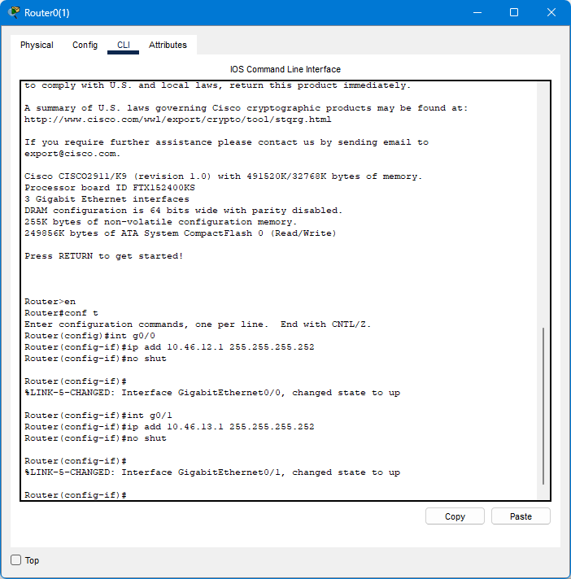

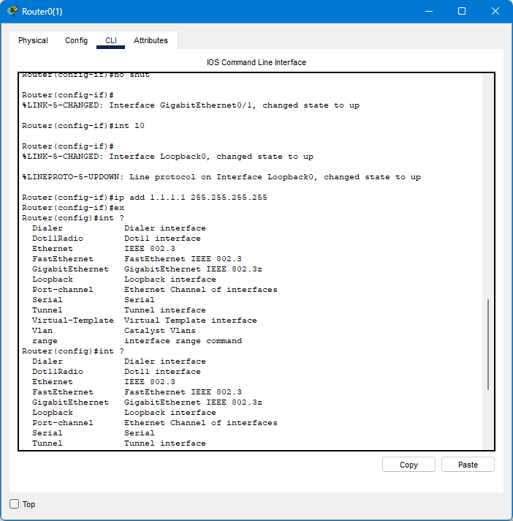

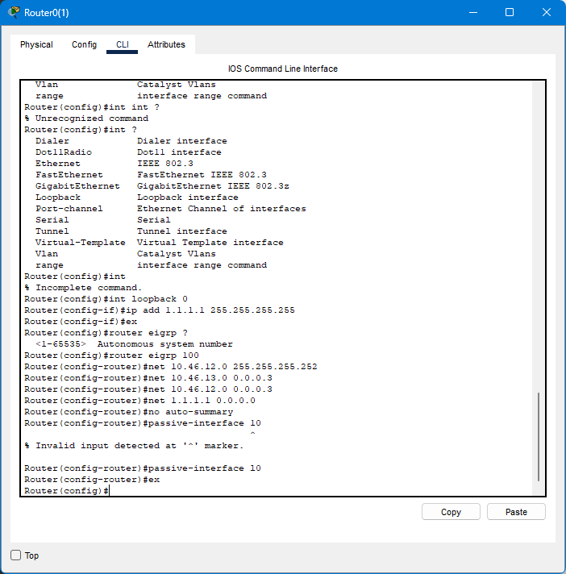

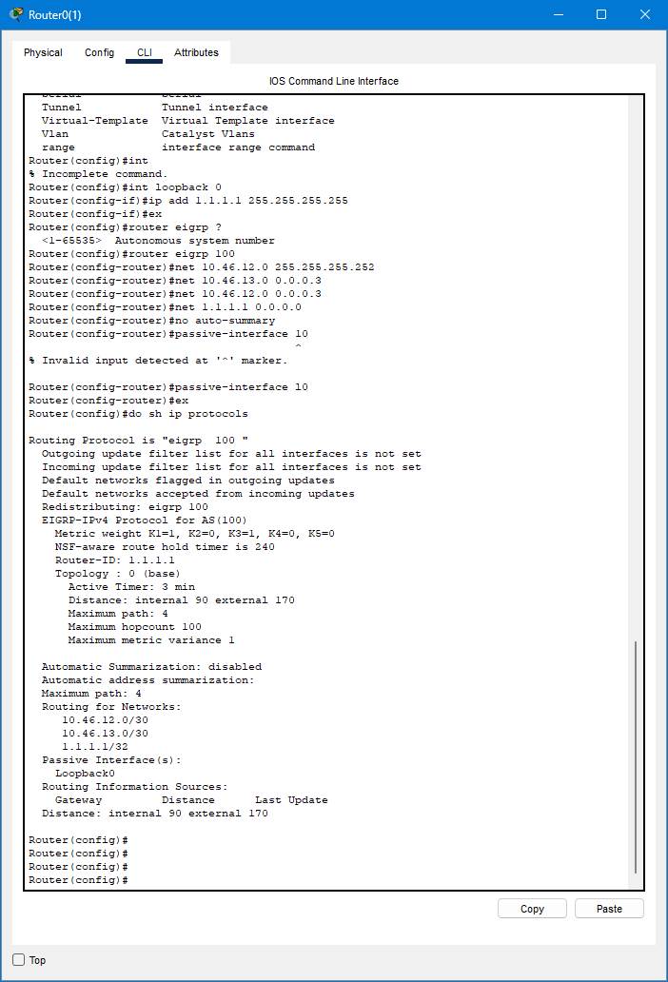

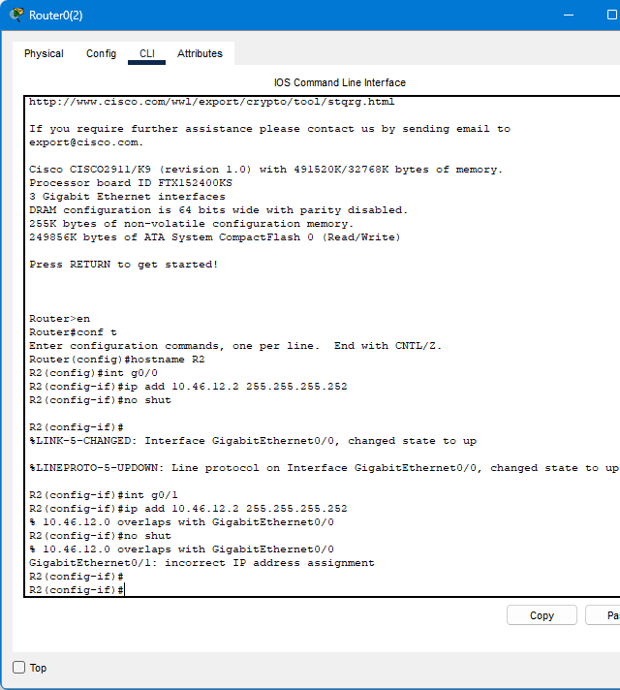

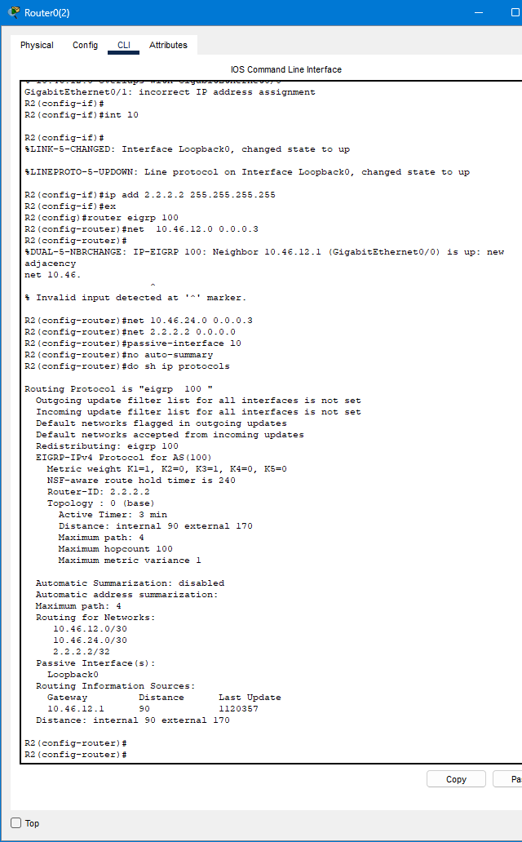

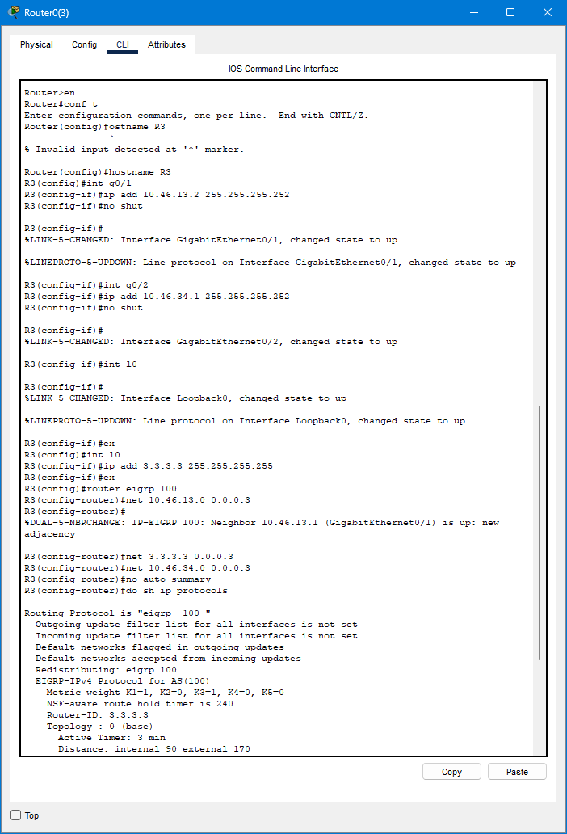

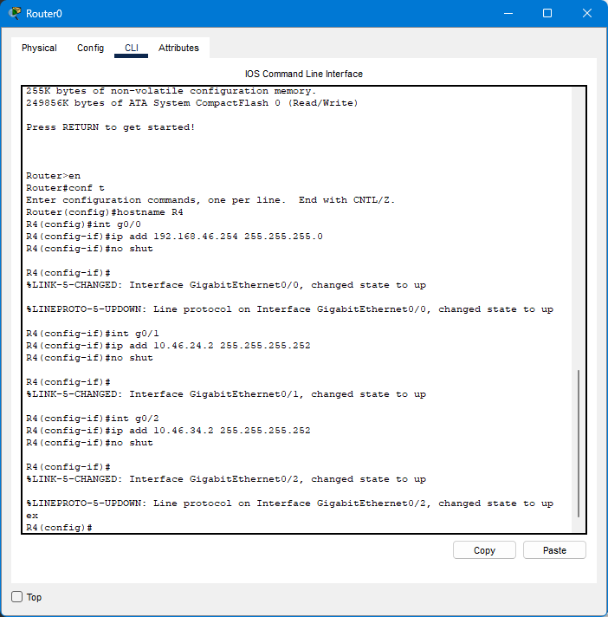

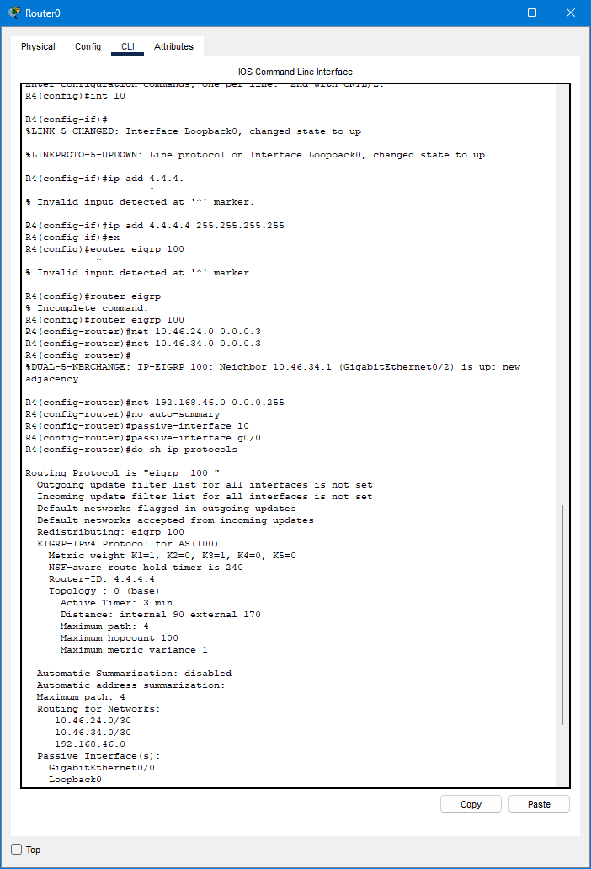

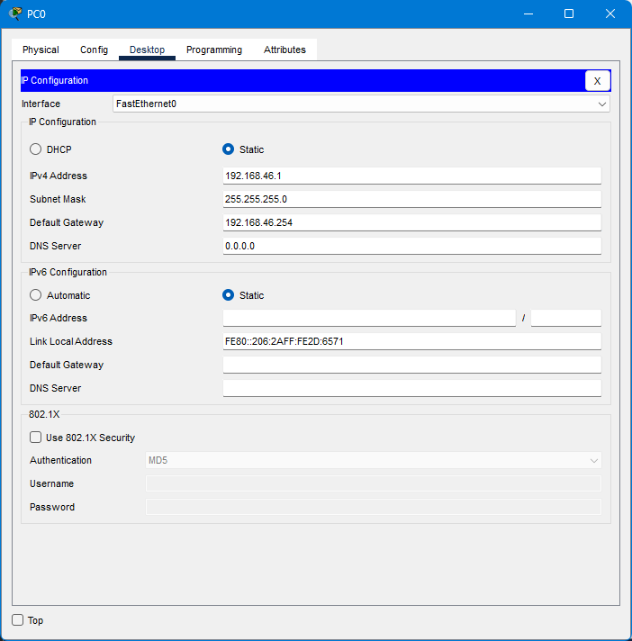

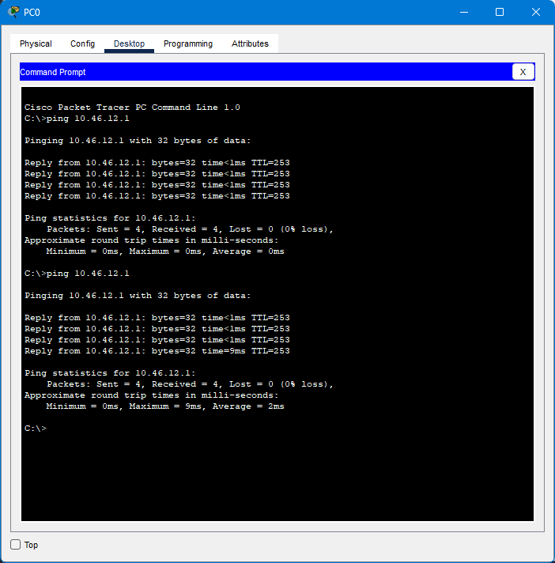

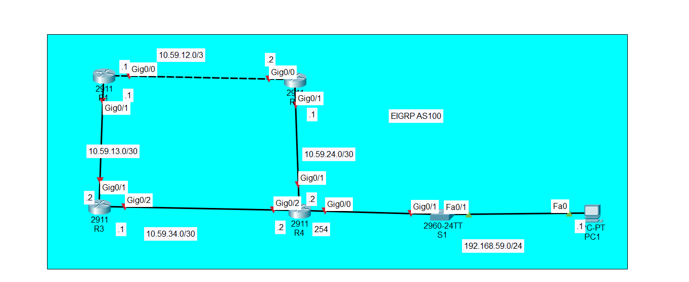

Discussion:

From this session I have learn that the basic configuration of the eigrp

Got to know about how to route in a network

Pinged successfully

References:

Practical lecture session