**NST31042 – Practical for Scaling and Connecting**

Lab Report-5

SEU-IS-19-ICT-046

**Title:** OSPF Basic Configuration Lab

**Aim:**

1. Understand the fundamentals of OSPF routing protocol.
2. Configure OSPF routing protocol in a small network topology.
3. Verify OSPF neighbor relationships and routing table entries.

**Task:**

1. Topology Setup
2. OSPF Configuration
3. Neighbor Verification
4. Routing Table Verification
5. Testing and Observation

**Introduction:**

1. OSPF is a widely used link-state routing protocol in computer networks.
2. It provides efficient and scalable routing by calculating shortest path routes based on link cost.
3. The aim of this lab is to gain hands-on experience with configuring and verifying OSPF in a simulated network environment

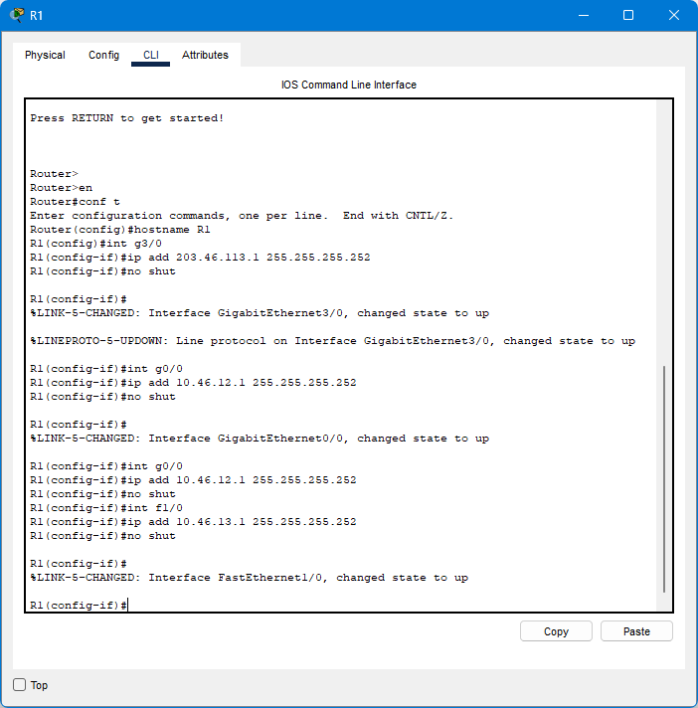

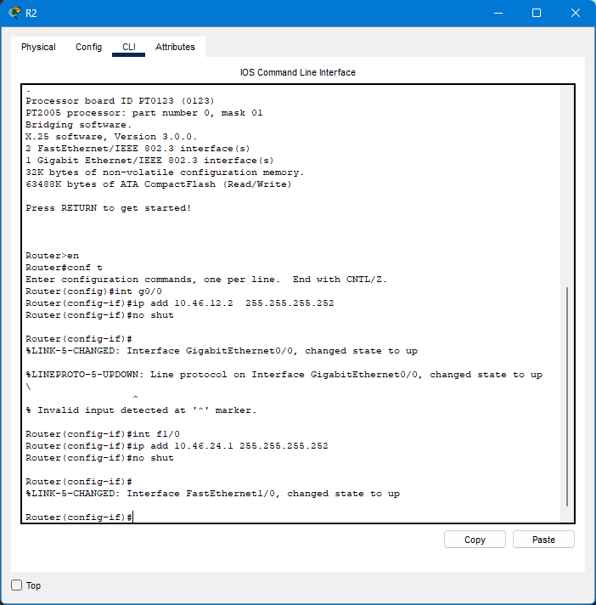

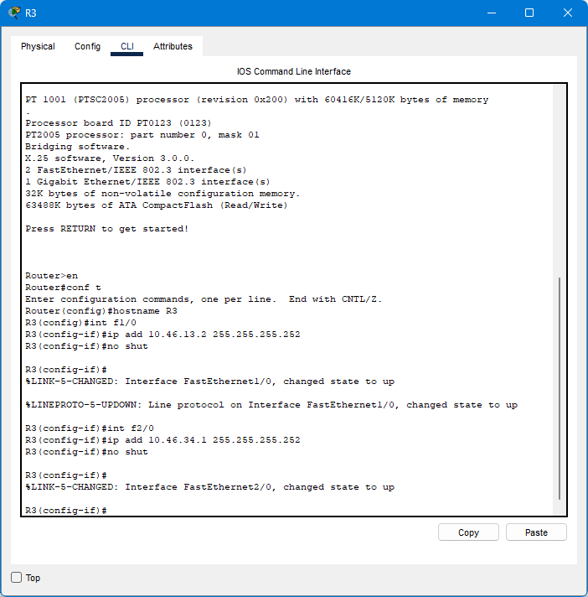

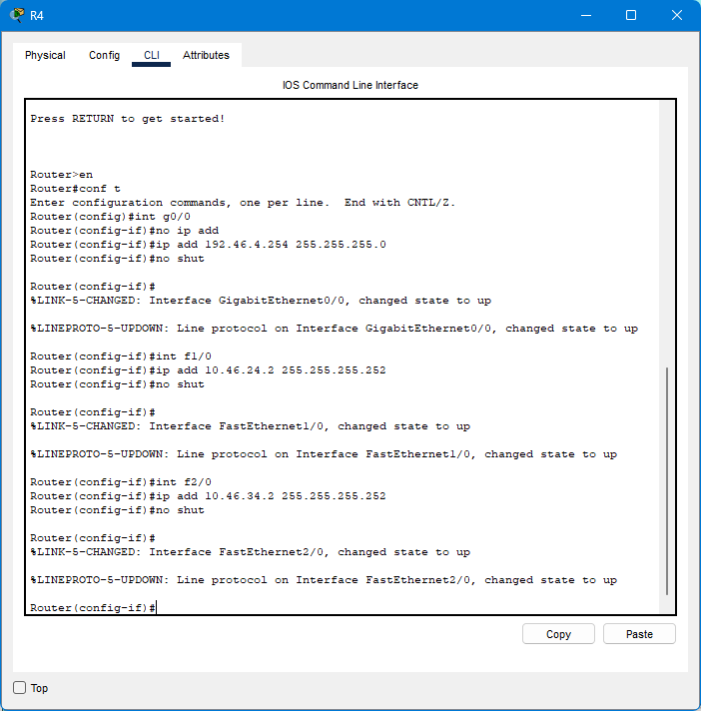

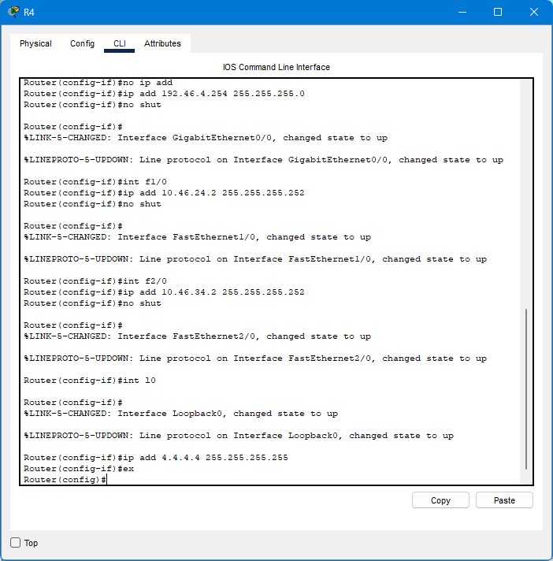

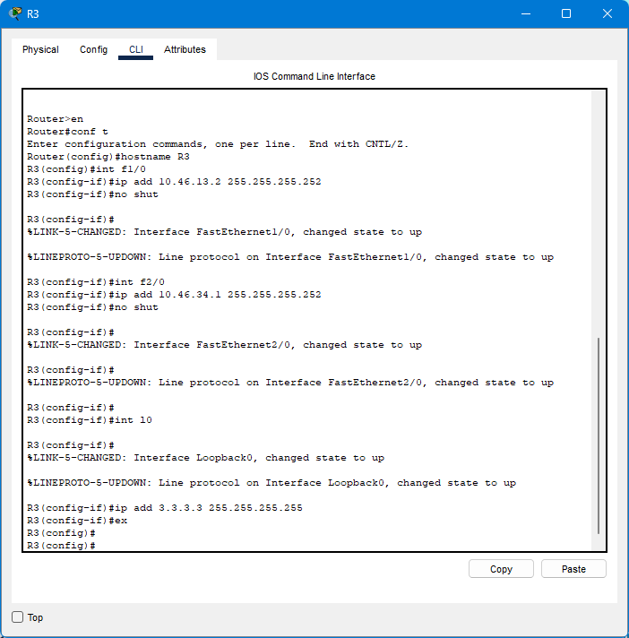

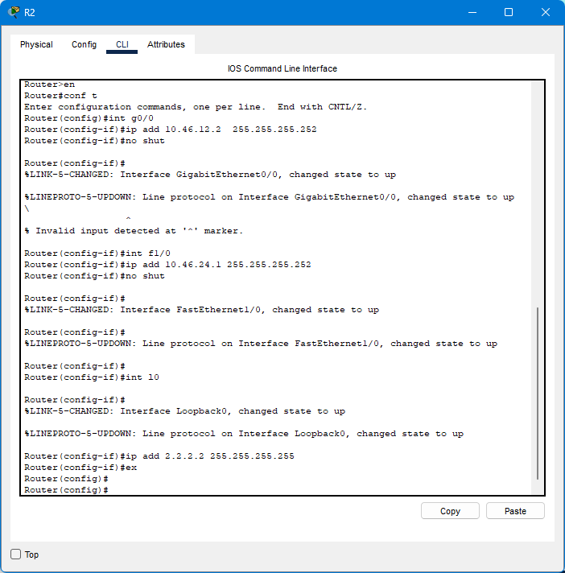

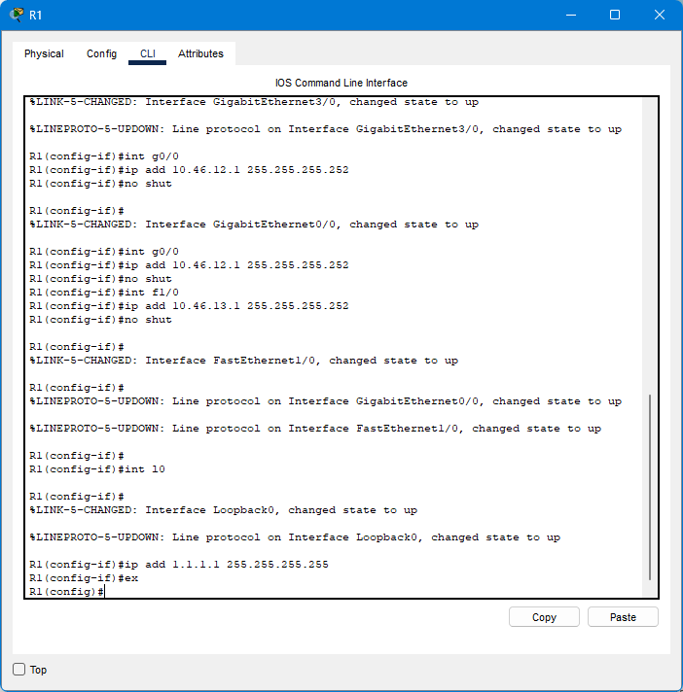

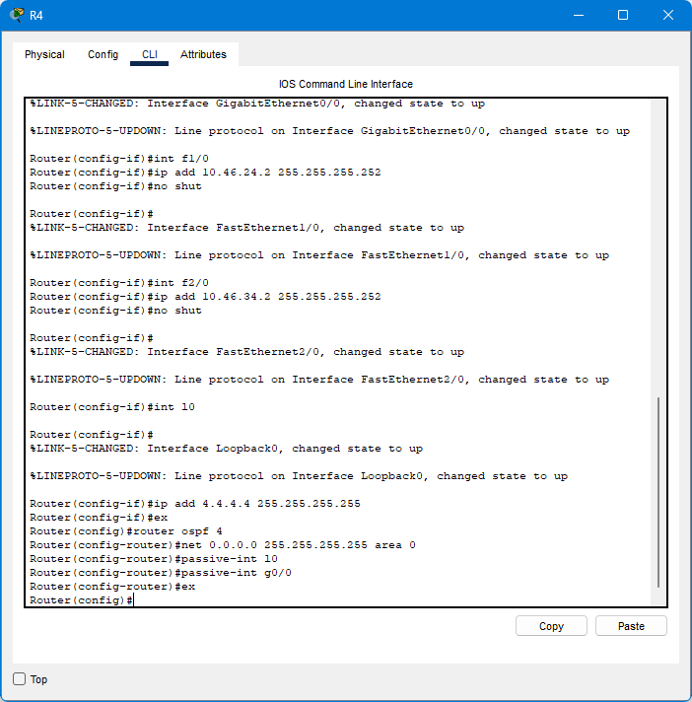

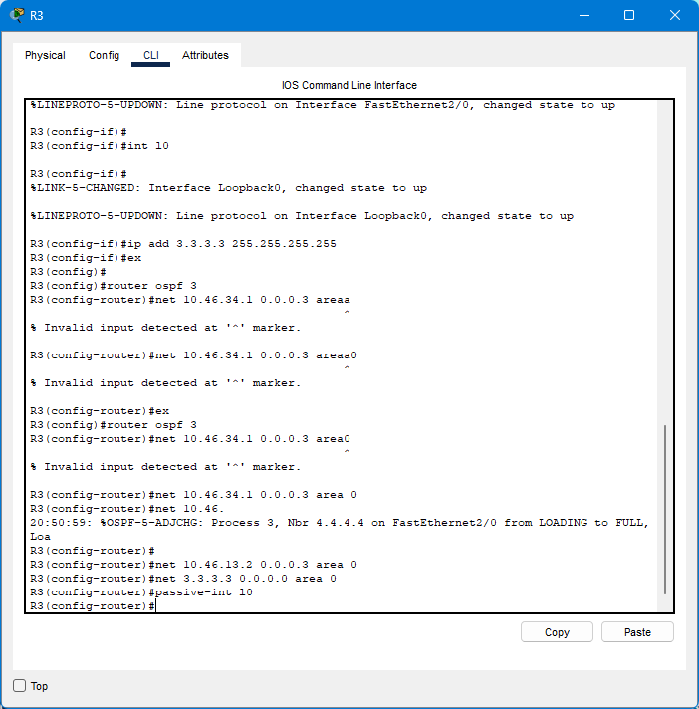

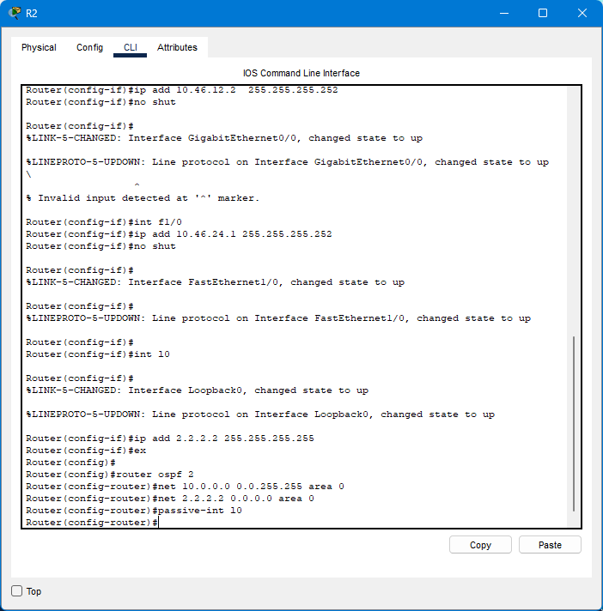

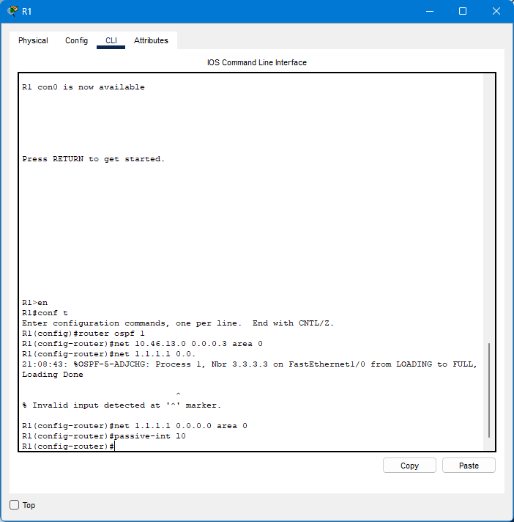

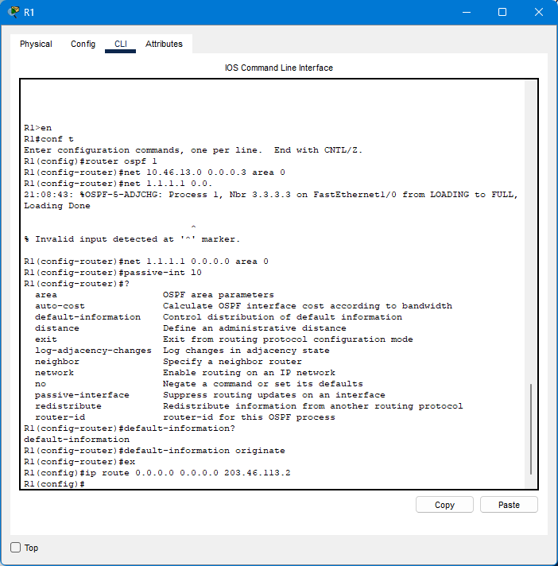

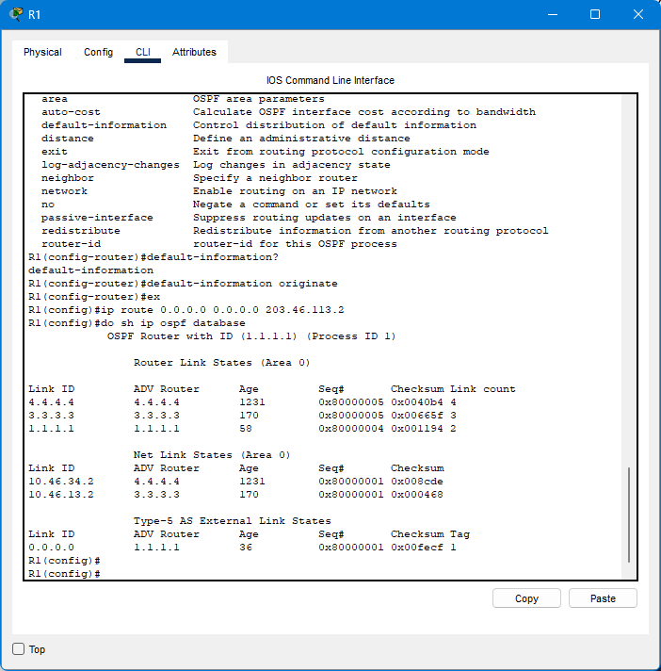

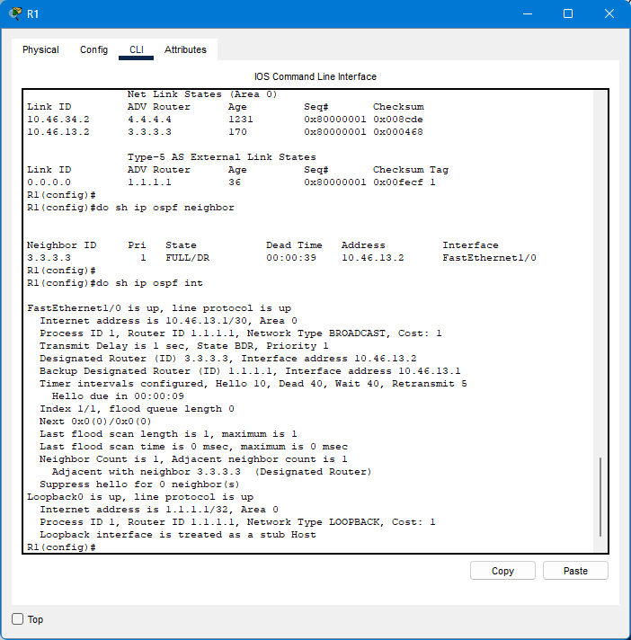

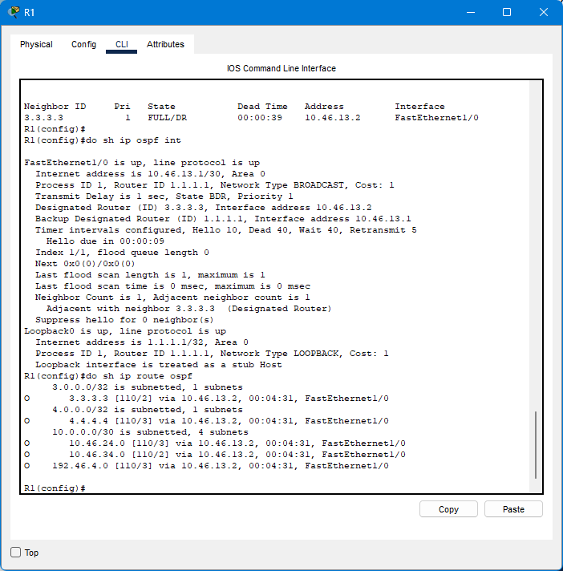

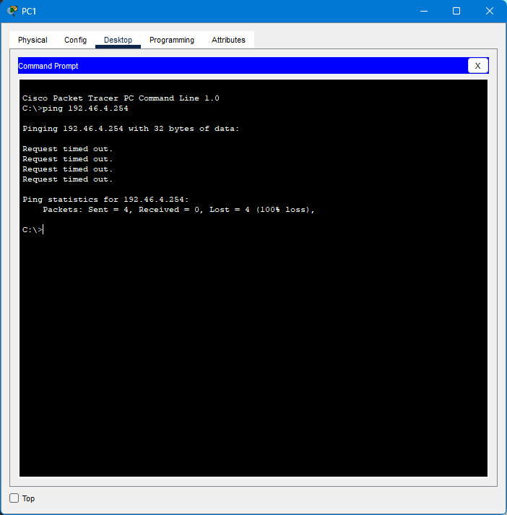

Discussion:

I have studied the fundamentals of the ospf routing

From this session I have learnt that how to identify the neighbor for each router

References:

Practical lecture session