**NST31042 – Practical for Scaling and Connecting**

Lab Report-8

1. Registration number: SEU/IS/19/ICT/046
2. Academic Year: 2019/2020
3. Practical Number: 8

**Title:** Standard ACL Configuration

**Aims:**

1. Standard Named ACL Configuration
2. Standard Numbered ACL Configuration

**Tasks:**

1. IP Configuration
2. Apply the ACL Configuration
3. Verify

Question 1:



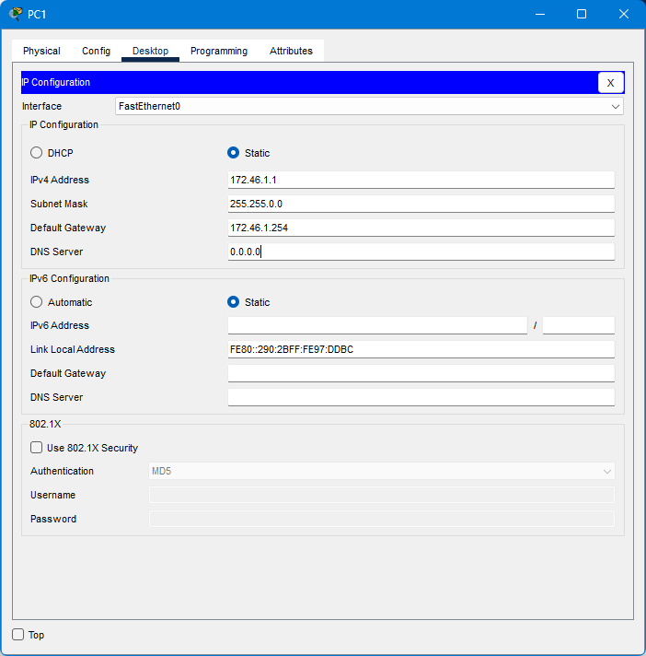

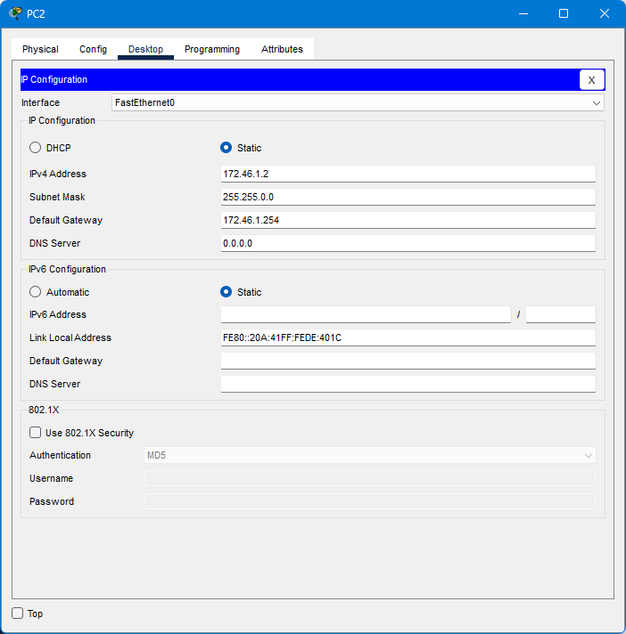

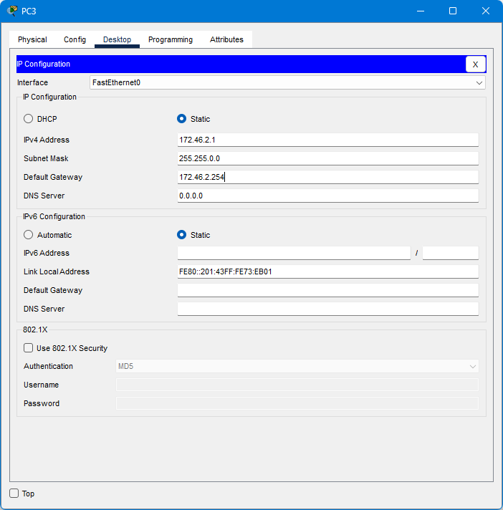

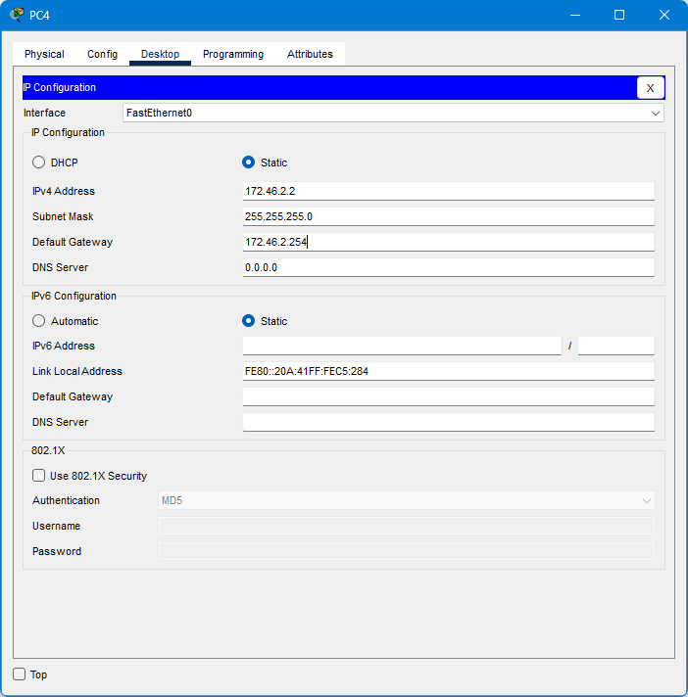

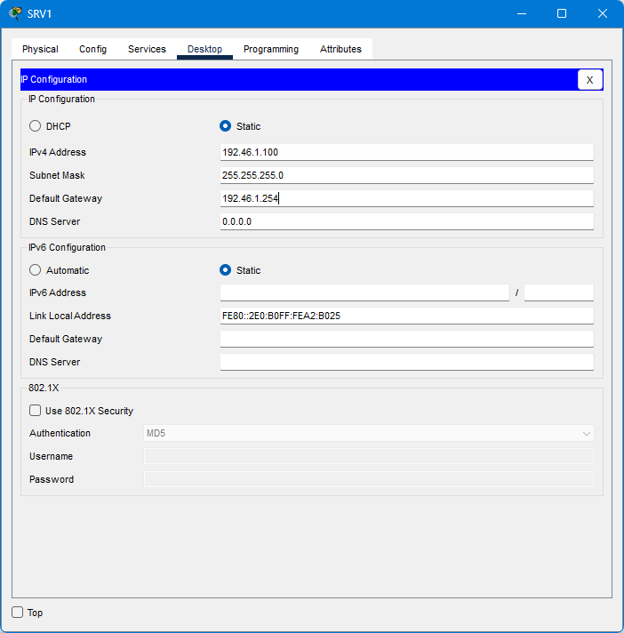

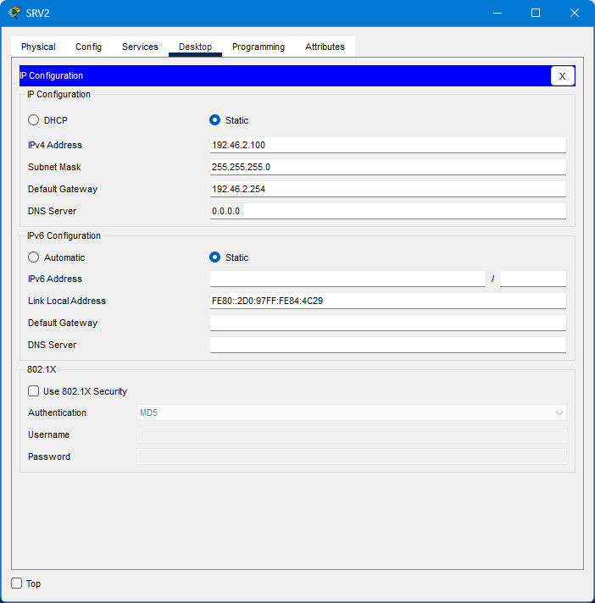

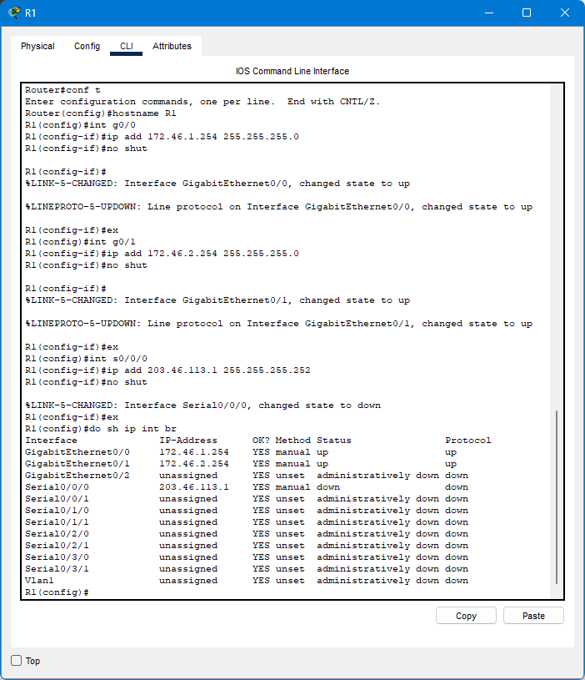

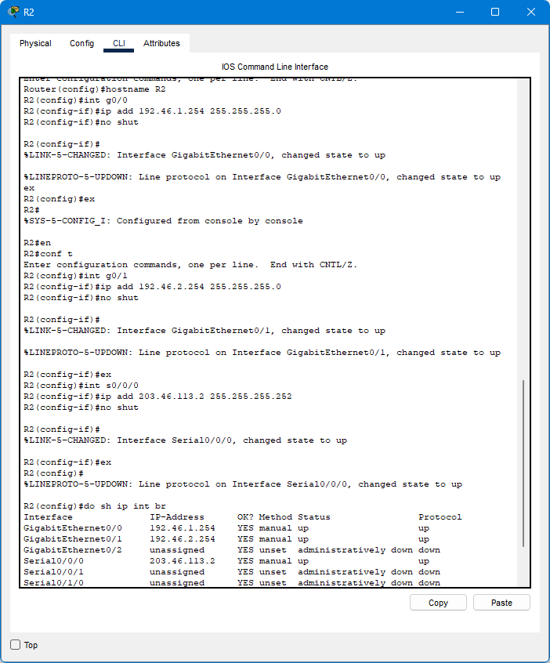

Q2

1. Configure OSPF on R1 and R2 to allow full connectivity between the PCs and servers.

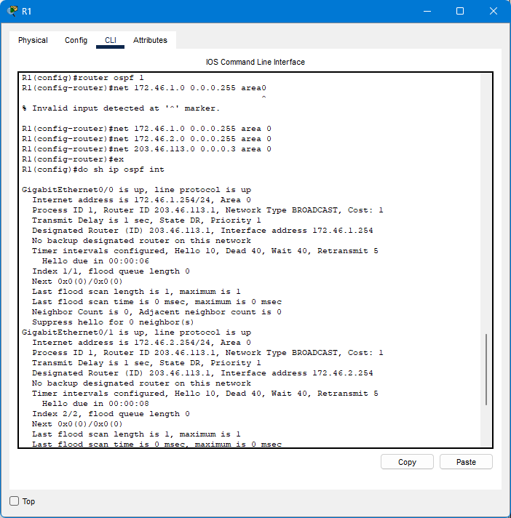

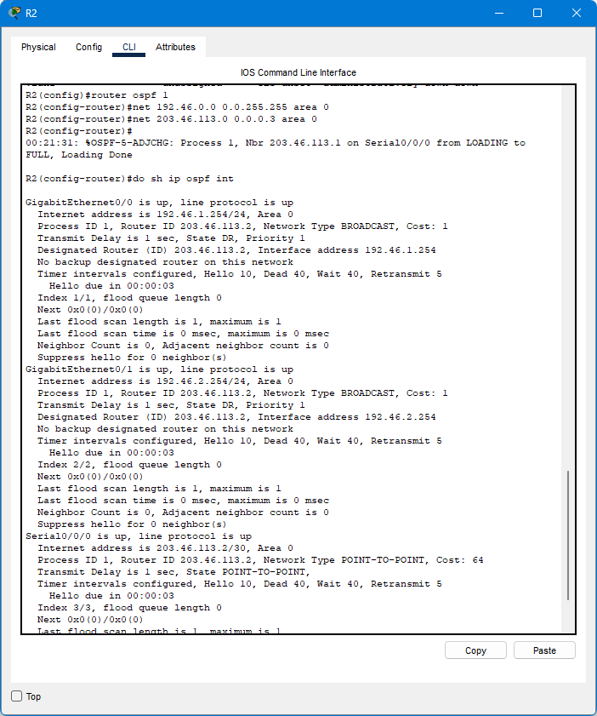

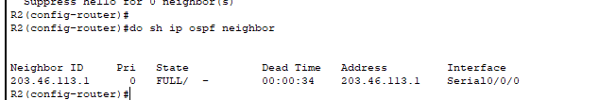

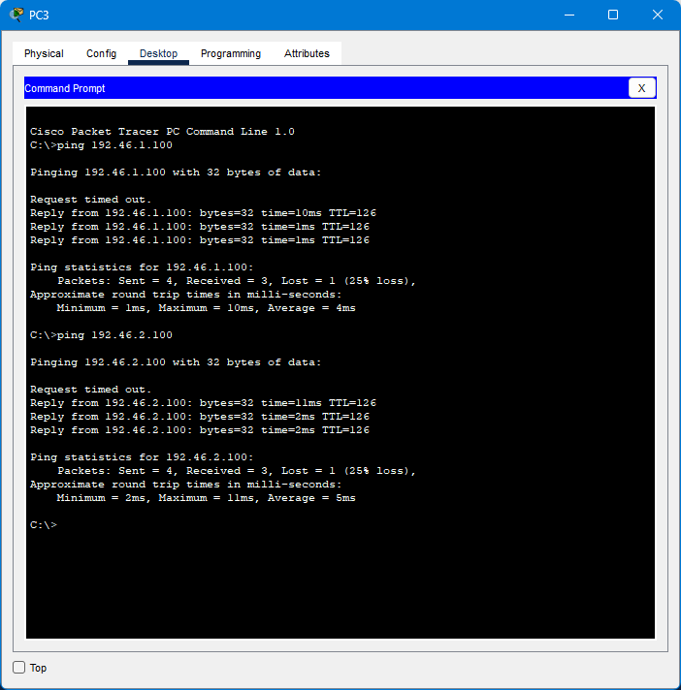

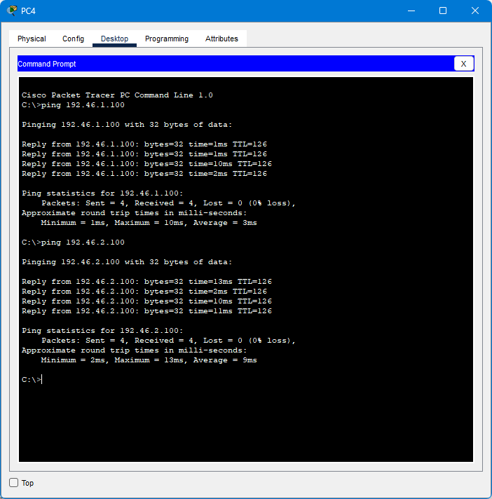

Q3

1. Configure standard numbered ACLS on R1 and standard named ACLs on R2 to fulfill the following network policies:

-Only PC1 and PC3 can access 192.168.1.0/24

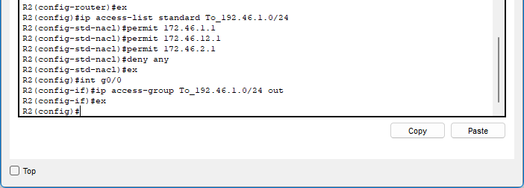

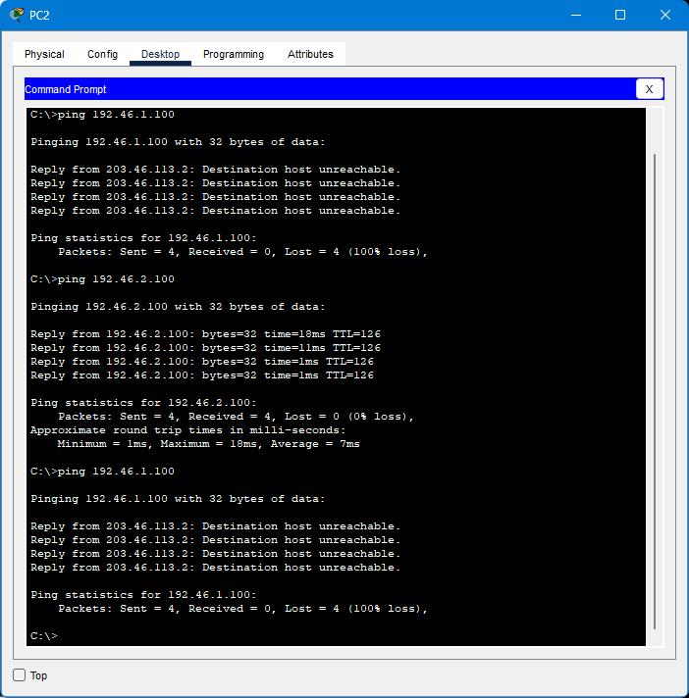

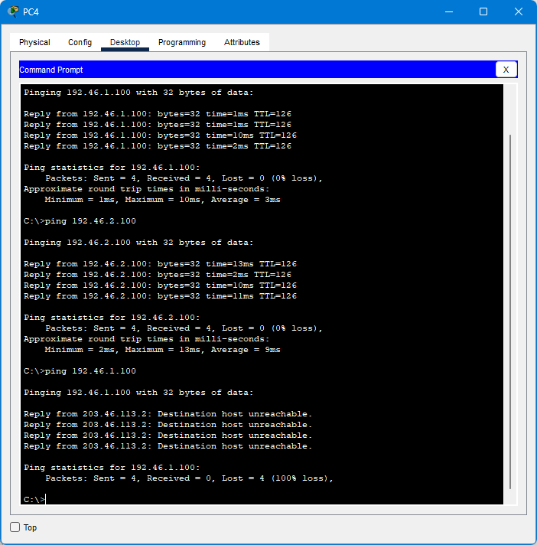

-Hosts in 172.16.2.0/24 can’t access 192.168.2.0/24

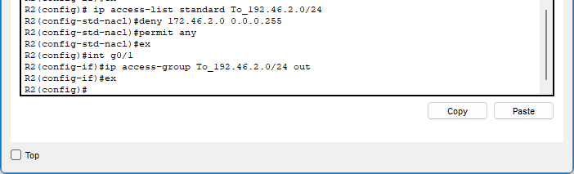

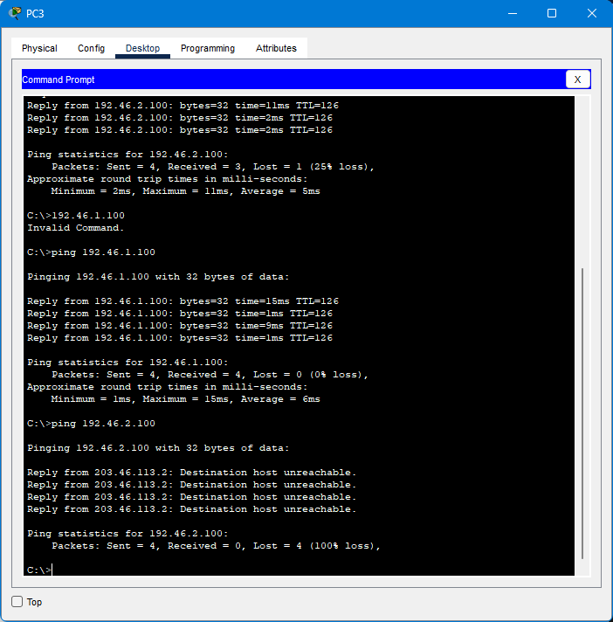

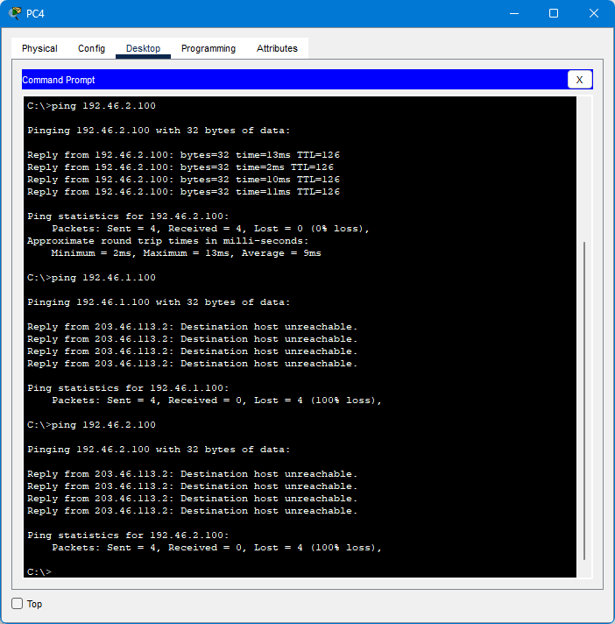

-172.16.1.0/24 can’t access 172.16.2.0/24

-172.16.2.0/24 can’t access 172.16.1.0/24

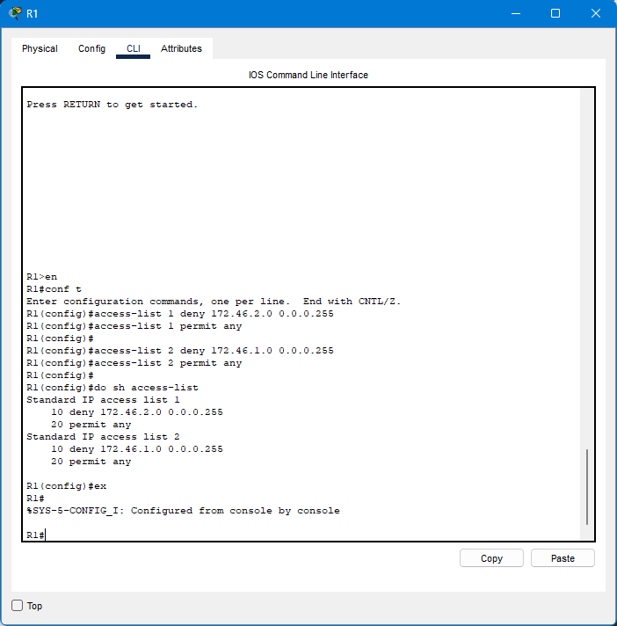

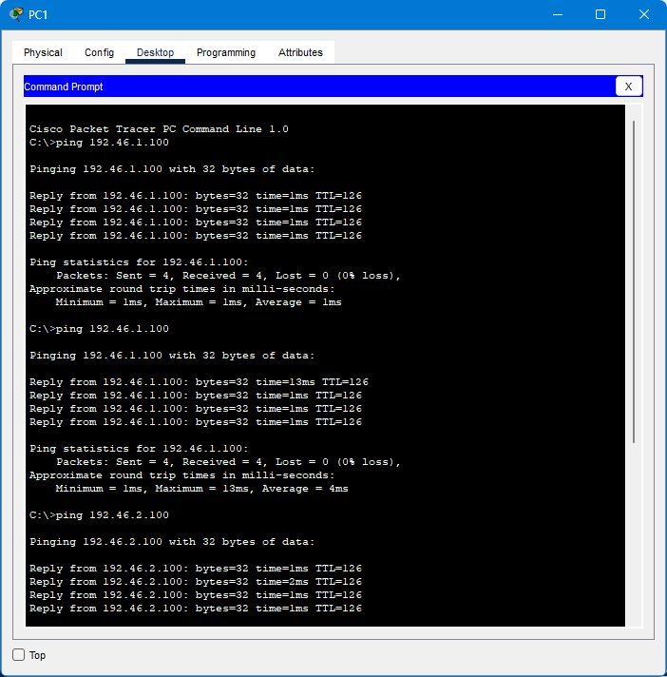

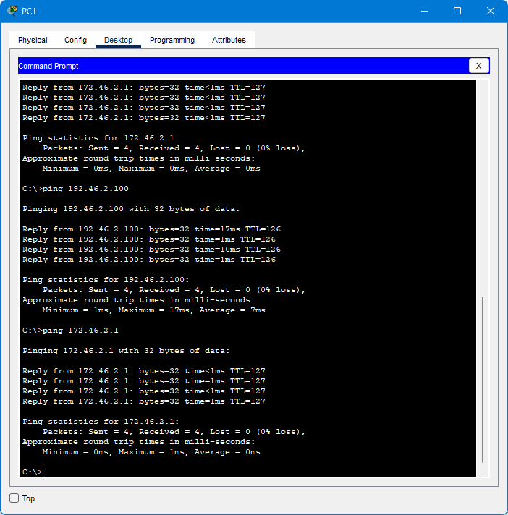

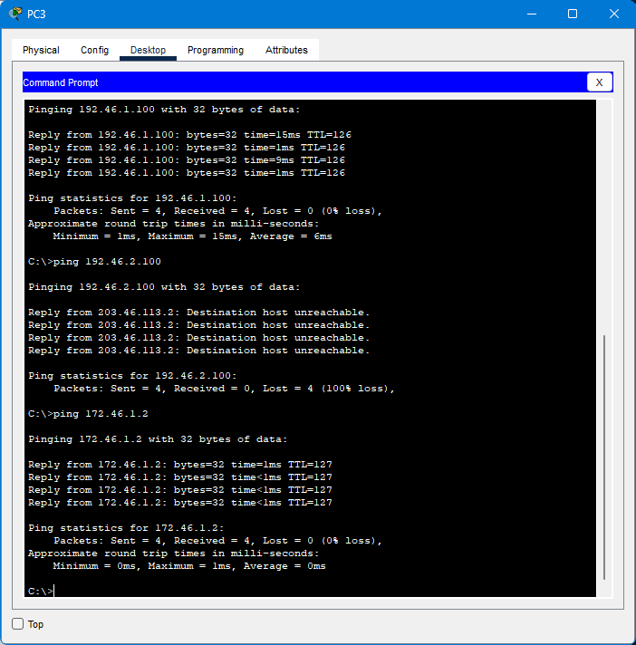

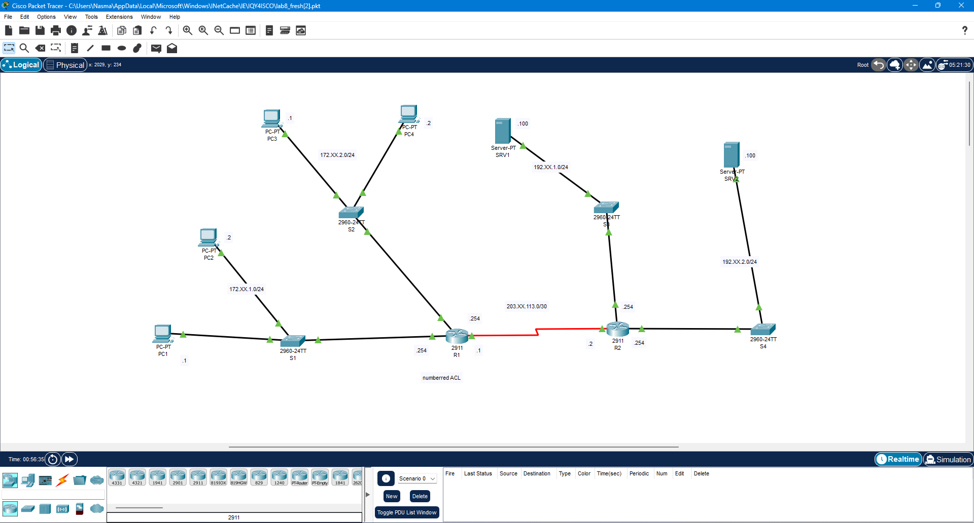

Discussion:

I learned about Standard Named ACL Configuration and Standard Numbered ACL Configuration during this hands-on training.

An alphanumeric string up to 64 characters can be used to identify a named, standard ACL, which is formed by entering the Named ACL (nacl) context. A numbered, standard ACL can be built without exiting the global configuration context and is distinguished by a number between 1 and 99.

Reference:

“Configuring standard ACLs,” Hpe.com. [Online]. Available: https://techhub.hpe.com/eginfolib/networking/docs/switches/RA/15-18/5998- 8151_ra_2620_asg/content/ch10s06.html. [Accessed: 05-Apr-2024]