SEU.IS.19.ICT.046

NST31042 – Practical for Scaling and Connecting
Lab Report-15
- Registration number: SEU/IS/19/ICT/046
- Academic Year: 2019/2020
- Practical Number: 15

Title: CDP & LLDP Configuration
Aim:
• Configure and Familiar with CDP & LLDP
Task:
• CDP Identify
• CDP Disable
• LLDP Enable

1. Use CDP (and other commands) to identify and label the missing IP addresses
and interface IDs of the devices in the network.

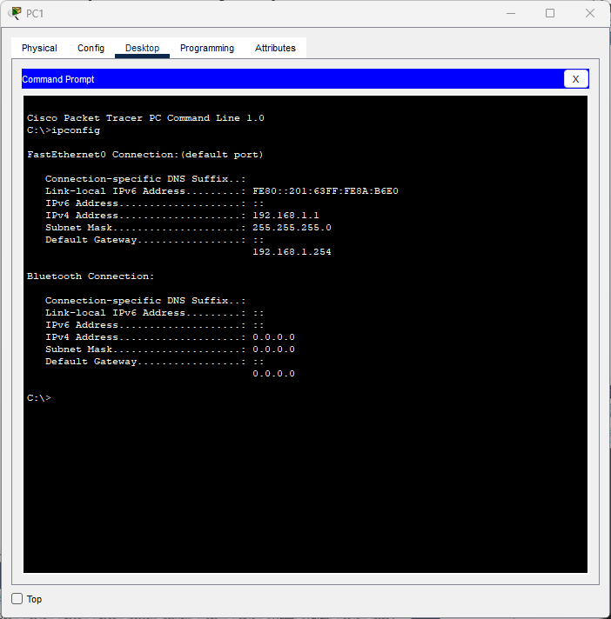
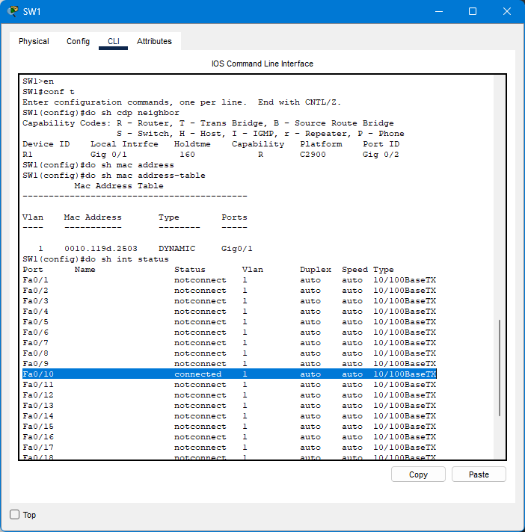
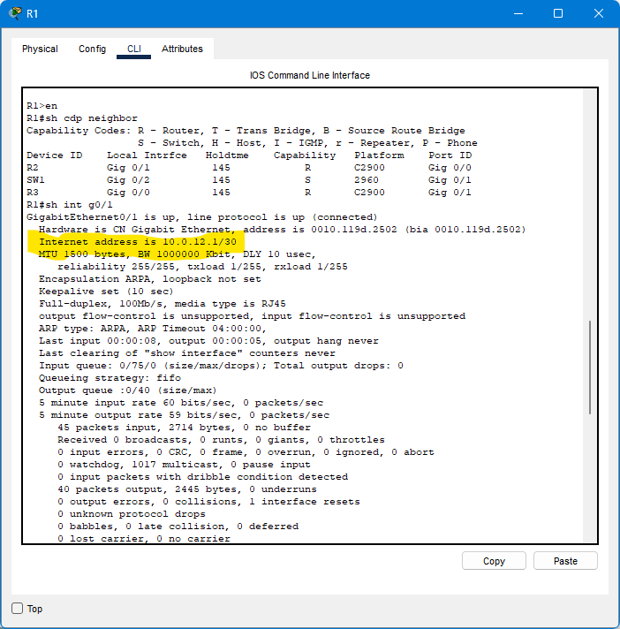
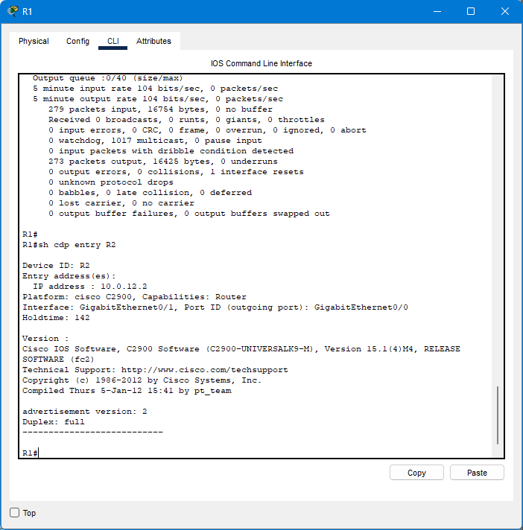
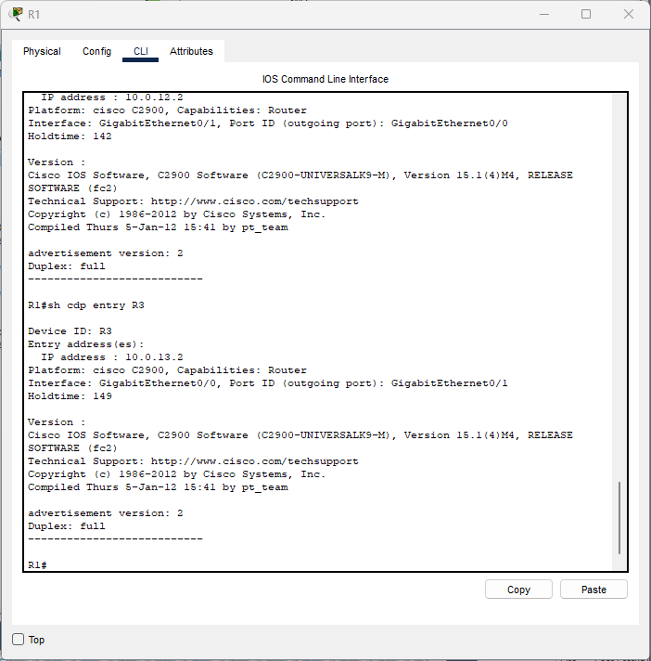
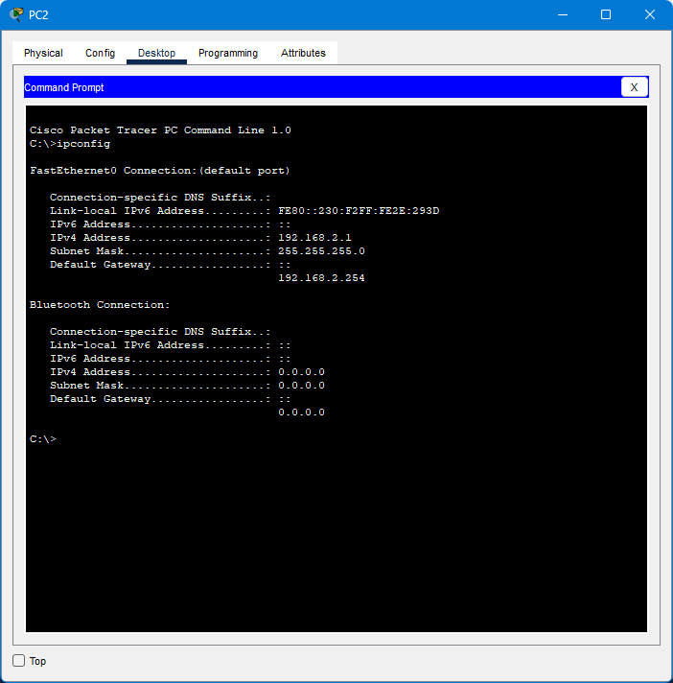
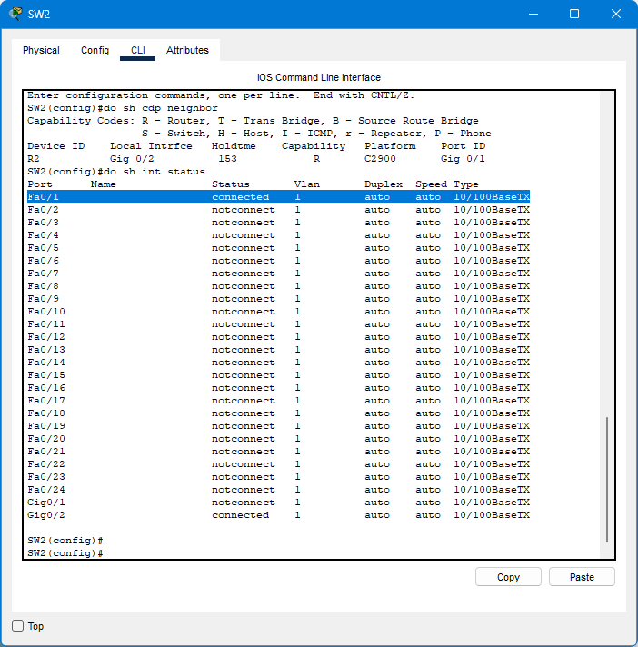
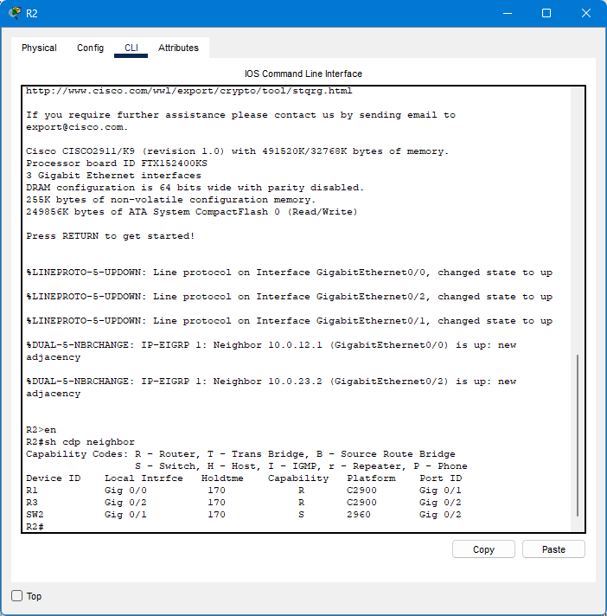
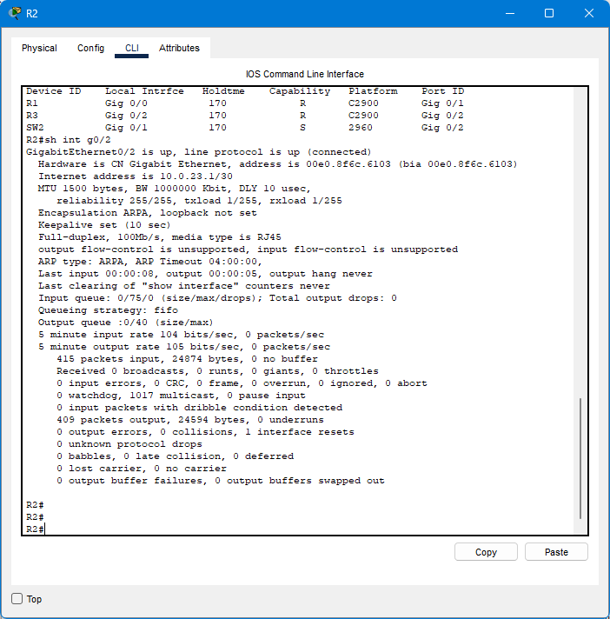
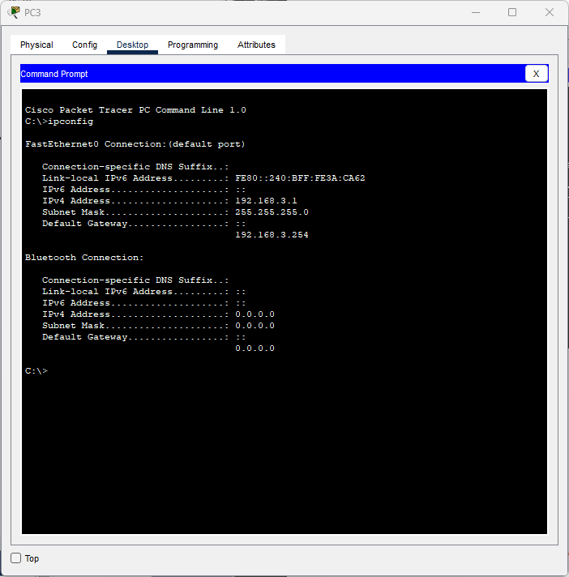
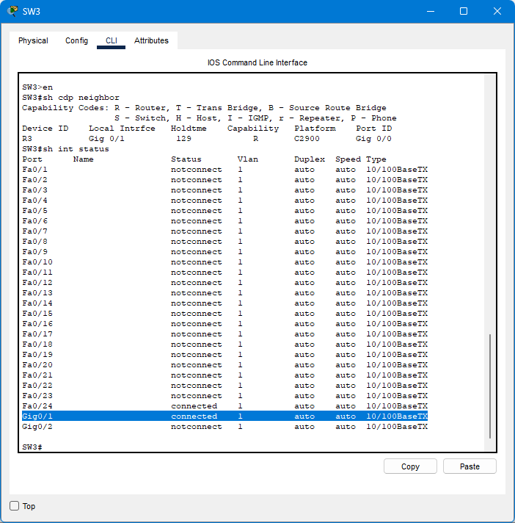

2. Disable CDP on the switch interfaces currently connected to PCs.
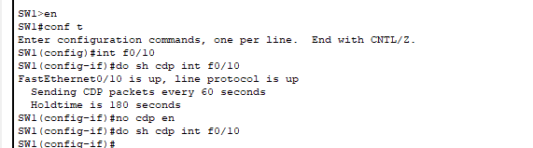
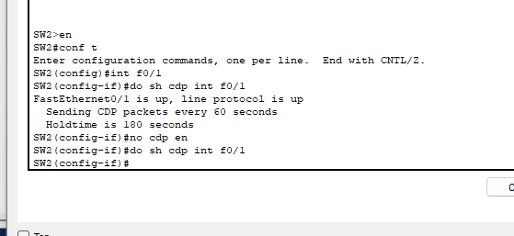
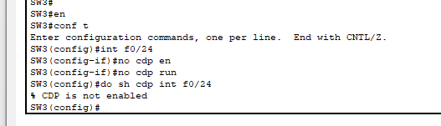

3. Disable CDP globally on each network device.
4. Enable LLDP globally on each network device, and enable Tx/Rx on the interfaces
connected to other network devices.
*Tx/Rx are currently disabled on all interfaces
These steps are included Que3 and Que4
Starting from sw3 and R3
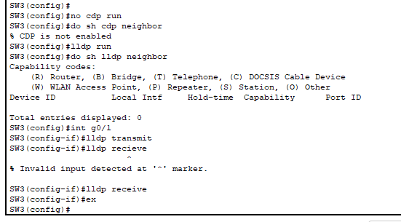
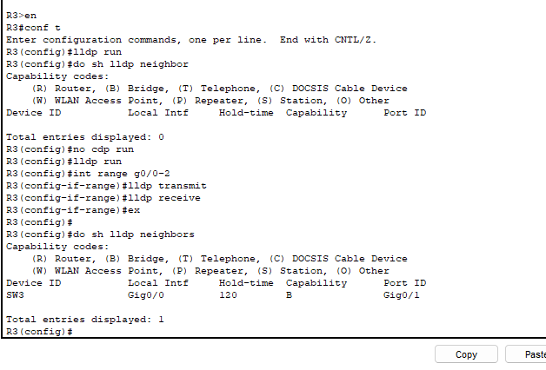
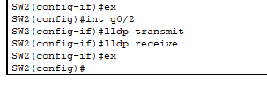
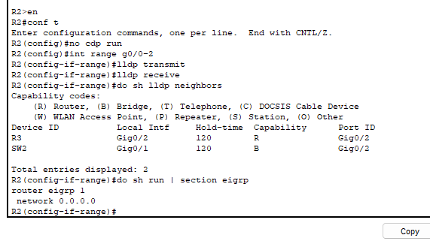
Discussion:
➢ This lab taught me that although CDP and LLDP have comparable functions, selecting one over the other frequently comes down to things like vendor preferences, the state of the network infrastructure, criteria for interoperability and the need to adhere to open standards
➢ Finally, I tested all the commands and got correctly
Reference:
- practical session of lecture
- https://www.flackbox.com/cisco-cdp-and-lldp

