ClickPlay
AI-Assisted Development: Exam Project
Author: Atanas Ivanov
Repository: https://github.com/naso01GitHub/clickplay

1. Project idea and requirements
ClickPlay is a desktop application for Windows and macOS that watches the sports-booking site clicktoplay.io for free court hours (padel, tennis, football and others) at clubs the user chooses, and notifies the user by email when a new free hour appears. It only reads the club schedules: it never logs in, books, or clicks a free slot. The user books on the site after the notification.
The idea came with the start of winter, when free indoor courts are hard to find. The functional spec was written by hand in Request.txt and the binding rules in AGENTS.md and target_web.md.
- Startup: read every sport from the site's sport bar and fill the Sport list.
- Cascade: choosing a sport loads its cities; choosing a city loads its clubs (locations), and several can be selected.
- Search loop: for every selected club, read free slots for the start date plus Days ahead days. Keep slots inside one of two time windows, weekdays or weekends/Bulgarian holidays. Show only slots that were not free in the previous scan, then wait Repeat (min) minutes (default 2) and repeat until Stop.
- Email: after a scan with new slots, send one mail to every recipient. The subject is the Subject field, the sport and the number of slots. The SMTP password is kept in the OS secure store.
- Non-functional: one cross-platform C# code base; headless browser by default; wait for the site after every click; the PC must not go to sleep during a search; component tests must not touch the live site or send mail.

Technology stack
Area | Technology
Language / runtime | C#, .NET 10 (net10.0), nullable reference types, async/await
UI | Avalonia 12.1.4 (Fluent theme), MVVM with CommunityToolkit.Mvvm 8.4.2
Web automation | Microsoft.Playwright 1.63.0 driving Chromium (headless; visible in Debug mode)
Email and secrets | MailKit 4.18.1; MSAL Extensions 4.91.1 (DPAPI on Windows, Keychain on macOS)
Testing | xUnit with hand-written fakes, about 130 tests
Tooling | Git + GitHub CLI, VS Code, Cursor, Claude Code, GitHub Copilot, Homebrew/pwsh for macOS

2. System architecture: modules
With the AI tools, the system was split into three projects: ClickPlay.Core (UI-free logic and Playwright), ClickPlay.App (Avalonia window and view model) and ClickPlay.Tests. It was also split into six modules. The view model talks to the site only through interfaces: IClickToPlayCatalog → PlaywrightClickToPlayCatalog → IClickToPlaySession → ClickToPlayBrowserSession. This is what makes every module testable with fakes.
# | Module | Main components
M1 | GUI (Avalonia + MVVM) | MainWindow.axaml, MainViewModel (split into GUI / Web / Mail partial files), status banner
M2 | Web navigation and cascade | ClickToPlayBrowserSession, OverlayRecovery, HumanPointer, CityNameParser
M3 | Availability scan and search loop | BookingSlotParser, SearchDatePlanner, ListingTimePlanner, BulgarianHolidayCalendar, AvailabilityScan
M4 | Email and secure settings | MailKitMailSender, ResultsMailFormatter, SmtpSettingsValidator, MailSettingsStore, ProtectedSecretStore
M5 | Platform and reliability | SystemKeepAwake (no idle sleep), ErrorLog (weekly errors-log.txt), diagnostics screenshots, macOS publish
M6 | Testing layer | xUnit tests plus fakes: FakeClickToPlaySession, FakeMailSender, FakeSecretStore, FakeOverlayTarget, FakeKeepAwake

3. Development process per module

M1: GUI (Avalonia + MVVM)
Approach & reasoning: As a warm-up, GitHub Copilot built a small C# GUI for sending email; it worked on the first try. For the real app, Cursor (Grok 4.6 Low) recommended .NET 10 + Avalonia + Playwright, because WinForms/WPF do not run on macOS. The GUI was designed first, with no logic, so the fields could be reviewed early.
Step-by-step workflow: Cursor plan ClickPlay availability app. Then: create the GUI, add the days-ahead text box and two time windows, multi-select locations. Claude Code later added the Gmail/Yahoo host and port pickers, the "Remember login" option, a more distinctive status banner, and the split of MainViewModel into GUI / Web / Mail files.
Testing strategy: The view model is tested directly instead of clicking controls. MainViewModelCascadeTests covers sport → cities → locations, Select all / Clear, and Search being enabled only when a location is ticked. The window was checked by running the app.
AI tool choice: Cursor (Grok 4.6) for the first layout: it foresaw almost every field except the mail Subject. Claude Code (Opus 5.5) for later UI changes. Arranging controls by prompt was harder than placing them with a mouse would have been.
Key prompts:
"Create project GUI"
"On the email window, add selectable drop-down menu for popular, known hosts and respectively for port. Start from Google and Yahoo. Keep option for free editing also."
"Separate functionality in different files: GUI, web, mail"

M2: Web navigation and cascade (Playwright)
Approach & reasoning: First the site was explored interactively with Cursor's browser: open it, pick Bulgarian, click a sport and then "Резервирай". The confirmed steps were turned into rules in target_web.md: Bulgarian-text locators, wait after every click, check visibility before clicking, no login or booking.
Step-by-step workflow: Cursor plan Startup browser cascade: load sports on start, cities on sport change, clubs on city change. A language/consent overlay blocked the sport bar, so a written recovery procedure became OverlayRecovery behind IOverlayTarget. Claude Code later changed the session to open the browser only for each step and to read clubs from a direct listing URL.
Testing strategy: OverlayRecoveryTests drive the recovery with FakeOverlayTarget; SiteUrlTests and CityNameParserTests check URL building and parsing. The live site was only checked by hand, never in tests.
AI tool choice: Cursor (Grok 4.6) handled navigation and filling the GUI without difficulty. Its plan-then-execute mode suited the step-by-step cascade.
Key prompts:
"open https://clicktoplay.io/index.php, Select Bulgarian language and click on 'Пикълбол', then click on 'Резервирай'"
"Recovery procedure: Check whether a dialog or consent overlay is blocking interaction. If the 'Запази' button is visible, select 'Български' and then click 'Запази' … Do not repeatedly click buttons without verifying the result."

M3: Availability scan and search loop
Approach & reasoning: The hardest module. Cursor tried to drive the site's datepicker, clock and club popup, but scans kept failing, and the site often answered "MySQL: Too many connections". Claude Code (Opus 5.5) read the error log, the code and the rules, found the real causes, and proposed a new approach.
Step-by-step workflow: Cursor plans Repeatable availability loop and Harden calendar listing did not fix it. In Claude Code the analysis found two causes. Playwright throws System.TimeoutException, not PlaywrightException, so one slow page aborted the scan. The UI-driven calendar also cost 4–6 requests per club per day. The fix was to open club/?club={slug}&date=… directly (one page load per club and day), filter the hours in code, and on "Too many connections" wait 3 s, reload once, then skip that club or day. About 600 lines of calendar code were removed.
Testing strategy: AvailabilityLoopTests (new vs seen records, skipped scans, Stop) and SearchInputValidatorTests (days ahead, repeat, weekday vs holiday windows) use the injectable ScanClock and CalendarClock. A live run on Padel / Varna / 3 clubs / 2 days found 25 slots in about 6 s with no errors.
AI tool choice: Claude Code with Opus 5.5. From one text description it did what Cursor could not, with two corrections, although it spent a long time testing how to move through the page.
Key prompts:
"I have problem described in results-log.txt. Try to investigate what cause it. Try new approach to control web."
"After a successful scan, how do you decide which records to send via email?" and then "do both", which led to the rule that a record is new only if it was not in the previous successful scan.

M4: Email and secure settings
Approach & reasoning: Planned in Claude Code plan mode. Before writing code, the assistant asked clarifying questions about how to store the credentials. The agreed design: non-secret fields in %AppData%/ClickPlay/smtp.settings.json, the password only in the OS secure store. Fields show * and are read-only while Search runs.
Step-by-step workflow: Add the Subject field. Build the SMTP section with MailKit. Store the password through ProtectedSecretStore (DPAPI or Keychain). Send one mail per scan with new slots, with a blank line between records. Add "Remember login", and set the subject to Subject + sport + count, e.g. Padel Падел (3).
Testing strategy: MailTests use FakeMailSender and FakeSecretStore; they cover formatting, the subject, validation and saved settings. No real mail is sent in tests. A live mail to two addresses was then checked by hand (see the screenshot).
AI tool choice: Claude Code (Opus 5.5), because the clarifying questions in plan mode surfaced the security decisions early.
Key prompts:
"Plan to prepare mail functionality. Add one more field for 'subject' … Credentials should be invisible while 'search' is running, stars only. How can these credentials be securely saved?"
"Change subject on sent mails: Subject from GUI + Sport from GUI + count of records in this mail."

M5: Platform and reliability
Approach & reasoning: Long searches stopped when the PC went to sleep, and the results log kept growing. These are OS-level concerns, so they stay in ClickPlay.App behind an interface (IKeepAwake) and Core stays cross-platform.
Step-by-step workflow: SystemKeepAwake calls SetThreadExecutionState(ES_SYSTEM_REQUIRED) on Windows and caffeinate -i -w <pid> on macOS. The display may still turn off. Writing results-log.txt was stopped and errors-log.txt (errors only, restarted weekly) was added. INSTALL-MAC.md and the osx-arm64/osx-x64 self-contained publish followed, and release tag 2.0 was pushed to GitHub.
Testing strategy: ErrorLogTests and FakeKeepAwake in the loop tests; the full suite is designed to pass on both Windows and macOS.
AI tool choice: Claude Code (Opus 5.5): it explained the OS-specific options and kept the single justified Win32 call out of shared code, as AGENTS.md requires.
Key prompts:
"Application does not work when PC is in sleep mode. Application should not allow PC to sleep. Only display may sleep, if it is possible."
"How to run it on MAC. What I need to copy from here and how to install it. Make detailed doc as instructions."

M6: Testing layer
Approach & reasoning: AGENTS.md made tests a rule from day one: test the view model and Core types, not the controls; never open the live site; never send real mail. Every external dependency is therefore an interface with a fake.
Step-by-step workflow: Each feature prompt was followed by a request to add or update tests. Claude Code ran dotnet build and dotnet test after each change, and fixed failing tests before reporting.
Testing strategy: About 130 xUnit tests across MainViewModelCascadeTests, AvailabilityLoopTests, SearchInputValidatorTests, MailTests, OverlayRecoveryTests, SiteUrlTests, ErrorLogTests and others. Run with dotnet test ClickPlay.slnx.
AI tool choice: Cursor and Claude Code both follow AGENTS.md; Claude Code was more consistent about running the suite before saying a task was done.
Key prompts:
"Add coding standards, browser automation rules" (which added the testing requirements to AGENTS.md)

4. AI toolkit: skills, hooks, agents and plans
Kind | Name | Purpose / how it was used
Rules | AGENTS.md, target_web.md, CLAUDE.md | Binding project rules for every agent (cross-platform, MVVM, Playwright, tests); site rules; Claude Code project guide created with /init.
Skill | doxygen-comments (custom) | Written in Cursor (.cursor/skills) and copied to .claude/skills: Doxygen-style XML comments plus a usage example on every function.
Skill | docx (anthropics/skills) | Installed in .agents/skills; used to write the user manuals and this document. Haiku 4.5 did not notice it until prompted; Opus 5.5 used it without hints.
Skill | pdf (anthropics/skills) | Installed for a PDF manual; Opus 5.5 chose to render the PDF with Chromium instead.
Hook | Cursor save-conversation | .cursor/hooks.json: beforeSubmitPrompt, afterAgentResponse, stop and sessionEnd save every chat to conversations/.
Hook | Claude Code log-conversation.js | .claude/settings.json: UserPromptSubmit, Stop and SessionEnd log every prompt and reply.
Agents | Cursor Agent; Claude Code subagents | Cursor agent mode for building; Claude Code Explore and Plan subagents to map the app UI and code before the manuals and plans.
Plans (Cursor) | 4 plans in .cursor/plans | ClickPlay availability app, Startup browser cascade, Repeatable availability loop, Harden calendar listing.
Plans (Claude Code) | 5 plans in plan mode | Mail functionality; PDF manual (EN+BG); detailed Bulgarian manual; macOS installer package; build-process document.
Models | Copilot, Grok 4.6 Low, Claude Opus 5.5, Claude Haiku 4.5 | Warm-up email GUI; GUI and navigation; web scanning, mail and platform; documentation comparison.

5. Challenges and tool comparison

Biggest challenges
- The site's calendar and popups: driving them through the UI was slow and fragile, and Cursor/Grok could not make it reliable even with detailed explanations. The fix was a redesign to direct URLs.
- "Too many connections": the site's own MySQL limit. At one point Cursor answered that the error was the site's problem, not the app's. ClickPlay now detects it, reloads once, skips that club or day and continues. Opus 5.5 fix it.
- Layout by prompt: positioning controls through text instructions took several rounds.
- Documentation skills: Haiku 4.5 model ignored an installed skill until reminded. The same docx prompt gave a clearly better result with Opus 5.5 (style, detail, visuals).

Which tool helped the most and why
Claude Code with Opus 5.5. It read the whole project (code, rules, logs), asked clarifying questions in plan mode, verified each change with build and tests, and solved the web-scanning problem that blocked the project. Cursor (Grok 4.6) was fast and good for the initial GUI and navigation. Copilot was fine for a small isolated warm-up.

What I would improve next
- A signed macOS .app bundle and a Windows installer instead of dotnet run or a self-contained folder.
- Push notifications (Telegram or mobile) in addition to email.
- An Avalonia headless UI test for the main window, and a CI pipeline on GitHub Actions running the tests on Windows and macOS.
- Several sports or cities per search, and saved search profiles.

6. Working system evidence
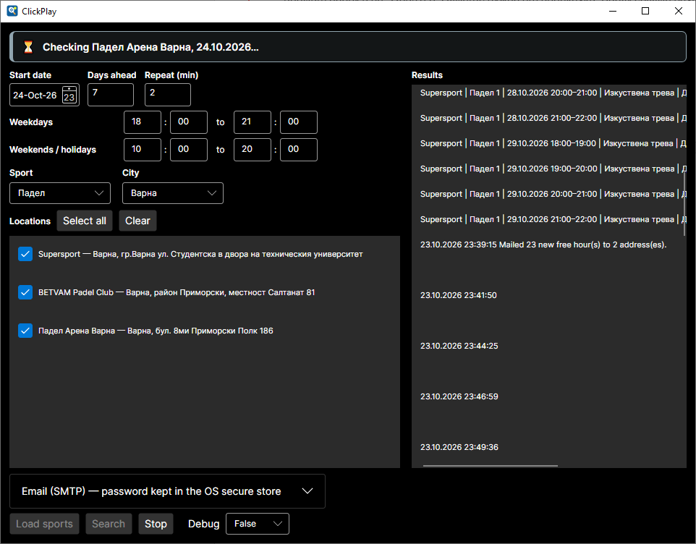
Figure 1: Search running (Padel, Varna, 3 clubs): new free hours in Results and "Mailed 23 new free hour(s) to 2 address(es)".
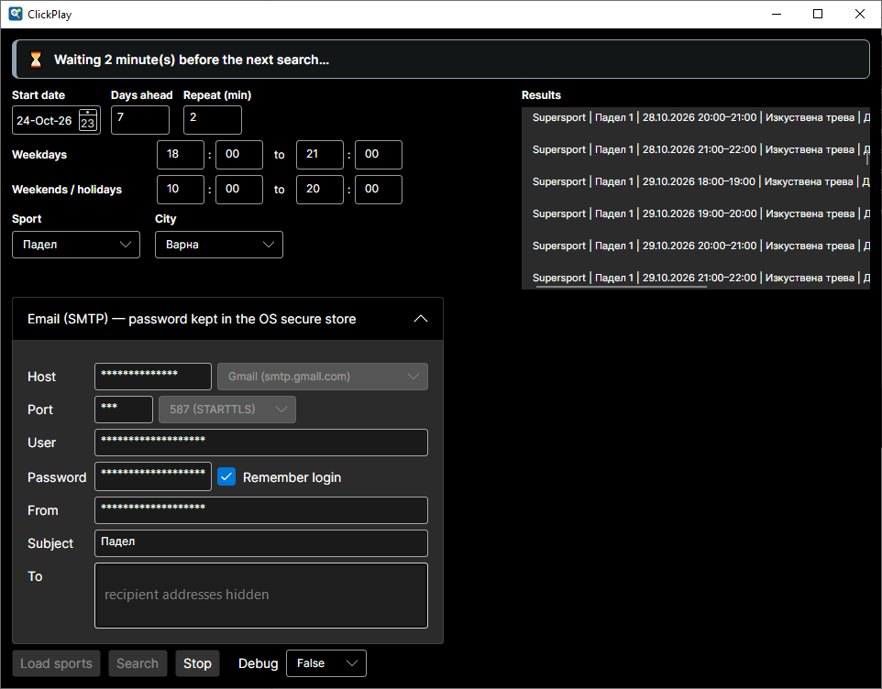
Figure 2: Waiting between cycles. Email (SMTP) settings are masked and read-only while Search runs (recipients hidden for privacy).
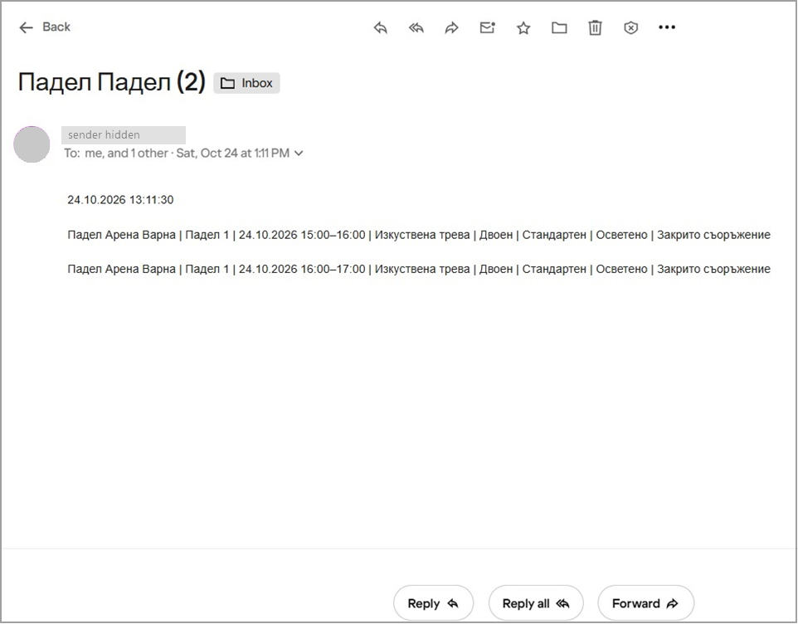
Figure 3: The received email in Yahoo Mail. Subject "Падел Падел (2)" = Subject field + sport + number of new free hours, one record per line (sender hidden for privacy).

7. Repository
Source code: https://github.com/naso01GitHub/clickplay
Build and run: dotnet build ClickPlay.slnx, then pwsh src/ClickPlay.Core/bin/Debug/net10.0/playwright.ps1 install chromium, then dotnet test ClickPlay.slnx, then dotnet run --project src/ClickPlay.App.

