Data Construction

Overview
The empirical analysis rests on a corpus of floor speeches delivered in the U.S. House of Representatives and Senate between January 2001 and the present, spanning the 107th through the 119th Congress. No existing dataset covers this entire span in a form suitable for the analysis, so the corpus is assembled from two sources and built as two parallel construction pipelines rather than one.
The first source is the Congressional Record corpus compiled by Gentzkow, Shapiro and Taddy, which covers sessions 107 through 114 and ends in September 2016. The second source is built directly from the Congressional Record as published through the govinfo.gov API, covering September 2016 onward. Neither source alone spans the full period, and the point at which they meet required its own verification, described below.
Each speech record in the resulting data carries a date, chamber, speaker, party affiliation, the full text of the speech, and, where it could be resolved unambiguously, the speaker’s ICPSR identifier. The identifier allows individual speeches to be linked later to roll-call-based measures of ideology, including DW-NOMINATE. The remainder of this section describes how each source was constructed, how speakers were identified and matched to party and ICPSR records, what filtering was applied, and what the resulting data looks like once validated.

The Stanford dataset (2001 – 2016)
The first segment of the corpus draws on the hein-daily release of the Congressional Record, built by Gentzkow, Shapiro and Taddy and distributed by Stanford University. For each two-year Congress, the release provides three separate files: the raw speech text, speech-level metadata including the date, and a speaker map linking each speech to a specific member, their party, and their state. These three files were merged on a shared speech identifier, and the small number of speeches with no matched speaker, typically short procedural entries such as a clerk reading a bill title, were dropped.
Stanford’s own documentation describes this release as covering the daily edition of the Congressional Record from the 97th through the 114th Congress, 1981 through 2017. The actual data behind it ends earlier. Checking both the merged output and the raw session-114 source file directly shows the last recorded speech falls on September 9, 2016, several months before the documented range would suggest. This discrepancy mattered for the second segment of the corpus, since it left an unaccounted gap between where the Stanford data actually stops and where the govinfo-based data begins; the gap is closed separately, as described below.
After merging, this segment contains 823,341 speeches across sessions 107 through 114. Party is recorded as a single letter, predominantly Democrat (441,536) and Republican (377,021), with a small number of Independents (4,730) and a handful of speeches attributed to minor historical parties. The release does not include a standard cross-dataset member identifier such as ICPSR, which the Stanford-internal speaker identifier does not substitute for. An ICPSR identifier was added separately, matched against the congress-legislators reference project on last name, first name, and date, with the member’s state used to break ties when more than one sitting legislator shared a name. The first name used for this match came from the speaker map’s own first-name field rather than the field already present in the release, which was found to be unpopulated placeholder text throughout. The match succeeded for 97.7% of speeches. As a secondary check, the party implied by this same match was compared against Stanford’s own party field: the two agree in 99.99% of cases where both are available, and the handful of disagreements trace to two identifiable members rather than being spread across the data, which suggests the disagreement reflects isolated coding issues in the original release rather than a problem with the matching procedure.

The govinfo-based dataset (2016–present)
No comparable pre-structured dataset exists for the period after the Stanford release ends, so this second segment of the corpus had to be built from the underlying source material. The U.S. Government Publishing Office publishes the Congressional Record day by day through the govinfo.gov API, but the daily documents it returns are not pre-split into individual speeches. A given day’s proceedings arrive as a small number of larger documents, and within each one, a change of speaker is marked only by a recurring textual convention rather than by any structured field.
That convention has been stable for decades: a new speaker’s remarks begin with their title, Mr., Ms. or Mrs., followed by their surname and a period, at the start of a new paragraph, for example “Mr. SMITH.” Individual speeches were recovered by matching this pattern against the raw text of each document, restricted to genuine paragraph starts so that an ordinary sentence ending in a capitalized name is never mistaken for a change of speaker. The pattern was developed to handle a number of recurring edge cases: hyphenated and apostrophized surnames, middle initials that could otherwise be mistaken for the tag’s closing period, and the small number of cases where two sitting members share a surname and the Record spells out a fuller name or a state to tell them apart. Procedural terms of address such as “Mr. Chairman” and “Mr. Speaker” were excluded from the match through an explicit list, since they refer to the presiding officer rather than naming a member. Where the Record does append a state to a speaker’s name for disambiguation, for example “Mr. SMITH of Texas,” that state was captured separately and carried forward into the matching step described in the next section.
Each day’s full set of documents was retrieved by following the API’s own pagination through to its end, rather than requesting only the first page of results; an earlier version of this pipeline had not done so, and because the Record lists House documents before Senate documents within a day’s package, the omission had disproportionately dropped Senate speeches on days with heavy House activity. This is discussed further in the validation section below. With that corrected, this segment covers September 10, 2016 onward, beginning exactly where the gap in the Stanford data was found to start, through the most recent complete day of data at the time of writing. The most recent calendar year should be read as partial rather than complete in any year-over-year comparison, since Congress continues to add to it.

Speaker identification and party assignment
Party and ICPSR identifiers were assigned to govinfo speeches through the same congress-legislators reference project used for the Stanford segment, matched on the recovered name against each legislator’s terms of service for the date the speech was delivered. Because a captured name may be only a surname, a full name, or a compound surname depending on how the Record wrote it, three matching strategies were tried in order of specificity: first name combined with the remainder as a last name, the full captured string treated as one compound surname, and finally the last word alone. Whichever strategy produced a result was used; if more than one sitting member matched on name and date, the state captured alongside the speaker’s name, where available, was used to narrow the match further.
A party or ICPSR value was only recorded where exactly one legislator matched. Where a surname was shared by multiple members serving at the same time and no state resolved the ambiguity, the field was left blank rather than assigned by guesswork. This is a deliberate choice: an incorrect party label would be harder to detect later than a missing one. Under this procedure, 96.5% of govinfo speeches were matched to a party and 86.4% to an ICPSR identifier. The gap between the two figures is expected rather than a sign of a weaker match: ICPSR identifiers are assigned only to members who cast recorded votes, so non-voting territorial delegates, who speak on the floor as often as any other member but never appear in a roll call, are structurally excluded from ICPSR regardless of how reliably their name resolves to a party.

Filtering and cleaning
The same two length-based filters were applied to both segments of the corpus. Speeches under 50 characters were dropped as procedural fragments, typically a single line agreeing to a routine motion rather than substantive remarks. Speeches over 30,000 words were dropped as likely extraction errors, where an entire multi-speaker document had been captured as a single speech, or as cases where a short spoken introduction was followed by a lengthy block of inserted bill text rather than genuine floor remarks. The threshold was set using two reference points found during development: the longest confirmed genuine speech observed was just under 19,000 words, while the shortest confirmed case of this kind of contamination ran to over 40,000. A threshold at 30,000 sits comfortably between the two. A content-based filter aimed specifically at inserted bill text was also tested and rejected, since it excluded confirmed-genuine speeches that happened to reference a bill section number in passing; the length cap alone proved to be the safer criterion.
For the govinfo segment, Extensions of Remarks, written statements inserted into the Record without having been spoken aloud, were excluded, matching how the Stanford release is itself constructed. Keeping this category out of both segments means a speech in either half of the corpus can be treated as something a member actually said on the floor, not something they chose to submit in writing afterward.

Validation
The main check on this corpus is whether the balance between the two chambers stays consistent across the full period, since an earlier version of the govinfo pipeline had under-collected Senate speeches on days with heavy House activity, as noted above. Figure 1 shows the Senate’s share of speeches in each year of the govinfo segment against the share in Stanford’s final session.
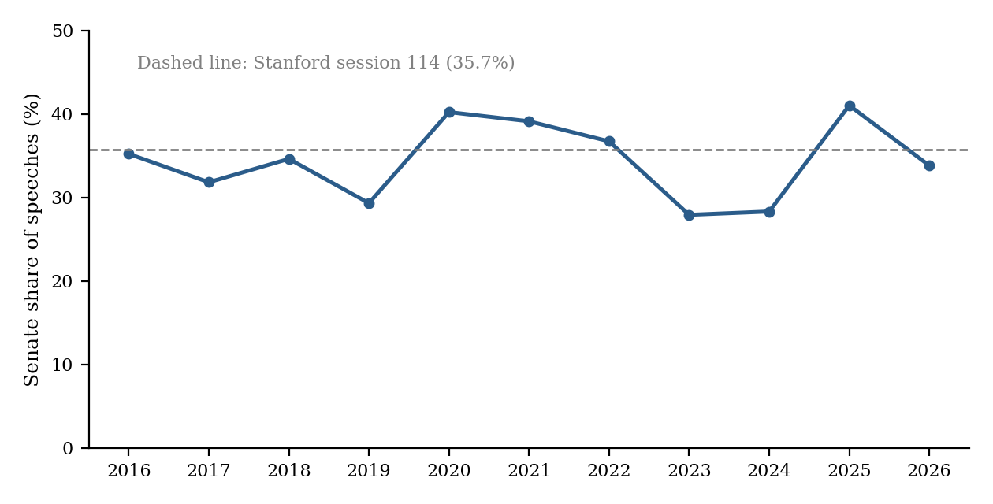
Figure 1: Senate share of speeches per year, govinfo-based dataset (2016–2026), with Stanford’s session-114 share as reference
The Senate’s share of speeches sits between 27.9% and 41.0% in every year of the govinfo segment, with no sustained drift and no sharp break at the point where the two sources meet: Stanford’s final session shows a 35.7% Senate share, and the first year of govinfo data shows 35.2%, a difference small enough to read as noise rather than a seam artifact.
Across the corpus as a whole, 823,341 Stanford speeches and 276,513 govinfo speeches were retained after filtering, with no duplicate records in either segment. Match rates for party and ICPSR follow the pattern described above, higher for Stanford, where speaker names arrive already split into first and last name, than for govinfo, where they must first be parsed out of running text. A random sample of speeches was read through by hand in both segments to check for garbled extraction or truncation. One minor issue surfaced this way: a small number of govinfo records carry trailing HTML markup left over from a document boundary the extraction pattern did not fully clean, limited to the end of a document’s final speech and not judged to affect its substantive content. The longest speech retained in either segment falls just under the 30,000-word cutoff, consistent with the cutoff doing its intended job of excluding outliers rather than cutting into ordinary long speeches.

Limitations
A number of speeches in both segments carry no party or ICPSR identifier, by design rather than by omission. This happens when a surname is shared by more than one sitting member and the source text gives no further detail to tell them apart; rather than assign a party by guesswork, these speeches are left unresolved. Any analysis that relies on party or member identity will necessarily work with a corpus somewhat smaller than the full speech count, and the unresolved share is not uniform across members, since it depends on how common a given surname happens to be.
Party affiliation itself is recorded per full term of service, not per individual day. A member who switches party mid-term, a rare but real event, is shown under their end-of-term affiliation for the whole term, including speeches delivered before the switch actually took place. ICPSR coverage is also structurally incomplete in one specific way: non-voting territorial delegates, who address the floor as regularly as any other member but never cast a recorded vote, are never assigned an ICPSR identifier by the reference source this corpus matches against, regardless of how reliably their name resolves to a party.
The two segments were built through different procedures and differ accordingly in a few respects. Stanford’s speaker and state fields arrive already parsed from the source release; govinfo’s are recovered from running text through pattern matching, which is a less direct process and the likely reason its match rates sit a few points below Stanford’s. The most recent calendar year of the govinfo segment is necessarily partial, since Congress continues to add to it after the point this corpus was built.

