Q. What is Line Follower Robot?

Ans. Line follower robot is an Autonomous Robot that can take after a way. The way can be unmistakable like a dark line on the white surface (or bad habit verse). It is a coordinated outline from the information of Mechanical, Electrical and PC building (Programming with PC). The LDR (Light Dependent Resistor) or IR (Infrared) sensor based line robot configuration and manufacture method which continuously coordinates along the dark imprint on the white surface.

Q. Concepts of Line Follower

Ans. Concept of working of line follower is related to light. We use here the behavior of light at black and white surface. When light fall on a white surface it is almost full reflected and in case of black surface light is completely absorbed. This behavior of light is used in building a line follower robot. In this **arduino based line follower robot** we have used IR Transmitters and IR receivers also called photo diodes. They are used for sending and receiving light. IR transmits infrared lights. When infrared rays fall on white surface, it’s reflected back and catch by photodiodes which generates some voltage changes. When IR light falls on a black surface, light is absorb by the black surface and no rays are reflected back, thus photo diode does not receive any light or rays

Here in this arduino line follower robot when sensor senses white surface then arduino gets 1 as input and when senses black line arduino gets 0 as input.

**Components Required**

* Arduino UNO
* L293D Motor Driver IC
* Geared Motors x 2
* Robot Chassis
* IR Sensor Module x 2
* Black Tape (Electrical Insulation Tape)
* Connecting Wires
* Power supply

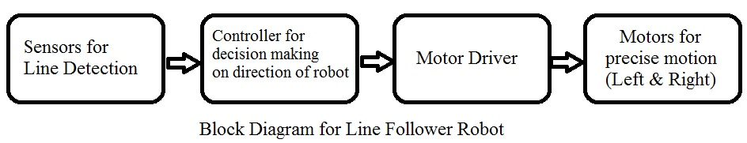

**Infrared Red Sensor**: We have used IR Sensor Module as the line detecting sensor for the project. It consists of an IR LED and a Photo diode and some other components like comparator, LED etc. IR sensor work on the principal in which IR LED emits IR radiation and Photodiode sense that IR radiation. Photodiode resistance changes according to the amount of IR radiation falling on it, hence the voltage drop across it also changes and by using the voltage comparator (like LM358) we can sense the voltage change and generate the output accordingly.

Q. What is Arduino UNO?

Arduino UNO is the main controller in the project. The data from the sensors (IR Sensors) will be given to Arduino and it gives corresponding signals to the Motor Driver IC.

**Arduino Uno**is an open source platform that can be used to design various electronic projects. **Arduino uno**is hardware which is based on microcontroller Atmega 328P.It has 14 digital input/output pins (of which 6 can be used as PWM outputs), 6 analog inputs, a 16 MHz quartz crystal, a USB connection, a power jack, an ICSP header and a reset button.

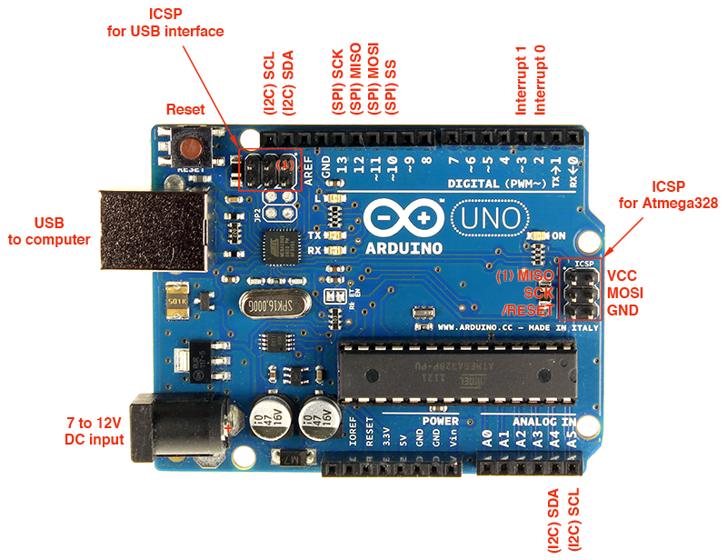

Fig. Arduino Uno

Out of these 14 pins, some pins have specific functions as listed below:

* **Serial Pins 0 (Rx) and 1 (Tx):** Rx and Tx pins are used to receive and transmit TTL serial data. They are connected with the corresponding Atmega328P USB to TTL serial chip.
* **External Interrupt Pins 2 and 3:** These pins can be configured to trigger an interrupt on a low value, a rising or falling edge, or a change in value.
* **PWM Pins 3, 5, 6, 9 and 11:** These pins provide an 8-bit PWM output by using analogWrite() function.
* **SPI Pins 10 (SS), 11 (MOSI), 12 (MISO) and 13 (SCK):** These pins are used for SPI communication.
* **In-built LED Pin 13:** This pin is connected with an built-in LED, when pin 13 is HIGH – LED is on and when pin 13 is LOW, its off.

Download Arduino IDE from here

<https://www.arduino.cc/en/Main/Software>

**Motor Driver (L293D)**:

L293D Motor Driver IC is used in this project to drive the motors of the robot. It receives signals from Arduino based on the information from the IR Sensors.

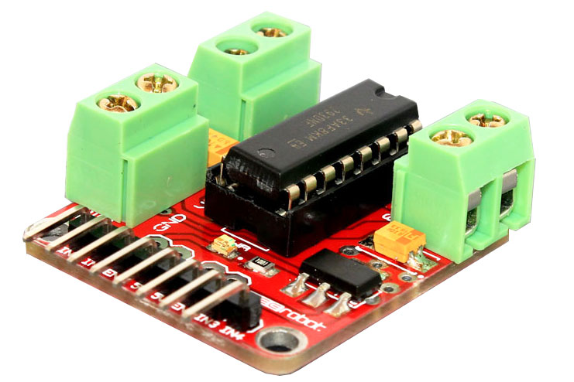

Circuit Diagram

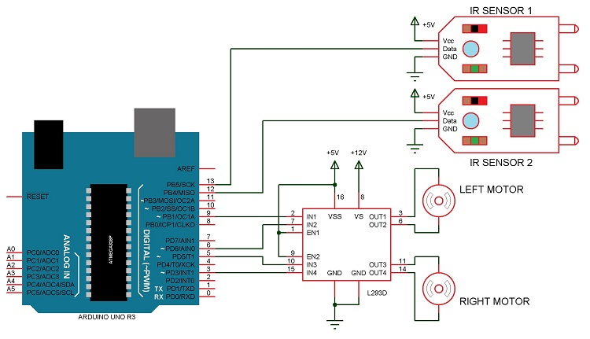

CODE:

/*------ Arduino Line Follower Code----- */  
/*-------defining Inputs------*/  
#define LS 2      // left sensor  
#define RS 3      // right sensor

/*-------defining Outputs------*/  
#define LM1 4       // left motor  
#define LM2 5       // left motor  
#define RM1 6       // right motor  
#define RM2 7       // right motor

void setup()  
{  
  pinMode(LS, INPUT);  
  pinMode(RS, INPUT);  
  pinMode(LM1, OUTPUT);  
  pinMode(LM2, OUTPUT);  
  pinMode(RM1, OUTPUT);  
  pinMode(RM2, OUTPUT);  
}

void loop()  
{  
  if(digitalRead(LS) && digitalRead(RS))     // Move Forward  
  {  
    digitalWrite(LM1, HIGH);  
    digitalWrite(LM2, LOW);  
    digitalWrite(RM1, HIGH);  
    digitalWrite(RM2, LOW);  
  }  
    
  if(!(digitalRead(LS)) && digitalRead(RS))     // Turn right  
  {  
    digitalWrite(LM1, LOW);  
    digitalWrite(LM2, LOW);  
    digitalWrite(RM1, HIGH);  
    digitalWrite(RM2, LOW);  
  }  
    
  if(digitalRead(LS) && !(digitalRead(RS)))     // turn left  
  {  
    digitalWrite(LM1, HIGH);  
    digitalWrite(LM2, LOW);  
    digitalWrite(RM1, LOW);  
    digitalWrite(RM2, LOW);  
  }  
    
  if(!(digitalRead(LS)) && !(digitalRead(RS)))     // stop  
  {  
    digitalWrite(LM1, LOW);  
    digitalWrite(LM2, LOW);  
    digitalWrite(RM1, LOW);  
    digitalWrite(RM2, LOW);  
  }  
}

Code Explanation:

In program, first of all we defined input and output pin, and then in loop we checks inputs and sends output according to inputs to output pin for driving motor. For checking input pin we used “if” statements.

/*-------defining Inputs------*/  
#define LS 2      // left sensor  
#define RS 3      // right sensor

/*-------defining Outputs------*/  
#define LM1 4       // left motor  
#define LM2 5       // left motor  
#define RM1 6       // right motor  
#define RM2 7       // right motor

|  |  |  |  |  |  |  |
| --- | --- | --- | --- | --- | --- | --- |
| **Input** | | **Output** | | | | **Movement**  **Of Robot** |
| **Left Sensor** | **Right Sensor** | **Left Motor** | | **Right Motor** | |
| LS | RS | LM1 | LM2 | RM1 | RM2 |  |
| 0 | 0 | 0 | 0 | 0 | 0 | Stop |
| 0 | 1 | 1 | 0 | 0 | 0 | Turn Right |
| 1 | 0 | 0 | 0 | 1 | 0 | Turn Left |
| 1 | 1 | 1 | 0 | 1 | 0 | Forward |