About:-

The high demand of automobiles has increased the traffic hazards and the road accidents. Life of the people is under high risk. This is because of the lack of best emergency facilities available in our country. This design is a system which can detect accidents in significantly less time seconds covering geographical coordinates, the time and angle in which a vehicle accident had occurred. This alert message is sent to the nearby hospitals and control room in a short time, which will help in saving the valuable lives. A switch is also provided in order to terminate the sending of a message in rare case where there is no casualty, this can save the precious time of the medical rescue team. When the accident occurs the alert message is sent automatically to the rescue team and to the police station. The message is sent through the GSM module and the location of the accident is detected with the help of the GPS module. The accident can be detected precisely with the help of both FORCE SENSING RESISTOR 400 and ACCELEROMETER and ECHO SENSOR. This application provides the optimum solution to the poor emergency facilities provided to the roads accidents in the most feasible way. Also device will help driver to get alert by over speeding vehicles and some obstacles which will not visible during fog.

Approach:

I have tried to install sensors in the car and they will detect any car crash .

In case of an accident, an SOS message will be sent to the nearest control room and nearby ambulance with GPS location of accident area along with details of the car owner.

The device will also help driver during foggy weather when visibility is lost. Device will alert driver about other vehicles behind and ahead of him by providing distance and speed of other vehicle from its. So that driver would take precautions for the same.

**Circuit Diagram:-**

LCD

Ambulance

Control Room

GSM Module

GPS

Arduino

Mega

2560

Echo Sensor

Force Sensor

Accelerometer

The following list of hardware is required for this system.

* ARDUINO Mega 2560
* GSM Module(SIM900A)
* GPS Module(SIM28ML
* FORCE SENSING RESISTOR
* ACCELEROMETER(ADXL335)
* LIQUID CRYSTAL DISPLAY(16x2)
* POWER SUPPLY
* 10 K Potentiometer
* RESET BUTTON

Connections:-

1. GSM module

SIM900 GSM Module provides an industry-standard interface. SIM900 delivers GSM/GPRS 850/900/1800/1900MHz performance for voice, SMS, Data with low power consumption. It is easily available in the market.

* SIM900 designed by using single-chip processor integrating AMR926EJ-S core
* Quad - band GSM/GPRS module in small size.
* GPRS Enabled

**AT Command:**

AT means ATTENTION. This command is used to control GSM module. There are some commands for calling and messaging that we have used in many of our previous [GSM projects with Arduino](https://circuitdigest.com/search/node/gsm%20and%20arduino). For testing GSM Module we used AT command. After receiving AT Command GSM Module respond with OK. It means GSM module is working fine. Below is **some AT commands** we used here in this project:

AT+CNMI=2,2,0,0,0 <ENTER> Auto opened message Receiving.

ATD<Mobile Number>; <ENTER>

AT+CMGF=1 <ENTER> Selecting Text mode

AT+CMGS=”Mobile Number” <ENTER> Assigning recipient’s mobile number

>>Now we can write our message

>>After writing message

Ctrl+Z send message command (26 in decimal).

ENTER=0x0d in HEX

**Booting the GSM Module!**

**1.** Insert the SIM card to GSM module and lock it.

**2.** Connect the adapter to GSM module and turn it ON!

**3.** Now wait for some time (say 1 minute) and see the blinking rate of ‘status LED’  or ‘network LED’ (GSM module will take some time to establish connection with mobile network)

**4.** Once the connection is established successfully, the status/network LED will blink continuously every 3 seconds. You may try making a call to the mobile number of the sim card inside GSM module. If you hear a ring back, the gsm module has successfully established network connection.

### Accelerometer(ADXL335):

Pin Description of accelerometer:

1. Vcc         5 volt supply should connect at this pin.
2. X-OUT   This pin gives an Analog output in x direction
3. Y-OUT   This pin give an Analog Output in y direction
4. Z-OUT   This pin gives an Analog Output in z direction
5. GND      Ground
6. ST          This pin used for set sensitivity of sensor

FORCE SENSING RESISTOR 400:

Because FSRs are basically resistors, they are non-polarized. That means you can connect them up 'either way'a and they'll work just fine!

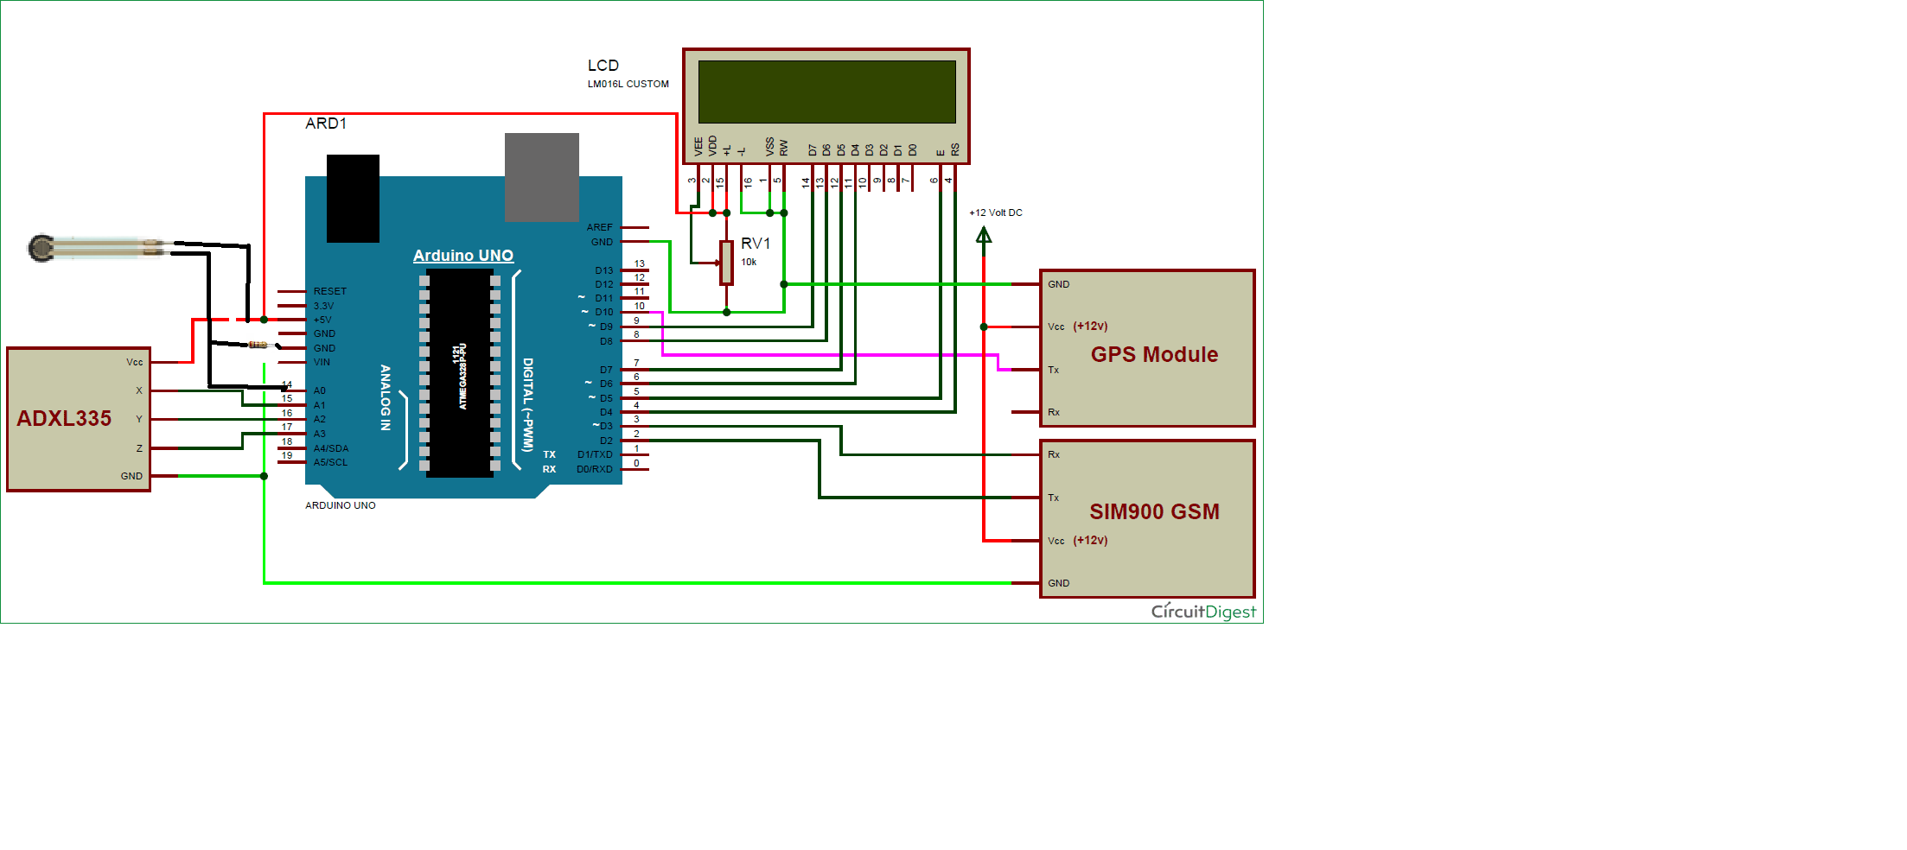

Here Arduino is used for controlling whole the process with a **GPS Receiver and GSM module**. GPS Receiver is used for detecting coordinates of the vehicle, GSM module is used for sending the alert SMS with the coordinates and the link to Google Map. **Accelerometer namely ADXL335** is used for detecting accident or sudden change in any axis. And FSR 400 is used for detecting any kind of force and crash in vehicle. And an optional 16x2 LCD is also used for displaying status messages or coordinates. **We have used GPS Module SIM28ML and GSM Module SIM900A.** Whenever there is an accident, the car gets tilt and accelerometer changes his axis values and if vehicle crashes the amount of pressure applied on **FSR 400** will detect car had been crashed or not. These values read by Arduino and checks if any change occurs in any axis. If any change occurs then Arduino reads coordinates by extracting $GPGGA String from GPS module data (GPS working explained above and send SMS to the predefined number to the police or ambulance or family member with the location coordinates of accident place. The message also contains a Google Map link to the accident location, so that location can be easily tracked. When we receive the message then we only need to click the link and we will redirect to the Google map and then we can see the exact location of the vehicle. **Speed of Vehicle, in knots** (1.852 KPH), is also sent in the SMS and displayed on the LCD panel.