Account Takeover Streamlit Project
Week 1 | Path 3 | ATO Investigator

Problem and final application
Fraud analysts need to connect login attempts, device and country changes, credential recovery, beneficiary additions, and transfers into an account story. A suspicious login can represent a takeover or a legitimate customer change. ATO Investigator makes the evidence and alternative explanations visible in a working Streamlit data application.
The final app uses Python, Streamlit, pandas, and Plotly. Its five workspace views cover the overview, account investigation, detection playground, data methodology, and vibe coding build journal. The Python entrypoint is app.py. The earlier static HTML demo is retained only as development history.

Dataset and reproducibility
A Python standard-library generator with seed 42 creates 1,578 fictional events across 80 accounts for October 1–11, 2026 UTC. Scenarios include 8 strong-signal takeovers, 4 low-signal takeovers, 8 legitimate travelers, 6 password recoveries, 6 new phones, and 48 routine accounts. Amounts are USD; there is no real customer data.
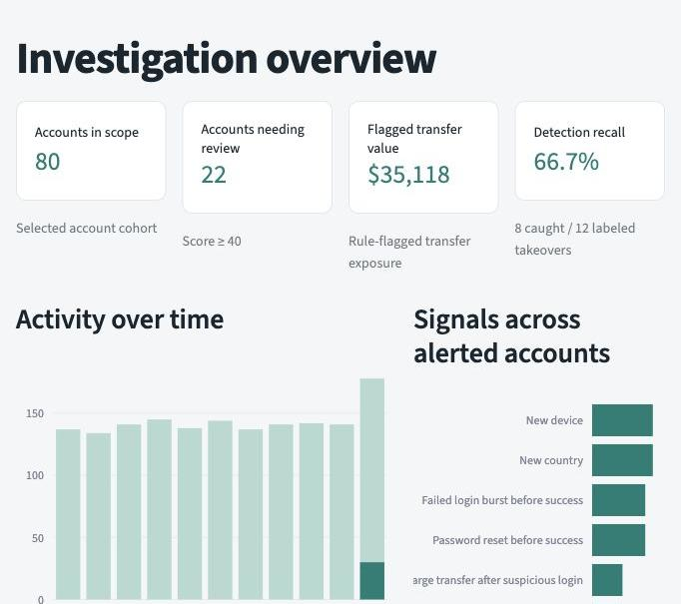
Figure 1 The live Streamlit overview shows 80 accounts, 22 alerts, $35,118 of flagged transfer exposure, and 66.7 percent recall.
Run locally with streamlit run app.py after installing requirements.txt. Streamlit runs Python on a server and presents its interface in a browser; this replaces the original static frontend.

Actual prompts used during vibe coding
The following are the actual human messages used to direct this project. They preserve the original wording. Implementation decisions and commands are documented separately in the build steps, rather than presented as invented user prompts.

Prompt 1 Project ideation
Hi Codex - Need help with project suggestions for my project. Here are the guidelines. I prefer picking path-3 and I need ideas to build something in fraud domain that I work on for this project.

Prompt 2 Project selection and build authorization
I want to pick account takeover project and would need help building the project end to end for submission.

Prompt 3 Repository publication preference
Create a new public repository

Prompt 4 Framework correction
Can you create streamlit app instead of liocal browser window? You missed part of teh instructions in the report.

Prompt 5 Streamlit conversion and documentation requirements
Please go ahead with Streamlit. The report should include the prompts used, screenshots of the vibe-coding process, and the full step-by-step build breakdown, not just the finished app screenshots.
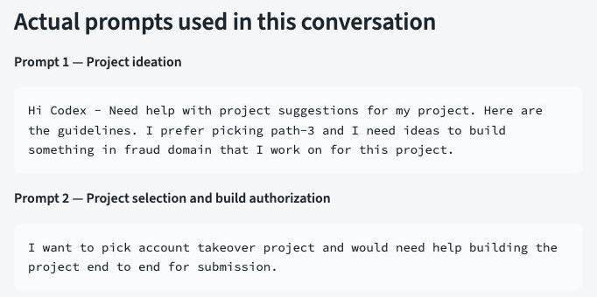
Figure 2 Screenshot of the live Streamlit journal rendering the original project prompts. This is a journal capture, not an original Codex chat UI screenshot.
Process evidence includes actual messages, current source files, and saved executed command outputs. Automated capture of the original Codex interface was blocked. If original chat UI images are required by the evaluator, add those manually; the journal images are explicitly identified here.

Full build breakdown from idea to prototype

1 Read the assignment
Read the supplied Week 1 guidelines. Identify the Path 3 problem statement, full build breakdown, prompts, process screenshots, a live video of five minutes or less, and the GitHub code link.

2 Choose account takeover
Discuss fraud-domain project options. The user selects account takeover and authorizes an end-to-end build.

3 Define investigation scope
Connect login attempts, device and country changes, password resets, beneficiary additions, and transfers. Include both suspicious behavior and legitimate lookalikes.

4 Create reproducible synthetic data
Implement scripts/generate_data.py using Python standard-library CSV, JSON, datetime, and random with seed 42. Produce 1,578 events across 80 accounts spanning October 1–11, 2026 UTC.

5 Build and test the initial prototype
The initial implementation used JavaScript chronological rules and a static interface. Nine engine tests and thirteen browser checks passed. This was a framework mismatch with the user's intended Streamlit project and was corrected below.

6 Prepare and publish the initial code
Generate screenshots, create a report and narration script, publish the initial private static demo, and upload 24 assets to the user's public GitHub repository. The original report documented outputs but did not sufficiently show the full coding process.
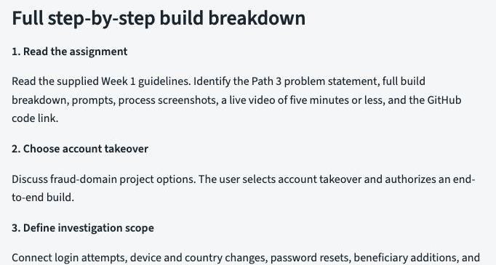
Figure 3 The running build journal records scope, dataset generation, and the original prototype stages.
The initial report emphasized finished-app screenshots. The user correction led to the Streamlit conversion and this expanded process-focused report. The history is retained so the iteration is visible.

Full build breakdown for the Streamlit version

7 Apply the user's corrections
The user explicitly requests Streamlit and a report containing actual prompts, process screenshots, and the full step-by-step breakdown. Preserve the fraud scenarios but make Python and Streamlit the primary implementation.

8 Set up the Python environment
Create a project-local .venv. Install Streamlit, pandas, and Plotly after native network permission. Pin the versions used in requirements.txt and define .streamlit/config.toml.

9 Port chronological rules to Python
Create fraud_engine.py with strict CSV validation, earlier-event context, configurable time and amount thresholds, account-level metrics, and safe exports. Keep is_ato labels and scenario descriptions out of scoring.

10 Build the Streamlit workspace
Create app.py with sidebar navigation and shared cohort filters, Plotly charts, review queues, chronological timelines, rule forms, session case notes, uploads and downloads, and a build journal containing actual prompts and artifacts.

11 Test and inspect the converted app
Run Python engine tests and Streamlit AppTest checks, start the local Streamlit server, and inspect the running views. Capture screenshots of the actual Streamlit app and build journal. Save executed commands and outputs as validation evidence.

12 Rebuild submission materials and publish
Replace the report with a detailed Streamlit report containing actual prompts, step-by-step implementation, process screenshots, validation, iterations, and limitations. Update README, demo script, checklist, code ZIP, and GitHub. The narrated video and final form submission remain the user's actions.
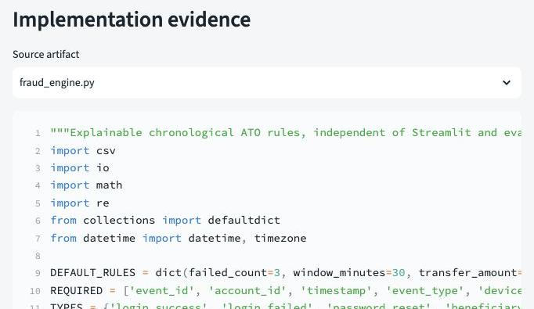
Figure 4 The live code evidence view displays fraud_engine.py, including rule defaults and input validation.
Source artifacts: app.py, fraud_engine.py, requirements.txt, .streamlit/config.toml, tests/test_fraud_engine.py, and tests/test_streamlit_app.py. The build journal reads these real files rather than displaying mock code.

Testing debugging and validation evidence
The final Python validation run passes 14 tests. Nine engine tests verify expected outcomes, threshold effects, label independence, exclusion of future activity, expired time windows, absent labels, CSV quoting, invalid uploads, and export formula protection. Five Streamlit AppTest workflows cover overview filters and empty results, investigations and notes, rule comparisons, data methodology, and the process journal.
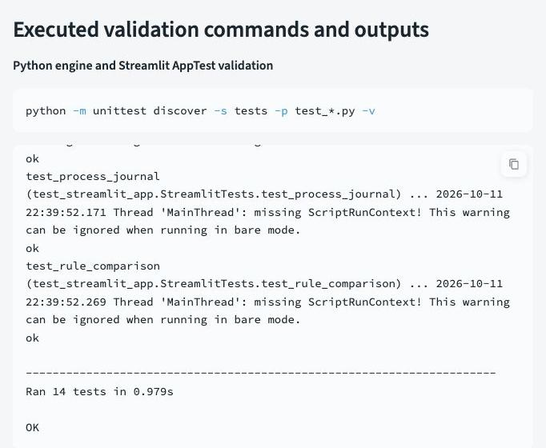
Figure 5 Screenshot of the executed command output displayed in the live build journal. The saved full output is in submission/streamlit_validation.json.

Observed bug and correction
Adding a second radio selector exposed a test-harness error: a positional widget index targeted the wrong radio group. The failing output is retained in streamlit_validation_failure.json. Stable widget keys workspace_view and journal_evidence corrected the selection; the final run passes all 14 tests. This is a recorded iteration, not an invented debugging example.
The local environment also required native network permission for dependencies and socket permission for the Streamlit server. The installed dependency versions are pinned. AppTest warnings about missing ScriptRunContext are expected in bare test mode; the final test exit code is zero.

Working investigation and detection tradeoffs
In ACC-0001, failed logins are followed by a password reset, a successful login on a new device in a new country, a new beneficiary, and a $6,322 transfer. The account score is 80. The analyst can inspect all activity or signal events, reveal optional synthetic ground truth, record an outcome, and export the timeline.
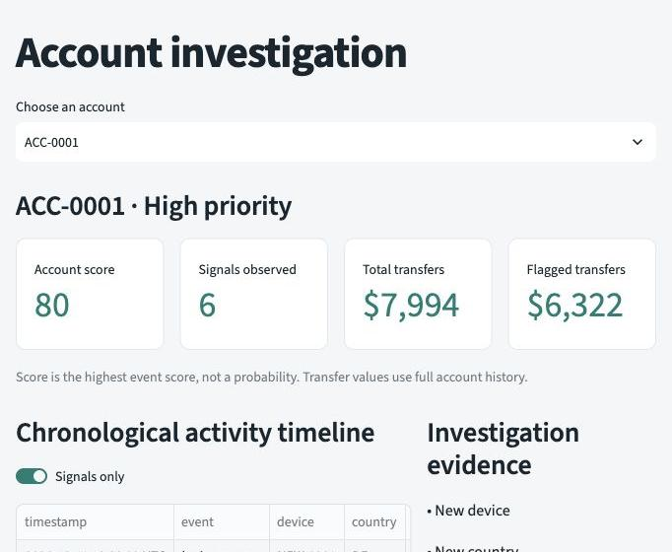
Figure 6 The running Streamlit account investigation exposes score, transfer values, and chronological activity.
Default threshold 40 produces 8 takeovers caught, 14 legitimate accounts flagged, and 4 takeovers missed: precision 36.4 percent and recall 66.7 percent. Threshold 70 removes the 14 benign alerts in this sample, retaining the same 8 caught takeovers and 4 missed takeovers. These engineered synthetic results are not a production performance claim.

Learnings and interpretation
Labels and scenario text are excluded from scoring. Rules use earlier events only. Dates select an account cohort while preserving historical rule context. Flagged transfer value is review exposure rather than confirmed loss. Benign travel and password recovery expose false positives; low-signal takeovers show that changing thresholds alone cannot create missing evidence.

Demo and submission
The demo script covers the problem, overview, ACC-0001, benign ACC-0013, threshold comparison, data schema, and build journal within five minutes. Submit a Google Doc imported from this report, a narrated live video, and the public repository link: https://github.com/naspter333/ato_investigator.
Streamlit CSV uploads are processed on the Python server. Local execution processes them on the user computer; hosted execution processes them on the host. Case notes last for the current session and should be exported before ending it. The narrated recording, Google Doc import, and final form submission remain separate completion steps.

