WEB PAGE 03

GameZone Community
Website Description, HTML Structure, CSS Styling, and Output

1. Website Description
GameZone Community is a gaming and sports community webpage created for people who enjoy video games, sports, and connecting with others. It introduces the community with the message “Play Together. Win Together!” and provides navigation links to Home, Games, Sports, Events, and Community. The webpage includes popular gaming categories, sports cards, upcoming community events, a community invitation, and contact information.
The goal of this project is to demonstrate how HTML structures the content and how CSS styles the page to create a consistent, dark-themed design. The interface uses gaming-related images, section headings, cards, links, and event panels to make the content easy to browse.

2. HTML Code
HTML (HyperText Markup Language) provides the structure and content of the webpage. Figures 1 and 2 show the page setup, navigation, hero section, popular games, and sports content.

What I have used in the HTML
- Document setup: <!DOCTYPE html>, <html>, <head>, and <body> define the webpage structure.
- Metadata and page title: UTF-8 encoding supports common characters, while the viewport meta tag helps the page fit different screen widths. The title is “GameZone Community.”
- External CSS file: The link element connects the HTML to gaming_esports.css so the appearance can be managed separately.
- Header and navigation: <header> and <nav> contain the GameZone name and links to Home, Games, Sports, Events, and Community.
- Hero section: A section with class hero and id home displays the main slogan, a short description, and a “Join Our Community” link.
- Content sections and cards: Sections with ids such as games and sports organize the page. Containers and card elements group images, headings, descriptions, and Explore links.
- Images and alternative text: <img> elements display gaming and sports images; alt attributes provide text descriptions for accessibility.
- Anchor links: href values such as #home and #community allow visitors to jump to relevant sections on the same page.
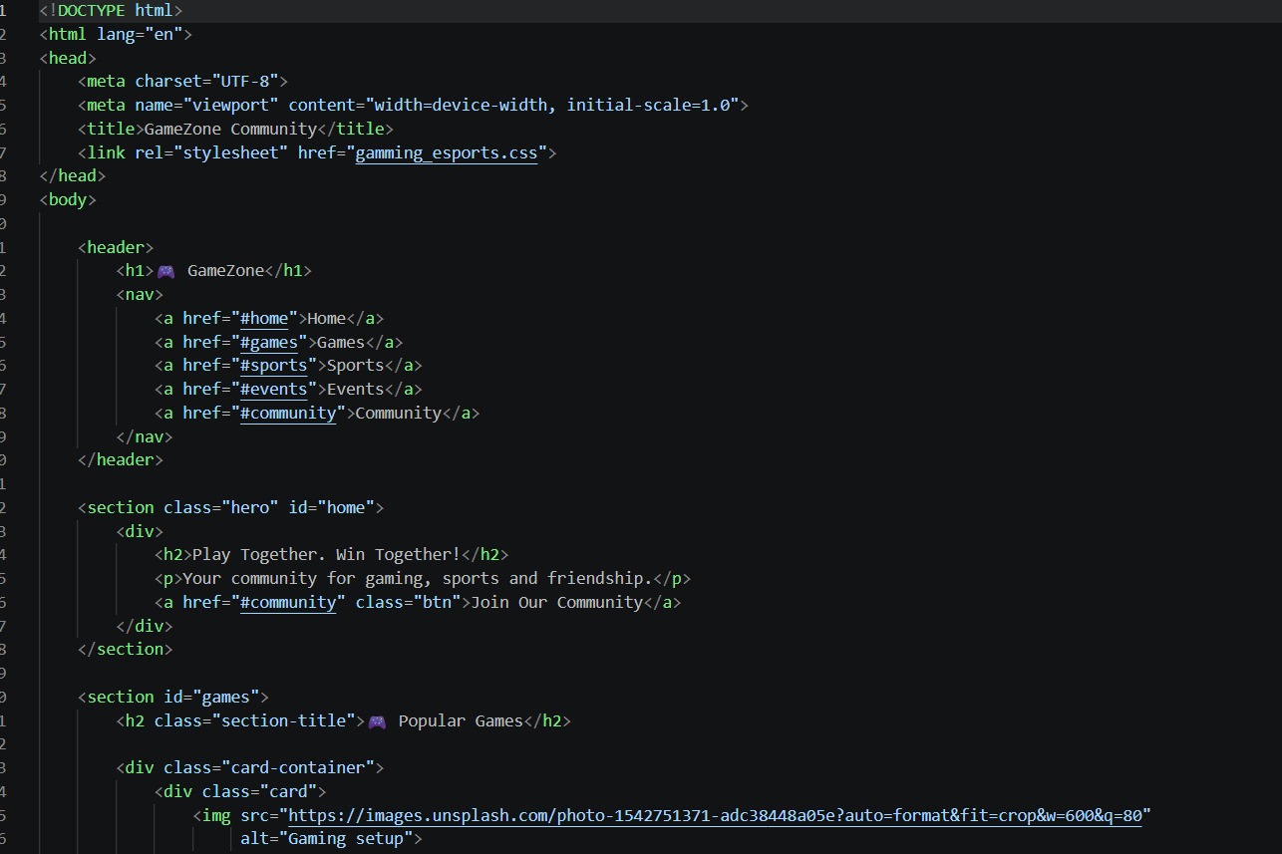
Figure 1. HTML page setup, navigation menu, hero banner, and beginning of the Popular Games section.
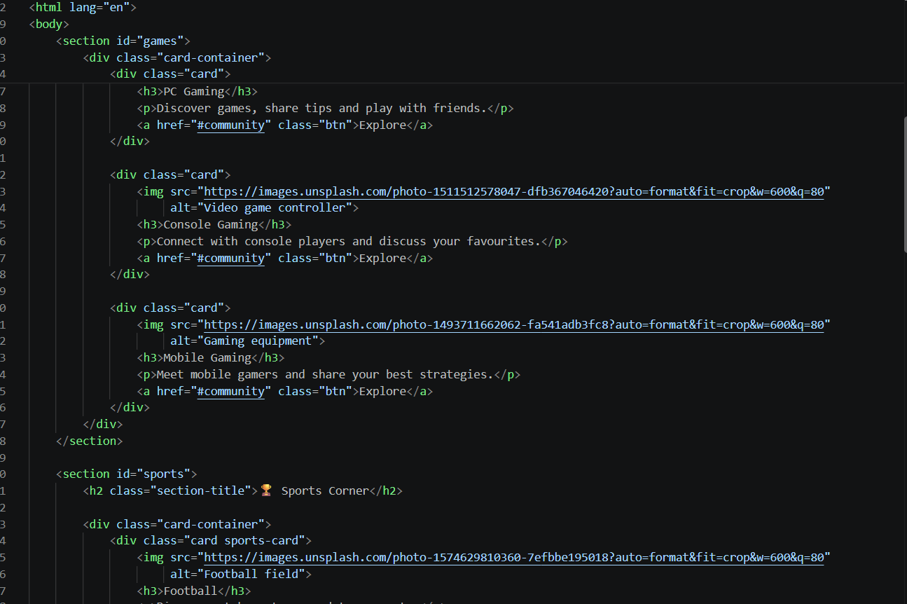
Figure 2. HTML markup for gaming cards and the start of the Sports Corner section.

3. CSS Code
CSS (Cascading Style Sheets) controls the visual design of the HTML elements. Figure 3 shows the universal reset, smooth scrolling, body colors, header design, heading color, and navigation-link styles.

What I have used in the CSS
- Universal selector (*): Resets margin and padding to zero, applies border-box sizing, and sets Arial as the default font.
- Smooth scrolling: scroll-behavior: smooth makes movement between in-page anchor sections smoother in supported browsers.
- Body theme: A dark background (#101522) and white text create a gaming-style appearance with strong contrast.
- Header styling: A deep blue header (#080c16), padding, and centered text establish the top navigation area.
- Heading styling: The main heading uses a bright cyan color (#00e5ff) and bottom spacing to stand out against the dark background.
- Navigation links: White, bold links without underlines are spaced evenly; a hover rule changes the link color to cyan for visual feedback.
- Consistent visual design: The dark navy panels and cyan accents are echoed in the rendered page, helping sections and interactive-looking links stand out.
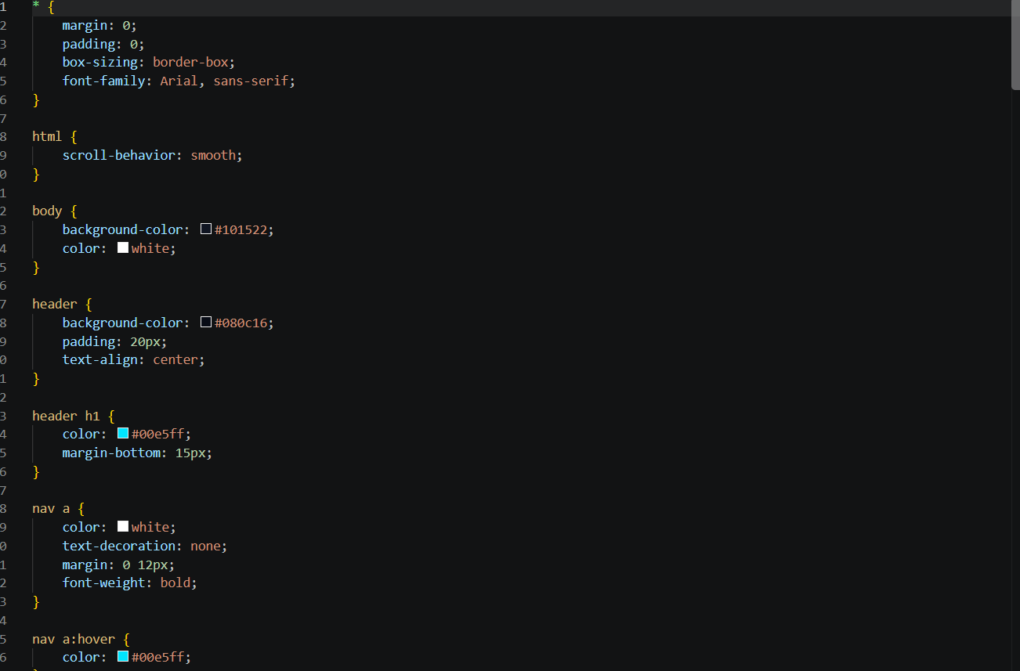
Figure 3. CSS rules for global spacing, smooth scrolling, body background, header, headings, and navigation hover styling.

4. Output
Figure 4 shows the completed GameZone Community webpage. At the top, the GameZone heading and navigation menu provide access to the main sections. The hero banner presents the slogan “Play Together. Win Together!” with a button inviting visitors to join the community.
The Popular Games section contains cards for PC Gaming, Console Gaming, and Mobile Gaming. Each card includes an image, a short description, and an Explore link. Below it, the Sports Corner presents Football, Cricket, and Tennis cards. The Upcoming Community Events section lists activities such as a gaming night, football challenge, and cricket fan meetup, with dates marked as coming soon.
Further down, a highlighted community banner encourages visitors to join, followed by a Contact Us section and a footer. The dark background, blue panels, and cyan headings/buttons create a consistent gaming-inspired appearance. The output demonstrates how the HTML content and CSS rules work together to form a single, organized webpage.
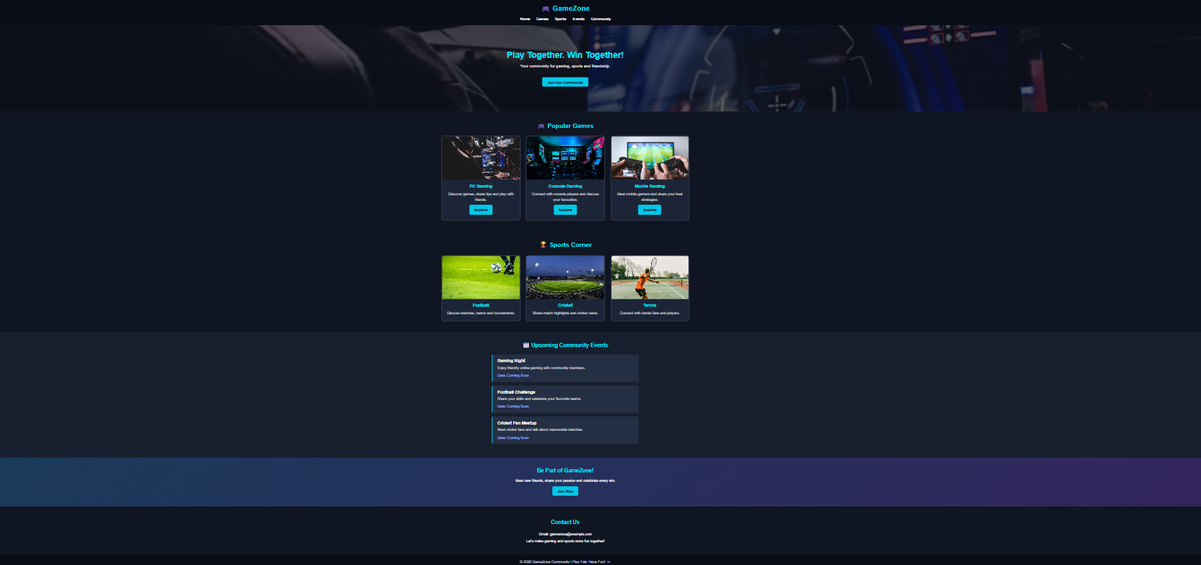
Figure 4. Final browser output showing the GameZone navigation, hero banner, gaming cards, sports cards, events, community invitation, and contact area.

5. Conclusion
This project demonstrates the use of HTML and CSS to build a gaming and sports community webpage. HTML organizes the page into navigation, hero, games, sports, events, and contact sections. CSS provides the dark theme, cyan accents, typography, spacing, and hover effects. Together, they create a clear and visually consistent interface. The links and buttons shown are interface elements; any real community registration or event-management features would require additional functionality.

