WEB PAGE 02

ElectroMart – Electronics Store
Website Description, HTML Structure, CSS Styling, and Output

1. Website Description
ElectroMart is a simple electronics e-commerce webpage designed to present popular gadgets in a clear and attractive layout. The page includes a navigation bar, a promotional hero banner, product categories, featured product cards, and a section explaining the store’s benefits. Products display images, discount labels, short specifications, ratings, prices, and Buy Now links. The design uses a blue-and-white color scheme to create a clean, modern shopping experience.
The purpose of this project is to demonstrate how HTML organizes webpage content and how CSS controls its appearance, spacing, colors, alignment, and product-card layout. The screenshots below document the HTML structure, CSS rules, and final browser output.

2. HTML Code
HTML (HyperText Markup Language) defines the structure and content of the webpage. The code shown in Figures 1 and 2 includes the document setup, page title, linked stylesheet, navigation links, hero banner, category links, and featured product cards.

What the HTML code uses
- Document structure: <!DOCTYPE html>, <html>, <head>, and <body> establish a standard HTML page.
- Metadata and title: UTF-8 character encoding, viewport settings for responsive sizing, and the browser-tab title are defined in the head.
- External stylesheet: <link rel="stylesheet" href="electronic_store.css"> connects the HTML page to the CSS file.
- Semantic sections: <header>, <nav>, and <section> group the navigation, hero banner, categories, and products meaningfully.
- Navigation and anchors: Links such as #home, #categories, #products, and #contact let visitors jump to page sections.
- Product information: Product cards use <div>, <img>, headings, paragraphs, discount badges, ratings, prices, <del> for old prices, and Buy Now links.
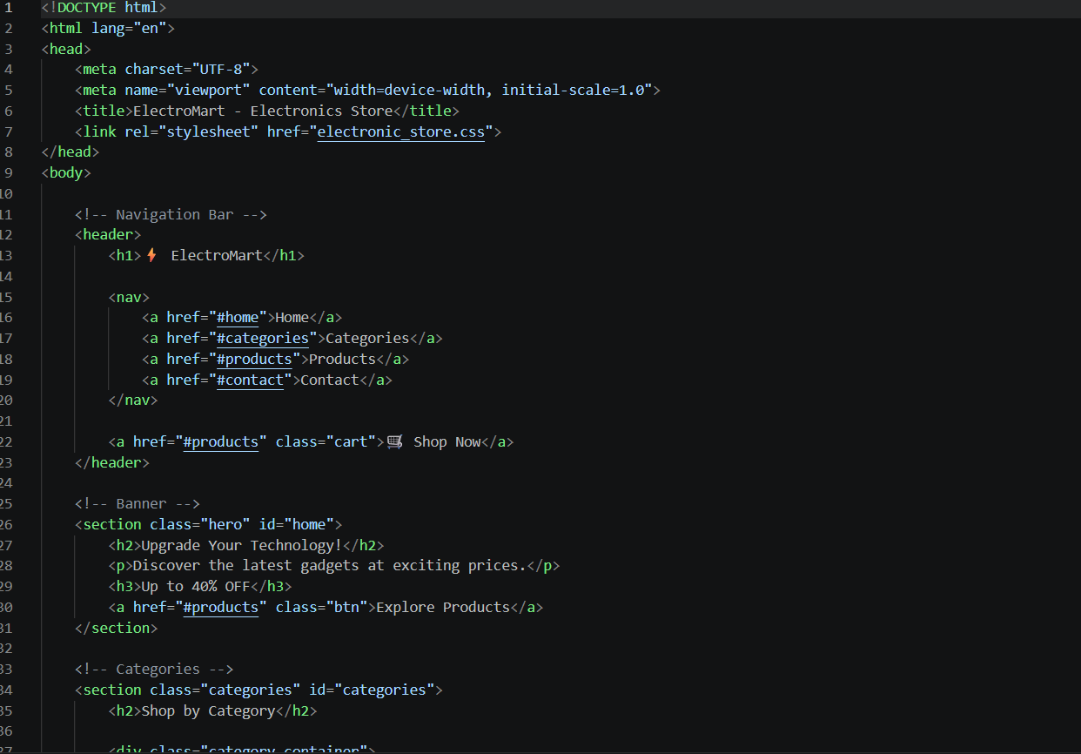
Figure 1. HTML document setup, navigation bar, hero banner, and beginning of the category section.
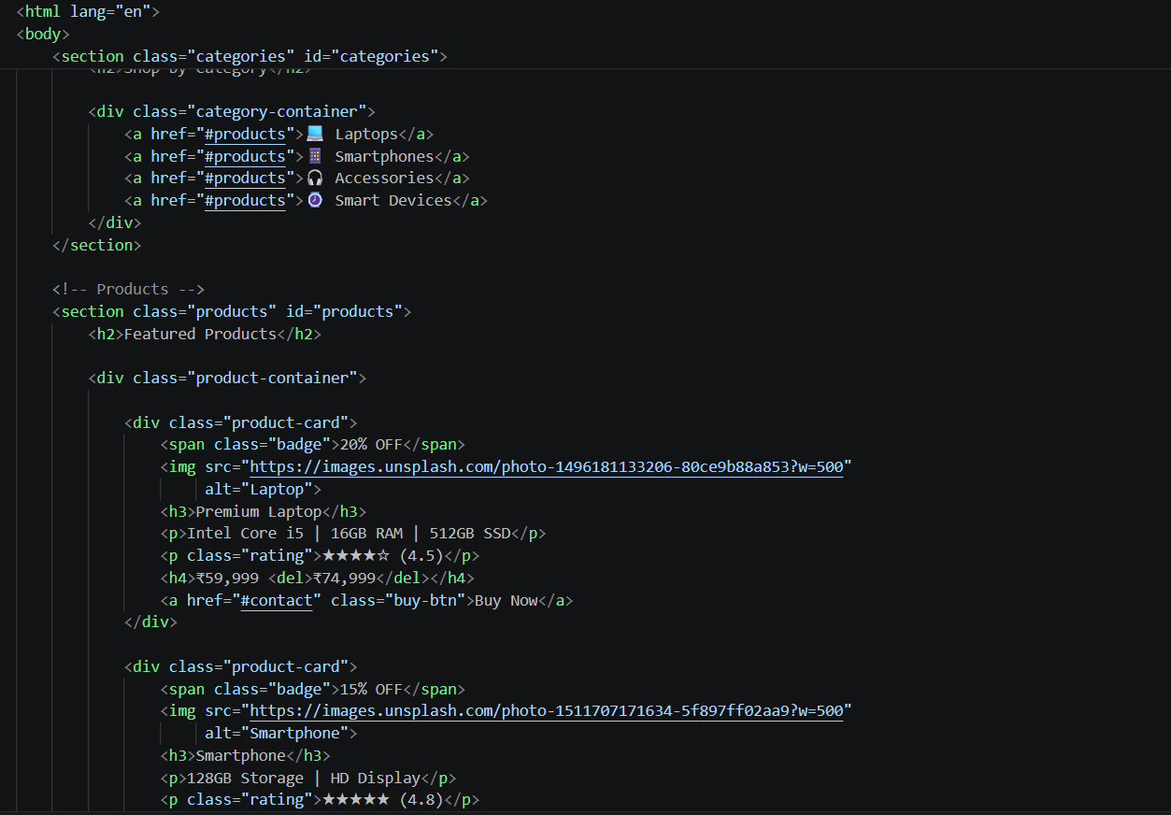
Figure 2. Category links and featured product-card markup, including images, discount badges, ratings, prices, and purchase links.

3. CSS Code
CSS (Cascading Style Sheets) controls the visual presentation of the HTML elements. The screenshots in Figures 3 and 4 show the general styling and navigation styles used for ElectroMart.

What the CSS code uses
- Universal reset: The * selector sets margin and padding to zero and uses box-sizing: border-box for predictable element sizing.
- Body styling: Arial is selected as the font, a light background (#f4f7fb) is applied, and dark text (#333) improves readability.
- Header styling: A dark navy background (#172554), white text, and padding create a clear navigation bar.
- Flexbox layout: display: flex, justify-content: space-between, align-items: center, and flex-wrap arrange the logo, navigation, and shopping link.
- Navigation links: White, bold links without underlines are spaced apart for easy navigation.
- Consistent visual theme: The CSS supports the page’s blue, white, and light-grey palette, which is reflected in the final output.
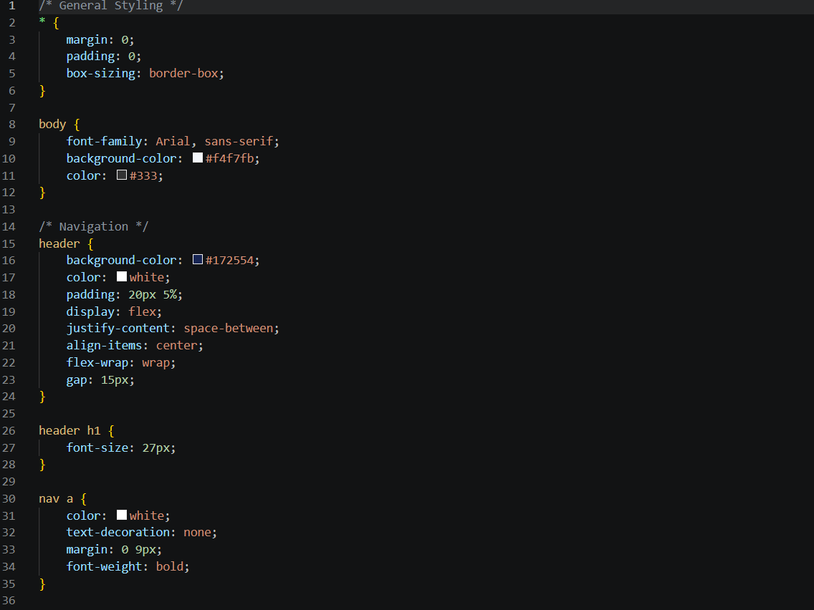
Figure 3. CSS reset, body typography and colors, and header layout rules.
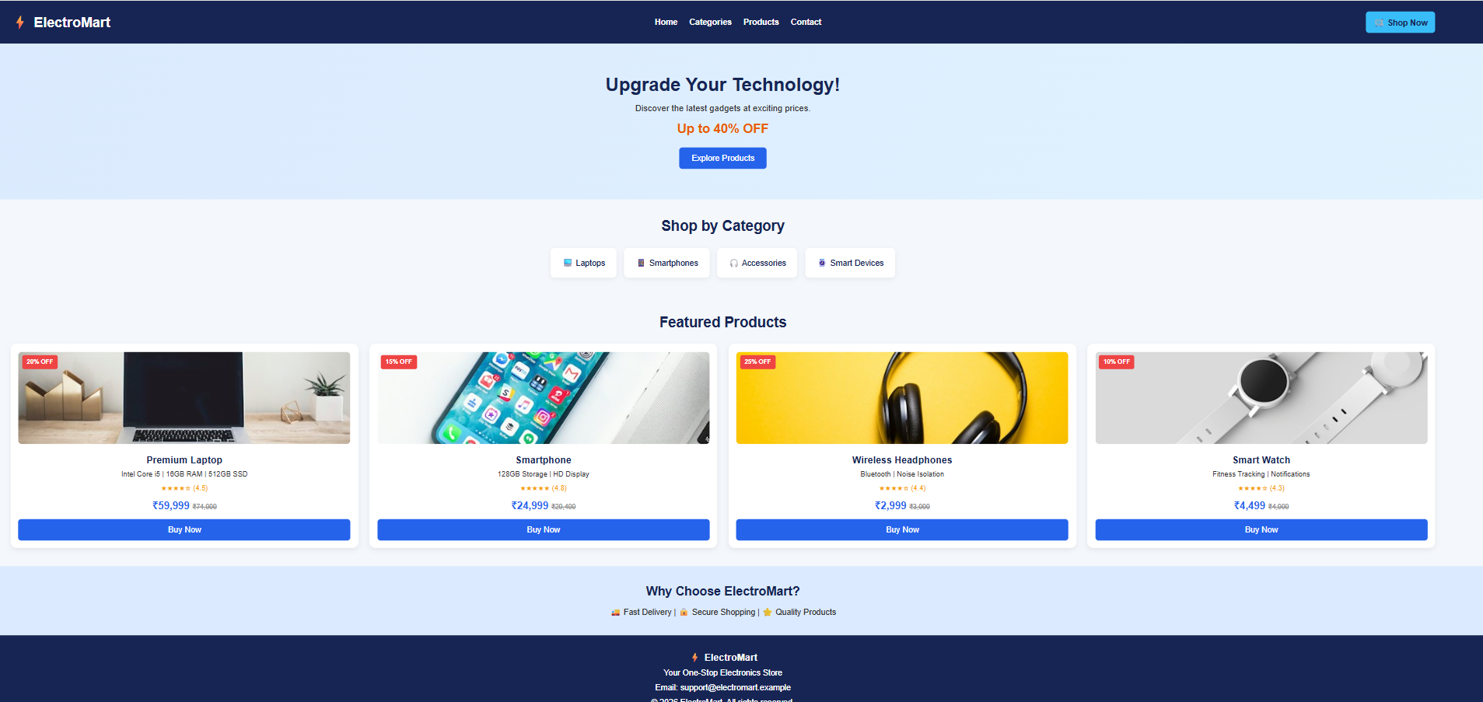
Figure 4. Final rendered ElectroMart webpage showing the navigation bar, hero banner, categories, product cards, benefits, and footer.

4. Output
The final output shows the completed ElectroMart storefront in a browser. A dark navy navigation bar appears at the top, followed by a light-blue promotional banner with the message “Upgrade Your Technology!” and an Explore Products button. The category section provides quick links to laptops, smartphones, accessories, and smart devices.
The Featured Products section displays four product cards: Premium Laptop, Smartphone, Wireless Headphones, and Smart Watch. Each card includes a product image, discount badge, short description, star rating, current price, previous price, and a Buy Now button. At the bottom, the “Why Choose ElectroMart?” section highlights fast delivery, secure shopping, and quality products, followed by a footer with the store name and contact information.
Overall, the output demonstrates the connection between HTML structure and CSS styling. The layout is organized and easy to scan, with consistent colors, clear headings, product-focused cards, and prominent purchase links.

5. Conclusion
This project demonstrates a basic electronics store webpage built with HTML and CSS. HTML provides the page structure and product content, while CSS creates the color theme, alignment, spacing, and visual hierarchy. Together, they produce a neat storefront suitable for presenting featured electronic products. The Buy Now and navigation links are shown as interface elements; actual shopping, checkout, or payment functionality would require additional implementation.

