WEB PAGE 01

Sweet Treats Bakery
Website Design and Development Documentation

1. Description of the Website
Sweet Treats Bakery is a simple bakery website designed to introduce bakery products in an attractive and easy-to-understand format. It presents a welcoming home section, navigation links, and product cards for items such as cakes, cupcakes, and cookies. Each product card includes an image, product name, short description, price, customer rating, and an “Order Now” link.
The website uses HTML to organise the content and CSS to style the page. Its soft pink and cream colour palette is intended to create a warm, friendly bakery theme. Navigation links help visitors move between the Home, Our Cakes, About, and Contact sections.

2. HTML Code
HTML (HyperText Markup Language) provides the structure and content of the webpage. The following screenshots show the HTML code used for the page.

HTML Screenshot 1
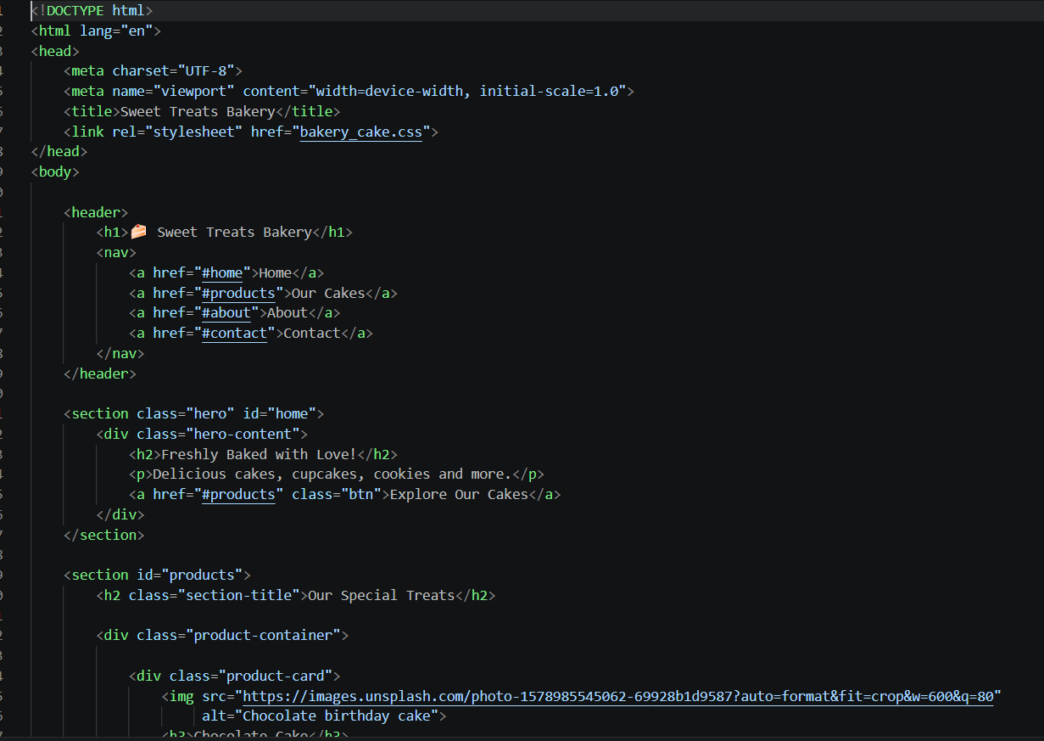
This part of the code defines the HTML document, language, character encoding, viewport settings, page title, and link to the external CSS file named bakery_cake.css. The body contains the header, bakery heading, navigation links, and hero section. The hero section introduces the bakery with the message “Freshly Baked with Love!” and a link to explore the products.

HTML Screenshot 2
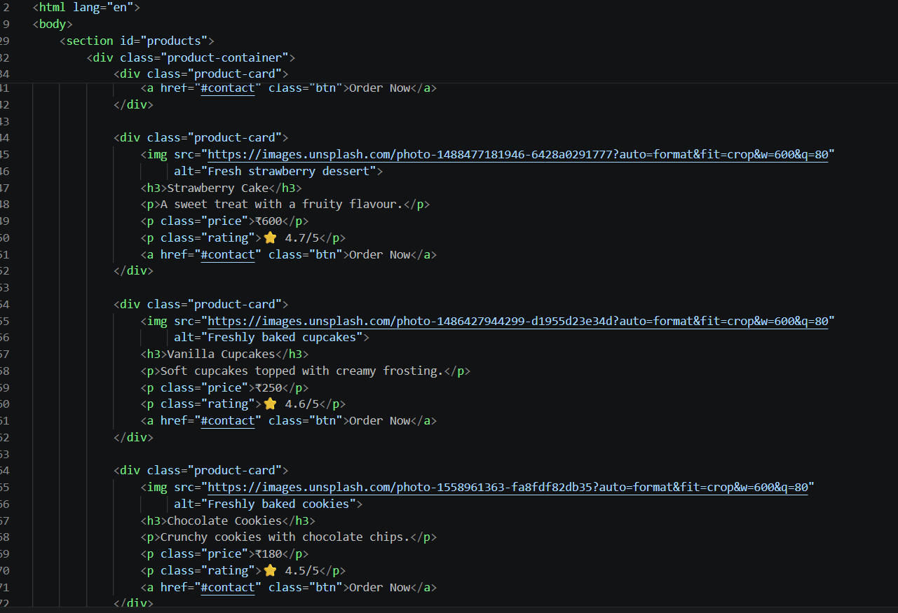
This part shows the product-card structure. The <div> elements group each product, while <img> displays product photographs and the alt attribute provides alternative text. Heading and paragraph elements show product names and descriptions. CSS classes such as product-card, price, rating, and btn are used to apply consistent styling. The Order Now links point to the Contact section.

HTML Elements and Features Used
- <!DOCTYPE html>, <html>, <head>, and <body> to define the document structure.
- <meta> elements for character encoding and responsive viewport settings.
- <title> and <link> to set the browser-tab title and connect the external stylesheet.
- <header>, <nav>, and <section> to organise the webpage into meaningful areas.
- <h1>, <h2>, <h3>, and <p> to display headings and descriptions.
- <a> links for navigation and product-order actions.
- <div> containers and CSS class names to group and style product cards.
- <img> elements with alt text to display and describe product images.

3. CSS Code
CSS (Cascading Style Sheets) controls the appearance and layout of the webpage. The screenshot below shows the CSS rules used to style the bakery website.

CSS Screenshot
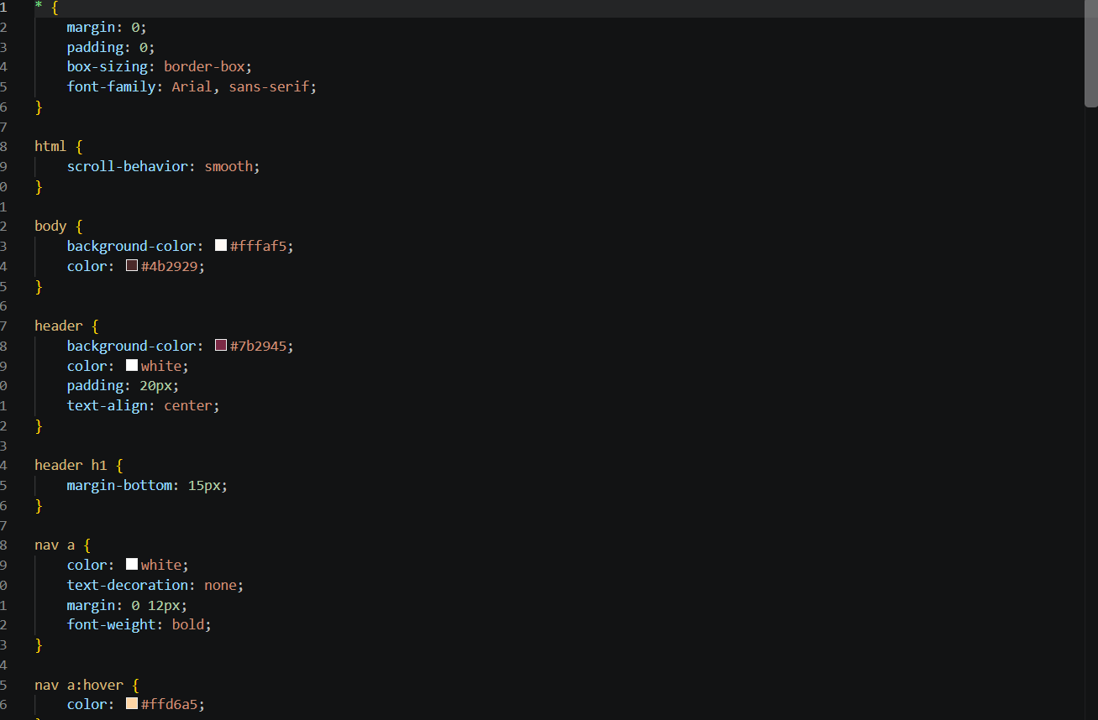
The universal selector (*) resets the default margin and padding and applies border-box sizing and the Arial font. The html rule enables smooth scrolling. The body rule sets a cream background (#fffaf5) and dark text colour (#4b2929). The header rule gives the top section a deep pink background (#7b2945), white text, padding, and centred alignment. The header h1 rule adds spacing below the main heading. The nav a rule styles navigation links with white text, removes underlines, adds horizontal spacing, and makes the text bold. The nav a:hover rule changes the link colour when a visitor points to it.

CSS Properties and Selectors Used
- Universal selector (*): resets margin and padding and sets box-sizing and font-family.
- Colour properties: background-color and color create the cream, pink, and dark-text theme.
- Spacing properties: padding and margin control space around elements.
- text-align: centres the content in the header.
- text-decoration: none removes the default underline from navigation links.
- font-weight: bold makes navigation labels more prominent.
- :hover pseudo-class: changes a navigation link’s appearance when hovered over.
- scroll-behavior: smooth makes movement between in-page sections smoother.

4. Output
The expected output is a bakery webpage with a pink header, the “Sweet Treats Bakery” title, navigation links, a welcoming hero section, and a product area containing cards for cakes, cupcakes, and cookies. Each card is designed to show a product image, name, description, price, star rating, and an Order Now link. The cream background and dark text complement the pink header to give the page a consistent bakery theme.

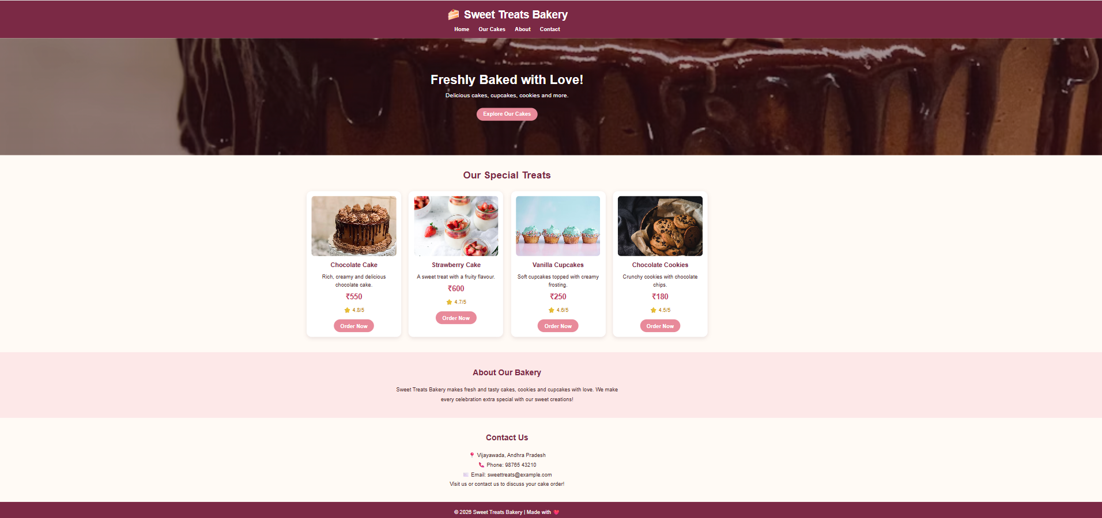

5. Conclusion
This webpage demonstrates the use of HTML to structure website content and CSS to improve its visual presentation. Semantic sections, navigation links, product cards, images, colours, spacing, and hover styling work together to create a clear and user-friendly bakery website. The project provides practice in linking an external stylesheet and organising content for a simple business webpage.

