**The relationship between body size and metabolic rates in *Manduca sexta* caterpillars**

**Introduction**

All animals consume food to gain energy and materials from the environment. This ﬁnite supply of energy and matter must be allocated to maintenance, growth, reproduction, movement, and their attendant metabolic costs. Both metabolism and material exchange with the environment are complex and intricately related processes that depend heavily on animal size (Sears *et al.* 2012).

*Manduca* serves as good model organism for investigating scaling relationships because it grows almost 10,000-fold in mass in less than 3 weeks. *Manduca* larvae have ﬁve discrete developmental stages (instars). Between instars, larvae go through a moult period, during which most of their cell proliferation occurs (Baldwin and Hakim 1991). These discrete developmental stages provide a natural basis for asking whether the parameters of scaling relationships and the efﬁciencies of growth and assimilation change over ontogeny

Larvae undergo substantial physiological and behavioural changes at or near times of moult (Chamberlin et al. 1997) that warrant the restriction of our data set for analysis. For example, larvae decrease their food intake, frass production, and growth rate considerably as they approach times of moult.

In this study, we aimed to determine whether body size and/or instar had an influence on the metabolic rate of *Manduca sexta* caterpillars. It was hypothesized that body size would have a positive correlation with metabolic rate and that instar would have a positive correlation with metabolic rate as well.

**Methods**

Animal Rearing

In the summer of 2009, two cohorts of *Manduca sexta* larvae from eggs to adults, were reared, at a constant temperature of 27oC and long-day photoperiod (16 hours light and 8 hours dark). The initial eggs were obtained from the Carolina Biological Supply. Upon hatching, individuals were placed in sperate containers. All larvae were fed a wheat germ–based laboratory diet (tobacco hornworm medium bulk diet) but in controlled amounts to facilitate accurate measures of metabolic rates. To facilitate the collection of frass, caterpillars and food were elevated above the ﬂoor of the containers on a small wire mesh frame constructed of hardware cloth. Data were analysed only for larvae that successfully entered pupation.

Growth and Metabolism Measurements

Animal mass, instar, and day of instar were recorded for each larva at approximately the same time each day. Early-instar animals (<10 mg) were weighed on a digital microbalance while larger animals were weighed on a Mettler-Toledo XS-204. Values of animal mass were converted to dry mass based on a preliminary study that measured the water content of Manduca larvae. The wet and dry masses of three larvae were measured at each day of each instar, providing a wide range of animal sizes and accounting for all stages of the larval cycle.

The metabolic rate of each larva was also measured at approximately the same time every day using a four-channel respirometry system and G283 channel switcher run into a model S151 infrared gas analyser) in a 27 C temperature-controlled chamber. The respirometry system was calibrated (both zero and span) each morning and recalibrated between each set of measurements using standardized reference gases. After acclimation to the chamber for 25 min, CO2 exchange was measured for each animal over three 5-min intervals, and these three measurements were averaged to obtain average values of metabolic rate (uL CO2 h-1).

Data Analysis

It was assumed that the rates of metabolism and growth all scale as allometric power laws of the form: R = cMd, where R is the measured rates of interest, M is measured animal body weight (g, dry mass), and c and d are ﬁtted parameters. For analysis, we linearize the relationship by log transformation and assume that errors are lognormally distributed. Log transformation was used not only to normalize residual variation but also because ontogenetic growth is a multiplicative process and spans several orders of magnitude.

A one-way Analysis of Variance (ANOVA) on the instar and metabolic rate was conducted in the “tidyverse” package in R version 3.5.2 (R Development Core Team 2011). This was performed to determine whether variance among the selected variables existed. A Tukey HSD test was performed on the ANOVA results dataset in order to make pairwise comparisons of all of the groups being compared. The HSD test results were visualized as a boxplot using the library “ggpubr”.

A Kendall correlation test was performed on the non-normally distributed data log body size and log metabolic rate to find a correlation. These results were visualised with an overlay of the heatmap and the correlation coefficients, on each panel for each variable. A linear regression was performed to determine if body size influenced metabolic rate. This was done using a linear model and visualised using the ggplot function in the library “ggpubr”.

Note that since the linear model provides the best unbiased parameter estimate for the log-transformed data, this back-transformation process yields asymmetrical conﬁdence intervals for the intercept terms.

**Results**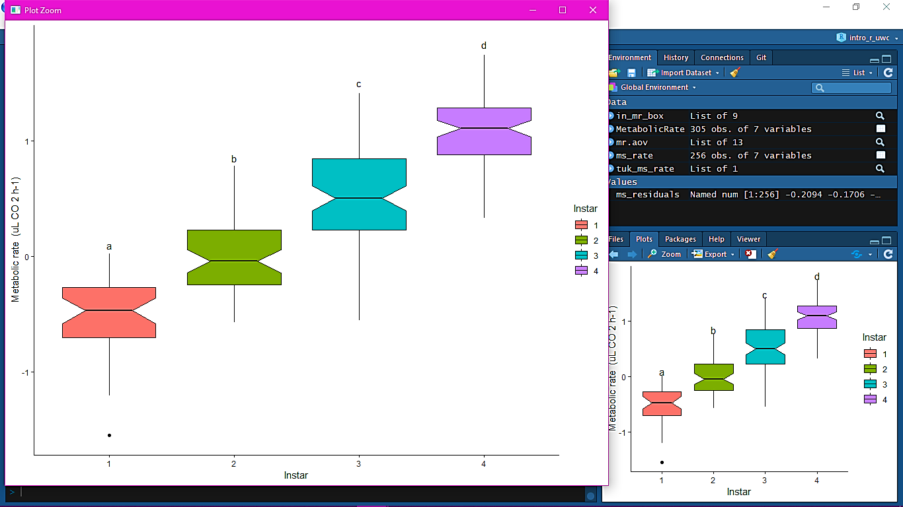

**Figure 1.** Boxplots of the variance in metabolic rate (uL CO2 h-1) between the 4 instar phases.

The null hypothesis was that the instar groups did not differ from one another, whereas, the alternate hypothesis was that at least one of these groups differed. Due to the overlay in the boxplots a & b, a, b & c, and b, c & d (in Figure 1.) there were differences in variation between these instars and metabolic rate (F = 177.5, df = 3, P = <2e-16). Thus the null hypothesis was rejected and the alternate hypothesis accepted.

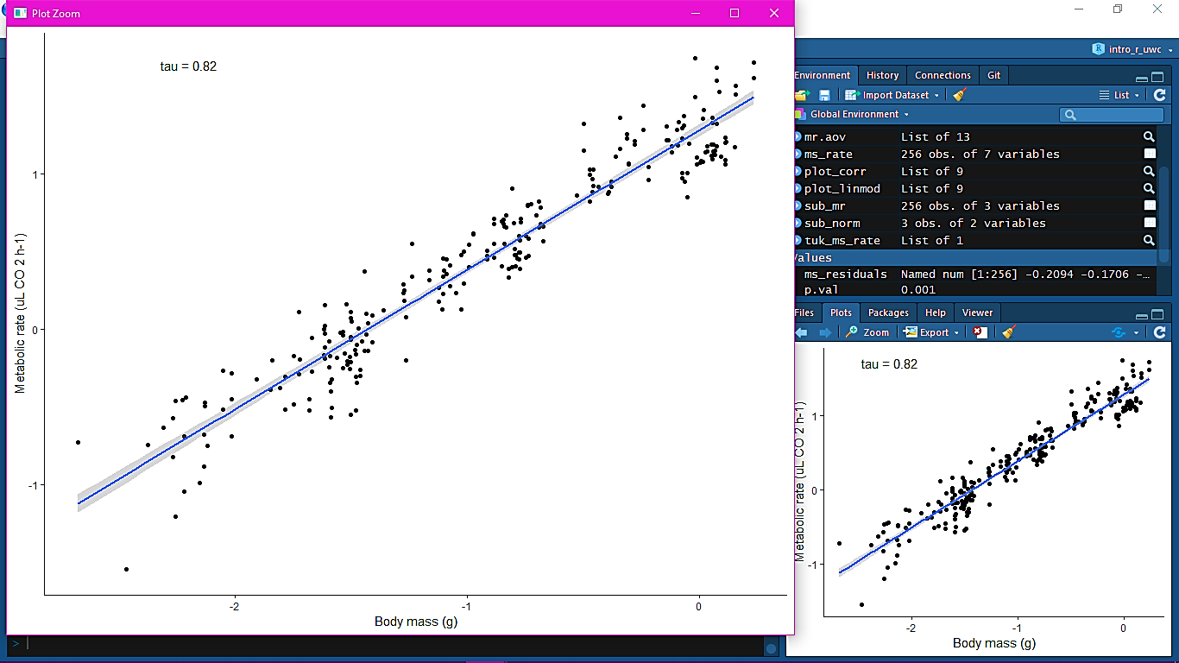

**Figure 2.** The correlation between metabolic rate (uL CO2 h-1) and body mass (g) in *Manduca sexta*

A Kendall rank correlation test (tau = 0.82) and its supporting plot (Figure 2) determined a relationship between body size and metabolic rate. This was a positive relationship, as metabolic rate increases, so does body mass increase.

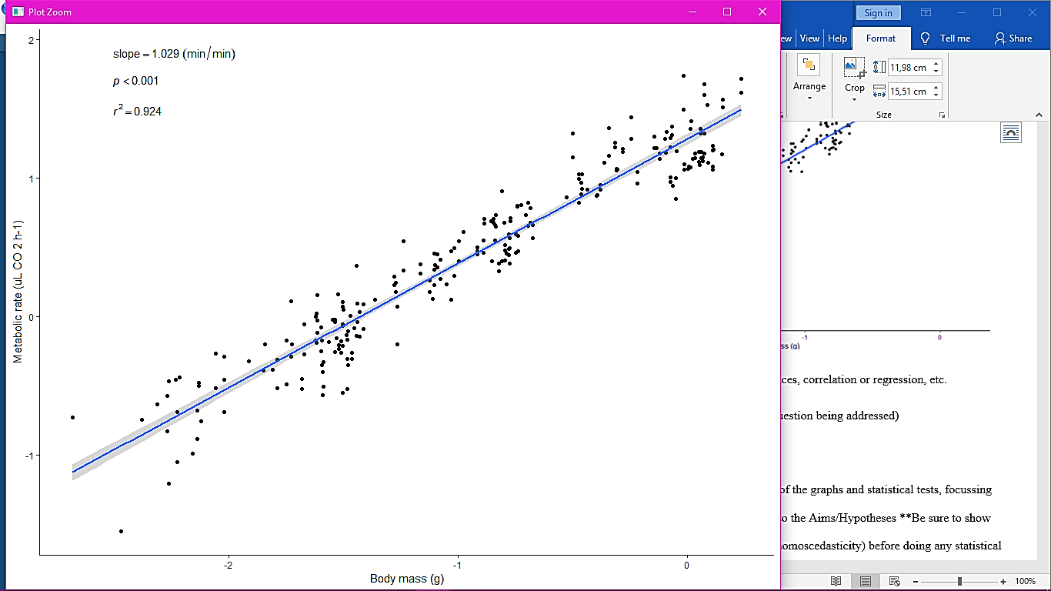

**Figure 3.** The influence of body mass (g) on metabolic rate (uL CO2h-1) using a linear model.

A linear regression determined that body size influences metabolic rate (p < 0.001, r = 0.9224).

**Discussion**

It was determined that instar phases differed from one another and that every consecutive phase varies from its previous and following phase. Differences between scaling exponents between and within instars may be related to the particulars of the growth process. Based on histological studies of the Manduca gut epithelium (Baldwin and Hakim 1991), it appears that during each instar, larvae grow primarily through cell expansion rather than cell division. During moult, not only do new cells proliferate from stem cells but also existing cells shrink, such that epithelial cells are approximately the same size at the beginning of each instar, despite an estimated 200-fold increase in cell number and epithelial surface area from ﬁrst to ﬁfth instar (Baldwin and Hakim 1991). In larval insects, the diameters of major tracheae and spiracles are generally ﬁxed during an instar. In Manduca, mass speciﬁc tracheal system conductance decreases almost 50% on average as animals grow within each of the ﬁrst four instars (Greenlee and Harrison 2005), suggesting that as animals grow, the delivery capacity of the tracheal system may not be able to keep up with their expanding oxygen demands. Thus, the increase in metabolic intensity observed across instars may result from the restoration of oxygen supplies when the major tracheae and spiracles are replaced at moult. This suggests that different patterns of metabolic scaling may be present in supply- versus demand-driven systems.

There is a correlation (Figure 2.) and influence (Figure 3.) between body mass (g) and metabolic rate (uL CO2 h-1). It suggested that metabolic rate is driven by cell-membrane-dependent processes, and that the scaling of metabolic rate is determined by the changes in the proportion of membranes per unit volume. Other hypotheses about demand-driven metabolic rates suggests that growth rate (and by extension, metabolic rate) reflects the growth potential of tissues for cell proliferation and growth, which decrease as the tissues achieve functional maturity; metabolic rate is not limited by resource supply, but by tissue growth potential. Although this argument is plausible, there is no straightforward way to measure “tissue growth potential”. (Sears *et al.* 2012).

**Conclusion**

Instar phases variation is due to the increase in metabolic intensity which may have resulted from the restoration of oxygen supplies when the major tracheae and spiracles are replaced at moult. The metabolic rate is driven by cell-membrane-dependent processes, and that the scaling of metabolic rate is determined by the changes in the proportion of membranes per unit volume.

**References**

Baldwin K.M. and R.S. Hakim. 1991. Growth and differentiation of the larval midgut epithelium during molting in the moth, Manduca sexta. *Tissue Cell* 23:411–422.

Chamberlin M.E., C.M. Gibellato, R.J. Noecker, and E.J. Dankoski. 1997. Changes in midgut active ion transport and metabolism during larval-larval moulting in the tobacco hornworm (*Manduca sexta*). *J Exp Biol* 200:643–648.

Greenlee K.J. and J.F. Harrison. 2005. Respiratory changes throughout ontogeny in the tobacco hornworm caterpillar, *Manduca sexta. J Exp Biol* 208:1385–1392

Sears K.E., Kerkhoff A.J., Messerman A. and Itagaki H. 2012. Ontogenetic scaling of metabolism, growth and assimilation: Testing metabolic scaling theory with *Manduca sexta* larvae. *Physiological and Biochemical Zoology* 85(2):159–173.