Labs:

1. Web App

Create web app through Create Resource section, provide resource group, region, subcription, OS, Plan(Standard S1) and create.

To enable Monitoring, Go to Monitoring section, in App Service Logs, enable Application logs etc as given in below screenshot.  
  
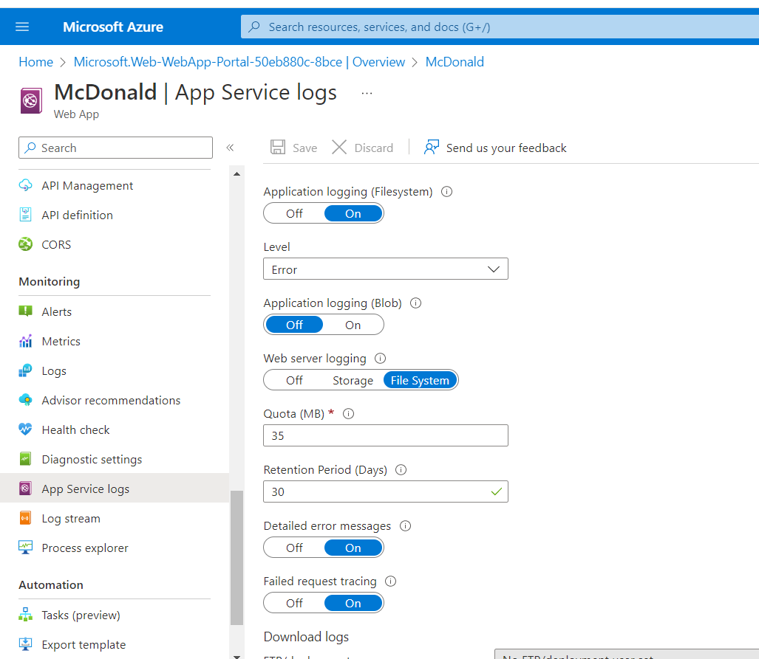

1. Deploy a local application to Azure portal from Vs2019.  
     
   Download Publish profile of WebApp from Azure portal   
   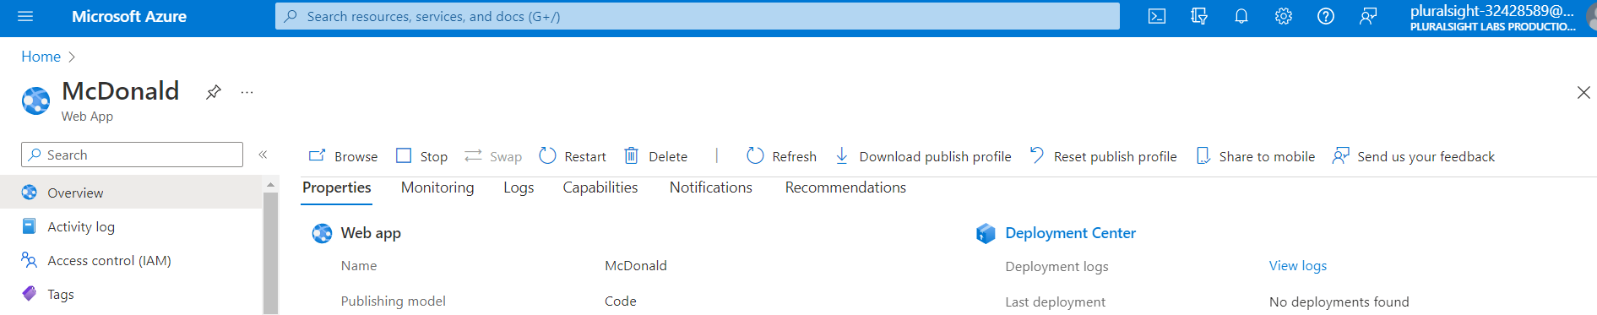  
     
     
   Publish local application  
   Import downloaded publish profile. Check the imported features, change mode to Debug from Release if require.  
   then Publish.  
   https://www.c-sharpcorner.com/article/how-to-deploy-web-app-to-azure-using-visual-studio/
2. Create Function app  
     
   Create a function app in Portal just like web app.  
   <https://www.c-sharpcorner.com/article/how-to-create-publish-azure-function-from-visual-studio/>
3. Consume Function through WebApp  
   <https://www.c-sharpcorner.com/article/create-and-consume-azure-function-from-asp-net-core/>