**Computer Information Systems Department**

**Senior Practicum – CAIS 401**

**Proposal Evaluation/Assessment Feedback**

**Fall 2017**

|  |  |
| --- | --- |
| ***Title of Project*** | Text-Matching Plagiarism Checker Software |
| ***Students Names and Numbers*** | Nasri Nizar Baseel Yatim  201303964 |
| ***Advisor*** | *Ms. Rawan Gedeon* |
| ***Submission Date*** | *February 7th, 2017* |

|  |
| --- |
| *Name of teacher doing assessment:* |
| ***Comments for the students***  ***Strengths:***  ________________________________________________________________________________________  ________________________________________________________________________________________  ________________________________________________________________________________________  ________________________________________________________________________________________  ________________________________________________________________________________________  ________________________________________________________________________________________  ________________________________________________________________________________________  ________________________________________________________________________________________  ***Areas for improvements***  ________________________________________________________________________________________  ________________________________________________________________________________________  ________________________________________________________________________________________  ________________________________________________________________________________________  ________________________________________________________________________________________  ________________________________________________________________________________________  ________________________________________________________________________________________  ________________________________________________________________________________________  ________________________________________________________________________________________ |



##### C:\Users\nasri\OneDrive\מסמכים\Bethlehem University\Fall2016\Managment Information System\proposal\2a1d118.png

***COMPUTER INFORMATION SYSTEMS DEPARTMENT***

##### ***TITLE OF PROJECT***

Text-Matching Plagiarism Checker Software

##### ***PROPOSAL***

###### *Submitted by*

Nasri Nizar Yatim

201303964

##### ***Advisor***

##### Ms. Rawan Gedeon

##### ***SENIOR PRACTICUM***

##### ***CASI 401***

##### *Spring 2017*

**Table of Contents**

**Executive Summary** 4

**Description of the Problem** 5

Online Plagiarism 5

Copying previously submitted work 5

How is it affecting us 6

**Project Purpose and Goals** 6

Why choosing us among others 7

Why are we Special 7

**Project Deliverables** 8

**Project Approach and Methodologies** 9

Technologies 10

**References** 11

## **Executive Summary**

Plagiarism is one of the problems that all universities are facing, it’s not only affecting students, but teachers and university in general. Therefore, an effective solution is required to be taken. A text-matching plagiarism software is a perfect solution for this problem. It offers instructors the ability to control student essays by controlling the content and its sources. This software will provide the ability to detect documents with potential plagiarized contents by providing a text similarity percentage to other documents in the database. What makes it special, is that the database will be built over the years. It will therefore consist of previously submitted document assignments and other outsourced contents, giving students no chance of plagiarizing other people’s work and claim ownership.

## **Description of the Problem**

For many years’ prior, universities and educational academies have prohibited plagiarism. It is considered an academic crime as it prevents students from learning in the right way and putting in their own ideas, but rather taking someone else’s work and not giving the original owner his right of ownership. When a student presents his essay as it is his own work while it’s not, and does not give any credit to the owner, he does not only deceive the course instructor marking his work, but he also prevents himself from developing skills and acquire his own knowledge. With that, universities missions are useless, and academic outcomes are insignificant. (Kennes 2015)

## Online Plagiarism

One of the problems faced when considering plagiarism is online plagiarism. Many post graduate students and researchers tend to upload their days, if not months, of work online for educational purposes, reputation gaining or even social benefits. They work hard and in return expect good feedback and good income for their hard work. However, many search engines have made anything a student needs one click away. So these projects and articles can then easily be found and used. Unfortunately, students tend to abuse that privilege and normally take other people’s work and claim it as their own.

## Copying previously submitted work

In addition to online plagiarism, another major problem faced in Bethlehem University when considering plagiarism is that some students not only plagiarize online work, they also try to plagiarize their fellow students’ work. That branches out to include same course section students, previous year students’ course essays, or even copying work straight out of their classmates’ assignments because they are too lazy and irresponsible to do their own assignments. It has reached a point where a student that does not agree to give his/her effort to fellow students when asked to, gets accused of selfishness and lack of loyalty or friendship. Plagiarizers almost never take into consideration that student might have spent hours working and editing in hopes of getting a good mark and assume that it is their right as a friend and fellow student to take credit for that person’s efforts.

What several students in Bethlehem University may not understand is that such plagiarism is completely unacceptable and may in some cases even lead them to legal issues. Numerous countries are very strict in such cases and have serious legal repercussions for plagiarism. As small, silly or insignificant plagiarism may sound, it may sometimes lead to prison sentences. After all, as a student, it should be made clear that to plagiarize is a serious ethical and perhaps legal issue. That’s something our university should consider. (ithenticate 2016)

## How is it affecting us

In addition to everything discussed previously, it is important to realize as an institution that plagiarism is harming our universities. According to Bethlehem University’s mission statement, hundreds of thousands of dollars are spent each year, in hopes of providing a good quality of higher education to the people of Palestine and to serve them in its role as a center of advancement, sharing and use of knowledge. (BU 1973) Therefore, anyone breaking that mission is not worthy of the university’s services, and shall be expelled and charged for violating their mission statement. Plagiarism even in its smallest cases must not be tolerated or accepted in any course, essay and especially bachelor senior seminar.

As a university, it’s also important for us to realize the problem we’re heading towards. Our Students are now highly dependent on last years’ work as a major source for their assignments. This method of learning causes students to lose their will to strive and become better because they can simply find other previous solutions to any problem they could ever face. Since university instructors are not stopping them from that and even allowing them to pass their courses with little to no effort, students are now finishing their courses and graduating without the full knowledge that they deserve to be receiving. This then is also leading these instructors to lose faith in what they are teaching because they feel as if students are not benefiting and the desired outcome is not being accomplished. Overall, there tends to be no achievement of course outcomes and objectives, and such courses will then be marked as failed for not meeting its requirements.

# **Project Purpose and Goals**

Overcoming this problem is never easy, but in the same way it is also not impossible. Unfortunately, students for generations have accepted plagiarism as a normal operation, because it was clear that there was no absolute solution for preventing it, but rather only novice techniques to detect it. For that reason, a great solution to this problem will be a text-matching software for plagiarism detection. And that’s what we offer. It’s basically a website that provides a full document checking and a plagiarism preventing software that can be used by students and faculty. This software provides the ability for an instructor to set up a class online and an assignment session with a drop box that allows students to upload their work. Students who are enrolled in this class can submit their papers. After that, the instructor, and him the instructor, can view these papers. Once a paper is uploaded to the website, it will be analyzed regarding its paragraphs, sentences and words. From each word document, multiple keywords will be extracted according to its occurrence and uniqueness. These keywords will then be uploaded to a database that keeps the top keywords as well as a reference to that document. This will ease the process of querying the documents with a possible similarity according to its subjects. Then once the instructor clicks a student submission to see the document, all other similar subject documents in the database will be queried and the website will compare them to the student document. This will output a similarity percentage of matching sentences and paragraphs, these percentages will then be shown to the instructor accordingly with a reference of the document it matches. Of course, those documents exist in our database that is built over the years containing old and new submitted papers. This not only gives instructors the ability to call plagiarism, but also provides him with a full documentation of the plagiarism process (as will be discussed later). In conclusion, it is clear to see that with something as simple as a few clicks, the previous problem is handled.

## Why choosing us among others

There are some websites that provides similar features, but at rather very high cost. Though there is no doubt in the advantages that those websites provide, the disadvantages are noticeable and may be the cause of some frustration. One of the main disadvantages in this case is the subscription cost. An example of these websites is Turnitin, which is known to cost around $900 a year according to Turnitin.com. Some of the other disadvantages is that there must be direct access to the internet, as well as the necessity of student subscription in order to see his assignment grades.(Glamorgan2014)  
Therefore, it is clear that such websites may be a solution to the presented issue, but the question is: Will these websites manage to meet our university’s requirements?

## Why are we Special

You may start to wonder, why is this so important? How will this even benefit students in any way? Will it cause the opposite effect and be of any inconvenience for students to submit their work online? The answer to all these is a definite no.

As universities worldwide are heading towards using technology in their academic plans, installing these programs shouldn’t be troublesome. In fact, not only will it save costs of printing and lots of time and it will also be an easy and convenient way to submit assignments online. It will be a source of credibility for students as well as instructors, as students can easily find out how they have been graded while being provided with feedback especially drafted for them on our website. On the other hand, instructors will be more relaxed and confident marking their student’s work knowing that the assignments provided are in fact of their own effort and work. This should push our university’s mission statement to its peak. This software will not only drive, but rather force students to work harder, be aware of the importance of the academic credibility, and make sure to use citation as a part of their homework routine. This will finally help bring our university’s mission back to life, stronger than ever.

# **Project Deliverables**

In addition to helping revive goals and aims, a text-matching plagiarism checker should deliver four specific benefits for our teacher and instructors.

First, it will work in parallel with the internet search engines. Although search engines can look for plagiarized materials, they will never be able to provide previously submitted assignments. Our software can provide teachers that may teach the same topic with that possibility. After all, it’s their specialty and must be an option. Correspondingly, it will do a good job in cases of different teachers giving the same lecture topics. Because our software can track different sections of student’s submissions and keep a trace of them, it can then prove successful with finding the similarity between the similar papers assignments. This will then help prevent cases of which different students try to submit the same assignment or essay to a different course section. We know that some courses do not require a change in the assignments and exercises given to the students over a couple of years. This means that such websites like Turnitin will not do the full job, but our website will. On the other hand, imagine a free, open source software with similar specification that meets our requirements. Plagiarism problem should get to a solution sooner or later. Instructors and teachers will be able to grade freely and comfortably knowing that they have a reliable tool that gives justice to the correction process and give credibility to the grading rubrics.

Second, the software itself shows the specific sentences from the specified document that the student may have plagiarized from. This provide instructors the absolute power to call a plagiarism.

Third, as mentioned prior, our software will give a similarity percentage of each submitted paper. This can allow our university to set a minimum percentage of the accepted documents. It will also assist teachers instantly if a paper contains plagiarized content depending on the given percentage. For example, if a document has a %20 similarity to a previously submitted document, it has a lower chance to be having plagiarized content than a %50 percent submitted document given percentage. Notice that proper citation may give no sense to a %50 percent similarity. After all, the instructor cannot call it a plagiarism.

Fourth and finally, as also already mentioned previously, our software will give the instructor a proof of concept when giving the call of a plagiarized content. By printing a student report, teachers should be in the safe side with assurance of their plagiarism judgment. Although the internet contributed to the spread of plagiarism, it also managed to help find a solution that ends it.

# **Project Approach and Methodologies**

Implementing our software started from the first of January and will take a place to the 28th of April, 2017. For a duration of approximately 4 months. The estimated duration of implementing each task will be as following:

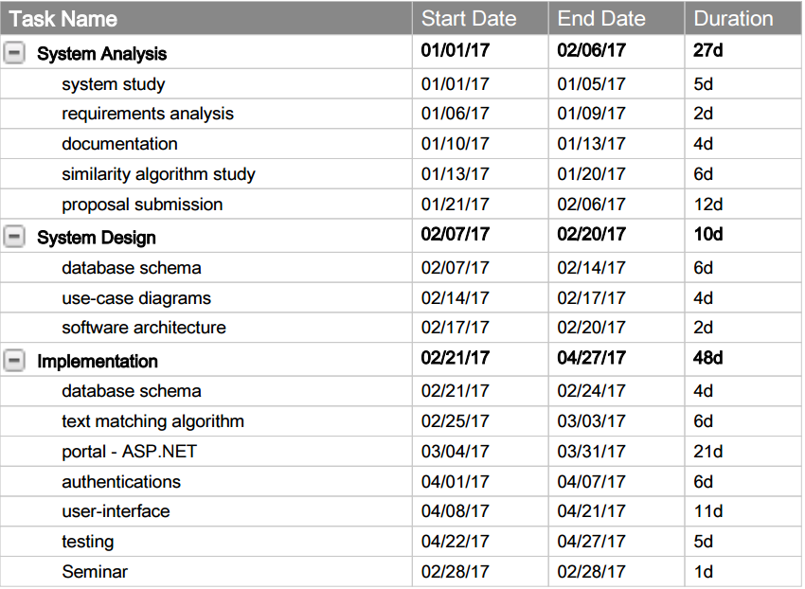

This 4-month period should be enough to deliver our software with the specified requirements. The implementation of this is also taking place in Zeva solutions company that is originated in the US, and have a team in Palestine, Beit Sahour. It will be supervised by the software development team in general, and Mr. Majd Andoni in specific. Of course, this is beside the supervision of Bethlehem University computer information system department and Ms. Rawan Gedeon in specific. The complete software development tools and technologies are provided from Zeva with no personal costs.

## Technologies

Main technologies that will be used in this process are as follows:

* C# for the text matching algorithm
* Microsoft SQL Server / MongoDB NoSQL database. Of course only one database will be implemented after testing the performance of each and choose what suits the best.
* ASP.NET MVC for Portal implementation.
* Kendo UI HTML framework. Which is a complete UI library for HTML and JavaScript Development. A great tool ZEVA offered with no costs.

# **References**

* "Why is plagiarism bad?" Reference, n.d. Web. 06 Feb. 2017. [https://www.reference.com/world-view/plagiarism-bad-27fc033d518096b7#](https://www.reference.com/world-view/plagiarism-bad-27fc033d518096b7)
* 6 Consequences of Plagiarism. (n.d.). Retrieved December 8, 2016, from <http://www.ithenticate.com/resources/6-consequences-of-plagiarism>

Bethlehem University. (1973, October). Mission Statement. Retrieved from <https://www.bethlehem.edu/about/mission-history>

The University of Glamorgan.(n.d.). TurnItIn VS Safe Assign. Retrieved from https://www.jiscmail.ac.uk/cgi-bin/webadmin?A3=ind0806&L=PLAGIARISM&E=quoted-printable&P=174367&B=--_000_047AF98B6D162541AACCFA33D05381EDA024C7E63FEXCMBX2cfslea_&T=text/html; charset=us-ascii