**Assignment-7**

9.Write the HTML and JS code to demonstrate the use of this keyword along with method such as call() apply() and BInd() such that it can be explained to any beginner with the demonstration.

= <!DOCTYPE html>

<html lang="en">

<head>

<meta charset="UTF-8">

<meta name="viewport" content="width=device-width, initial-scale=1.0">

<title>Demonstration of THIS, call(), and bind()</title>

<style>

body {

font-family: Arial, sans-serif;

}

.output {

margin: 10px 0;

font-weight: bold;

}

button {

padding: 8px;

margin: 5px;

cursor: pointer;

}

</style>

</head>

<body>

<h2>Demonstrating "this", "call()" and "bind()"</h2>

<button id="button1">Use "this" in an Object Method</button>

<div class="output" id="output1"></div>

<button id="button2">Use "call()" Method</button>

<div class="output" id="output2"></div>

<button id="button3">Use "bind()" Method</button>

<div class="output" id="output3"></div>

<script>

// Object with a method to demonstrate 'this'

const person = {

name: 'John Doe',

sayHello: function() {

return 'Hello, my name is ' + this.name;

}

};

// A separate object

const anotherPerson = {

name: 'Jane Doe'

};

// Event listener for first button - demonstrating 'this'

document.getElementById('button1').addEventListener('click', function() {

document.getElementById('output1').textContent = person.sayHello();

});

// Event listener for second button - demonstrating 'call()'

document.getElementById('button2').addEventListener('click', function() {

document.getElementById('output2').textContent = person.sayHello.call(anotherPerson);

});

// Event listener for third button - demonstrating 'bind()'

document.getElementById('button3').addEventListener('click', function() {

const boundFunction = person.sayHello.bind(anotherPerson);

document.getElementById('output3').textContent = boundFunction();

});

</script>

</body>

</html>

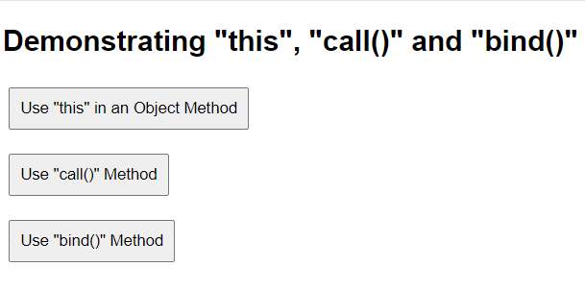Output: